新北市立溪崑國民中學110學年度第一學期第二次定期評量 英語科 試題卷
八年級 班 座號 姓名
一 聽力測驗25%
一、辨識句意：每題均有三張圖片，請依據所聽到的句子，選出符合描述的圖片 5%
1.
(A) 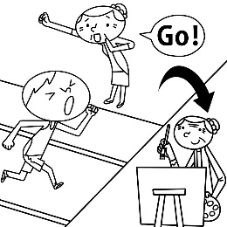 (B) 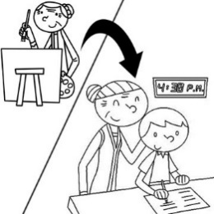 (C) 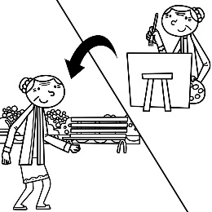
2..
(A) 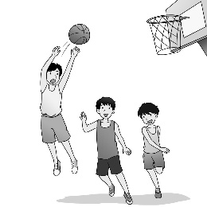 (B) 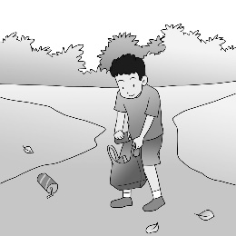 (C) 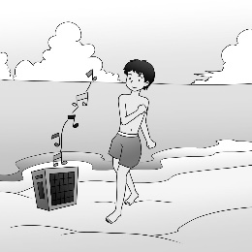
3.
(A) 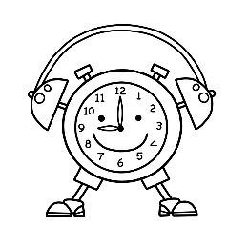 (B) 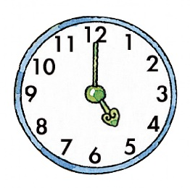 (C) 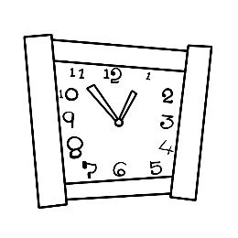
4.
(A) 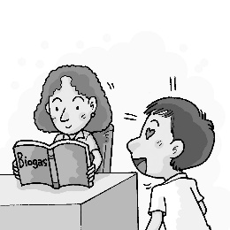 (B) 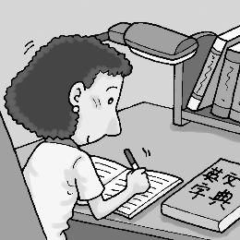 (C) 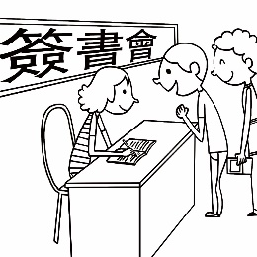

5.
(A) 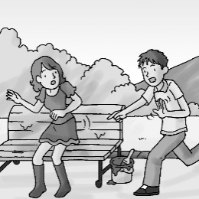 (B) 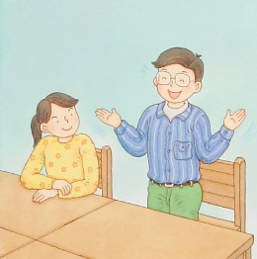 (C) 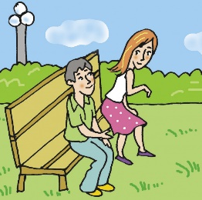

二、基本問答：每題均有三個選項，請依據所聽到的內容，選出一個最適合的回應 10%
- (A) We were in a park. (B) I was reading a comic book then. (C) I got home at eight last night.
- (A) I have no idea. This road is strange to me. (B) I just saw my favorite singer. (C) I lost my dog. I can’t find her.
- (A) Yes, I saw him at the school gate. (B) No, he doesn’t teach computer. (C) Yes, you can ask him questions.
- (A) I wasn’t serious. I only did it for fun. (B) I prepared some special gifts for them.
(C) I stayed up practicing almost every day.
- (A) She can be an actress, too. (B) Well, she’s afraid of cameras. (C) She doesn’t want to be a reporter.

三、言談理解：每題均有三個選項，請依據所聽到的對話與問題，選出一個最適當的答案 10%
- (A) The movie isn’t interesting. (B) It wasn’t quiet when he watched the movie. (C) The woman didn’t go with him.
- (A) After she washed the dishes. (B) Before she mopped the floor. (C) When her dad came home.
- (A) Their daughter has a gift for cooking. (B) Their daughter wants to be a cook in the future.
(C) Their daughter plans to make a big meal for them.
- (A) Emma is a TV reporter. (B) The man plans to move to another city. (C) The man doesn’t know much about his sister.
- (A) She’s making money for a trip. (B) She’s planning a trip for her mother.
(C) She’s uploading some photos of a beautiful town.

二 綜合測驗（50％）
16. A：How did you go to the museum last Friday? B：I ＿＿＿ there. (A) sang (B) fed (C) drove (D) shook
17. This actor is very ＿＿＿ with fans. They are happy to see him. (A) popular (B) exciting (C) bright (D) strange
18. There are four people here, so everyone can get a(n) ＿＿＿ of the cake. (A) half (B) other (C) back (D) quarter
19. A：Look! Is that woman in the restaurant your sister? B：Yes, she works there. She’s a(n) ______.
(A) secretary (B) housewife (C) actress (D) waitress
20. A：It’s five _____ one. Time for bed. B：But I still _____ a lot of homework to do .
(Ａ) of ; have (Ｂ) past ; did (Ｃ) to; was doing (Ｄ) after ; have
21. This road doesn’t ＿＿＿ to the movie theater. Please try another way. (A) lead (B) upload (C) train (D) act
22. A：You look tired（疲倦）. Didn’t you have enough sleep? B：No, I didn’t. I had a terrible ＿＿＿ last night.
(A) plan (B) dream (C) future (D) star
23. Some of my classmates like to chat in the classroom during the break time. ＿＿＿, the others like to play basketball outside.
(A) Finally (B) In fact (C) On the other hand (D) For example
24. Taking care of pets ＿＿＿ not interesting to me. (A) be (B) to be (C) are (D) is
25. Clean up your bedroom first. ______ you finish it, you can watch TV. (A) Until (B) After (C) Only (D) Before
26. James always brushes his teeth ______ he goes to bed. (A) before (B) after (C) when (D) but
27. It ______ heavily when I walked out of my office this evening. (A) rains (B) is raining (C) was raining (D) rain
28. I _____ about being a YouTuber before, but a YouTuber needs a good face _____ the camera.
(Ａ) thought; for (Ｂ) got; of (Ｃ) barked ; of (Ｄ) waved ; for
29. Sorry, I didn’t answer the phone five minutes ago. When you ______, I ______ a shower.
(A) were calling; took (B) call; was taking (C) called; was taking (D) called; am taking
30. My grandma is good at ______ pies. We can’t wait ______ them every time she makes them.
(A) making; eating (B) to make; to eat (C) to make; eating (D) making; to eat
31. Taking photos and collecting comic books ＿＿＿ my favorites. I never feel tired _____ them.
(A) is; of (B) are; of (C) to be; for (D) being; for
32. A：Thank you for ＿＿＿ me ＿＿＿ the housework. It’s nice _____ you. B：Not at all.
(A) helping; at; for (B) help; with; to (C) helped; by; from (D) helping; with; of
33. Mom told my brother and me ______ with each other.
(A) not fighting (B) not fight (C) don’t fight (D) not to fight
34. A：How can I pass（通過）the tests? B：______ studying three hours a day, _____ you can make it.
(A) Keeping; or (B) Keep; and (C) By; but (D) Without; so
35. I enjoy ______ in the park, but I never do that without ______ my dog with me.
(A) jogging; take (B) to jog; take (C) jogging; taking (D) to jog; taking
36. A：What are you ______? B：My notebook. Oh, it’s here. I _____ it.
(A) looking at; find (B) looking for; find (C) finding; looked at (D) finding; looked for
37. Eating fruit and vegetables ____ important to everyone; however, eating habits ____ not easy to change.
(A) is; is (B) are; is (C) is; are (D) are; are
38.When they _____ their teacher coming, they stopped_____ and began _____ their books.
(A) see; to talk; to read (B) saw; to talk; reading (C) saw; talking; to read (D) see; talking; reading
39.Look！Joe _____ the guitar with Vicky. (A) is practicing playing (B) is practicing to play (C) practices playing
(D) practices to play
40. A：What was Ray ______ at nine last night? B：Wasn’t he ______ music in her room?
(A) doing; listening to (B) did; listened to (C) did; listened (D) doing; listening

三. 閱讀測驗 6%

Although more than half of the people in the United States have been vaccinated, the government still hopes that people can comply with epidemic prevention regulations and maintain social distancing. The US Centers for Disease Control and Prevention (CDC) gave guidelines for fall celebrations. Traditional Halloween activities, such as indoor parties, haunted houses, and door-to-door trick-or-treating are risky for spreading COVID-19. To prevent an increase of the virus, the CDC discourages these high-risk activities. The CDC recommended safer ways to celebrate Halloween, such as decorating the house and living space. The officials are encouraging lower-risk activities like carving pumpkins with household members, watching a Halloween movie at home or holding an online Halloween costume party. The officials also stressed the importance of wearing a face mask and maintaining social distance, instead of using costume masks.
vaccinate 打疫苗 government 政府 epidemic prevention regulation 防疫規範 guideline 指導原則 traditional 傳統的 prevent 避免 increase 增加 recommend 建議 encourage鼓勵 lower-risk 低風險costume 化裝服 stress 強調 maintain 保持 crowded 擁擠的

41. What did the CDC recommend for Halloween this year?
(A) To go to a crowded costume party with friends.
(B) To have indoor parties.
(C) To join a party held in a crowded place.
(D) To avoid (避免)door-to-door trick-or-treating.

42. Which of the following is considered(認為) a high-risk Halloween activity?
(A) Decorating the house and living space.
(B) Visiting a pumpkin farm.
(C) Going into a haunted house.
(D) Visiting an old friend.
43. Which of the following is a low-risk Halloween activity?
(A) Watching a Halloween movie in the house.
(B) Holding an online Halloween costume party.
(C) Carving pumpkins with household members.
(D) All of the above.

四. 翻譯 14% (44-45每題3分，46-47每題4分)
44. 當我正走回我家時，我在路邊看到了一個小女孩。
45. 那位母親微笑著，將她抱入雙臂中。
46. 當專業玩家對青少年來說可能很有趣，因為他們享受一天到晚玩電玩遊戲。
47. 令人難過地，有些人甚至有健康的問題，因為他們通常不間斷地玩好幾個小時，而且他們時常熬夜。

五. 單字中翻英 5%

48. 郵差 49.警察 50.野餐 51.長椅 52.錯過

(試題結束)

新北市立溪崑國民中學110學年度第一學期第二次定期評量 英語科 答案卷
八年級 班 座號 姓名
四. 翻譯 14% (44-45每題3分，46-47每題4分)

44.
45.
46.
47.

五. 單字中翻英 5%

48. | 49. | 50. | 51. | 52.

110-1-2 八年級 英語科－解答
1-5 每題1分 6-43每題2分共81分
1. C B C C A 6. B C A C B 11. B A A B B 16. C A D D D
21. A B C D B 26. A C A C D 31. B D D B C 36. B C C A A
41. D C D
四. 翻譯 14% (44-45每題3分，46-47每題4分)

44. When I saw a little girl by the side of the road, I was walking to my house. .
45. The mother smiled and hugged her in her arms.
46. Being pro gamers can be a lot of fun for teenagers because they enjoy playing video games day and night.
47. Sadly, some people even have health problems because they usually play for hours without stopping, and they often stay up.

五. 單字中翻英 5%

48. mailman/mail carrier 49. policeman/police officer 50. picnic 51. bench
52. miss

新北市立溪崑國民中學110學年度第一學期第二次定期評量
八年級 英語科 聽力測驗稿

一、辨識句意：每題均有三張圖片，請依據所聽到的句子，選出符合描述的圖片(每題1分，共5分)
1. Before Grandma took a walk, she drew a picture.
2. The boy was cleaning the park when I saw him
3. It’s five to one at night.
4. My cousin always wanted to be a writer, and she is famous now.
5. The man tried to stop the woman from sitting down.

二、基本問答：每題均有三個選項，請依據所聽到的內容，選出一個最適合的回應(每題2分，共10分)
6. What were you doing at eight last night?
7. You look sad. What happened?
8. Did you see our teacher? I have some math questions to ask him.
9. What else did you do to make your dream come true?
10. Why doesn’t the singer come out? Many reporters are waiting for her.

三、言談理解：每題均有三個選項，請依據所聽到的對話與問題，選出一個最適當的答案(每題2分，共10分)
11.
W: Did you enjoy the movie at Star Cinema yesterday?
M: No, I didn’t.
W: Why not?
M: When I was there, some kids were making noises. And the woman next to me talked on her cellphone for minutes.
W: That’s terrible.
Q: Why didn’t the man enjoy the movie?
12.
G: Dad, I did a lot of housework today.
M: Really? I’m all ears.
G: First, I mopped the floor in the living room. After that, I did the dishes. And then I washed the dirty clothes.
M: You did all of them?
G: Yes. Mom gave me 50 dollars for doing all the housework.
Q: When did the girl wash the dirty clothes?
13.
M: These dishes are delicious.
W: Our daughter made them, and she started learning cooking last week.
M: Wow! She can be a great cook in the future.
W: I think so, too.
Q: What can we know from the talk?
14.
M: Look! That’s my sister, Emma.
W: Your sister is a TV reporter? Why didn’t you tell me?
M: Sadly, I didn’t know that until now. Emma and I seldom talked to one another. And she moved to another city when I was still a student.
Q: Which is NOT true?
15.
M: The small town looks beautiful. Do you want to take a trip there?
W: Maybe. Mother’s Day is coming. I want to plan a vacation for my mom.
M: Wow. Your mother must be very happy to have a daughter like you.
Q: What is the woman doing?

