新北市立溪崑國民中學110學年度第一學期第一次定期評量 英語科 試題卷
八年級 班 座號 姓名
一、 聽力測驗 30%
(A) 辨識句意：每題均有三張圖片，請依據所聽到的句子，選出符合描述的圖片 10%
- (A)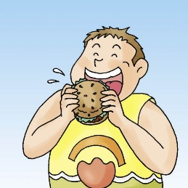 (B)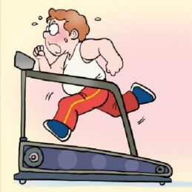 (C)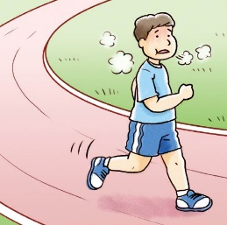
- (A)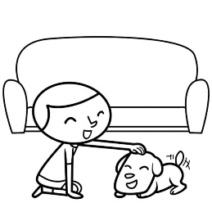 (B)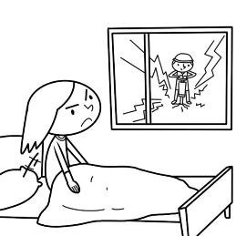(C)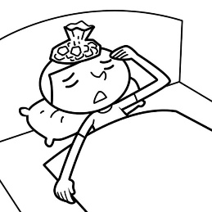
- (A)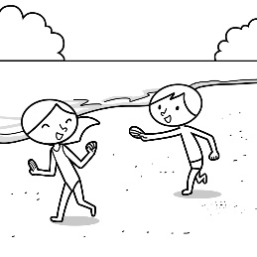 (B)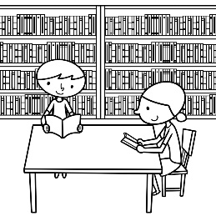(C)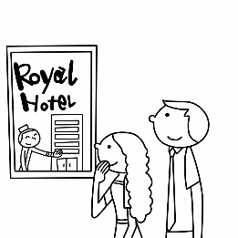
- (A)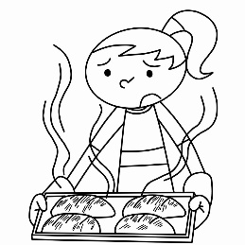 (B)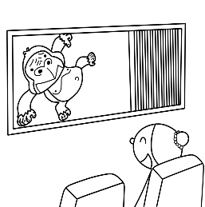(C)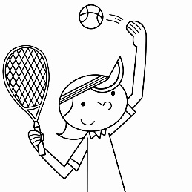
- (A)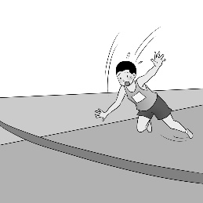 (B)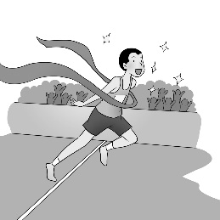(C)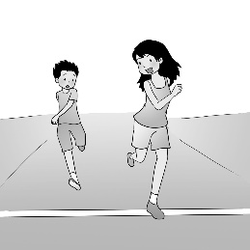

(B) 基本問答：每題均有三個選項，請依據所聽到的內容，選出一個最適合的回應 10%
- (A) The view was wonderful there.
(B) We jogged and played basketball.
(C) I went to the park with my friends.
- (A) It was fun. I learned a lot of things.
(B) I liked science and history very much.
(C) Wonderful. I can tell you some English stories.
- (A) It’s cold. Put on your coat.
(B) It’s cold. The coat is too heavy.
(C) It’s sunny. Bring your coat with you.
- (A) She really treated you badly.
(B) She felt sorry about that.
(C) She really cared about you.
- (A) She gave up and lost.
(B) She practiced almost every day.
(C) She didn’t show up. Where did she go?
(C) 言談理解：每題均有三個選項，請依據所聽到的對話與問題，選出一個最適當的答案 10%
- (A) The man didn’t visit the museum before.
(B) The woman worked in the museum before.
(C) The woman took the man to the museum before.
- (A) On the phone.
(B) In a hospital.
(C) In a clothes factory.
- (A) She read the newspaper.
(B) She used her dad’s basket.
(C) She made a basket for her dad.
- (A) Kelly’s mom didn’t answer the phone.
(B) Kelly couldn’t answer the phone, so she sent the message.
(C) Kelly didn’t call her mom back.
- (A) At home.
(B) In a restaurant.
(C) In a hospital.
二、綜合測驗 30%
- James ate too much ice cream, so he had a _______.
(A) stomachache (B) medicine (C) hospital (D) health
- Mrs. Lin: Why are you late again, David?
David : Well…My alarm clock didn’t work, so I didn’t _____ the school bus.
(A) speak (B) surf (C) call (D) catch
- Henry studied in China before, so she knows a lot about the ______.
(A) country (B) balloon (C) beach (D) science
- We love Ms. Lin’s math class because it’s _____.
(A) strong (B) interesting (C) learning (D) healthy
- We can’t go to Michael’s party ____ we’re going out for camping that weekend.
(A) but (B) or (C) so (D) because
- Mom cut the cake into eight pieces and _____ one piece to each of us.
(A) gives (B) will give (C) gave (D) is giving
- A: Did Alex ______ video games yesterday ? B: Yes, he did. He ______ video games every day.
(A) played; plays (B) play; plays (C) play; played (D) play; play
- A: Where ______ you ______ Carol this morning ? B: In the park. We both jogged there.
(A) do; meet (B) did; met (C) did; meet (D) do; met
- Playing baseball _____ a lot of fun, so we enjoy it very much.
(A) has (B) is (C) had (D) was
- A: Why did you come to school late this morning?
B: I didn’t come to school on time ______the heavy traffic.
(A) because (B) ,so (C) because of (D) and so
- A: Tina’s birthday is next week. B: Let’s send ______ a card.
(A) her (B) to her (C) for her (D) hers
- A: Why not ____ as his birthday gift. Robots are his favorite. B: Good idea!
(A) give a robot for Tim (B) give Tim to a robot (C) buy to Tim a robot (D) buy Tim a robot
- Simon didn’t go hiking last weekend ______ he _____ .
(A) , so ; got hurt badly (B) , so ; hurt badly (C) because ; got hurt badly (D) because ; hurt badly
- Amy didn’t _____ her lunchbox today. Her classmate Ken ______ his lunchbox with her.
(A) bring; shared (B) brought; shared (C) take; shares (D) took; shares
- Ben _____ afraid. He ______ to his mom and cried.
(A) is; runs (B) is ; ran (C) is ; is running (D) was ; ran
三、克漏字測驗 (31-35) 10%
Bella and Scott did different things for their colds. Bella went to the doctor, and the doctor ___31___, but Scott didn’t. Bella __32__ and didn’t drink any cold drinks. She __33__ a heavy coat even on a hot summer day. She also stayed at home all weekend.
__34___ Scott, he just kept his body cold and he even ate some ice cream for his sore throat. His ways were really different from ___35___ .
However, they are both healthy again now.
- (A) gives some medicine to her (B) gave her some medicine
(C) gives her some medicine (D) gave some medicine for her
- (A) ate the medicine (B) eats the medicine (C) takes the medicine (D) took the medicine
- (A) put off (B) tried on (C) put on (D) took off
- (A) Because of (B) As for (C) Thanks to (D) Through
- (A) she (B) her (C) his (D) hers
四 、閱讀理解 (36-44) 18%
(A)
Percy and Adams lived in a great neighborhood. He had many friends there. Percy woke up one morning and took a long stretch. He had a good night and was very rested. First, he walked in the kitchen and ate a good breakfast. He waited at the door for someone to open it and let him out. He had things to do. Percy walked outside and looked around. Everything seemed fine. Then, he went and checked on his friend, Al the dog. Al was still sleeping and didn’t want to go with Percy. Percy walked across the yard and visited the Mother Bird and her babies. They were fine and were eating some worms for breakfast. They didn’t even look at Percy. They were busy. Percy walked across the street and visited his friend Bubba. Bubba was outside and stretched out in the sun. Bubba was glad to see Percy. They were great friends. Bubba said hello to Percy with a big MEOW. Percy gave a MEOW right back. Percy and Bubba played and played. They visited their other friends in the neighborhood. It was time to go home. They were tired and it was a good time to take a nap.

* wake up 醒來 * stretch 伸展 * yard 院子

- What kind of animals were Percy and Bubba ?
(A) Dogs. (B) Birds. (C) Mice. (D) Cats.
- Who did Percy visit first when he went outside?
(A) Al (B) Bubba (C) Mother bird (D) The frog
- Why didn’t the birds look at Percy ?
(A) They were asleep. (B) They were afraid. (C) They were gone. (D) They were eating breakfast.
- What did Percy do when he went home ?
(A) Played with Al. (B) Took a nap. (C) Ate some food. (D) Visited the birds.
(B)
A Trip to the National Museum of Natural Science
Judy : Peter, I heard your class took a field trip to Taichung during winter break. Where did you go?
Peter : My teacher think we can learn a lot when we visit places, so he sets up a couple of trips a year. Last winter, we
went to an art gallery; they had an exhibit of some paintings from Taiwan’s important painters. It was a great
experience. This time, we went to a museum.
Judy : That sounds great. Which Museum did you go to ?
Peter : We went to the National Museum of Natural Science. It’s one of the most important museums in Taiwan.
Judy : I know. What did you see there?
Peter : They have two types of exhibits, permanent and temporary. Permanent ones are always there. Temporary ones
are only in one museum for a while, and the they move to another one. We went to see a temporary exhibit, Jehol
Biota Special Exhibition.
Judy : That sounds cool. There must be a lot of interesting fossils. I want to see them, too. When does the exhibition end ?
Peter : It ends on May 26. Maybe your uncle can take you there during spring break; he likes fossils.
Judy : That’s a good idea.
* field trip 校外教學 * gallery 畫廊 * exhibit 展覽 * exhibition 展覽 * fossil 化石

- What are Judy and Peter talking about?
(A) A trip to Tainan. (B) A visit to a museum. (C) Some special exhibition. (D) A plan for the spring break.
- What does the word temporary mean?
(A) For a short time. (B) For a long time. (C) In a big place. (D) In a small place.
- What can we know from the dialogue?
(A) There’s only one museum in Taichung. (B) Judy’s teacher never takes her class on a trip.
(C) Jehol Biota Special Exhibition starts in spring. (D) Peter’s teacher takes his class on a trip sometimes.
(C)
The Missing Post Office
Do you want to send a letter to a stranger? Or would you like to send one to a person who has left this world? The Missing Post Office in Awashima, Japan can help you do that. Well, this post office does not actually send the letters but keeps them open in the office for people to read. When you visit this place, you can take a letter home if you believe the letter was written to you.
To get here, you can take a train to JR Takuma Station and then a bus to Suda Port. From this port, you can take a ship or a water taxi to Awashima. A ship ticket only costs 360 yen each way. However, if you are in a hurry, you can take the water taxi. The cost for that is 2,000 yen per person.
So, if you ever have the chance to visit Japan, remember to put this place on you traveling list. You will not regret coming here to read the letters and experience this very curious and special place.
* yen 日圓 * per 每 * actully 實際地 * regret 後悔 * curious 稀奇的
* Awashima 粟島 * JR Takuma Station 日本鐵道詫間車站 * Suda Port 須田港

- What does “do that” refer to in the reading ? refer to 指稱
(A) Visit the post office and take a letter home.
(B) Send a letter to a stranger or to someone who is dead.
(C) Keep the letter you wrote to your friends in the post office.
(D) Take a bus to Suda Port and take a water Taxi to Awashima.
- Vivian would like to go to the Missing Post Office, but she does not have too much money with her. According to the reading, which is the best wasy for her to go there? according to 根據
(A) take a bus to JR Takuma Station take a train to Suda Port walk to the post office
(B) ride a bike to JR Takuma Station take a bus to Suda Port go to the post office on foot
(C) take a train to JR Takuma Station take a bus to Suda Port take a taxi to the post office
(D) take a train to JR Takuma Station take a bus to Suda Port take a ship to the post office
五、 翻譯 12%
- 我去了鹿港 (Lukang)，且很享受在那裡的時光。
- 這營隊持續了一週。透過它，我學到很多關於小鎮的事情。
- Jack 昨天在家休息因為他感冒了並且發燒了。
- 現在，因為如此，我再度恢復健康，可以像隻猴子般到處活蹦亂跳。

新北市立溪崑國民中學110學年度第一學期第一次定期評量 英語科 答案卷
八年級 班 座號 姓名

五、 翻譯 (45-48) 12%

45
46
47
48

110-1-1 八年級 英語科－解答

1 | 2 | 3 | 4 | 5 | 6 | 7 | 8 | 9 | 10
C | C | B | B | A | B | A | A | C | B
11 | 12 | 13 | 14 | 15 | 16 | 17 | 18 | 19 | 20
B | A | C | C | C | A | D | A | B | D
21 | 22 | 23 | 24 | 25 | 26 | 27 | 28 | 29 | 30
C | B | C | B | C | A | D | C | A | D
31 | 32 | 33 | 34 | 35 | 36 | 37 | 38 | 39 | 40
B | D | C | B | D | D | A | D | B | B
41 | 42 | 43 | 44
A | D | B | D

翻譯 每題 3 分 共12 分
45 | I went to Lukang and enjoyed my stay there.
46 | The camp lasted for a week. Through it, I learned a lot about the town.
47 | Jack rested at home yesterday because he caught a cold and had a fever.
48 | Now, because of that, I am healthy again and can jump around like a monkey.

新北市立溪崑國民中學110學年度第一學期第一次定期評量
八年級 英語科 聽力測驗稿
溪崑國中一段聽力 英語科 考試卷 ___年 ___班 座號：___ 姓名：__________
一、辨識句意：每題均有三張圖片，請依據所聽到的句子，選出符合描述的圖片
- 《腳本區》
CD: The man jogged in the park every morning last year. He’s thin and healthy now.
《題目區》
(A) (B)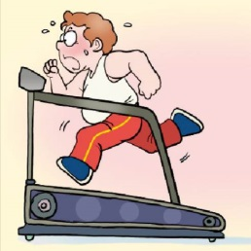 (C)
《答案區》
答案：C
- 《腳本區》
CD: My cousin couldn’t sleep because of the high fever.
《題目區》
(A)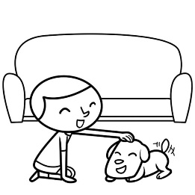 (B)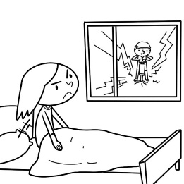(C)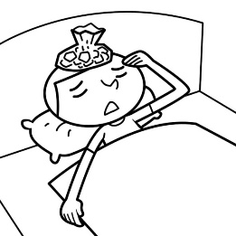
《答案區》
答案：C
- 《腳本區》
CD: My friends didn’t go to the movies or the beach yesterday. They studied together.
《題目區》
(A)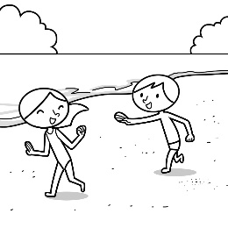 (B)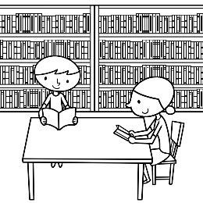(C)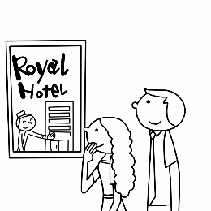
《答案區》
答案：B
- 《腳本區》
CD: The girl went to the movies and had a great time.
《題目區》
(A) (B)(C)
《答案區》
答案：B
- 《腳本區》
CD: The boy fell down, so he didn’t win the race.
《題目區》
(A) (B)(C)
《答案區》
答案：A
二、基本問答：每題均有三個選項，請依據所聽到的內容，選出一個最適合的回應
- 《腳本區》
CD: What did you do in the park this morning?
《題目區》
(A) The view was wonderful there.
(B) We jogged and played basketball.
(C) I went to the park with my friends.
《答案區》
答案：B
- 《腳本區》
CD: How was your science camp?
《題目區》
(A) It was fun. I learned a lot of things.
(B) I liked science and history very much.
(C) Wonderful. I can tell you some English stories.
《答案區》
答案：A
- 《腳本區》
CD: How’s the weather in the city today?
《題目區》
(A) It’s cold. Put on your coat.
(B) It’s cold. The coat is too heavy.
(C) It’s sunny. Bring your coat with you.
《答案區》
答案：A
- 《腳本區》
CD: Jenny didn’t sleep and took care of me last night.
《題目區》
(A) She really treated you badly.
(B) She felt sorry about that.
(C) She really cared about you.
《答案區》
答案：C
- 《腳本區》
CD: Jenny won the race! How did she make it?
《題目區》
(A) She gave up and lost.
(B) She practiced almost every day.
(C) She didn’t show up. Where did she go?
《答案區》
答案：B
三、言談理解：每題均有三個選項，請依據所聽到的對話與問題，選出一個最適當的答案
- 《腳本區》
CD: M: Where did you work before?
W: MOMA. I worked there for five years. Do you know the art museum? It’s in New York City.
M: Of course. I joined a camp in New York City many years ago, and I visited many museums. MOMA was my favorite one.
Q: What do we know about the museum?
《題目區》
(A) The man didn’t visit the museum before.
(B) The woman worked in the museum before.
(C) The woman took the man to the museum before.
《答案區》
答案：B
- 《腳本區》
CD: M: May I speak to Jamie?
W: She just went out. Do you want to leave a message?
M: Yes, please. This is Mike from Sunshine Hospital....
Q: Where might the dialogue take place?
《題目區》
(A) On the phone.
(B) In a hospital.
(C) In a clothes factory.
《答案區》
答案：A
- 《腳本區》
CD: G: Dad, I used some newspaper to make a basket for you last night.
M: Really? You’re so nice. Can I use it now?
G: Sure. But... it’s not very strong.
M: Don’t worry. Thank you.
Q: What did the girl do last night?
(A) She read the newspaper.
(B) She used her dad’s basket.
(C) She made a basket for her dad.
《答案區》
答案：C
- 《腳本區》
CD: M: Dear, you called me many times this evening. What’s wrong?
W: Kelly got a message this afternoon and went out. I called her many times, but she didn’t answer.
M: Who sent her the message?
W: I have no idea.
Q: What happened?
(A) Kelly’s mom didn’t answer the phone.
(B) Kelly couldn’t answer the phone, so she sent the message.
(C) Kelly didn’t call her mom back.
《答案區》
答案：C
- 《腳本區》
CD: W: Doctor, my son caught a bad cold. He has a runny nose and a fever.
M: Don’t worry. Go home and take the medicine on time.
W: Is that all?
M: Well… drink more water and take some rest.
Q: Where are the man and the woman?
(A) At home.
(B) In a restaurant.
(C) In a hospital.
《答案區》
答案：C

