新北市立溪崑國民中學110學年度第一學期第一次定期評量 英語科 試題卷
七年級 班 座號 姓名
一、聽力測驗: 30% (每題兩分)
(一)辨識句意：每題均有三張圖片，請依據所聽到的句子，選出符合描述的圖片。
1.（ ）(A) 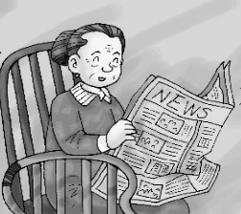 (B) 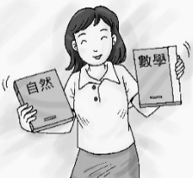 (C) 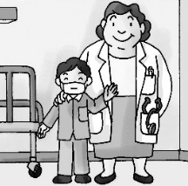
2.（ ）(A) 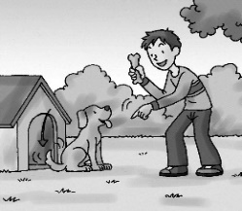 (B) 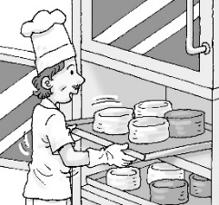 (C) 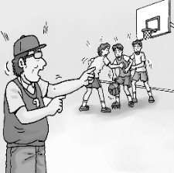
3.（ ）(A) 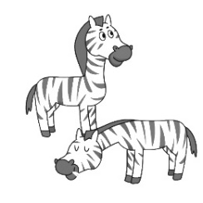 (B) 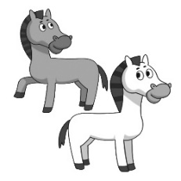 (C) 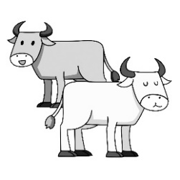
4.（ ）(A) 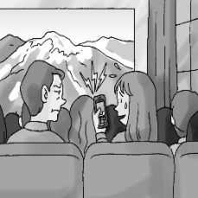 (B) 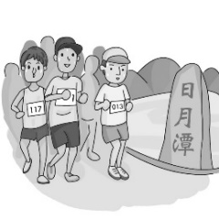 (C) 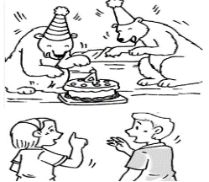
5.（ ）(A) 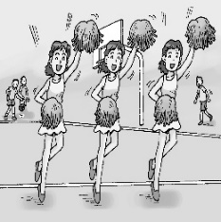 (B) 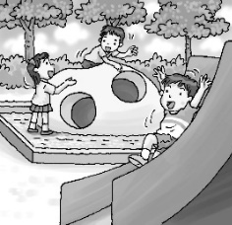 (C) 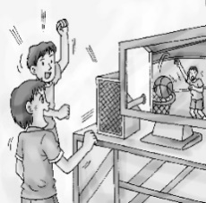
(二)基本問答：每題均有三個選項，請依據所聽到的內容，選出一個最適合的回應。
6.（ ）(A) No, it’s not. (B) No, I’m not. (C) No, you’re not.
7.（ ）(A) It is sad. (B) Thank you. (C) You’re welcome.
8.（ ）(A) It’s a toy for you. (B) Yes, the box is big. (C) They are pens and pencils.
9.（ ）(A) Yes, I am. What about you? (B) No wonder you’re energetic!
(C) That’s true. I’m a horse.
10.（ ）(A) No, they’re not. (B) No, they’re smart. (C) No, they’re not cute.
(三)言談理解：每題均有三個選項，請依據所聽到的對話與問題，選出一個最適當的答案。
11.（ ）(A) A pencil. (B) A pencil box. (C) A banana.
12.（ ）(A) Today is the man’s birthday. (B) The gift is from the man’s son.
(C) The robot dog is a birthday gift.
13.（ ）(A) The woman’s watch and the man’s watch are the same.
(B) The woman took away（拿走）the man’s watch.
(C) The woman’s watch is on the table.
14.（ ）(A) The animals on TV are sheep.
(B) The pictures on the woman’s smartphone are goats.
(C) The boy and the woman are at a movie theater.
15.（ ）(A) The book is about animals.
(B) The book is about a lion’s family.
(C) The woman and the boy are in a zoo.
(背面尚有試題)
二、綜合測驗: 30% (每題兩分)
16.（ ）A: ＿＿＿ your favorite food? B: I like ＿＿＿. It is very yummy.
(A) What’s; noodles (B) What; chocolate (C) What’s; ice cream (D) What; apples
17.（ ）Lora：My brother is only two ＿＿＿ old. Joe：Really? He looks like a three-＿＿＿-old boy.
(A) years; years (B) year; years (C) years; year (D) year; year
18.（ ）A：＿＿＿ Eason and Gary’s sister tall ? B：No, ＿＿＿.
(A) Is; she’s short (B) Isn’t; she’s tall (C) Are; they’re short (D) Aren’t; they’re tall
19.（ ）A: Is it my ＿＿＿ pencil case? B: No, ＿＿＿ not. His pencil case is on that desk.
(A) brother’s; its (B) brother; its (C) brother’s; it’s (D) brothers’; its
20.（ ）＿＿＿ are my favorite animals. They like bananas and they can climb (爬) trees.
(A) Rabbits (B) Goats (C) Monkeys (D) Pigs
21.（ ）A：Look! There is a snake over there. B：Oh, no. It looks ＿＿＿. It’s poisonous (有毒的).
(A) scary (B) cute (C) beautiful (D) nice
22.（ ）I have two sons and a daughter. They are my ＿＿＿.
(A) children (B) men (C) women (D) parents
23.（ ）A：What are these? B：＿＿＿ Alex’s watches.
(A) You are (B) They are (C) I am (D) She is
24.（ ）A: Who is that girl? Is she your sister? B: No, she is my aunt’s daughter. She is my _________.
(A)child (B) student (C) wife (D) cousin
25.（ ）A：My father is a cook. B：＿＿＿ A：No, he is a teacher.
(A) How are you? (B) This is my father. (C) My father is a cook, too.
(D) Is your uncle a cook, too?
26.（ ）A: What’s your animal __________? B: I’m a tiger.
(A) size (B) sing (C) snake (D) sign
27.（ ）A：＿＿＿ Jane’s and Lily’s husbands good friends? B：Yes, ＿＿＿.
(A) Is; he is (B) Are; they are (C) Is; he’s (D) Are; they’re not
28.（ ）A：Is this ＿＿＿ car new? B：No,it isn’t. It’s ＿＿＿ old car.
(A) a; ╳ (B) a; an (C) ╳; a (D) ╳; an
29.（ ）A：＿＿＿ are those? B：_______ are my new shoes.
(A) What; That (B) How; They (C) Who; That (D) What; They
30.（ ）Which is correct? (選出正確的句子)
(A) That is my new books.
(B) Is the house an old?
(C) What are this?
(D) She is a beautiful woman.

- 克漏字選擇: 10% (每題兩分)
Kitty：Mom, look at my picture.
Mom：It’s beautiful! What are ＿31.＿?
Kitty：This is a fox. That is a bear. A rabbit is on the bear’s back. On the tree __32.__ birds.
Mom：How interesting! A rabbit is on a bear’s back! ＿33.＿ this bear scary to the rabbit?
Kitty：No! They are friends. These animals are here __34.__ the rabbit’s birthday.
Mom：They look very happy. ＿35.＿
Kitty：They are the rabbit’s neighbors. And the lion is their teacher.
Mom：That’s great, Kitty. These animals are cute!
back 背部 owl 貓頭鷹 interesting 有趣的 neighbor 鄰居
31.（ ）(A) these animal (B) this animals (C) that animals (D) these animals
32.（ ）(A) is (B) are (C) am (D) be
33.（ ）(A) Are (B) Aren’t (C) Isn’t (D) It
34.（ ）(A) for (B) from (C) at (D) of
35.（ ）(A) How are these mice?
(B) What about those mice?
(C) How old are the animals?
(D) Who is the rabbit’s brother?

(背面尚有試題)
- 閱讀測驗: 10% (每題兩分)
36.（ ）There are ＿＿＿ people in Lucy’s family. there are 有
(A) ten (B) eight (C) seven (D) nine
37.（ ）Who is Lucy’s brother?
(A) Nate. (B) Dan. (C) Jack. (D) Ben.
38.（ ）Wendy is Lucy’s __________.
(A) sister (B) daughter (C) aunt (D) cousin
39.（ ）Pauline is ________ mother.
(A) Dan’s (B) Jack’s (C) Sandra’s (D) Nate’s
40.（ ）Which is true? (which 哪一個 ， true 真的)
(A) Dan is Nate’s father.
(B) Ben is Lucy’s father.
(C) Wendy is Dan’s sister.
(D) John is Nate’s grandpa.

五、字母大小寫替換:將下列各單字大寫改小寫，小寫改大寫。4% (每題一分)
41. PREPARE
42. special
43. DIFFERENT
44. advanced
六、依提示回答問題：: 4% (每題兩分)
45. Is this your box?（改成複數句）
46. Emma is my junior high school student.（依畫線部分造原問句）

七、翻譯: 12% (每題三分)
47. 我的寵物是一隻聰明的狗。
48. 這隻手錶是給妳的生日禮物。
49. 這個年輕人來自一個溫暖的家庭。
50. Amy 對Joey來說是一個好朋友，也像個姊妹。

(試卷結束)

新北市立溪崑國民中學110學年度第一學期第一次定期評量 英語科 答案卷
七年級 班 座號 姓名
五、字母大小寫替換:將下列各單字大寫改小寫，小寫改大寫。4% (每題一分)

41 |  | 42 |  | 43 |  | 44

六、依提示回答問題：: 4% (每題兩分)

45
46

七、翻譯: 12% (每題三分)

47
48
49
50

110-1-1 七年級 英語科－解答
一、聽力測驗: 30% (每題兩分)
1-5 CCACB 6-10 BBCAA 11-15 BCABA
二、綜合測驗: 30% (每題兩分)
16-20 CC A(C) CC 21-25 AABDD 26-30 DBDDD
三、克漏字選擇: 10% (每題兩分)
  - DBCAB
四、閱讀測驗: 10% (每題兩分)
36-40 DACBD
五、字母大小寫替換:將下列各單字大寫改小寫，小寫改大寫。4% (每題一分)
41. prepare 42. SPECIAL 43. different 44. ADVANCED
六、依提示回答問題：: 4% (每題兩分)
45. Are these your boxes?
46. Who is Emma?
七、翻譯: 12% (每題三分)
47. My pet is a smart dog.
48. This watch is a gift for your birthday.
49. This young man is from a warm family.
50. Amy is a good friend and like a sister to Joey.

新北市立溪崑國民中學110學年度第一學期第一次定期評量
七年級 英語科 聽力測驗稿
一、辨識句意：每題均有三張圖片，請依據所聽到的句子，選出符合描述的圖片。
- Mrs. Lin is Bill’s mother. She is a doctor, too.
- Uncle Larry is a PE teacher at a junior high school.
- They’re zebras, not horses.
- These people are at a zoo.
- We like this nice beautiful park.
二、基本問答：每題均有三個選項，請依據所聽到的內容，選出一個最適合的回應。
- Are you a doctor?
- Your car is beautiful.
- What are those in the big box?
- What’s your animal sign? Are you a dragon?
- Are those roosters on the farm?
三、言談理解：每題均有三個選項，請依據所聽到的對話與問題，選出一個最適當的答案
- G: Happy birthday, Jimmy!
B: Thank you.
G: This is for you.
B: A banana?
G: It’s a pencil box.
B: Cool.
Q: What is the birthday gift?
- M: What is it in the box?
W: It’s robot dog.
M: Great. I like robots.
W: Well, it’s for your son, not for you. Today is his birthday.
Q: What is right?
- M: Excuse me. This is my watch.
W: No, it’s my watch. Your watch is on the table.
M: Oops, I’m sorry.
W: That’s OK. Our watches are the same.
Q: What is right?
- B: Those sheep on TV are cute.
W: Hey, they’re not sheep.
B: No? What are they?
W: They’re goats. Look at the pictures on my smartphone. These are goats.
Q: What is right?
- B: Look at the pictures in this book.
W: They’re beautiful. Is this a lion family?
B: Yes, it is. And look at this. The elephant’s ears are so big.
W: This book is cool.
Q: What is right?

