新北市立溪崑國民中學110學年度第一學期第二次定期評量 英語科 試題卷
七年級 班 座號 姓名
一、聽力測驗 (30%)

(A) 辨識句意：根據聽到的內容，選出符合描述的圖片。
1. (A)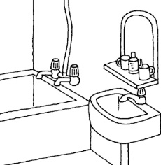 (B)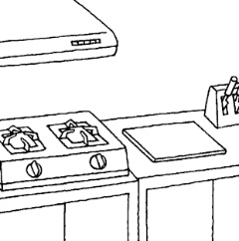 (C)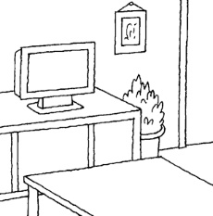

2. (A)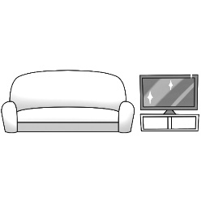 (B)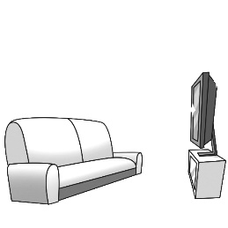 (C)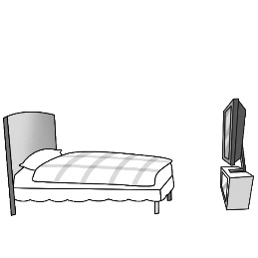

3. (A)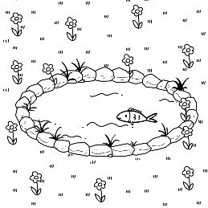 (B)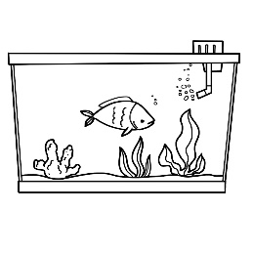 (C)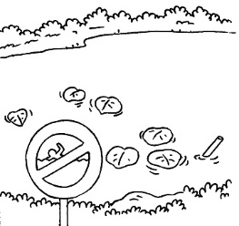

4. (A)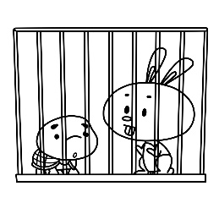 (B)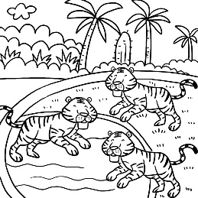 (C)

5. (A)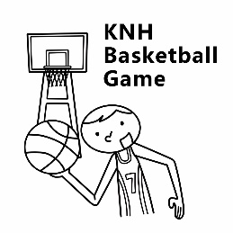 (B)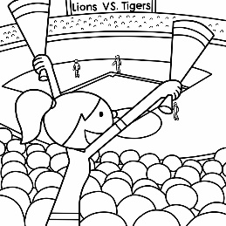 (C)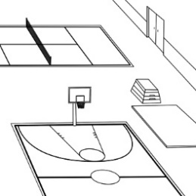

(B) 基本問答：根據聽到的內容，選出一個最適合的回應。

6. (A) My cellphone is in the living room. (B) It’s my birthday gift from Dad. (C) It’s in your bedroom.

7. (A) No, it’s a library. (B) Yes, it’s a gym. (C) The photo is from my sister.

8. (A) Yes, he is my roommate. (B) His room is near my room. (C) No, his bed is big and soft.

9. (A) Yes, there is a gym in my school. (B) There are two swings in the playground. (C) No, there isn’t. My school is very small.

10.(A) There is a kitchen in our house. (B) Wow! The dining table is big. (C) It’s between the kitchen and the dining room.
(C) 言談理解：根據聽到的內容，選出一個最適合的答案。
11. (A) Today is Lucy’s birthday. (B) There is a lot of food in Ted’s house. (C) Peter and Lucy are at Ted’s place now.
12. (A) The students are from the USA. (B) The students are in Mr. Wang’s class. (C) The students are not in the library.
13. (A) Yes, there are. (B) No, there aren’t. (C) Yes, there are three rabbits.
14. (A) A tiger. (B) A lion. (C) A zebra.
15. (A) Her books are on the bed, and her schoolbag is on the desk.
(B) Her books are on the desk, and her schoolbag is on the bed.
(C) They are on the bed.
二、綜合測驗 (26%)
16. Emma：Houses ________ the lake are very beautiful. Jay：Let’s go and take a look!
(A) around (B) about (C) inside (D) between
17. Alan：It’s cold today. Where is the _________? Meg：It’s on your bed.
(A) basket (B) cap (C) photo (D) blanket
18. There are _________ beautiful pictures in this storybook.
(A) a lots of (B) lots of (C) a lot (D) lots
19. Peggy：Is Ms. Shen nice ________ serious (嚴肅的)? Vivian：She is a nice teacher.
(A) or (B) and (C) but (D) too
20. Mr. Lin is a bus driver. He is driving ________ the bus.
(A) in front of (B) in back of (C) in the front of (D) in the back of
21. Elsa：Aren’t ________ any tigers in the zoo? Anna：Yes, there are. ________ in the cage (籠子).
(A) there；There are (B) they；They’re (C) they；There are (D) there；They’re
22. Belle：Isn’t the teacher ________ the door? Cinderella：________, she is behind it.
(A) next to；Yes (B) behind；No (C) in front of；No (D) in；Yes
23. Ariel：Look！Justin is ________ now. Jasmine：Yeah, he’s a great singer.
(A) on the TV (B) on the screen (C) in TV (D) in the screen
24. Sandy：Are there ________ storybooks in the library? Lily：Yes, there are ________.
(A) some；some (B) any；some (C) any；any (D) some；any
25. Eason：________ Nancy：No, we’re from South Africa.
(A) Are you from the USA? (B) Where are you from? (C) Is he from South Africa? (D) We’re from Taiwan.
26. Ann：Is your bedroom in the castle very small? Joe：________
(A) Yes, there are two bathrooms in my castle. (B) No, it is a big bedroom.
(C) The castle is very big and beautiful. (D) My house is next to the castle.
27. Dora：Are there any tests today? Diego：________
(A) Yes, there is one in the morning. (B) No, there are two English tests.
(C) Yes, there are seven classes today. (D) We are here for grades.
28. Bob：________ Diana：Yes, there are twenty.
(A) Where are the students? (B) Where are those boys from?
(C) Is there a boy in the classroom? (D) Are there any students in the gym?

三、克漏字測驗 (12%)
(一)
alone 單獨 cram school 補習班 visit 參觀 next time 下次
Jerry：Where are your mom and dad?
Steve：My 29 family are in my grandma and grandpa’s house now.
Jerry：But why are you alone here?
Steve：I have a math 30 in the cram school today.
Jerry：Oh, poor you！
Steve：That’s OK. Today is my grandma’s birthday.
Jerry：Wow！Happy birthday to your grandma！Is your grandma’s house 31 ?
Steve：Yes. it is. There are trees and flowers near her house. It’s a beautiful place.
Jerry：Maybe we can visit your grandma’s house next time.
29. (A) magic (B) whole (C) soft (D) fun
30. (A) photo (B) screen (C) test (D) classes
31. (A) in the tree (B) under the sea (C) in the lake (D) in the mountains


(二)
panda 熊貓 fur 皮毛 hold in one’s arms 抱在懷裡 opening hours 開放時間 besides 此外 limit 限制
Betty ：Mom, 32
Ms. Wu：It’s a panda, Yuanzai. She is Tuan Tuan and Yuan Yuan’s daughter.
Betty ：Her fur looks soft and white. I really want to hold her in my arms.
Ms. Wu： 33 , but we can’t do that. Let’s go to the Taipei Zoo this afternoon and take a look at cute Yuanzai.
Betty ：Great！I know the opening hours of Panda House in the Taipei Zoo is from 9 am to 5 pm.
Ms. Wu：Yes. Besides, 34 The limit is 19,200 people a day.
Betty ：OK, I see！Here I come, Yuanzai！
32. (A) What’s that cute animal in the photo ?
(B) Who’s that cute girl over there ?
(C) Is it a panda in the photo?
(D) What’s the panda’s name?
33. (A) That’s right
(B) I’m happy
(C) It’s small
(D) That’s all right
34. (A) There are six pandas in the Taipei Zoo.
(B) Panda House is closed from 9 am to 5 pm.
(C) There are 400 people visiting Panda House every 10 minutes.
(D) Tuan Tuan and Yuan Yuan is Yuanzai’s grandparents.

四、閱讀測驗 (12%)
(一)
House B For Rent
1 living room
3 bedrooms
1 kitchen
2 bathrooms
★Free parking

- Here are two houses for rent.

- House A is between Shulin Train Station and Xi Kun Junior
High School. It’s about a five- minute walk to the gym.

- House B is big and new. It’s next to Showtime Movie Theater.
It’s about ten-minute walk to the library.

House A For Rent
1 living room
2 bedrooms
1 kitchen
1 bathroom
★No pets allowed
★Females only
rent 出租 allowed 允許 females only 只限女性 free parking 免費停車
35. Who can rent House A?
House B For Rent
1 living room
3 bedrooms
1 dining room
1 kitchen
2 bathrooms
★Free Parking
(A) Silvia：I am a teacher in Xi Kun Junior High School. I like animals. I have a dog and two rabbits.
(B) Peter：I am a tall man. I like sports. I want a house near the gym.
(C) Ivy：I am a nurse. I have a son and a daughter. I want a house with (有) three bedrooms.
(D) Katie：I work (工作) in Showtime Movie Theater. I don’t have pets because (因為) I don’t like animals.
36. Which is TRUE about House B?
(A) It’s small and old.
(B) It’s next to the library.
(C) There isn’t a kitchen in it.
(D) There are two bathrooms in it.

(二)
principal 校長 twin 雙胞胎 during 在…期間 break 休息

Hi, my name is Andrew. I am twelve years old. I am a junior high school student. I like my school a lot. There are a library and a gym in my school. Most teachers are nice and so is the school principal. There are eight students in my class. My best friend, Tim, sits next to me. Nick is also my good friend, and he sits behind me. Nick’s cousin, Mary, is in my class, too. She sits in front of Tim. My class leader, Lucy, is a cute girl. She sits between Nick and Kevin. Eva and Claire are twin sisters. Eva sits beside Mary, and Claire sits beside Tim. I like my classmates. During the break, we go to the playground and have a great time.

Andrew

Front of Class
Back of Class
①

②

37. Who is ① ?
(A) Nick (B) Mary (C) Tim (D) Lucy
38. Who is ② ?
(A) Eva (B) Claire (C) Lucy (D) Kevin
39. What is the reading mainly (主要地) about?
(A) Andrew’s school and classmates. (B) Andrew’s best friends. (C) Andrew likes his class a lot. (D) Andrew’s grades.
40. According to (根據) the reading, which is TRUE?
(A) Andrew and his classmates go to the library during the break.
(B) Tim sits between Andrew and Claire.
(C) There are eight boys in Andrew’s class.
(D) Mary is Tim’s cousin.

~ 試題結束 ~

新北市立溪崑國民中學110學年度第一學期第二次定期評量 英語科 答案卷
七年級 班 座號 姓名
五、寫出單字的英文 (4%)
41. 報紙 42. 冰 43. 特別的 44. 滑梯
六、依提示作答 (4%)
45. Irene’s bedroom is next to the dining room. (依畫線部分造原問句)
46. There are three playgrounds in Da-An Forest Park. (依畫線部分造原問句)
七、翻譯 (12%)
47. 這是 Harry 在他阿姨與姨丈家的臥室。它在樓梯的下面。
48. 事實上，世界各地的床都不一樣。
49. 你的學校有任何籃球場嗎？
50. 在運動場附近的花園是我最喜歡的地方。
五、寫出單字的英文 (4%)(每題1分)
41 | 42 | 43 | 44
六、依提示作答 (4%)(每題2分)
45
46
七、翻譯 (12%) (每題3分)
47
48
49
50
110-1-2 七年級 英語科－解答
- 聽力測驗 (30%)
1 | 2 | 3 | 4 | 5
A | B | A | C | C
6 | 7 | 8 | 9 | 10
C | A | A | C | B
11 | 12 | 13 | 14 | 15
B | B | B | C | A
- 綜合測驗 (26%)
16 | 17 | 18 | 19 | 20
A | D | B | A | C
21 | 22 | 23 | 24 | 25
D | C | B | B | A
26 | 27 | 28
B | A | D
- 克漏字測驗 (12%)
29 | 30 | 31 | 32 | 33 | 34
B | C | D | A | A | C
- 閱讀測驗 (12%)
35 | 36 | 37 | 38 | 39 | 40
D | D | B | D | A | B
- 寫出單字的英文 (4%)(每題1分)
41 | 42 | 43 | 44
newspaper | ice | special | slide
六、依提示作答 (4%)(每題2分)
45 | Where is Irene’s bedroom?
46 | What is there in Da-An Forest Park?
七、翻譯 (12%) (每題3分)
47 | This is Harry’s bedroom in his aunt and uncle’s home. It’s under the stairs.
48 | In fact, beds around the world are different.
49 | Are there any basketball courts at your school?
50 | The garden near the sports field is my favorite place.
新北市立溪崑國民中學110學年度第一學期第二次定期評量
七年級 英語科 聽力測驗稿
- 辨識句意：根據聽到的內容，選出符合描述的圖片。
- This is a bathroom, not a kitchen.
- The TV is new and big. It’s in front of the sofa.
- Look！There is a fish in the pond.
- There are some animals at the gate of the zoo.
- The gym is very big. There is a basketball court in it.
- 基本問答：根據聽到的內容，選出一個最適合的回應。
- Mom, where is my cellphone?
- What’s the place in the photo? Is it a school?
- Is Harry’s bed next to your bed?
- Is there a playground in your school?
- This is our dining room. It’s beside the kitchen.

(C) 言談理解：根據聽到的內容，選出一個最適合的答案。
- B：Hey, Lucy, are you home?
G：Yeah, why?
B：Today is Ted’s birthday. Peter, Mary, and I are at his place now. Come here! There is a birthday cake and a lot of food in the house.
Q：Which is right?
- M：Where are those students in the library from? The USA?
W：No, they’re from South Africa.
M：Are they in your class?
W：No, they’re in Mr. Wang’s class.
Q：Which is right?
- B：Annie, are there any pets in your house?
G：Yes, there are.
B：What are they?
G：Two dogs, one cat, and three rabbits.
B：Wow！There are a lot of animals in your house.
Q：Are there any fish in Annie’s house?
- B：Lisa, what’s that animal under the tree? Is it a tiger?
G：No, it’s not.
B：Is it a lion?
G：No, it’s not. It’s a zebra.
Q：What is under the tree?
- B：Welcome to my house.
G：Thank you. Wow！Your house is very big and beautiful. Where is your bedroom?
B：Here.
G：Hey, your books are on the bed. Is your schoolbag on the bed, too?
B：No, it’s not. It’s on the desk.
Q：Where are the girl’s books and her schoolbag?

