新北市立溪崑國民中學109學年度第二學期第二次定期評量 英語科 試題卷
九年級 班 座號 姓名
一、聽力測驗: 30% (每題2分)

(一)、辨識句意：根據聽到的內容，選出符合描述的圖片。
1. ( )
(Ａ) | 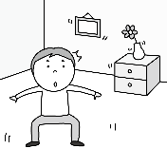 | (Ｂ) | 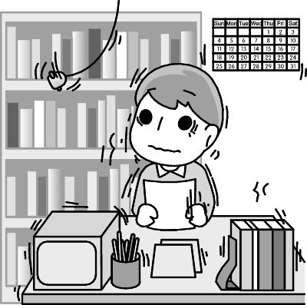 | (Ｃ) | 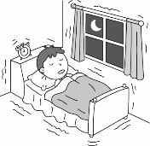

2. ( )
(Ａ) | 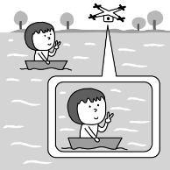 | (Ｂ) | 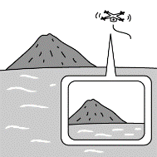 | (Ｃ) | 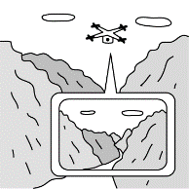

3. ( )
(Ａ) | 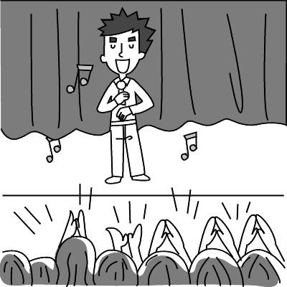 | (Ｂ) | 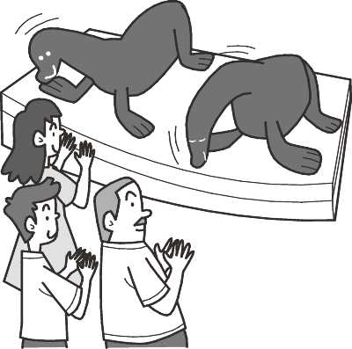 | (Ｃ) | 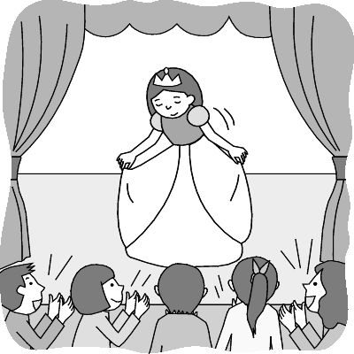

4. ( )
(Ａ) | 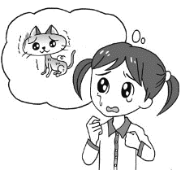 | (Ｂ) | 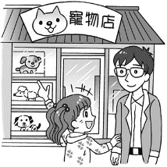 | (Ｃ) | 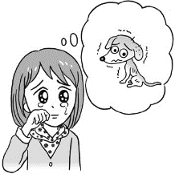

5. ( )
(Ａ) | 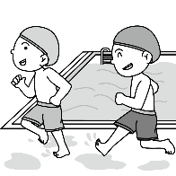 | (Ｂ) | 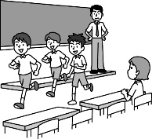 | (Ｃ) | 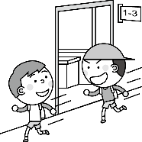

(二)、基本問答：根據聽到的內容，選出一個最適合的回應。
6. ( ) (Ａ) Me, too. We should really respect the power of nature.
(Ｂ) To protect the Earth from being sick, we should use water wisely.
(Ｃ) We are very lucky to live on an island where there are no typhoons.
7. ( ) (Ａ) I want to have a barbecue.
(Ｂ) I used to count sheep.
(Ｃ) I want to be a salesman in the future.
8. ( ) (Ａ) He will not be angry with you.
(Ｂ) You should say sorry to him.
(Ｃ) Poor boy! He must be in a great sorrow now.
9. ( ) (Ａ) All of the things are free here.
(Ｂ) Well, I go mountain climbing, take pictures, and enjoy the nature.
(Ｃ) The life in the country is too difficult for me.
10. ( ) (Ａ) Maybe once.
(Ｂ) Sorry, Dad. I will never do it again.
(Ｃ) I will call my friends very soon.

(三)、言談理解：根據聽到的內容，選出一個最適合的答案。
11. ( ) (Ａ) She was hit by a car.
(Ｂ) She was burned by fire.
(Ｃ) She was pushed around by some bullies.
12. ( ) (Ａ) On the Net.
(Ｂ) At a shop.
(Ｃ) At a department store.
13. ( ) (Ａ) In the yard.
(Ｂ) In the cage.
(Ｃ) In the pool.
14. ( ) (Ａ) He has nine children.
(Ｂ) He was born in Indonesia in 1958.
(Ｃ) He started singing in the Jackson Five at age five.
15. ( ) (Ａ) The students are heartbroken.
(Ｂ) The sorrow that most students have.
(Ｃ) A teacher who cares about her students.

二、綜合測驗: 40% (每題2分)
16. ( ) Angela had a hard tim in her twenties, but she never gave up. (Ａ) Because (Ｂ) If (Ｃ) Though (Ｄ) X
17. ( ) The house they live in is bigger and more comfortable than the apartment we live .
(Ａ) which; which (Ｂ) where; where (Ｃ) which; where (Ｄ) where; that
18. ( ) Please tell me ______.
(Ａ) what it is (Ｂ) when do you get here (Ｃ) what is the matter (Ｄ) how could that happen
19. ( ) John is tall he can hold the handrail(扶手) on the bus.
(Ａ) so; that (Ｂ) enough; to (Ｃ) too; to (Ｄ) very; that
20. ( ) in class is not good for you. You may not learn well and fail the exam.
(Ａ) Sleep (Ｂ) Slept (Ｃ) Have slept (Ｄ) Sleeping
21. ( ) This flying machine_______ clear pictures of volcanoes is known as a drone.
(Ａ) that used to take (Ｂ) which is used to take (Ｃ)which is used to taking (Ｄ) that can use to take
22. ( ) She kept talking about everything happened during her summer camp ______ her parents.
(Ａ) what; at (Ｂ) that; to (Ｃ) who; X (Ｄ) in which; with
23. ( ) A strong earthquake hit last week. Many houses were knocked down and the police tried to find people who were still _______ in the rubble.
(Ａ) lazy (Ｂ) alive (Ｃ) dead (Ｄ) killed
24. ( ) Because of the serious ________, there was a big traffic jam on the highway and it made me late for work. .
(Ａ) cause (Ｂ) forest (Ｃ) deliver (Ｄ) accident
25. ( ) Jason: I wonder ____ you’d like to go camping with me? Lucy: Not me for sure. I hate sleeping outside.
(Ａ) though (Ｂ) when (Ｃ) whether (Ｄ) that
26. ( ) Emma: Your new skirt looks nice. Did it ______ you a lot? Jane: No, I only _____ $500 for it.
(Ａ) pay; cost (Ｂ) cost; spent (Ｃ) spend; take (Ｄ) cost; paid
27. ( ) Linda cut her finger when she was cooking, _______? Anne: Yes, she _______.
(Ａ) did she; did (Ｂ) didn’t she; did (Ｃ) was she; was (Ｄ) wasn’t she; was
28. ( ) Don’t lie on the sofa and watch TV all the time. You look like a potato.
(Ａ) drawer (Ｂ) pool (Ｃ) bottom (Ｄ) couch
29. ( ) The woman at the bus stop looks very nervous. It looks like she’s waiting for someone. She keeps looking at her
watch .
(Ａ) from the bottom of her heart (Ｂ) in the middle of the night (Ｃ) on the dot (Ｄ) from time to time
30. ( ) He stays up late every night. It’s not ________ that he’s always _______ .
(Ａ) surprised; tired (Ｂ) surprising; tiring (Ｃ) surprising; tired (Ｄ) surprised; tiring
31. ( ) When Ryan walked out of his room to get some water, a strong earthquake hit and ________ his house.
(Ａ) knocked down (Ｂ) put out (Ｃ) washed away (Ｄ) took out
32. ( ) The baby is sleeping. Please _________ and don’t _________
(Ａ) turn off the light; wake up him (Ｂ) turn the light off; wake him up (Ｃ) turn on the light ; wake up him
(Ｄ) turn the light on; wake up him
33. ( ) ______ John ______ Jason wants to be a teacher. Both of them want to be engineers.
(Ａ) Both; and (Ｂ) Neither; nor (Ｃ) Either; or (Ｄ) Not only; but also
34. ( ) Jane is good at dancing, in fact, she dances _______ than any other girls in my class.
(Ａ) beautiful (Ｂ) beautifully (Ｃ) more beautiful (Ｄ) more beautifully
35. ( ) Nessy seldom goes to school late, and _________ Peggy.
(Ａ) so does (Ｂ) so is (Ｃ) neither is (Ｄ) neither does

三、克漏字測驗: 16% (每題2分)
1.
Jenny, a student from New York, is studying Chinese in Taipei. She 36 in Taiwan for over one year, and she can
speak Chinese 37 now. She 38 to be a cook since she was young. By 39 working hard, she will be able to enter a good school to study cooking next summer. As the saying goes, 40 . She wants everything to go well before making her dream come true.
36.( ) (Ａ) was (Ｂ) is (Ｃ) will be (Ｄ) has been
37.( ) (Ａ) bad (Ｂ) good (Ｃ) worse (Ｄ) well
38.( ) (Ａ) decided (Ｂ) decides (Ｃ) has decided (Ｄ) will decide
39.( ) (Ａ) kept (Ｂ) keeping (Ｃ) keeps (Ｄ) keep
40.( ) (Ａ) seeing is beliving (Ｂ) actions speak louder than words (Ｃ) half a loaf is better than no bread
(Ｄ) two heads are better than one
2.
There once was an old lion. He was too old to hunt, so he thought of an idea to feed himself. He put up a notice outside his den. It said “ Old Lion is dying. Pay him a visit 41 it’s too late.” A lot of animals read the notice and went into the den, but they never came out because they were eaten by the lion.
One day, a fox walk by the den. He noticed that the footprints in the mud 42 in, but not out. The fox left quickly and told other animals what the lion 43 . And no one has visited the lion’s den ever since.
den洞穴 footprint 腳印 mud泥土 ever since從此之後
41.( ) (Ａ) if (Ｂ) after (Ｃ) when (Ｄ) before
42.( ) (Ａ) went (Ｂ) going (Ｃ) goes (Ｄ) to go
43.( ) (Ａ) has done (Ｂ) did (Ｃ) had done (Ｄ) does

四、閱讀測驗: 14% (每題2分)
1.
The moon is more than a bright, beautiful orb in the night sky. Our nearest neighbor also plays a big part in making the Earth a good place to live. Located an average of only 384,400 kilometers (238,855 miles) away, it’s got enough gravity to help stabilize the Earth on its axis. That makes our planet’s climate more stable than it would be otherwise. The moon’s gravity also pulls the oceans back and forth, producing tides.
As the moon orbits the Earth, it passes through different phases. They are the result of sunlight reflecting off the moon, and where the moon is in relation to the Earth. During a full moon, we see one entire half of the moon lit by the sun because the Earth is between the moon and the sun. During the new moon, none of the moon is visible and the sky is dark. That’s because the moon is between the Earth and the sun, and only the dark side of the moon faces our planet.
The moon cycles through all its phases once every 27 days. This is also the amount of time it takes to go around the Earth. As a result, the same side of the moon always faces the Earth. The far side of the moon was a mystery until people developed spacecraft. Now that far side is a bit less of an unknown. China has even landed a spacecraft on this far side of the moon, to learn more about it.
The moon’s light and its effect on the tides are important to animals here on Earth. Some animals time their breeding with the tides. Others change their feeding to stay safe from lions when the moon is dark. And deep in the Arctic night, the moon can provide some illusive illumination for living things.
orb 球狀物 locate位於 gravity重力 stabilize穩定
axis軸 mystery神秘 breeding繁殖 Arctic北極
illusive難以捉摸的 illumination照明 reflect 反射
44.( ) What does orbits mean? (Ａ) To follow a path(路徑) around a planet or star. (Ｂ) To go closer to a planet or star.
(Ｃ) To go away from a planet or a star. (Ｄ) To go over a planet or a star.
45.( ) When can’t we see the moon? (Ａ) When the moon is between the Earth and the sun.
(Ｂ) When the Earth is between the moon and the sun. (Ｃ) When the sun is between the Earth and the moon.
(Ｄ) We don’t know.
46.( ) How long does it take the moon to cycle through all its phases once ?
(Ａ) A month. (Ｂ) A week. (Ｃ) Twenty-seven days. (Ｄ) A year.
47.( ) Which is true in the reading?
(Ａ) The moon is always between the Earth and the sun.
(Ｂ) The moon help the sun stabilize on its axis.
(Ｃ) In the past, people can see only the same side of the moon.
(Ｄ) The moon is only a bright, beautiful orb in the sky.
2.
Last Saturday, at about one o’clock in the morning, Kelly and her family were woken up by their dog. They were surprised to see smoke everywhere. Kelly’s dad ran to the bathroom to get everyone a wet towel, and her mom asked them to crawl on the floor. It was difficult to see clearly in the dark, but they were lucky enough to be able to get to the door and get out quickly.
They lost everything in the house, which made them sad. But they were thankful because no one got hurt this time.
48.( ) What happened to Kelly and her family?
(Ａ) There was a fire in their house in the middle of the night.
(Ｂ) They were woken up by their neighbors’ loud noise.
(Ｃ) Their house shook while they were sleeping.
(Ｄ) A bad guy came into their house.
49.( ) What does the word which mean?
(Ａ) Everything in the house was lost.
(Ｂ) Failing to leave the house in time.
(Ｃ) The fact that Kelly’s house was knocked down.
(Ｄ) The fact that everyone in her family was safe.
50.( ) Which is “ NOT “ true about the reading?
(Ａ) The dog woke Kelly’s family up.
(Ｂ) Kelly’s mom asked them to crawl on the floor
(Ｃ) Kelly ran into the bathroom and get a wet towel
(Ｄ) All Kelly’s family got out safely.

109-2-2 九年級 英語科－解答
一、聽力測驗
1-5 BBACB 6-10 ACCBB 11-15 ACACC
二、綜合測驗
16-20 DCAAD 21-25 BBBDC 26-30 DBDDC
31-35 ABBDD
三、克漏字測驗
36-40 DDCBB 41-43 DBC
四、閱讀測驗
44-47 AACC 48-50 AAC

新北市立溪崑國民中學109學年度第二學期第二次定期評量
九年級 英語科 聽力測驗稿

一、辨識句意：根據聽到的內容，選出符合描述的圖片。
1. When the earthquake came, I was studying.
2. We can take clear pictures of volcanoes easily with a camera drone.
3. They are clapping for the singer they love a lot.
4. Betty was in a great sorrow because her dog was missing.
5. Some boys are running in the classroom. Let’s tell them not to do that.

二、基本問答：根據聽到的內容，選出一個最適合的回應。
6.I was really scared by the strong typhoon last night. Many trees were blown down.
7.What do you want to be in the future?
8. I feel sorry for the boy who lost his family in the accident.
9.You really enjoy your life in the country. What do you usually do in your free time?
10. How many times do I have to tell you, dear son? Never forget your wallet or cellphone if you want to use the public restroom.

三、言談理解：根據聽到的內容，選出一個最適合的答案。
11. M: Are you all right? Why are you walking like that?
W: I was hit by a car when I was riding a bike.
M: That’s terrible. Your bag looks heavy. Let me lend you a hand.
W: Thanks. You are so kind.
Q: How did the woman get hurt?
12. M: Look at Kelly. She is stylish beautiful. I wonder where she usually buys her clothes.
W: Oh, she told me before. She usually buys her clothes either at a shop or on the Net.
M: Maybe I can try next time.
Q: Where doesn’t Kelly buy her clothes.
13. (Dog barks.)
M: Look! Your dog is digging a hole there.
W: I know. He usually digs a hole and buries bones in it.
M: Will he remember to dig them out and eat them?
W: Sure thing! He never forgets what he’s done.
Q: Where might the dog be?
14. W: American superstar Michael Jackson was born in Gary, Indiana, in 1958. He was the seventh of nine children. He was five years old when he began singing with his brothers in the group called the Jackson five.
Q: Which is true about Michael Jackson?
15. W: Judy is a nice teacher. She always takes time to listen to her students when they have problems. When she gets a phone call from a student who is tired or heartbroken, she puts down what she is doing and listens to him or her. That’s why her students love her so much. They are lucky to have a teacher who loves them and understands them.
Q: What’s the speaker talking about?

