新北市立溪崑國民中學109學年度第二學期第二次定期評量 英語科 試題卷
八年級 班 座號 姓名
一、聽力測驗 30%

A.辨識句意：根據聽到的內容，選出符合描述的圖片。

- (Ａ) 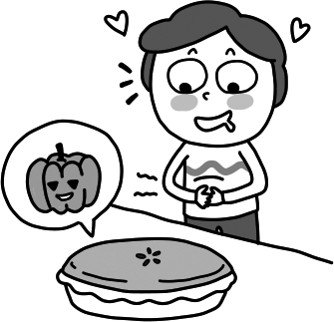 (Ｂ) 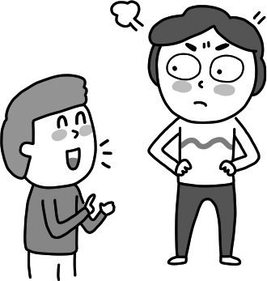 (Ｃ) 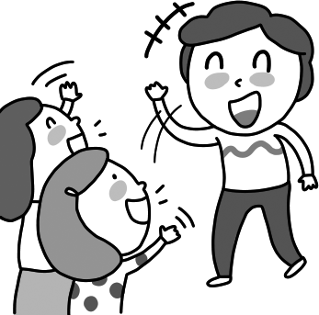

- (Ａ) 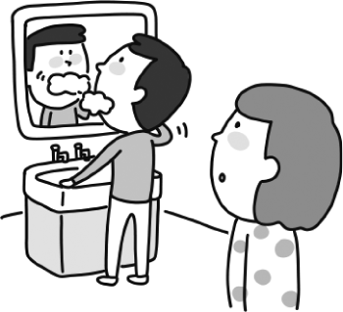 (Ｂ)  (Ｃ) 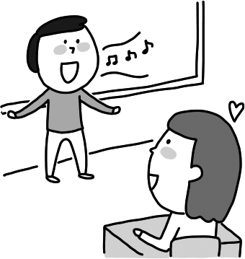
- (Ａ) 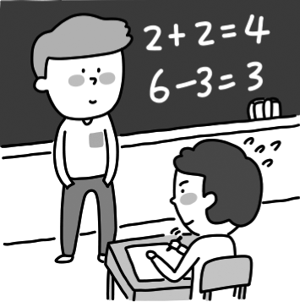 (Ｂ) 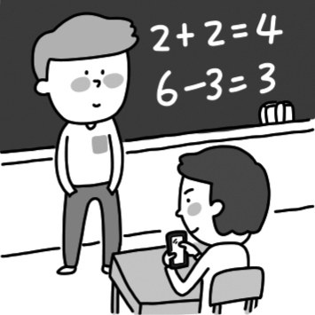 (Ｃ) 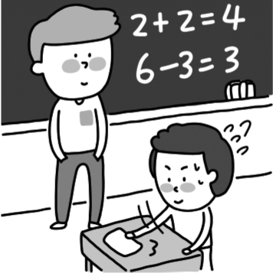

- (Ａ) 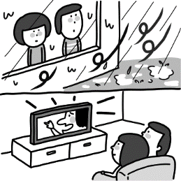 (Ｂ) 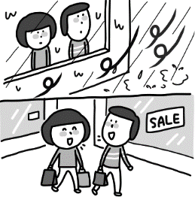 (Ｃ) 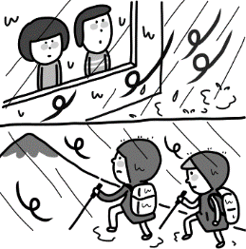

- (Ａ) 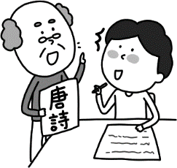 (Ｂ)  (Ｃ) 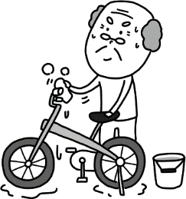

B.基本問答：根據聽到的內容，選出一個最適合的回應。
6. (Ａ) They are so friendly and brave.
(Ｂ) They will make a sound to let their team know.
(Ｃ) They walked through the rubble and sharp glass.
- (Ａ) Yes, it was so yummy.
(Ｂ) No, I didn’t make dinner.
(Ｃ) Yes, I made it for my mom because today is her birthday.
- (Ａ) She has a lot of things to do.
(Ｂ) She has to go to school early.
(Ｃ) She has me clean the table before lunch.
- (Ａ) I have a gift for Grandmother.
(Ｂ) I want to buy the latest cellphone for her.
(Ｃ) She doesn’t need to buy a gift for me.
- (Ａ) He sings so terribly.
(Ｂ) He can sing many songs.
(Ｃ) He was singing in the bathroom at that time.

C.言談理解：根據聽到的內容，選出一個最適合的答案。
- (Ａ) Art. (Ｂ) Math. (Ｃ) Business.
- (Ａ) Mr. Wang’s class was boring to Wendy.
(Ｂ) Wendy loves insects very much.
(Ｃ) Wendy enjoyed the science class today.
13. (Ａ) He lives his life happily.
(Ｂ) He doesn’t eat meat at all.
(Ｃ) He sleeps a lot, more than 10 hours a day.
14. (Ａ) Finish the fish.
(Ｂ) Take food home.
(Ｃ) Order too much food.
15. (Ａ) Cindy was so busy, so she didn’t do the report last week.
(Ｂ) Cindy will still go camping if it rains tomorrow.
(Ｃ) Cindy has to hand in the report soon, or her teacher will be angry.

二、綜合測驗30%
16. ( ) If Mike free time, he will play the violin in his bedroom.
(Ａ) is (Ｂ) has (Ｃ) will have (Ｄ) is having
17. ( ) Parents in Taiwan always make their children hard to enter their ideal school in the future.
(A) study (B) to study (C) studying (Ｄ)will study
18. ( ) My wife enjoys going to the movies with her friends, but I like to watch TV at home by .
(Ａ) me (Ｂ) my (Ｃ) mine (Ｄ) myself
19. ( ) Your English is much than your brother’s, so you need to study more .
(Ａ) bad; harder (Ｂ) worse; often (Ｃ) more terrible; long (Ｄ) poorer; early
20. ( ) Jacky drives as as he can. (Ａ) careful (Ｂ) carefully (Ｃ) less careful (Ｄ) more careful
21. ( ) Of all the dancers at the party, Ruby dances . I want to learn something from her.
(Ａ) loudest (Ｂ) the best (Ｃ) the most beautiful (Ｄ) much more slowly
22. ( ) It’s great the sun come up and go down in a day.
(Ａ) to watch (Ｂ) listening to (Ｃ) finding (Ｄ) looks at
23. ( ) Kids under six years old stay at home alone . Maybe something bad will happen to them.
(A) should；by themselves (B) shouldn’t；by yourself
(C) don’t have to；by yourselves (D) mustn’t；by themselves
24. ( ) You were almost hit by a car. You more careful. (A) can be (B) must be (C) should be (D) may be
25. ( ) The movie really made me . (A) sad (B) sadly (C) felt sad (D) to cry
26. ( ) You must care of your younger sister after school. (A) taking (B) to take (C) take (D) took
27. ( ) Should there any garbage cans in the night market? (A) are (B) be (C) have (D) has
28. ( ) Boys, please make at home and enjoy the party.
(A) themsel ves (B) himself (C) yourself (D) yourselves
29. ( ) Jimmy felt so because he felt someone his body.
(A) angry ; touch (B) angry ; touched (C) angrily ; touch (D) angrily ; touching
30. ( ) Jolly likes summer the because she has serious（嚴重的）problems sleeping in the summer heat.
(A) best (B) last (C) least (D) first
三、克漏字選擇10%
A.
(Max and Jay are talking about how their boss, Mr. Chen, treats all his workers.)
: How I hate to work for this kind of boss. He makes us 31 for long hours, and he seldom lets us take a company trip
in Taiwan or in foreign countries. It’s so-called “labor exploitation,” right?
: I agree. My sister’s boss, Mr. Lu, treats his workers in a different way. He even 32 them to do something to
relax, like doing exercise in their own gym or enjoying free tea, coffee, or snacks during tea break. But take a look at
Mr. Chen. He treats us less well than Mr. Lu. Who can 33 us to take him down?
: Did you hear about the Labor Department before? Let’s try to report Mr. Chen’s case to them. They’ll ask him to make
a change and improve our lives.
: Sounds like a great idea! I can’t wait to give it a try!
※ company trip員工旅遊 so-called 所謂的 labor exploitation勞工剝削 relax放鬆 tea break 下午茶時間
case案例
31.（ ）(Ａ) work (Ｂ) working (Ｃ) worked (Ｄ) to work
32.（ ）(Ａ) makes (Ｂ) lets (Ｃ) has (Ｄ) gets
33.（ ）(Ａ) help (Ｂ) want (Ｃ) need (Ｄ) like

B.
Mrs. Lin: Li-hong! It’s twelve o’clock already! Are you going to stay in bed all day long?
Li-hong : Mom, it’s Sunday! And we don’t have any homework this weekend.
Mrs. Lin: That’s great! Why don’t you 34 after lunch?
Li-hong : OK, but I need to be paid for that. How about one hundred NT dollars for cleaning my room and twenty NT dollars for taking out the trash?
Mrs. Lin: Okay. But I cleaned your room and took out the trash yesterday. I can 35 , too. Now, come on! Get up!
※ already已經 to be paid被付費
34.（ ）(Ａ) play the piano (Ｂ) study English and math
(Ｃ) help clean up the house (Ｄ) go out for a walk
35.（ ）(Ａ) lose fifteen kilograms (Ｂ) wait for fifteen days
(Ｃ) get up fifteen minutes earlier (Ｄ) get one hundred twenty NT dollars

四、閱讀測驗10%
A.
Do you know why we should protect our earth and how we can save our earth? We people care about ourselves and do lots of damage to our earth. If we can cut down fewer trees, we can protect our earth from being damaged. When it rains heavily, we don’t need to worry about landslides. Then, the house won’t move from the top of a mountain to the bottom of it. If we can take more public transportations or share a taxi, we can keep the air cleaner. If we can bring our own shopping bags and bring our own spoons and chopsticks, we can help reduce trash. If we can eat less meat, we can have a healthy body and do less damage to our earth.
We all know the Earth is always a giving planet. It gives us fresh air, clean water, lots of resources and a comfortable place. Without it, we can’t live. It’s just like our mother, but we take it for granted. We can’t find any place like it, so we should love and protect it because we only have one earth.
※ care about關心 damage 破壞 protect…from being damaged保護…免受損害 bottom底部
public transportation 大眾運輸工具 bring 帶來 reduce 減少 planet星球 fresh新鮮的 resource 資源
36. （ ） What does landslides mean?
(Ａ) An animal for people to like. (Ｂ) A sudden shake of the land.
(Ｃ) A sudden fall of rocks down a hill. (Ｄ) An activity for people to join.
37. （ ） Why does the writer say we take it for granted?
(Ａ) Because the Earth will not live anymore.
(Ｂ) Because the Earth becomes dirty and disgusting（噁心的）.
(Ｃ) Because human beings（人類）can find another place to live.
(Ｄ) Because human beings think the Earth should give us everything.
B.
Everyone knows child labor — children cannot go to school because they need to work for their families. COVID-19 is familiar to everyone, too. But few people know because of COVID-19, child labor is getting more serious.
Child labor happens to those children from poor families. They need to work for their families to get money for food. Love World helps them by saving their countries’ economy. It is making the economy in 98 countries better. In those countries, fewer children need to make money for their families.
With their help, child labor did not become so serious. However, because of COVID-19, a deadly disease, the problem is getting worse and worse. Many schools closed and a lot of people lose their jobs, so kids need to work again. Care Children’s study shows COVID-19 sent around fifty million people into poverty this year.
Luckily, Donate Kindness gives money to poor families. In a few months, they helped families in China, Malawi, India, Kenya, Uganda, and Rwanda. They also help those families fight COVID-19. In total, they gave away three million dollars to help fight child labor and COVID-19.
We may see a lot of sad stories every day, but there is always hope.
-Lisa Smith
※ familiar 熟悉的 serious 嚴重的 economy經濟 deadly disease 致命疾病 poverty貧窮
38.（ ）Which is the right order（順序）of the reading?
a. Two familiar things to everyone. b. Who is giving money to poor families.
c. Why child labor is getting more serious. d. Who is saving economies in poor countries.
(Ａ) a → b → c → d (Ｂ) a → c → d → b (Ｃ) a → d → b → c (Ｄ) a → d → c → b
39.（ ）Why did Lisa Smith say “there is always hope?”
(Ａ) Child labor is not so serious now. (Ｂ) COVID-19 is helpful for facing child labor.
(Ｃ) People are trying to find different ways to help improve child labor.
(Ｄ) People are taking kids in poor families away.
40.（ ）What can we learn from the reading?
(Ａ) Lisa Smith once worked for Care Children. (Ｂ) Love World gives money and food to poor families.
(Ｃ) It’s hard for children from poor families to find a job.
(Ｄ) Donate Kindness helps poor families from more than five countries.

- 翻譯20% (41-4%，42-6%，每格2分; 43-2%，44-45各4%。)
41. 在地震的搜救當中，我們常看到搜救犬英勇地執行牠們的任務。 (4%)
In an rescue, we often see rescue dogs doing their job .
42. 拿著這手電筒。你真的應該要訓練自己面對你對黑暗的恐懼。 (6%)
Take a with you. You really should yourself to face your of the dark.
- 你可以幫我查證一下這項資訊嗎? (2%)
- 越來越多人正在為這些兒童的權益而奮鬥，因為他們需要幫助。 (4%)
- 人們可以看到她和其他狗狗在臺灣各處拯救生命。牠們真的是我們最好的朋友。 (4%)
試題結束!

新北市立溪崑國民中學109學年度第二學期第二次定期評量 英語科 答案卷
八年級 班 座號 姓名
五、翻譯20% (41-4%，42-6%，每格2分; 43-2%，44-45各4%。)
41. (4%)

42. (6%)

43. (2%)

44. (4%)

45. (4%)

109-2-2 八年級 英語科－解答
(1-40 – each 2%，80%)
1-15 ACBAA BCCBA BAACB
16-30 BADBB BADCA CBDAC
31-40 ADACD CDDCD
41.earthquake, bravely (each- 2%))
42.flashlight, train, fear (each- 2%)
43. Could you help me check out this information? (2%)
44. More and more people are fighting for the children’s rights
because they need help. (4%)
45. People can see her and other dogs working all over Taiwan to save lives.
They are truly our best friends. (4%)

109-2-2 八年級 英語科－解答 (1-40 – each 2%，80%)
1-15 ACBAA BCCBA BAACB
16-30 BADBB BADCA CBDAC
31-40 ADACD CDDCD
41.earthquake, bravely (each- 2%)
42.flashlight, train, fear (each- 2%)
43. Could you help me check out this information? (2%)
44. More and more people are fighting for the children’s rights
because they need help. (4%)
45. People can see her and other dogs working all over Taiwan to save lives.
They are truly our best friends. (4%)

109-2-2 八年級 英語科－解答 (1-40 – each 2%，80%)
1-15 ACBAA BCCBA BAACB
16-30 BADBB BADCA CBDAC
31-40 ADACD CDDCD
41.earthquake, bravely (each- 2%)
42.flashlight, train, fear (each- 2%)
43. Could you help me check out this information? (2%)
44. More and more people are fighting for the children’s rights
because they need help. (4%)
45. People can see her and other dogs working all over Taiwan to save lives.
They are truly our best friends. (4%)

八年級 英語科 聽力測驗稿
新北市立溪崑國民中學109學年度第二學期第二次定期評量八年級英語科聽力測驗，本聽力測驗分A、B、C三部分(換大題間隔5秒)，每題會唸兩次(請間隔3秒)，聽力測驗開始:
A部分，辨識句意：根據聽到的內容，選出符合描述的圖片。
1. Jerry looks at the pumpkin pie hungrily.
2. Helen heard the boy sing a song in the classroom. He sang very well.
3. Mr. Lin let us use the cellphone in the math class.
4. If the typhoon gets stronger tomorrow, we will stay at home and watch the movies.
5. My grandpa helped me do the Chinese report.

B部分，基本問答：根據聽到的內容，選出一個最適合的回應。
6. What do the rescue dogs do if they find survivors or dead bodies?
7. Did you make all the breakfast by yourself this morning?
8. What does your sister have you do?
9. What do you want to buy for Mom as her birthday gift?
10. How does your brother, Ken, sing?

C部分，言談理解：根據聽到的內容，選出一個最適合的答案。
11. W: Why do you look so sad, Jerry?
M: I heard my parents talking about something in the living room last night.
W: What did they talk about?
M: My dad wanted to make me study business, and my mom wanted to make me study math in
college.
W: You don’t like those subjects?
M: Not at all. I just want to study art. I want to be an art teacher in the future.
Q: What did Jerry’s mom want him to study in college?
12. M: Wendy, did you enjoy your class today?
W: Yes, I did. I love the science class very much. We listened to Mr. Wang talking about interesting insects. He brought a lot of great pictures and even showed us a good short movie.
M: Aren’t you afraid of insects?
W: No, they are so beautiful. I love them.
Q: Which is not true?
13. W: Frank, how old is your grandpa?
M: He is almost 90 years old.
W: Wow, 90! What does he do to keep healthy?
M: He eats healthy food, exercises two times a day, and most important, he lives his life happily.
Q: How does Frank’s grandpa keep healthy?
14. W: I ordered too much food. Could you help me finish eating all the food, Alex?
M: I am a little bit full, so I just can finish the fish. You shouldn’t order that much next time.
W: Okay... okay... I won’t. I am so hungry today and I thought I could eat a horse. But...
M: Well, don’t waste food. Try not to order that much next time.
Q: What does Alex tell the woman not to do next time?
15. M: Cindy, will you go camping with us if it rains tomorrow?
W: No, I won’t. I will stay at home and do my history report.
M: The history report? You are still working on it?
W: Yes, I was so busy last week and I didn’t do it. I have to hand in the report by this Wednesday, or Mr. Lin will be very angry at me.
Q: Which is not true?

聽力測驗結束!

