新北市立溪崑國民中學109學年度第二學期第二次定期評量 英語科 試題卷
七年級 班 座號 姓名
一、聽力測驗：30%
I. 辨識句意：請依據所聽到的句子，選出符合描述的圖片
1. (A) (B) (C)
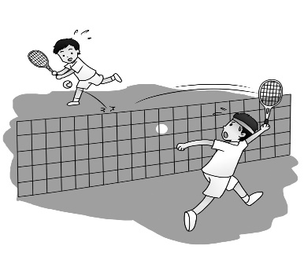
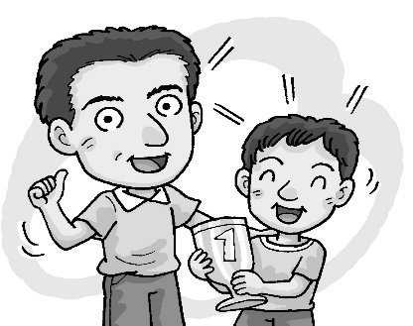
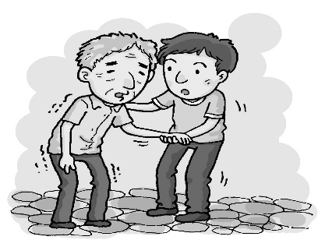

2. (A) (B) (C)

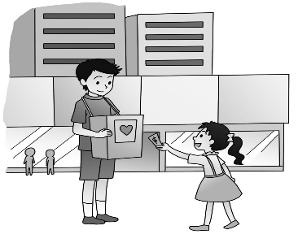
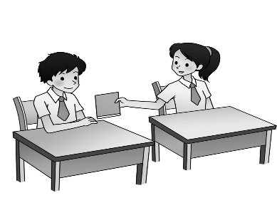

3. (A) (B) (C)
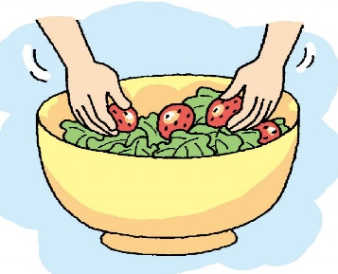
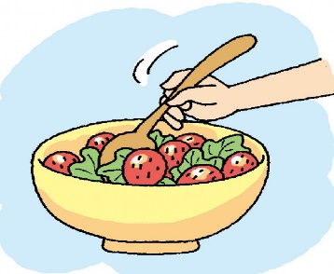
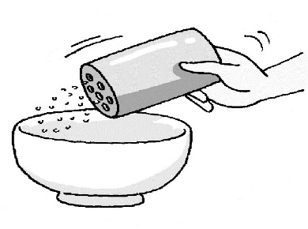

4. (A) (B) (C)
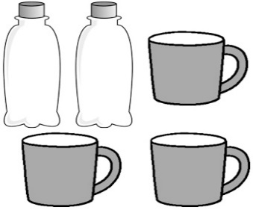
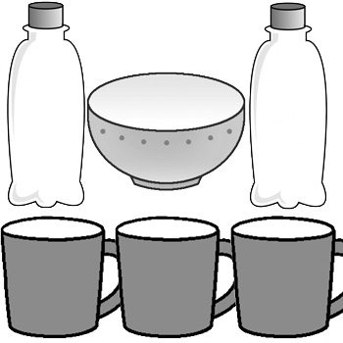
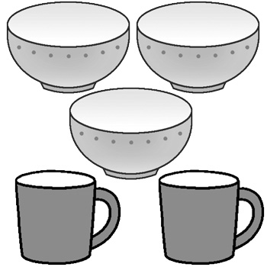

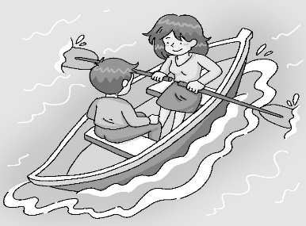
5. (A) (B) (C)
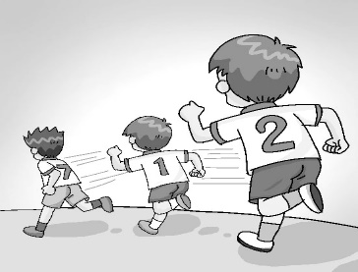
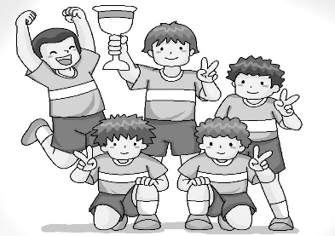

II. 基本問答：請依據所聽到的內容，選出一個最適合的回應
6. (A) It is in August.
(B) It is on the eighth floor.
(C) My dad comes here on weekends.
【背面尚有試題】
7. (A) I need milk.
(B) It’s yummy.
(C) I want both.
8. (A) No problem. It’s hard.
(B) Sure. Just follow the steps.
(C) No way. It’s very easy.
9. (A) Of course. Here you are.
(B) Of course not. I’m hungry, too.
(C) Of course. How much do you want?
10. (A) No, they’re my favorite.
(B) No, I don’t eat rice.
(C) Yes, I’m hungry.
III. 言談理解: 根據聽到的對話內容與問題，選出正確的答案
11. (A) In September.
(B) In October.
(C) In November.
12. (A) His grandparents take care of him when his parents are away from home.
(B) He isn’t in Taiwan. He studies in Japan.
(C) He doesn’t have parents, so his grandparents take care of him.
13. (A) Cook rice.
(B) Heat the rice.
(C) Make noodles.
14. (A) He doesn’t like the woman’s dishes.
(B) He wants to eat different food.
(C) He doesn’t want to eat lunch.
15. (A) He has different food every day.
(B) He doesn’t exercise.
(C) Fast food is his favorite.

二、請依題意選出最適當的答案：32 %
16. A: _______ is the date of the meeting? B: It’s ______ May 28.
(A) When ; on (B) What ; on (C) When ; x (D) What ; x
17. We can have a party on __________.
(A) tonight (B) next weekend (C) June 5 (D) October
18. A: _______ skirts are they? B: They’re __________.
(A)Which ; her (B) Whose ; her (C) Which ; hers (D) Whose ; hers
19. A: How many people ________ in the room? B: I have ________.
(A) is there ; an idea (B) is there ; no idea (C) are there ; an idea (D) are there ; no idea
20. Everything in her eyes ______ beautiful.
(A) is (B) are (C) do (D) does
21. A: The first ______ in the race is my son. B: You must be proud ___ him.
(A) runner ; of (B) role ; of (C) runner ; for (D) role ; for

22. My shoes are near the door, but my sister’s _______ under the bed.
(A) is (B) are (C) do (D) does
23. ________ is between January and March.
(A) July (B) December (C) May (D) February
24. Please write down your phone number on ________.
(A) a paper (B) a piece paper (C) piece of paper (D) a piece of paper
25. A: Don’t you like papayas? B:_________. They are yummy,
(A) Of course. (B) Of course not. (C) No, I do. (D) Yes, I am.
26. A: _______ do you like, pancakes ____ apple pie? B: I like pancakes.
(A) What ; or (B) Which ; or (C) What ; and (D) Which ; and
27. I don’t have _______ time. I have ______ work to do today.
(A) many ; much (B) much ; much (C) many; many (D) much; many
28. A: ________ butter do we need for a cake? B: Some ____ enough.
(A) How many; is (B) How many ; are (C) How much ; is (D) How much ; are
29. We will go out for dinner. Do you want to _____ us?
(A) join (B) add (C) miss (D) need
30. A: What do you add ______ the soup? B: I put some ____ in it.
(A) to ; noodle (B) to ; salt (C) in ; salt (D) in ; noodle
31. He’s going through a _______ time in his life. Let’s help him.
(A) easy (B) difficult (C) delicious (D) enough

三、克漏字選擇及閱讀測驗：16 %
Alice: Father’s Day is 32 . I want to prepare something special for him.
Joe: Today is July 33 . It’s still 34 .
Alice: Yes. Do you have any good ideas?
Joe: How about 35 a cake for him?
Alice: Thanks 36 your help. I'll give it a try.

32. (A) come (B) comes (C) coming (D) to come
33. (A) twenty-one (B) twentieth-one (C) twenty-first (D) twentieth-first
34. (A) three weeks (B) for three weeks (C) three weeks away (D) from three weeks
35. (A) make (B) making (C) do (D) doing
36. (A) to (B) about (C) of (D) for

There is a lot of rain in Taiwan, but there isn’t enough water for people in Taiwan. Though there are many dams in Taiwan, there are too much silt in them. So, they can’t hold too much rain. Where is the silt from? There aren’t enough trees in the mountains around the dams, and the problem comes out.
What can we do with the water shortage now? First, don’t use too much water in our lives. For example, we can take a shower, but don’t take a bath. We can also make good use of the water after mopping the floor or washing the clothes. We can use it to water the plants or flush the toilet. Second, we must take good care of the dams and plant many trees in the mountains. By doing that, there won’t be much silt slipping into the dams. Let’s try hard together to save more water.
dam 水壩 silt 淤泥 slip 滑動 flush 沖洗

【背面尚有試題】
37. What is the main idea of the reading?
(A) why we need more water (B) how to use water
(C) why we need to plant trees (D) how to deal with the problem of water shortage
38. What does the word “shortage” mean?
(A) not enough (B) enough (C) too much (D) silt
39. Which is true?
(A) There is not enough rain in Taiwan.
(B) The silt in the dams is from the mountains.
(C) We must make good use of the silt for water.
(D) We must plant many trees to hold rain.

………………………………………………………………………………………………………………
※ 將以下的答案寫在答案欄中
四、填空及依提示作答：10 % (每格1分，句子3分)
40. A: ________ _________ juice do you need? B: I need two bottles.
41. Thanksgiving is ____ the fourth Thursday ______ November.
42. A: _______ the cap over there yours? B: No. it’s not _________. It’s _______(John).
43. When is Nick’s birthday? (用英文拼出９月１２日詳答)
五、翻譯：12 %
44. 賽跑是在母親節，五月的第二個禮拜天。
45. 爸爸也可以扮演媽媽的角色。我爸爸每天拖地並洗碗盤。
46. 我還可以要那包麵粉嗎？當然。給你。
47. 跟著這些步驟，你可以做一個好吃的香蕉派。那並不困難。

【試題結束】

新北市立溪崑國民中學109學年度第二學期第二次定期評量 英語科 答案卷
七年級 班 座號 姓名
四、填空及依提示作答：10 % (每格1分，句子3分)
40. ___________ ___________
41. ___________ ___________
42. ___________ ___________ ___________
43. ____________________________________________________________________
五、翻譯：12 %
44. ____________________________________________________________________
____________________________________________________________________
45. ____________________________________________________________________
____________________________________________________________________
46. ____________________________________________________________________
____________________________________________________________________
47. ____________________________________________________________________
____________________________________________________________________

109-2-2 七年級 英語科－解答
1-10 ABACB ACBAC
11-20 BABBC BCDDA
21-30 ABDDA BBCAB
31-39 BCCCB DDAB

四、填空及依提示作答：10 % (每格1分，句子3分)
40. How much
41. on in / of
42. Is mine John’s
43. It’s / His birthday is on September twelfth.
五、翻譯：12 %
44. The race is on Mother’s Day, the second Sunday of / in May.
45. A father can also play the role of a mother. My dad mops the floor
and does / washes the dishes every day.
46. Can I also have that bag of flour? Of course. Here you are.
47. Follow these steps, and you can make a delicious banana pie. It’s not difficult.

新北市立溪崑國民中學109學年度第二學期第二次定期評量
七年級 英語科 聽力測驗稿

一、聽力測驗：30%
I. 辨識句意 : 請依據所聽到的句子，選出符合描述的圖片
1. Nick is taking care of his father. He’s really a good son.
2. Josh and Rita are going on a date.
3. Please add some salt to the bowl.
4. There are two bottles and three cups on the table, but there isn’t a bowl there.
5. These students want to win the race.

II. 基本問答：請依據所聽到的內容，選出一個最適合的回應
6. When is Father’s Day in Taiwan?
7. Which do you want, milk tea or black coffee?
8. This dish is yummy. Can you teach me?
9. Can I have a glass of water?
10. There are some noodles on the dining table. Do you want some?

III. 言談理解 : 請依據所聽到的對話與問題，選出一個最適當的答案
11. W: When can we start our guitar lessons?
M: What about in September?
W: Come on. I am busy then. What about a month after that?
M: OK. That works for me.
Q: When do they want to start their guitar lessons?
12. G: Where are your parents?
B: They aren’t in Taiwan this month. They’re in Japan.
G: Then who takes care of you?
B: My grandparents. They are just like my parents.
Q: What do we know about the boy?
13. M: I’m so hungry.
W: Well, I can make some noodles for you.
M: Thanks, but there is still some rice on the kitchen table. I can just have it.
W: Sure. Let me heat it up for you.
Q: What’s the woman going to do next?
14. M: What are you busy with in the kitchen?
W: I’m making noodles for our lunch.
M: Again? Can we eat out today?
Q: What does the man mean?
15. W: Jim, don’t eat too much fast food. It’s not good for you.
B: Sorry, Mom. But it is delicious.
W: I know. But you have fast food every day this week.
Q: What can we say about the boy?

