新北市立溪崑國民中學109學年度第二學期第一次定期評量 英語科 試題卷
九年級 班 座號 姓名
一、聽力測驗 (30%)

(A) 辨識句意：根據聽到的內容，選出符合描述的圖片。
- (Ａ) 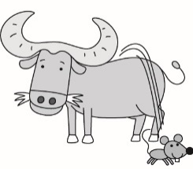 (Ｂ) 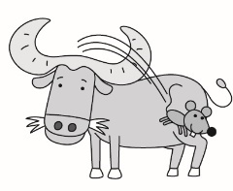 (Ｃ) 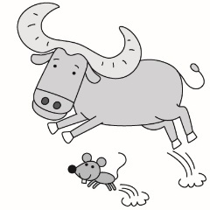
- (Ａ) 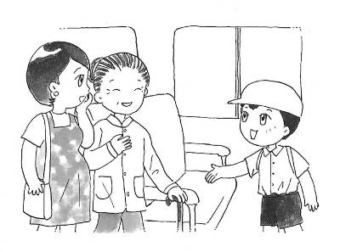 (Ｂ) 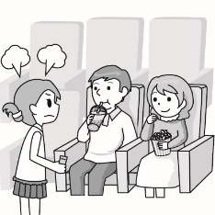 (Ｃ) 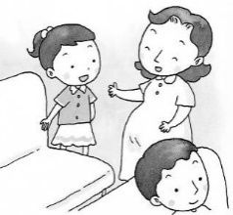
- (Ａ) 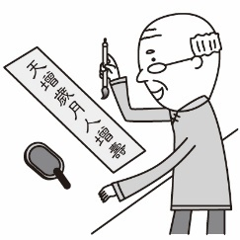 (Ｂ) 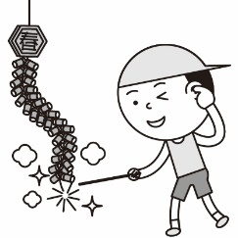 (Ｃ) 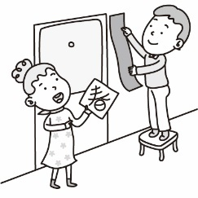
- (Ａ) 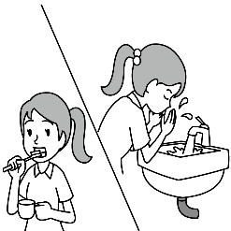 (Ｂ) 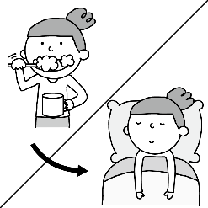 (Ｃ) 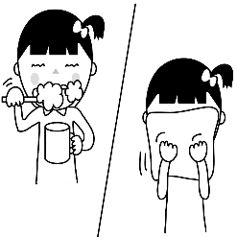
- (Ａ) 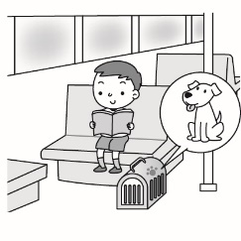 (Ｂ) 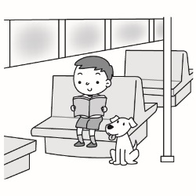 (Ｃ) 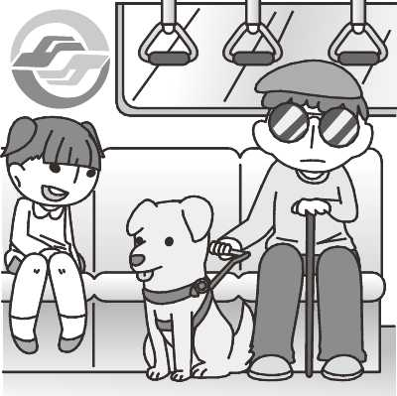

(B) 基本問答：根據聽到的內容，選出一個最適合的回應。

6. (A) The English test next week is bugging me. (B) I enjoyed myself in the camp last week. (C) Oh, are you all right?

7. (A) Good question. I’m not sure. (B) I thought I had a good knowledge of it. (C) The rat is the first sign of the Chinese zodiac.

8. (A) Stress is neither good nor bad.

(B) No, stress affects my nighttime sleep.

(C) Yes, I have so much homework to do and so many tests to take every day.

9. (A) Yes, I like to go surfing on the weekend.

(B) No, I’m looking for some information on my smartphone.

(C) Yes. As long as I have Wi-fi, I either read the news or listen to music online.

10.(A) Yes, you are too young to take care of a puppy.

(B) I don’t think that’s a good idea. Our apartment is too small.

(C) Sure. Nobody in my family except for you can spend time with a puppy.
(C) 言談理解：根據聽到的內容，選出一個最適合的答案。
11.(A) Seventy-two. (B) Sixty-eight. (C) Seventy.
12. (A) They are doing the homework. (B) They are guessing riddles. (C) They are looking up the words in the dictionary.
13. (A) You can be a great English teacher. (B) You have talent in singing. (C) You are the last person I want to see.
14. (A) Patty stayed up late to prepare for the history test.
(B) Patty went to bed at two o’clock this morning.
(C) Patty got up at two o’clock this morning.
15. (A) The boy’s parents said he was so young that he couldn’t deal with everything by himself.
(B) The boy’s parents had new jobs, so they decided to move to Taipei.
(C) The boy decided to leave his junior high school and have a new job in Taipei.
二、綜合測驗 (44%)
16. Let’s ________ for the peace of the world in the future.
(A) hold (B) waste (C) claim (D) pray
17. Don’t be the black ________ of the team, or you’ll be hated by your classmates.
(A) rooster (B) horse (C) sheep (D) rat
18. Studies have shown that ________ thinking can make your brain work better.
(A) negative (B) positive (C) responsible (D) modern
19. She couldn’t stop crying until her mother ________ her.
(A) hugged (B) nodded (C) adopted (D) pasted
20. ________ is power. That’s why I hope you read more.
(A) Performance (B) Noise (C) Knowledge (D) Taboo
21. If you feel _______ for a long time, your health will be affected.
(A) blind (B) helpful (C) stressed out (D) chemical
22. George：Everyone is back for the Chinese New Year ________ Cindy. Why didn’t she come back?
Ellie：Because she has gone to Korea on business.
(A) besides (B) beside (C) except (D) expect
23. Johnny ate his sister’s cookies, so she broke his toy car to ________ him.
(A) put out (B) turn out (C) deal with (D) get even with
24. A true friend always ________ to whatever you say.
(A) takes a deep breath (B) lends a helping hand (C) lends an ear (D) runs ahead of
25. Before we ________ at the station, the train had already left.
(A) arrived (B) arrive (C) have arrived (D) had arrived
26. Betty ________ in singing since she was four years old.
(A) had been interested (B) has interested (C) had an interest (D) has been interested
27. ________ my brother ________ I will go to Amy’s birthday party. Our mom had us do the housework at home that day.
(A) Either；or (B) Neither；nor (C) Both；and (D) Not only；but also
28. ________ it’s raining cats and dogs outside, the music party ________.
(A) Although；is cancelled (B) If；has been cancelled (C) Because；has been cancelled (D) While；has cancelled
29. Nora：How come _________? Ethan：I got up late this morning.
- did you miss the flight (B) were you late for school (C) you missed the train (D) you went to school so early
30. As long as the weather ________ good next Sunday, we will go mountain climbing.
(A) is (B) will be (C) was (D) had been
31. Irene’s dog loves ________ in cold water on hot days in summer.
(A) to wash (B) washing (C) to be washing (D) being washed
32. Either Julie or Lucy ________ stay home to take care of their little sister.
(A) hates (B) like (C) has to (D) have to
33. Peggy：Have you finished your science report yet? Vivian：No, but I ________ after eating dinner.
(A) will (B) have (C) won’t (D) haven’t
34. By the time Cindy thought her wallet was on the desk, it ________ away.
(A) had taken (B) has taken (C) had been taken (D) has been taken
35. Lisa：________ Annie：Not at all. Although I was born in the Year of the Tiger, the bride invited me to take a photo with her.
(A) What makes you say so? (B) Didn’t she mind? (C) Were you born in the Year of the Rooster? (D) Have you heard of it?
36. Grace：What have you been doing lately? Angela：________
- I’m copying the notes on the blackboard. (B) I will leave for America next week.
(C)I’ve been to Japan twice. (D) I have been busy for the exam.
37. Alex：Wow, the guide dog there is so cute. Can I play with it? Martin：________
- Sure. The guide dogs are friendly, aren’t they?
(B) Yes, the guide dogs are not only our pets but also our friends.
(C) Of course not. The guide dogs are trained to help the poor.
(D) No, you can’t do that because the guide dog is doing its job.
三、克漏字測驗 (12%)
(一)
Rudy was the shopkeeper of a coffee shop. One morning in January, while Rudy 38 the floor in the coffee shop, he heard a strange noise coming from outside. He pushed the door open and saw a cat 39 food in the trash can. Rudy gave the poor cat some fish and decided to keep her. He called her “Cutie.” To Rudy’s surprise, after he started taking care of Cutie, many people came to his coffee shop to see her. They liked Cutie because she was smart and liked to play with people. Rudy was glad that Cutie 40 his business better than before.
38. (A) is sweeping (B) swept (C) was sweeping (D) sweep
39. (A) look after (B) looking for (C) look at (D) looking up
40. (A) had made (B) makes (C) has made (D) making
(二)
There is an “honest” store run by Ms. Jiang in Taichung. People get the things they want to buy and put the money by themselves in a big urn, which is called “the honest urn”. 41 , it makes a clear sound. That’s “ the sound of honesty”.
It was an old store that was going to be shut down. Old people took a rest there, and children played and did the homework there, too. It was a place where people had a lot of beautiful memories .In order to keep the place, the shopkeeper, Ms. Jiang, bought the store and opened it again for everyone. But she couldn’t stay at the store all day, so 42 . Now there are a lot of visitors, including foreigners, coming to buy “honesty”.
Ms. Jiang waters the plants, cleans the place, and then leaves the store. She says that 43 because the price of not paying is expensive. They will feel guilty whenever they think of it. “ Once a visitor sent 20$ from Taipei just because he forgot to pay at the store.” Ms. Jiang always believes in people although sometimes she loses money because people don’t pay. However, Ms. Jiang still feels very touched that there are always people who understand what she’s doing.
guilty 有罪惡感的

41. (A) When the coin falls down into the urn (B) When the urn is touched by visitors
(C) If visitors call the shopkeeper (D) If the coin falls down on the ground
42. (A) she closed the store on weekends (B) she asked her husband to run the store
(C) she opened the store only at night (D) she came up with the honest idea
43. (A) people buy things at the store without paying (B) she never worries about those who don’t pay
(C) she trusts honesty is policy (D) she doesn’t like to stay at the store

四、閱讀測驗 (14%)
(一)
Who has seen the wind?
Neither I nor you:
But when the leaves hang trembling,
The wind is passing through.

Who has seen the wind?
Neither you nor I:
But when the trees bow down their heads,
The wind is passing by.

Written by Christina Rossetti (1830-1894)

44. What is the reading about?
(A) It’s about the trees. (B) It’s about the wind. (C) It’s about the leaves. (D) It’s about Christina Rossetti.
45. Which is true about the poem?
(A) When the wind passes by, Christina can see it.
(B) We can’t see the wind, but it is everywhere around us.
(C) The writer says everyone can see the wind.
(D) The leaves hang trembling because the trees bow down their heads.
(二)
What’s your Chinese zodiac sign? If you were born in the Year of the ox, your parents may expect you to be diligent and hard-working. If your Chinese zodiac sign is Monkey, you may be multi-talented, romantic, and easy-going. Below are some analyses about Chinese zodiac signs.
◎ Rooster：
Roosters are considered to be energetic, determined, and hard-working. They also love chatting with others and making a lot of friends. Roosters are sometimes a little stubborn and no one can change their mind.
◎ Dog：
Dogs are honest and always wear a smile every day. They know how to get along with others well. However, they sometimes feel anxiety for what aren’t needed to be worried about.
◎ Tiger：
Tigers are natural born leaders. They also like to help others, and they try the best to do everything all the time. Tigers are sometimes too proud to be cheated easily.
◎ Snake：
Though Snakes are given negative traits in many parts of the world, as one of the twelve zodiac signs, represent intelligence and mystery. Snakes are very responsible for everything, but they can’t trust others and like to do their jobs by themselves.
diligent 勤勞的 analyses 分析 energetic 有活力的 determined 有決心的 stubborn 固執的 anxiety 焦慮 natural 天生的 negative 負面的 trait 特質 represent 代表 mystery 神秘

46. What is the best title for the reading?
(A) The Best Chinese Zodiac Sign (B) Roosters Are Hard-working
(C) Talking About Chinese Zodiac Signs (D) Some Analyses About Animals
47. Below are four people who have different personalities. Whose Chinese zodiac sign may be Tiger?
(A) Aaron：I always hand in my homework on time. When my classmates have the problems that they can’t solve, I’ll try my best
to help them . So the teacher chose me to be the class leader this semester.
- Bill：I often donate money to the poor and help those in need. I am very friendly with my classmates, too. But I sometimes
worry that the end of the world is coming soon.
- Celine：I make phone calls with my friends and spend two hours chatting with them every day. Talking with my friends makes
me feel happy and comfortable.
- Davis：I think I can finish all the jobs by myself. I like to stay home on the weekend and don’t like to go out with my friends.
(三)
Eating healthy food can help fight inflammation and lower cortisol levels in our bodies. Therefore, how to choose right food is very important. Our food choices may reduce stress and affect our mental health.
Oily fish such as salmon, herring, and tuna are a rich source of omega-3 fatty acids, known as DHA and EPA. Moreover, mussels, clams, and oysters have a high level of vitamin B12 and omega-3s. They are both important nutrients in food that are connected with brain health. Food such as peppers, oranges, and kiwi are rich in vitamin C, which can improve moods.
In addition, eating fermented food that contain probiotics, such as yogurt and miso can lower stress and cortisol levels. On the contrary, eating too many cookies and sweets will make you feel more stressed.
inflammation 發炎 cortisol level 皮質醇水平 reduce 減少 mental 心智的 herring 鯡魚 tuna 鮪魚
omega-3 fatty acids 不飽和脂肪酸 mussel 淡菜 clam 蛤蠣 nutrient 營養 fermented 發酵的 probiotic 益生菌菌
48. What is the main idea of the reading?
(A) How to reduce stress. (B) Eat the right food to keep in shape.
(C) How to stay healthy. (D) Food that can lower stress levels.
49. According to the reading, what nutrients are connected with brain health?
(A) Vitamin A and C. (B) Vitamin B12 and omega-3 fatty acids. (C) Vitamin B12 and C. (D) Vitamin D and omega-3 fatty acids.
50. Which is NOT true about the reading?
(A) Eating healthy food can increase inflammation in our bodies.
(B) Vitamin C can make people have good moods.
(C) Fermented food, such as salmon and oysters can lower cortisol levels.
(D) Some vegetables and fruit are rich in Vitamin C.

109-2-1 九年級 英語科－解答
- 聽力測驗 (30%)
1 | 2 | 3 | 4 | 5
B | B | C | B | A
6 | 7 | 8 | 9 | 10
A | A | C | C | B
11 | 12 | 13 | 14 | 15
C | B | A | B | C
- 綜合測驗 (44%)
16 | 17 | 18 | 19 | 20
D | C | B | A | C
21 | 22 | 23 | 24 | 25
C | C | D | C | A
26 | 27 | 28 | 29 | 30
D | B | C | C | A
31 | 32 | 33 | 34 | 35
D | C | A | C | B
36 | 37
D | D
- 克漏字測驗 (12%)
38 | 39 | 40 | 41 | 42 | 43
C | B | A | A | D | B
- 閱讀測驗 (14%)
44 | 45 | 46 | 47 | 48 | 49 | 50
B | B | C | A | D | B | C(A)

新北市立溪崑國民中學109學年度第二學期第一次定期評量
九年級 英語科 聽力測驗稿
- 辨識句意：根據聽到的內容，選出符合描述的圖片。
1. The rat is hopping off the ox’s head.
- The woman said someone had taken her seat.
- Mr. Wang is pasting spring couplets on the wall.
- Before she went to bed, she brushed her teeth.
- Pets need to be kept in cages on the MRT.

(B) 基本問答：根據聽到的內容，選出一個最適合的回應。

6. Landy, you haven’t been yourself lately. What’s wrong?

7. Jack, which animal is the ninth sign of the Chinese zodiac, the monkey or the rooster?

8. As a teenager, do you feel as stressed as an adult?

9. Larry, are you surfing the Net on your smartphone now?

10. Dad, look. The puppies in the window are so cute. Can I get one, Dad?
(C) 言談理解：根據聽到的內容，選出一個最適合的答案。
11. Man：I’m twenty-two years old, an Ox. What’s your Chinese zodiac sign?
Woman：Tom, we are the same age. I’m an Ox, too.
Man：Wow! My mother and grandmother are also “Oxen”. You can join our ox family.
Question：How old may Tom’s grandmother be?
12. Man：What never asks questions but has a lot of answers?
Woman：Well, it’s too difficult for me to answer. Please tell me what it is.
Man：Come on. It’s very easy. It’s a dictionary.
Question：What are they doing?
13. Man：I met Alison last Friday.
Woman：Really? Since the last time we met him, it’s been three years. How was he?
Man：He looked great. He said he had taught English in the cram school for two years.
Woman：Wow! What you said to him at our last meeting did make a difference to his life.
Question：What may the man say to Alison three years ago?
14. Man：You looked so tired, Patty. Are you all right?
Woman：I didn’t go to bed until two o’clock and woke up at six o’clock this morning.
Man：Why did you go to bed so late?
Woman：I was doing the history report. My teacher asked us to hand in the report this morning.
Question：What do we know about the dialogue?
15. Man：My parents decided to move to Taipei because of their new jobs, so I’ll have to leave my junior high school.
Woman：But as long as you can take care of yourself well, why can’t you stay?
Man：They said I am too young to deal with everything by myself.
Woman：Well, Taipei is a big city. Look on the bright side, you can go to a better school and make the most of it.
Man：Maybe you’re right. Thanks.
Question：Which is NOT true about the dialogue?

