新北市立溪崑國民中學109學年度第二學期第一次定期評量 英語科試題卷
八年級 班 座號 姓名
一 聽力測驗(30%)
- 辨識句意 : 根據聽到的句子，選出符合描述的圖片(8%)
- (A) (B) (C)
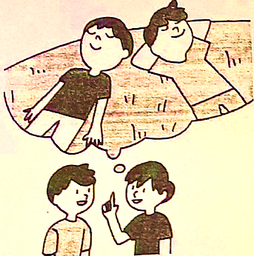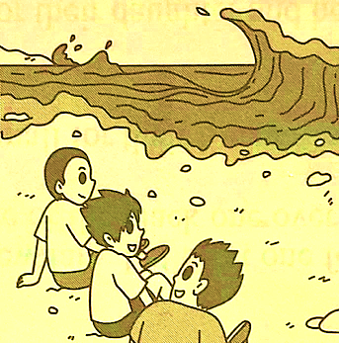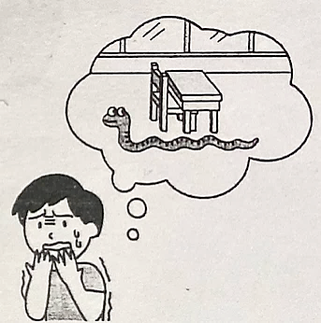
- (A) (B) (C)
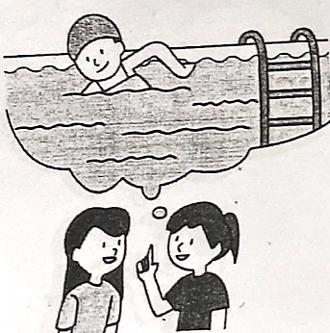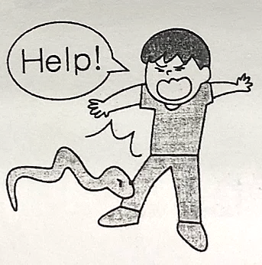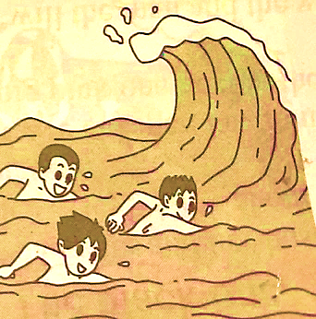
- (A) (B) (C)
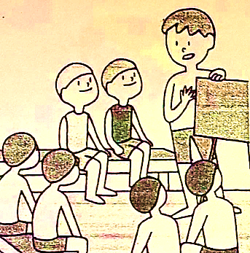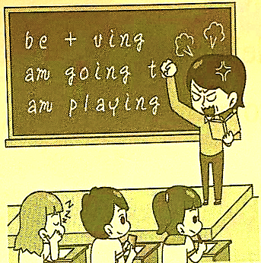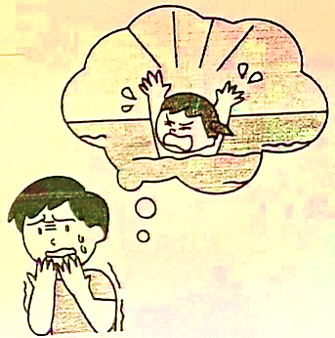
- (A) (B) (C)
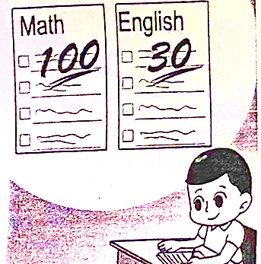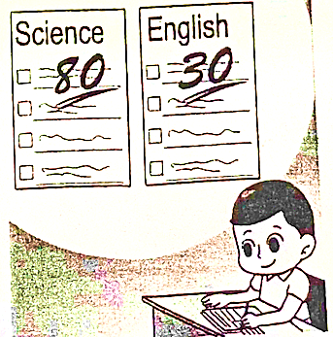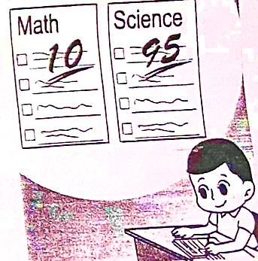
- 基本問答：根據聽到的內容，選出合適的回應。(12%)
- (A) No. It is nothing. (B) No. I am not worried at all. (C) No. It is better to be safe than sorry.
- (A) Sure. I can read the menu. (B) Yes. I’d like the beef noodles. (C) I’m not sure. What would you like to order?
- (A) It is big and beautiful. (B) He likes it. (C) It smells good.
- (A) The story is about a baseball player. (B) It’s getting more expensive. (C) I love the story and read it often.
- (A) Thank you for telling me. (B) It’s nothing. (C) I am not worried.
- (A) Don’t be worried. We can see each other at seven o’clock. (B) I’ll wait for you until six o’clock. Better late than never. (C) That’s okay. See you at eight o’clock.

- 言談理解：根據聽到的內容，選出最適合的答案。(10%)
- (A) Plant A (B) Plant B (C) Plant C
- (A) She will pay NT$400 for pumpkin pies. (B) She will buy pumpkin pies and she’ll need to pay NT$ 450. (C) She won’t buy anything.
- (A) A dog bit him on his right leg. (B) A dog ran after him on his way to the library. (C) He kicked a rock and hit a dog before he fought with his sister.
- (A) They’ll sit on the beach and listen to the sound of waves. (B) They’ll go surfing. (C) They will do some water activities.
- (A) Frank is the tallest of all. (B) Tim is taller than I. (C) My brother is the shortest.
二 綜合測驗 (32%)
- Jessica is ＿＿＿ student in the class. She often helps her classmates by ＿＿＿ them math and English.
(A) the nicest; to teach (B) the nicest; teaching (C) the nicer; teaching (D) nicer; teach
- The smartphone is the ＿＿＿ in the store, but it isn’t ＿＿＿ expensive ＿＿＿ all ＿＿＿. In fact, it sells very well.
(A) biggest; as; as; the others . (B) bigger; as; as; the others. (C) biggest; more; than; others (D) biggest; much; as; others
- 選出正確的句子:
(A) We left the classroom until our teacher told us to do so.
(B) Tina is taller than anyone in her class.
(C) He makes the more money of the two.
(D) To get farther information, you can ask your teacher.
- Tom is 20, but he looks older. (A) Tom is 20 years older than he looks. (B) Tom is more than 20 years old. (C) Tom is younger than he was twenty years ago. (D) Tom looks older than he really is.
- It costs me more to buy a house in a big city. (A) The house in a big city is more expensive. (B) The house in a big city is
not so good. (C) The house in a big city is cheaper. (D) The house in a big city is the least cheap.
- 選出正確的句子:
(A)To keep these accidents from happen, learning about water safety is the most important thing to do.
(B) Our pies are larger than any other restaurant in the city.
(C) The fruit salad tastes more delicious than all the other dishes in the restaurant. Everyone likes it.
(D) More you have, more you want.
- Cathy, do you feel or do you think about your class? (Ａ) what; what (Ｂ) how; what (Ｃ) what; how (Ｄ) how; how
- important of all, my mother is important person in my life. (Ａ) The most; most (Ｂ) Most; the most (Ｃ) Most; most (Ｄ) The least; the more
- The weather in Taipei is getting than . (Ａ) colder; in Kaohsiung (Ｂ) colder; Kaohsiung (Ｃ) cold; in Kaohsiung (Ｄ) colder; that in Kaohsiung
- The air in the city is becoming because there are too many cars and motorcycles. (Ａ) bad and bad (Ｂ) worse and
worse (Ｃ) worst and worst (Ｄ) better
- In minutes, he’ll feel tired and feel like ＿＿＿ to bed. (Ａ) a little; a few; to go (Ｂ) a few; a little; going (Ｃ) a little; a little; going (Ｄ) a few; a little; to go
- 選出正確的句子:
(A) It was less cold yesterday than today, so I did not turn on the fan during the night.
(B) For Linda, letting her kids eat too much fast food is the least thing to do. She cares more about their health.
(C) Jay is poor at studying math. For him, playing basketball has much more fun than studying math.
(D) Swimming in the river looks like fun, but the water safety is the most important thing to remember.
- It’s hotter today than yesterday. (Ａ) ever (Ｂ) more (Ｃ) lots of (Ｄ) much
- Something in the kitchen fried chicken. Aren’t you hungry? (Ａ) tastes; feeling (Ｂ) sounds like; becoming (Ｃ) smells like; getting (Ｄ) looks; feeling like
- Jane: Does Andy grow as many coffee beans as your dad and uncle? Lisa: No, he grows coffee beans of the three, so
he makes money than they both do. (Ａ) the least; less (Ｂ) the most; more (Ｃ) the fewest; less (Ｄ) most; the
more
- Ben: Is your math as good as ? Liz: No, mine is . (Ａ) your brother’s ; worse than his (Ｂ) your
brother’s; as good as his (Ｃ) your brother; worse than his (Ｄ) your brother ; so bad as he
三 題組 (18%)
A
Dear Maggie,
I know you won't be happy but I still have to say this again. It hurts me to think that you're going to 32 . I know you've always wanted to be like those actresses with big eyes and slim legs, but in fact you are already beautiful. What you are born with makes you special because nobody 33 .
It worries me more that you don't think you're good enough. But sadly, there's no quick fix to this, not even with the doctor's help. If you don't try to like yourself first, no one else will. People like you not because of your face, but because of your heart. You need to understand this first. Until you understand this, 34 even if you have this change.
I truly hope you think this through again.
Love,
Linda

- (A) change the way you are (B) give up being an actress (C) travel with a theater group (D) run away from your friends
- (A) likes you (B) sounds different from you (C) feels worse than you (D) looks the same as you.
- (A) that sounds great (B) nothing is going to be different (C) something is going to be different (D) nothing was the same
B
The human eye is like a living movie camera. It can adjust to light, distance, and many other conditions. When people's eyes cannot do a perfect job, they have to wear glasses. But there is one problem that even glasses are not able to correct. That problem is color blindness.
Color blindness is not really the right word to use. Most "color-blind" people can see some colors. So color confusion would be a better description. The official name for this difficulty is Daltonism. The name comes from John Dalton, who was the first to study the problem.
There are at least three different kinds of color confusion. Confusing yellow and blue is one type of Daltonism. It is often caused by illness. Two other kinds of color confusion are more common. Both types confuse red and green. But in one kind, the person can see different shades of red. In the other, the person can see shades of green. These two types of Daltonism are thought to be inherited. They seem to be handed on by the mother, even if she has no trouble with colors herself.
Most people with Daltonism get along just as well as people without it. When a traffic light changes from red to green, for example, they can tell the difference in how bright the light is. They may not even know that their world of color is different. All people have their own world of color, and nobody knows exactly what someone else sees.
adjust調整 confusion困惑;混淆 description描述

- The Daltonism that confuses yellow and blue is often caused by ＿＿＿.
- sun exposure (B) eye injury (C) genetics (D) illness
- You can conclude from the article that ＿＿＿.
(A) traffic lights should be white (B) there are many shades of blue
(C) people with Daltonism can't see purple (D) people may not know a friend has Daltonism
- Which word in paragraph 3 means "got from older family members"?
(A) caused (B) inherited (C) handed (D) thought

C
The praying mantis is a giant of the insect world. It can be up to five inches long. Even so, you may have trouble seeing it. The praying mantis is green and shaped like a leaf. This insect uses its four back legs to cling to a leaf. It folds its two front legs under its body. In this position, the insect looks as if it is praying. But it's really waiting for dinner! The word prey sounds like pray, but it has a very different meaning. To prey means "to hunt and eat." The praying mantis is also an insect that preys.
The giant insect is always hungry. When the babies first hatch, they sometimes eat each other. As the young mantises grow, they eat hundreds of other insects. Grown females often eat their unlucky mates. The praying mantis constantly looks around for food. It is the only insect that can turn its head. If a fly, grasshopper, or butterfly comes near, the mantis's long front legs flash out. The mantis grabs the insect and eats its body only. The mantis drops the head, wings, and legs on the ground as if they were old bones.
The female lays her eggs in the fall. She covers them with a case of white bubbles. This egg case soon hardens and turns brown. Then the praying mantis dies. The eggs rest quietly through the winter. Finally, on a warm day in spring, they hatch by the hundreds. Once again it is time for the praying mantis to prey.
mantis螳螂constantly不斷地harden硬化

- The article does not tell about the ＿＿＿ of the praying mantis.
(A) legs (B) color (C) babies (D) wings
- What happens last in the life cycle of a female praying mantis?
(A) She lays eggs in the fall. (B) She covers her eggs with bubbles. (C) She eats hundreds of other insects. (D) She helps the eggs hatch in the spring.
- You can decide from the article that＿＿＿.
(A) most praying mantises are five inches long
(B) the female praying mantis covers her eggs with white bubbles to feed the babies when they hatch
(C) praying mantises do not raise their babies
(D) praying mantises have a hard time finding food

四 文意字彙 (8%)
- Getting around in the big city is more c t than in the country.
- When the big wave hit him, he started to s e.
- It is d s to play basketball on the road.
- Eating noodles with c s is not easy for my friends from the USA.

五 翻譯(12%)
- 然而地球的人口數量仍不斷在攀升，以此食物的價格將變得越來越高。
- 此外，飼養動物製造很多溫室氣體，但是種植蔬菜對環境比較友善。
- 紅火蟻是最令人害怕，遠離他們是目前最好的方式。
- 教室裡很少學生知道這個問題的答案，所以除了我們老師以外，Jack和我是那裏唯一知道的學生。

新北市立溪崑國民中學109學年度第二學期第一次定期評量 英語科 答案卷
八年級 班 座號 姓名
四 文意字彙 (8%)
1 | 2 | 3 | 4

五 翻譯(12%)
1

2

3

4

109-2-1 八年級 英語科－解答
- 聽力測驗(30%)
- 辨識句意 : 根據聽到的句子，選出符合描述的圖片(8%)
1-4 BBCA
- 基本問答：根據聽到的內容，選出合適的回應。(12%)
5-10 CBACAC
- 言談理解：根據聽到的內容，選出最適合的答案。(10%)
11-15 CABAA
二、 綜合測驗 (32%)
16-20 BACDA 21-25 CBBDB 26-31BDDCCA
三、 題組 (18%)
32-35ADBD 36-40 DBDBC
四、 文意字彙 (8%)
- convenient 2 struggle 3 dangerous 4 chopsticks

五、 翻譯(12%)
- However, the number of people on earth is still growing, so the price of the food will get higher and higher.
- What’s more, raising animals creates a lot of greenhouse gas, but growing vegetables is more friendly to the environment.
- Red fire ants are the scariest, so staying away from them is the best way for now.
- Very few students in the classroom knew the answer to the question, so Jack and I were the only ones there besides our teacher.

新北市立溪崑國民中學109學年度第二學期第一次定期評量
八年級英語科聽力測驗稿
- 聽力測驗(30%)
- 辨識句意 : 根據聽到的句子，選出符合描述的圖片(8%)
- They decided to stay away from big waves in the sea.
- A snake hit Jerry and he shouted for help.
- I felt so scared because Cathy almost drowned.
- For Eason, English is much more difficult than math.
B. 基本問答：根據聽到的內容，選出合適的回應。(12%)
- W: The weather is really bad. Are you still going swimming later? (A) No. It is nothing. (B) No. I am not worried at all. (C) No. It is better to be safe than sorry.
- May I take your order? (A) Sure. I can read the menu. (B) Yes. I’d like the beef noodles. (C) I’m not sure. What would you like to order?
- How is David’s new house like? (A) It is big and beautiful. (B) He likes it. (C) It smells good.
- How do you like Jeff Kinney’s new book? (A) The story is about a baseball player. (B) It’s getting more expensive. (C) I love the story and read it often.
- Watch out. Some snakes might hide under the rocks. Their bites may cause death. (A) Thank you for telling me. (B) It’s nothing. (C) I am not worried.
- I need to work until 7 p.m. today, so I might get to your place one hour late. (A) Don’t be worried. We can see each other at seven o’clock. (B) I’ll wait for you until six o’clock. Better late than never. (C) That’s okay. See you at eight o’clock.

C. 言談理解：根據聽到的內容，選出最適合的答案。(10%)

Mrs. White bought three plants a week ago. Plant A was 4 centimeters tall. Plant B was 5 centimeters tall. Plant C was 6 centimeters tall. Now, plant A is 4 centimeters taller. Plant B is 2 centimeters taller. Plant C is 3 centimeters taller.
Q: Which plant is the tallest? (A) Plant A (B) Plant B (C) Plant C

M: Good evening, Miss. How may I help you?
W: I'd like a pumpkin pie.
M: OK. It'll be NT$150. Would you like to get three at a time? They'll be fifty NT
dollars cheaper.
W: Okay. I’ll get three.
Q: What will the woman buy, and how much will she need to pay?
(A) She will pay NT$400 dollars for pumpkin pies. (B) She will buy pumpkin pies and she’ll need to pay NT$ 450. (C) She won’t buy anything.

B: Today was really not my day. A big dog bit me in the afternoon, and it was the worst experience to me. My sister, Tina, fought with me before I kicked a rock on my way to the library. The rock happened to hit a dog, and it got so mad. Then, it started to run after me and bit me on my left leg. Oh my! It hurts so much!
Q: Which is true?
(A) A dog bit him on his right leg. (B) A dog ran after him on his way to the library. (C) He kicked a rock and hit a dog before he fought with his sister.

W: What a beautiful beach! It's getting so hot. Do you feel like going surfing for now?
M: It doesn't sound like a good idea .
W: How come?
M: How big and strong the waves look! It's dangerous to do any water activity, and it might cause death.
W: All right. It'll be better to be safe than sorry. Let's just sit on the beach and listen to the sound of waves.
Q: What will the man and the woman do?
(A) They’ll sit on the beach and listen to the sound of waves. (B) They’ll go surfing. (C) They will do some water activities.

I’m not as tall as Frank. Frank is taller than my brother, Tim.
Q: Which is true?
(A) Frank is the tallest of all. (B) Tim is taller than I. (C) My brother is the shortest.

