新北市立溪崑國民中學109學年度第二學期第一次定期評量 英語科 試題卷
七年級 班 座號 姓名
一. 聽力測驗(30%) 每題2分
一、辨識句意：每題均有三張圖片，請依據所聽到的句子，選出符合描述的圖片 10%
- (A) 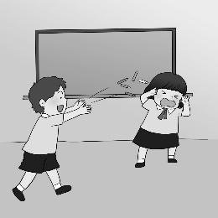 (B) 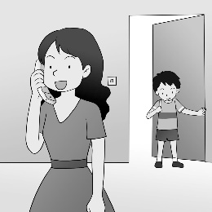 (C) 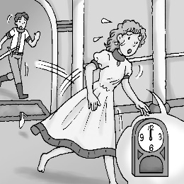
- (A)  (B) 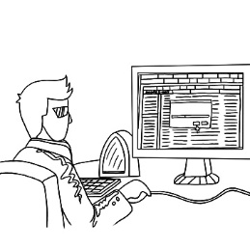 (C) 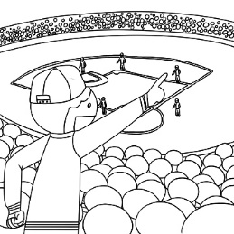
- (A) 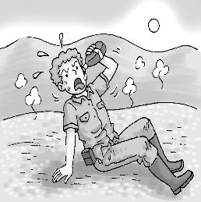 (B) 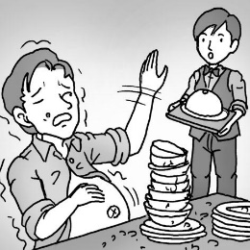 (C) 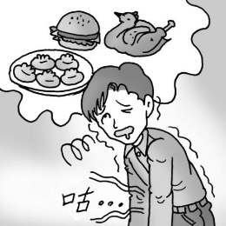
- (A) 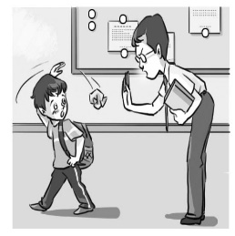 (B) 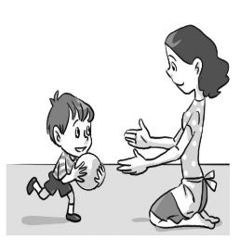 (C) 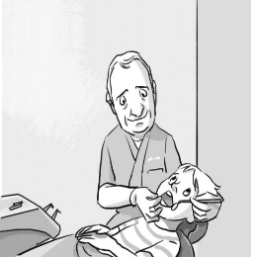
- (A) 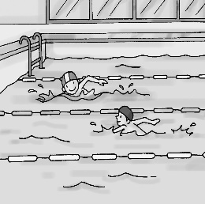 (B) 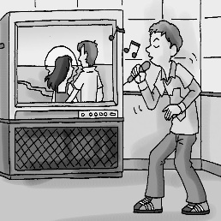 (C) 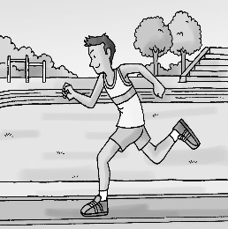

二、基本問答：每題均有三個選項，請依據所聽到的內容，選出一個最適合的回應 10%
- (A) I enjoy this sport very much. (B) I practice with my uncle. (C) I play it every day.
- (A) Yes, I love them. (B) No, I’m not like them. (C) Yes, I like my mother.
- (A) They are just fruit. (B) They are one hundred and fifty dollars. (C) I have a lot of them.
- (A) Sure. Give me a break. (B) OK. I’m very busy. (C) All right. I can teach you.
- (A) She goes to bed at different times every day.
(B) She has too much homework every evening.
(C) She does a lot of exercise.

三、言談理解：每題均有三個選項，請依據所聽到的對話與問題，選出一個最適當的答案 10%
- (A) The girl’s pet. (B) A ball game. (C) A video game.
- (A) They practice every day. (B) They practice from Monday to Friday. (C) They practice on weekends.
- (A) She can’t see a doctor. (B) She can’t stand or walk. (C) She can’t eat.
- (A) They are classmates. (B) They don’t have their books. (C) They are going to their teacher.
- (A) The woman can play basketball. (B) The woman can play tennis. (C) The woman can go jogging.

二. 綜合測驗 (44％) 每題2分
16. Rose ＿＿＿ her junior high school life, and her sister, Helen, ＿＿＿, too.
(A) enjoys ; does (B) enjoy ; does (C) doesn’t enjoy ; doesn’t (D) doesn’t enjoy ; does
17. A: I’m so thirsty. ＿＿＿ get something to ____? B: Sure! There’s a store in front of the school.
(A) Can we ; drink (B) Do we ; eat (C) Are we ; help (D) What about ; have
18. A: ＿＿＿ do Bill and his classmates do ＿＿＿ Sunday mornings? B: They play tennis at the park.
(A) What ; in (B) Where ; in (C) What ; on (D) Where ; on
19. Tina ＿＿＿ very nice and friendly. We all ＿＿＿ her so much.
(A) isn’t ; likes (B) doesn’t ; like (C) is ; like (D) does ; likes
20. A: Mr. Lin ____ in the living room. Where is he? B: He ＿＿＿ be in the restroom.
(A) is；does (B) isn’t；must (C) is；can (D) can’t；isn’t
21. A: ＿＿＿ does your uncle teach? B: PE. He is ___ PE teacher.
(A) What ; a (B) Who ; an (C) Where ; the (D) How ; X
22. A: Can you practice English ＿＿＿ me this afternoon? B: Sorry. I have a meeting ＿＿＿ 1 p.m. to 5 p.m.
(A) with ; from (B) and ; from (C) with ; for (D) and ; for
23. The box ____ so heavy. I ＿＿＿ carry it. (A) does ; doesn’t (B) be ; must (C) is ; can’t (D) are ; don’t
24. A: ______the bird sing and dance at the same time（同時）? B: No, it ______. It’s too hard for it.
(A) Can ; can (B) Can ; can’t (C) Can’t ; can (D) Cannot ; can’t
25. A: Who ＿＿＿ math hard every day? B: My cousin, Tom, ＿＿＿. He’s a great student.
(A) study ; do (B) teaches ; does (C) is teaching ; is (D) studies ; does
26. My brothers ＿＿＿ any homework today, but I do. And they ＿＿＿ TV in the living room.
(A) doesn’t have ; watch (B) don’t have ; are watching (C) can’t have ; watch (D) aren’t having ; are watching
27. A: I like soccer. ＿＿＿ you? B: Sure I ＿＿＿. (A) Are ; am (B) Don’t ; am (C) Aren’t ; do (D) Do ; do
28. Ken: Where Mark come from? Liz: He from the USA.
(A) is ; is (B) is ; comes (C) does ; come (D) does ; is
29. Sharon wants five for the cake. (A) guava (B) pine apple (C) juice (D) strawberries
30. Does your sister sports or exercise on Sunday morning?
(A) plays ; does (B) do ; play (C) play ; do (D) does ; do
31. My son can draw birds ＿＿＿ rabbits, but he can’t draw horses ＿＿＿ bears.
(A) or ; with (B) and ; or (C) or ; and (D) and ; with
32. A: ____ is the pencil case? B: I don’t know. It’s a gift ____ my aunt.
(A) How ; for (B) How much ; from (C) What color ; to (D) What ; of
33. A: _____ Peter late for school every morning? B: Yes, he always ＿＿ to school late.
(A) Does ; goes (B) Does ; does (C) Isn’t ; is (D) Is ; goes
34. A: There is a ball game on TV tonight. Let’s watch it. B: _____ I am busy. I have to prepare for a test.
(A) By the way. (B) Watch out. (C) Come on. (D) Get up.
35. A: ____ she look like her mother? B: No, she ____ her father.
(A) Is ; likes (B) Does ; likes (C) Is ; looks like (D) Does ; is like
36. A: Is the tall woman your new girlfriend? B: ____ She is just my sister.
(A) I see. (B) Give me a break. (C) Are you sure? (D) Hurry up.
37. A: The food is very expensive(昂貴). Let’s not eat here. B: Don’t worry. ____ I have much money.
(A) It’s on me. (B) Don’t say that again. (C) Baseball is my life. (D) Me too.

三. 閱讀測驗 (6%) 每題2分
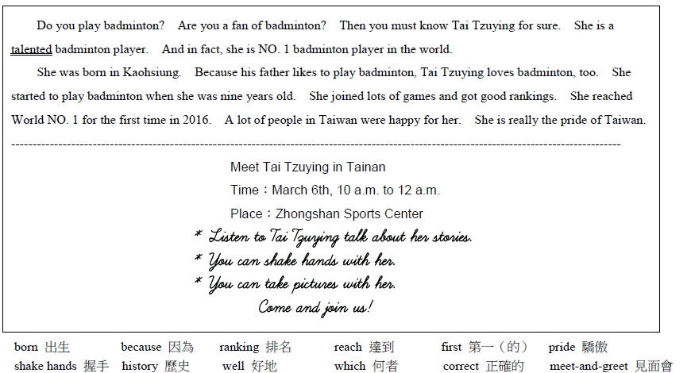
38. What is this reading about?
(A) The badminton history in Taiwan. (B) A badminton star in Taiwan.
(C) How to be a good badminton player. (D) A story about a man badminton player.
39. Tom is a “talented” soccer player. What does it mean?
(A) He is a tall soccer player. (B) He doesn’t know soccer much.
(C) He is good at playing soccer. (D) He can’t play soccer very well.
40. What is correct about the “meet-and-greet” from the poster?
(A) The meet-and-greet is in Taipei. (B) Only one fan can shake hands with Tai Tzuying.
(C) The meet-and-greet is in the evening. (D) Fans can take a picture with Tai Tzuying.

四. 文意字彙 (8%) 每題1分
41. 門票 42. 一起 43. 早餐
44. Of all the fruit, I like w_____ns most. They are very juicy.
45. I don’t have time for TV. I don’t have time for video games, e_____r.
46. My brother and I s____e a bathroom, and he uses it for an hour every morning.
47. Stephen is a good baseball player. We are p____d of him.
48. There are h_____ds of people in front of the gym. They are waiting for their favorite singer.

五. 翻譯 (12%) 每題3分
49. 你每天放學後在校隊練習籃球嗎?
50. 我們輸掉比賽會哭，但我們不放棄。
51. 他刷牙、洗臉，淋浴然後準備上學。
52. 我的哥哥 Eddie 是一名生活忙碌的大學生。他八點有課。

試題結束

新北市立溪崑國民中學109學年度第二學期第一次定期評量 英語科 答案卷
七年級 班 座號 姓名
四. 文意字彙 8% (每題1分)

41. | 42. | 43. | 44.
45. | 46. | 47. | 48.

五. 翻譯 12% (每題3分)
49.
50.
51.
52.
109-2-1 七年級 英語科－解答

1.C C A C C 6.C B B C A 11.C B B A C 16. A A C C B
21.A A C B D 26. B D D D C 31.B B D C D 36. B A B C D

四. 文意字彙 8% (每題1分)
41. ticket 42. together 43. breakfast 44. watermelons
45. either 46. share 47. proud 48. hundreds

五. 翻譯 12% (每題3分)

49. Do you practice basketball on the school team after school every day?
50. We lose games and cry, but we don’t give up.
51. He brushes his teeth, washes his face, takes a shower and then gets ready for school.
52. My brother Eddie is a college student with a busy life. He has class at eight o’clock.

新北市立溪崑國民中學109學年度第二學期第一次定期評量
七年級 英語科 聽力測驗稿
一、辨識句意：每題均有三張圖片，請依據所聽到的句子，選出符合描述的圖片10%
1.The girl is worried. She cannot be late.
2.I have two tickets for the game. Let’s watch it together.
3.The man must be very thirsty.
4.Brandon goes to the doctor for his teeth.
5.Jack starts to jog in the park at six every morning.
二、基本問答：每題均有三個選項，請依據所聽到的內容，選出一個最適合的回應10%
6.What day do you play badminton?
7.Are you like your parents?
8.How much are the strawberries?
9.Can you help me with my homework?
10.What time does Fiona go to bed?
三、言談理解：每題均有三個選項，請依據所聽到的對話與問題，選出一個最適當的答案10%
11. G: Do you play Hungry Birds?
B: What is that?
G: It’s a new video game. It’s fun.
B: Do you have it?
G: Yes, you can play it with me.
Q: What is Hungry Birds?
12. M: You’re so tall. Are you basketball players?
W: No, but we’re baseball players.
M: That’s cool. Do you practice baseball every day?
W: No, we don’t practice on weekends.
Q: When do the players practice?
13. M: Is your cat all right now?
W: No, Mimi can’t stand or walk.
M: Do you want to take her to the doctor?
W: Yes, I am going to take her to a different doctor today.
Q: What is wrong with Mimi?
14. G: The teacher is coming. Sit down.
B: All right. Oh, no. Where is my book?
G: You don’t have your book?
B: No, can I share a book with you?
Q: What do we know about the boy and the girl?
15. W: I’m so fat. What can I do?
M: You can do some exercise after school.
W: Like what?
M: You don’t like ball games, so you can jog. It helps a lot.
Q: What does the man mean?

