新北市立溪崑國民中學111學年度第二學期第二次定期評量 英語科 試題卷
九年級 班 座號 姓名
一、聽力測驗30%
(一)辨識句意：每題均有三張圖片，請依據所聽到的句子，選出符合描述的圖片
- (A)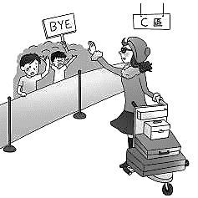 (B)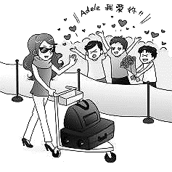 (C)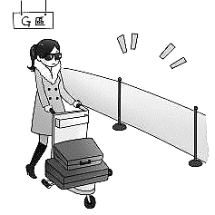
- (A)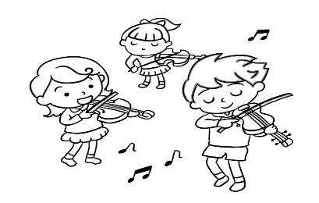 (B)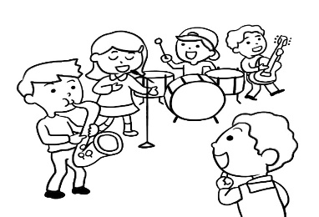 (C)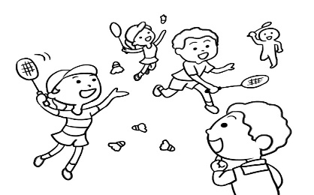
- (A)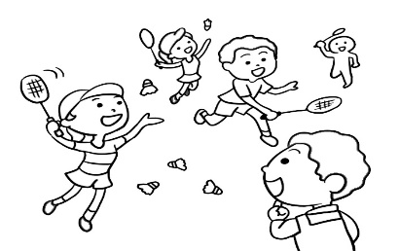 (B)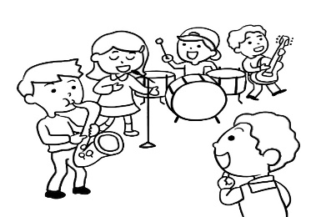 (C)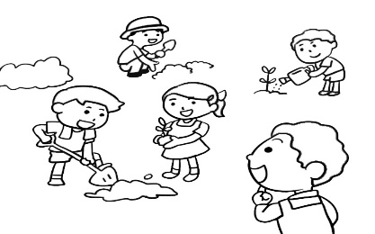
- (A)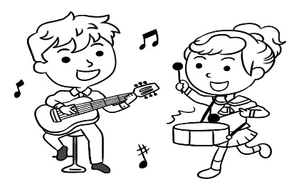 (B)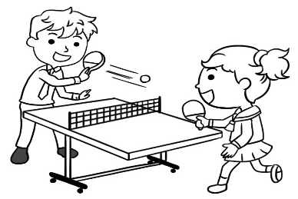 (C)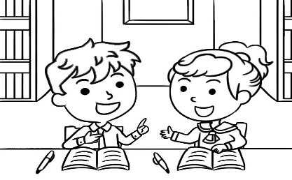
- (A)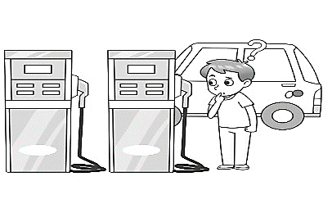 (B)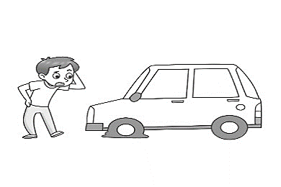 (C)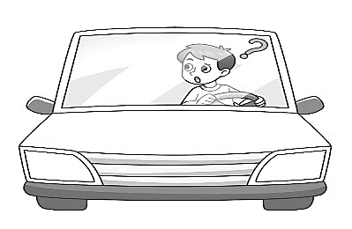

(二)基本問答：每題均有三個選項，請依據所聽到的內容，選出一個最適合的回應
6. (A) Right! She cares about her dad a lot. (B) Right! She doesn’t care how her dad feels about Romeo now.
(C) Right! Her dad’s words matter to her.
7. (A) Neither can I. Time does fly. (B) I can’t believe it, either. It’s never too late to make a change.
(C) Me, either. I can’t put up with my junior high school life anymore.
- (A) Of course. Let’s make a deal to stay good friends forever.
(B) Yes, I used to be a headache in my family. They always cover for me.
(C) No, you don’t need to pray for me. You should get to where you want to go.
- (A) No, nothing will knock him down. (B) Yes, he never made any mistakes in spelling.
(C) Yes, he said he would never make the same mistake again.

- (A) I don’t agree. You shouldn’t speak up for your friends. (B) You can say that again. I will fight back against bad guys.
(C) I agree. I won’t fight back even though Ivy is mean to me.

(三)言談理解：每題均有三個選項，請依據所聽到的對話與問題，選出一個最適當的答案
11. (A) The boy’s yearbook. (B) The boy’s workbook. (C) The boy’s homework.
12. (A) Because she loves the color red. (B) Because she wants to plant some flowers.
(C) Because he wants to show his love for her.
13. (A) He’s packing. (B) He’s washing a gray tie. (C) He’s cleaning his bedroom.
14. (A) He wants the students to enjoy their school life. (B) He is talking to the students in the junior high school.
(C) He thinks getting good grades is the most important thing for the students.
15. (A) She wanted to sell him her car. (B) She needed him to move his car. (C) She needed someone to fix her car.
二、綜合測驗40%
16. Tommy is going to Tokyo next week. He is not sure whether he should bring a coat or sweater. What words should he type in to look for the information on the Internet?
(A)  (B)  (C)  (D) 
17. Kevin Lin started to run across the Sahara Desert in November, 2006. He _____ for 111 days, and finally finished his run on
February 21, 2007. (A) has run (B) ran (C) was running (D) would run
18. Firefighters need to wear masks they go into a burning house, so they won’t breathe in the smoke.
(A)until (B) before (C) because (D) though breathe in吸入
19. Different kinds of bears have different colors, but most elephants are .
(A) gray (B) heavy (C) large (D) friendly
20. Harry: Tomorrow is Mom’s birthday. Let’s buy some flowers for her. Cindy: Good idea. I know she likes best.
(A) chocolates (B) dresses (C) rings (D) roses
21. Amy’s father is very sick. The doctors can do nothing for him, so Amy went to the temple to ＿＿ for him.
(A) care (B) look (C) pray (D) count
22. When I was a student, I liked to sit in the front of the classroom so that I could see the words better on the .
(A) desk (B) postcard (C) blackboard (D) dictionary
23. Paul misses his parents a lot. He ______ them since he came to work in Taiwan a year ago.
(A) didn’t see (B) doesn’t see (C) won’t see (D) hasn’t seen
24. Gina heard someone her, so she stopped her bike and turned around.
(A) calls (B) calling (C) called (D) to call
25. Jack: Have you decided ______ you will celebrate your 15th birthday?
Rose: Yeah, I’m going to have a big barbecue（烤肉）party.
(A) how (B) what (C) when (D) where
26. The man wants to know his money back.
(A) he gets (B) he can get (C) how to get (D) how can he get
27. A: How did you know I had a fight with Joe? B: Your voice even from my house.
(A) could hear (B) is heard (C) heard (D) could be heard
28. Irene, stop ＿＿＿ like a baby. You have to face the problem yourself.
(A) act (B) to act (C) acting (D) acted
29. Smartphones are convenient. Every person in my office has ＿＿＿.
(A) it (B) one (C) other (D) another

30. All the actors came out on stage and ＿＿＿ the people in the theater after the play was over.
(A) arrived at (B) ran after (C) bowed to (D) looked for
31. Jogging every day ＿＿＿ me the happiest.
(A) make (B) makes (C) making (D) to make
32. Give me a second. I’ll ＿＿＿ someone show you around.
(A) ask (B) tell (C) have (D) want
33. ＿＿＿ we were all very tired after hiking for five hours, we didn’t stop, and made it to the top.
(A) Although (B) Besides (C) Through (D) Because
34. My first choice for the job was ＿＿＿ young man I interviewed. All the people before him didn’t have the right experience.
(A) the last (B) the first (C) another (D) some
35. The young lady over there is your classmate, ＿＿＿?
(A) isn’t there (B) isn’t she (C) is there (D) is she
36. Do you know ＿＿＿ Gary is coming to the party tonight? I invited him, but he hasn’t given me an answer.
(A) what (B) why (C) where (D) whether
37. She thinks ＿＿＿ is better to have tried and failed, than not to have tried at all.
(A) it (B) there (C) that (D) what
38. Both the kids are helping out. One is doing the dishes, and ＿＿＿ is cleaning the bathroom.
(A) the others (B) the next (C) the other (D) another
39. My husband often ＿＿＿ to lock the door, so I usually have to remind him.
(A) remembers (B) forgets (C) gets (D) leaves
40. The woman didn’t trust her son to look after ＿＿＿, so she hired a babysitter. babysitter 保姆
(A) her him (B) herself (C)him (D) himself

三、克漏字選擇10%
The great dancer 41 many people know was Isadora Duncan. She enjoyed 42 at an early age, and even began teaching other children to dance when she was only six.
Duncan 43 the mother of modern dance because she brought lots of new ideas into the dancing of her time. She also said that 44 , rich and poor, young and old. That was why one time she did not agree to dance in a theaer where the tickets were very expensive.
Duncan also surprised the people of her time by dancing in comfortable clothes and without shoes on. She gave dance a new language. Now people 45 modern dance are still getting new ideas from this great teacher.
41. (A)X (B)which (C)what (D)whose
42. (A)dances (B)to dance (C)dancing (D)danced
43. (A)was called (B)called (C)are called (D) calls
44. (A)how to dance in her free time (B)dance belonged to everyone (C)she didn’t like to dance
(D)how often she danced
45. (A)who are interesting (B)who has interest in (C)who interest (D)who are interested in

四、閱讀測驗10%
(一)
Lights, camera, action! It's BLACKPINK time! Have you heard of the fabulous K-pop girl group? They’re called “BLACKPINK” and they have four members. They arrived in Taiwan for their great "Born Pink" world tour. Their awesome tunes and breathtaking performances have sent the fans in Taiwan going crazy, making them rush to grab all the cool BLACKPINK merchandise they can find.

Kaohsiung, a happy city in the south of Taiwan, is hosting BLACKPINK's concerts on Saturday (March 18) and Sunday night at the cool Kaohsiung National Stadium. The members and their helpers hopped on a flight from Gimpo International Airport in Korea and touched down at Kaohsiung International Airport around noon on Saturday.
★ 取自BLACKPINK Facebook
But the real party began before the concerts! Eager fans formed a huge 1-kilometer-long line to snatch up the hottest BLACKPINK items like trendy clothes, cute key chains, and stylish handbags. The first fan
in line, a super fan, started waiting at midnight and splurged a cool NT$20,000 on BLACKPINK treasures.
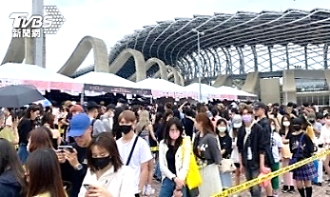
Even Kaohsiung's Mayor, Chen Chi-mai, joined the excitement, announcing that train tickets to the city were sold out on Friday. The city government is rolling out the red carpet for concertgoers, with a special treat for the upcoming Mayday and A-Mei concerts too! They're handing out cool $50 coupons that can be used at local night markets. But remember, these coupons will expire after May 31, so don't miss out on the fun!
★ 取自TVBS

fabulous adj. 極好的； merchandise n. 商品； hop v. 快速去（某地）； snatch v. 搶走； coupon n. 優惠券
46. What is the name of the world tour BLACKPINK is currently on?
(A) Born Pink (B) Pink Nation (C) Pink Man (D) Black Woman
47. The city government is distributing coupons worth how much to concertgoers?
(A) $20 (B) $50 (C) $100 (C) $120
(二)
People who speak different languages may use different sounds for the same things or objects. For example, people who speak Chinese say “Shoo!” to describe a quick move, but people who speak English might use “Whiz!”. What’s more, many people would say “Aiya!” in Taiwan after they make a small mistake, but in English, “Oops!” is used.
Also, people usually say “Ouch!” in the USA when they feel pain, but people in Taiwan may say “Aiyo!”. In Japan, a long “e” sound is often used by people when they find something interesting or surprising, but “Wow!” would be said by most people in Taiwan. There are many other examples. A lot of animal sounds are different in English and Chinese, too. However, English and Chinese have the same sound for one animal. Cats “meow” in both English and Chinese.
object物品; describe描述; pain疼痛
48. What sound might people who speak English use to describe a quick move?
(A) Aiyo! (B) Shoo! (C) Oops! (D) Whiz!
49. When is a long “e” sound used by people in Japan?
(A)When people get hurt. (B)When people make a serious mistake. (C)When people find something interesting.
(D)When people decide to keep a cat.
50. Which is true?
(A)English and Chinese have the same sound for dogs and tigers.
(B)People in the USA often say “Wow!” when they feel pain.
(C)People in Japan use the “Whiz!” sound for scary animals.
(D)In Taiwan, “Aiya!” is used when people make a small mistake.

111-2-2 九年級 英語科－解答
1.B | 2.B | 3.C | 4.C | 5.A | 6.B | 7.A | 8.A | 9.C | 10.B
11.A | 12.C | 13.A | 14.A | 15.B | 16.D | 17.B | 18.B | 19.A | 20.D
21.C | 22.C | 23.D | 24.B | 25.A | 26.C | 27.D | 28.C | 29.B | 30.C
31.B | 32.C | 33.A | 34.A | 35.B | 36.D | 37.A | 38.C | 39.B | 40.D
41.A | 42.C | 43.A | 44.B | 45.D | 46.A | 47.B | 48.D | 49.C | 50.D

新北市立溪崑國民中學111學年度第二學期第二次定期評量
九年級 英語科 聽力測驗稿
一、辨識句意：每題均有三張圖片，請依據所聽到的句子，選出符合描述的圖片
- CD: The fans got excited when they saw the pretty actress arrived at the airport.
(A)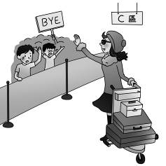 (B)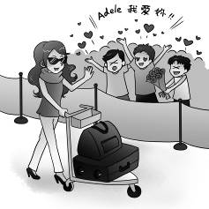 (C)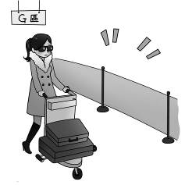
答案：B
- CD: (B:) Some of my friends like to play the drums when they’re free.
(A)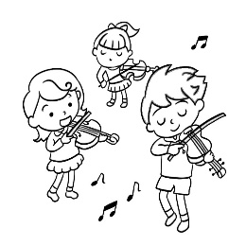 (B)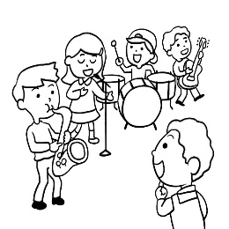 (C)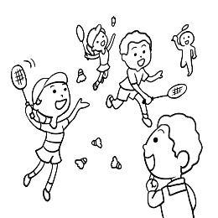
答案：B
- CD: The boy wants to join the gardening club. He is watching the students growing plants.
(A) 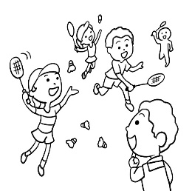 (B)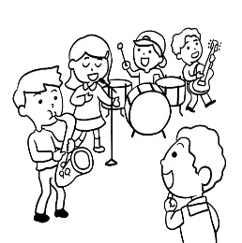 (C) 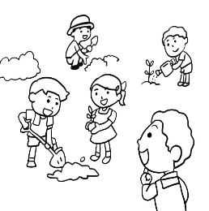
答案：C
- CD: Sam and Meg are good friends. They often share their study notes with each other after school.
(A)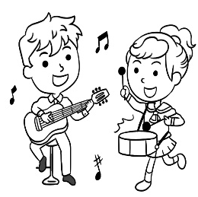 (B)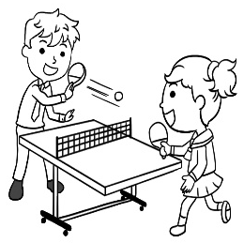 (C)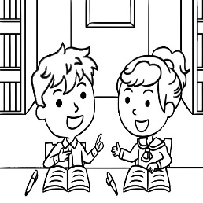
答案：C
- CD: Nate doesn’t know what type of gas is right for his car.
(A) 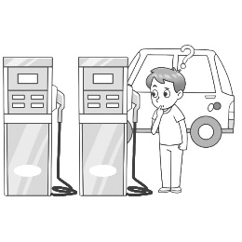 (B)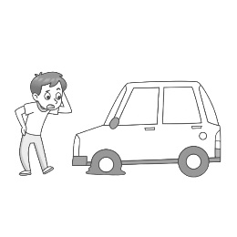 (C) 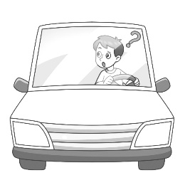
答案：A
- 基本問答：每題均有三個選項，請依據所聽到的內容，選出一個最適合的回應
- CD: Whether Juliet’s dad likes Romeo or not isn’t important to her anymore.
(A) Right! She cares about her dad a lot.
(B) She doesn’t care how her dad feels about Romeo now.
(C) Right! Her dad’s words matter to her. Right!
答案：B
- CD: I can’t believe that we are going to finish senior high school.
(A) Neither can I. Time does fly.
(B) I can’t believe it, either. It’s never too late to make a change.
(C) Me, either. I can’t put up with my junior high school life anymore.
答案：A
- CD: Will you still be my best friend after we left school?
(A) Of course. Let’s make a deal to stay good friends forever.
(B) Yes, I used to be a headache in my family. They always cover for me.
(C) No, you don’t need to pray for me. You should get to where you want to go.
答案：A
- CD: Has David learned a lesson from the mistake?
(A) No, nothing will knock him down.
(B) Yes, he never made any mistakes in spelling.
(C) Yes, he said he would never make the same mistake again.
答案：C
- CD: Being a people person doesn’t mean that you won’t fight back even when people try to knock you down.
(A) I don’t agree. You shouldn’t speak up for your friends.
(B) You can say that again. I will fight back against bad guys.
(C) I agree. I won’t fight back even though Ivy is mean to me.
答案：B
- 言談理解：每題均有三個選項，請依據所聽到的對話與問題，選出一個最適當的答案
- CD: W: Who is the boy next to you in the photo?
B: That’s my friend Jim.
W: He looks handsome. And who’s the girl next to him?
B: That’s Amy. She often helps us correct mistakes in our homework. I’m sad that we are going to different high schools, but I believe we will stay good friends.
Q: What are the boy and the woman looking at?
(A) The boy’s yearbook.
(B) The boy’s workbook.
(C) The boy’s homework.
答案：A
- CD: W: Wow. These red roses are beautiful.
M: Do you like them?
W: Sure. Are you giving them to me?
M: Yes. I’d like to thank you for adding color to my life.
W: Thank you, Jack, but do you know what red roses mean?
M: Of course I do. They mean, “I love you.” Kelly, will you be my girlfriend?
Q: Why does the man give roses to the woman?
(A) Because she loves the color red.
(B) Because she wants to plant some flowers.
(C) Because he wants to show his love for her.
答案：C
- CD: M: Honey, did you throw away my gray tie?
W: Why would I?
M: You never like its color and always want me to throw it away, don’t you?
W: Well, that’s true, but I don’t know where it is. Maybe you dropped it somewhere in the bedroom.
M: Oh, I found it. I’ve already packed it with my other clothes. Sorry. I’m not good at packing.
Q: What is the man doing?
(A) He’s packing.
(B) He’s washing a gray tie.
(C) He’s cleaning his bedroom.
答案：A
- CD: (M:) Students, today is the first day of school. I want you to remember that, in this senior high school, learning and helping each other are more important than getting good grades. I hope you all do your best to create wonderful memories with your classmates and teachers. That’s all. Have a good day!
Q: Which is true about the man?
(A) He wants the students to enjoy their school life.
(B) He is talking to the students in the junior high school.
(C) He thinks getting good grades is the most important thing for the students.
答案：A
15.CD: [Doorbell ringing...]
M: Who’s this?
W: Hi, I’m your new neighbor, Kelly Shaw. I’m not sure if the gray car is yours.
M: Yes. That’s mine. What’s wrong?
W: Could you please move your car? Your car is blocking my garage.
Q: Why did the woman ring her neighbor’s doorbell?
(A) She wanted to sell him her car.
(B) She needed him to move his car.
(C) She needed someone to fix her car. 答案：B

