新北市立溪崑國民中學111學年度第二學期第二次定期評量 英語科 試題卷
八年級 班 座號 姓名
一、聽力測驗30%
(一)辨識句意：每題均有三張圖片，請依據所聽到的句子，選出符合描述的圖片(每題2分，共10分)
- (A) 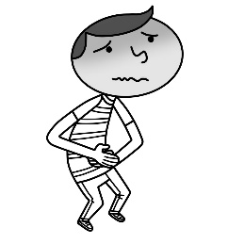 (B) 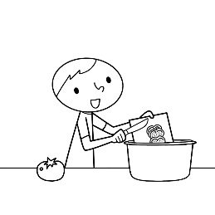 (C) 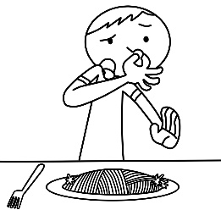
- (A) 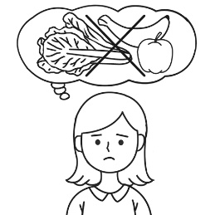 (B) 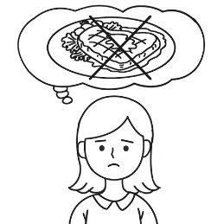 (C) 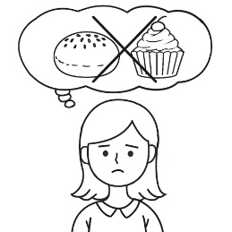
- (A) 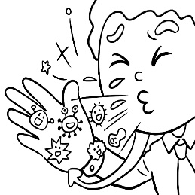 (B) 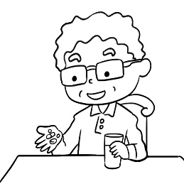 (C) 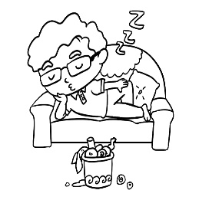
- (A) 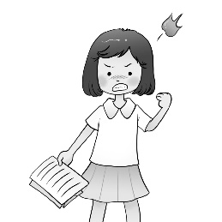 (B) 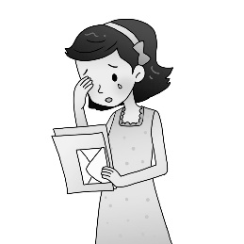 (C) 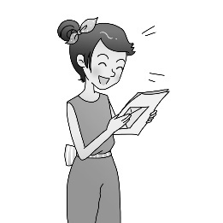
- (A) 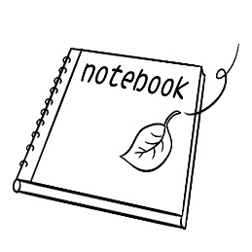 (B) 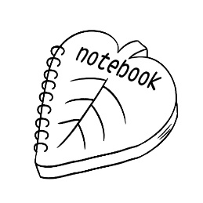 (C) 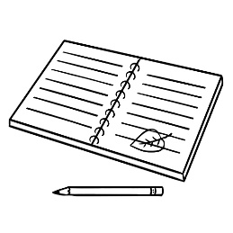
(二)基本問答：每題均有三個選項，請依據所聽到的內容，選出一個最適合的回應(每題2分，共10分)
- (A) Nothing serious. My team won the game.
(B) The food smells good. Do you want to have a bite?
(C) I fell down and bit my lip（嘴唇）
- (A) Does it even matter?
(B) Yes. Let’s call the police.
(C) Yes. He’s very friendly.
- (A) They plan to arrive at the campsite at noon.
(B) The moon is shining brightly. How beautiful!
(C) They are looking at the starry sky and counting stars.
- (A) They all dance better than you.
(B) You just need to practice harder.
(C) You can cheer loudly for them at the end of the game.
- (A) It was Kenny. He closed the door loudly.
(B) It must be Emma. She is not able to jump high.
(C) Jason did. He was the best singer at the party last night.

(三)言談理解：每題均有三個選項，請依據所聽到的對話與問題，選出一個最適當的答案(每題2分，共10分)
- (A) She looks like Vicky.
(B) She’s as friendly as Vicky.
(C) She looks very different from Vicky.
- (A) The woman likes to eat meat.
(B) The man will probably order steak.
(C) The man and the woman are talking on the sidewalk.
- (A) He’s a delivery driver.
(B) He’s a mail carrier.
(C) He’s a postman.
- (A) He’s making a fire.
(B) He’s trying to dry the leaves.
(C) He’s collecting leaves.
- (A) Get on the bus.
(B) Count the students.
(C) Check the campsite.

二、綜合測驗22%
16.Tina: Wow, your room is purple! You’re really a purple fan.
Ella: Yeah, it’s my favorite color. It makes me comfortable when I’m in my room.
(A) feel (B) look (C) smell (D) taste
17. Jack: Mom, where did you get the watermelon? It water. It isn’t sweet at all.
Mom: Really? I’ll tell the seller of that stand about it tomorrow.
(A) looks (B) looks like (C) tastes (D) tastes like
18. The weather hotter and hotter. We don’t need heavy coats any more.
(A) is getting (B) became (C) got (D) looks like
19. Our teacher asked us volleyball every day for the coming game, and this made us so tired.
(A) practice ; getting (B) to practice ; to get (C) to practice ; get (D) practicing ; get
20. My favorite food is stinky tofu. It really smells to me.
(A) worse (B) well (C) like good (D) good
21. If we want to drink the water from the river, it first , or we may have a stomachache.
(A) boil (B) carry (C) count (D) burn
22. Stella and fell over when she got off the bus. Luckily, she didn’t get hurt seriously.
(A) packed (B) clapped (C) tripped (D) collected
23. Andy ran , so his teacher wanted him to join the school team for the running race（比賽）in 2023.
(A) the fastest at his school (B) as slowly as his classmates did
(C) as fast as all his classmates did (D) slower than all students did
24. No one can sing than Elaine. I can’t think of anyone with a voice.
(A) more beautiful ; good (B) more beautifully ; good (C) more beautiful ; better (D) more beautifully ; better
25. More and more students stay online for long hours. Parents should take the problem than they did before.
(A) more seriously (B) serious (C) more serious (D) the most seriously
26. Mothers’ Day is on May fourteenth this year. We had a big dinner on that day.
(A) happy (B) happily (C) much happily (D) more happy

三、克漏字測驗8%
Behind the Colors of a Restaurant Sign
Some people may go to a restaurant because its food tastes great. (27) people may go there because it (28) a nice place. Still others may go there because of the colors of its store sign. For example, many fast food restaurants use red in their signs because red invites people into the stores. The color helps the restaurants (29) brighter and friendlier. Besides, when people see the color , they will become hungry and perhaps go in for a bite. (30) . For example, some fast food restaurants use green in their signs. For most people, the color stands for nature, and that makes them feel more comfortable when they have their meals. In the restaurant business, colors really matter.
27.(A) Others (B) Another (C) Other (D) The others
28. (A) looks like (B) looks (C) doesn’t look like (D) doesn’t become
29. (A) see (B) look like (C) looking (D) look
30. (A) The smell of the food is good. (B) Other colors are popular, too.
(C) It sounds great to have lunch there. (D) They use the same color.

四、閱讀測驗16%
(一) BLACKPINK Craziness in South Taiwan
Lights, camera, action! It's BLACKPINK time! Have you heard of the wonderful K-pop girl group? They’re called “BLACKPINK” and they have four members. They arrived in Taiwan for their great "Born Pink" world tour. Their beautiful tunes and great performances made the fans in Taiwan go crazy, made them rush to buy all the cool BLACKPINK merchandise they can find.
Kaohsiung, a happy city in the south of Taiwan, hosted BLACKPINK's concerts on Saturday (March 18) and Sunday night at the cool Kaohsiung National Stadium. The members and their helpers hopped on a flight from Gimpo International Airport in Korea and arrived at Kaohsiung International Airport around noon on Saturday.
But the real party began before the concerts! Crazy fans formed a huge 1-kilometer-long line to get the hottest BLACKPINK items like trendy clothes, cute key chains, and stylish handbags. The first fan in line, a super fan, started waiting at midnight and spent NT$20,000 on BLACKPINK treasures.
Even Kaohsiung's Mayor, Chen Chi-mai, joined the excitement, announcing that train tickets to the city were sold out on Friday. The city government put the red carpet for concertgoers, with a special treat for the upcoming Mayday and A-Mei concerts, too! They were also handing out cool $50 coupons that can be used at local night markets. But remember, these coupons can be used till May 31, so don't miss out on the fun!
Word bank: merchandise n. 商品 coupon n. 優惠券
31. What is the name of the world tour BLACKPINK is currently on?
(A) Born Pink (B) Pink Nation (C) Pink Man (D) Black Pink
32. The city government distributed coupons worth how much to concertgoers?
(A) $20 (B) $50 (C) $60 (D) $100
33. Which is right?
(A) BLACKPINK's concert took place in the northern part of Taiwan.
(B) Kaohsiung's Mayor, Chen Chi-mai, didn’t join the concert.
(C) Fans formed a 1-kilometer-long line to buy BLACKPINK merchandise.
(D) There are six members in BLACKPINK.
34. What types of merchandise did fans line up to purchase at the BLACKPINK concert?
(A) Cute key chains. (B) Lovely cookies. (C) Pink shoes. (D) Books about Black Pink.

(二)
Ugly Food
“Look! This strawberry has a big nose.”
“Ha! These apples look funny.”
“Let’s buy them to make some juice today.”
My children are shopping happily in a fruit and vegetable store, and I can hear them talking about each strange-looking fruit. They enjoy doing this.
The fruit and vegetables here are cheaper because they don't look good.
“Supermarkets don’t want to sell them, so farmers would just throw them away. What a waste”, said the shopkeeper. “Look at them. They are perfectly fresh and taste just as delicious as more beautiful produce. So, I thought of the idea of opening this store”, she said proudly.
Farmers won’t lose money from having to throw away ugly fruit and vegetables, and customers don’t need to spend more money on beautiful fruit and vegetables. Look at my kids. They love digging out the most strange-looking fruit in the store to make yummy juice for our family because we are just fine with the “ugly” food.
Word bank: shopkeeper 店主 produce 農產品
35. The writer’s children like the shopkeeper’s idea of opening a store to sell ugly food. They made a poster to promote sales. What’s the best slogan(標語) for it?
(A) Give It a Try. Our fruit is the most beautiful & cheapest.
(B) Buy Us & Eat Us. We may look ugly, but we are yummy & healthy.
(C) Big Sale. Come to enjoy our fruit.
(D) New Open. Our shop sells the best fruit.
36. What can we learn about the store from the reading?
(A) It can help both farmers and customers.
(B) People can enjoy delicious juice there.
(C) It is an interesting playground.
(D) People can only find beautiful-looking food there.
(三)
Climate Change
What is climate change?
When we talk about climate change, we mean how the Earth’s temperature is getting hotter because of human activities. It’s normal for the climate on Earth to change over time. It’s not normal for the Earth’s climate to change quickly. Like it is now.
Why is the Earth getting hotter?
When we use cars, planes, factories and electricity, it puts carbon into the air. Carbon traps heat the Earth’s atmosphere. This makes the Earth and our oceans a lot hotter, and puts nature out of balance.
Why does it matter if the planet gets hotter?
When you are sick with a temperature, you don’t feel well. It’s the same for the planet. If it’s too hot on the planet, the iceberg will melt and the sea will rise. The weather will also change. This means that there could be more disasters like droughts, bushfires or tsunamis. Some people will have to leave their homes for a safer place.
What can we do to stop climate change?
There are lots of things we can do to stop climate change. We can use more public transport, fewer cars and planes. We can use cleaner energy and look after our oceans and green spaces. We can buy less, share more and recycle.
How can I help to stop climate change?
The good news is there are so many ways you can help. You can save water and electricity. Walk or ride to school if you can. Eat plenty of fruit, grains and vegetables. Turn food scraps into garden compost and worm food. Plant a garden big or small. Most importantly, go outdoors and enjoy the wonders of nature.
37. What will happen if the planet gets hotter?
(A) It doesn’t matter at all. (B) There will be fewer cars and planes.
(C) The weather will be the same. (D) The iceberg will melt and the sea will rise.
38. What can we learn from the reading?
(A) There are few ways we can help to stop climate change.
(B) There could be more disasters like earthquakes if the planet gets hotter.
(C) We should go outdoors and enjoy the wonders of nature to love our planet.
(D) It’s very normal for the Earth’s climate to change quickly.

以下答案請寫在答案卷上
五、翻譯24%
(A)中翻英(4%)
1. 漢堡 | 2. 人行道 | 3. 抵達 | 4.草地
(B) 整句翻譯 (一句5分)
- 我們可以點任何東西且不必擔心增加體重。
- 許多速食餐廳在它們的招牌上使用黃色，因為黃色使人們感到快樂。
- 我們必須努力練習，否則我們將不能在大家面前跳得很好。
- 派對後，我們在星光閃耀的天空下分享了我們對未來的夢想。

--------------試題到此結束---------------

新北市立溪崑國民中學111學年度第二學期第二次定期評量 英語科 答案卷
八年級 班 座號 姓名
五 、翻譯:24％
(A)中翻英(4%)
1. 漢堡 | 2. 人行道 | 3. 抵達 | 4.草地

(B) 整句翻譯 (一句5 ,共20 分)
- 我們可以點任何東西且不必擔心增加體重。

- 許多速食餐廳在它們的招牌上使用黃色，因為黃色使人們感到快樂。

- 我們必須努力練習，否則我們將不能在大家面前跳得很好。

- 派對後，我們在星光閃耀的天空下分享了我們對未來的夢想。

111-2-2 八年級 英語科－解答

一~四 (2%)
1 | 2 | 3 | 4 | 5 | 6 | 7 | 8 | 9 | 10
C | C | A | C | B | C | B | C | B | A
11 | 12 | 13 | 14 | 15 | 16 | 17 | 18 | 19 | 20
A | B | A | C | B | A | D | A | C | D
21 | 22 | 23 | 24 | 25 | 26 | 27 | 28 | 29 | 30
A | C | A | D | A | B | C | A | D | B
31 | 32 | 33 | 34 | 35 | 36 | 37 | 38
A | B | C | A | B | A | D | C

五 、翻譯:24％
(A)中翻英(4%)
1. 漢堡 | 2. 人行道 | 3. 抵達 | 4.草地
Hamburger(burger) | sidewalk | arrive | grass
(B) 整句翻譯 (一句5分)
- 我們可以點任何東西且不必擔心增加體重。
We can order anything and don’t have to worry about putting on weight.
- 許多速食餐廳在它們的招牌上使用黃色，因為黃色使人們感到快樂。
Many fast food restaurants use yellow in their signs because yellow makes people feel happy.
- 我們必須努力練習，否則我們將不能在大家面前跳得很好。
We have to practice hard, or we won’t be able to dance well in front of everybody.
- 派對後，我們在星光閃耀的天空下分享了我們對未來的夢想。
After the party, we shared our dreams for the future under the starry sky.

新北市立溪崑國民中學111學年度第二學期第二次定期評量
八年級 英語科 聽力測驗稿
一、辨識句意：每題均有三張圖片，請依據所聽到的句子，選出符合描述的圖片。
- 《腳本區》
CD: The boy doesn’t want to eat the food because it smells bad.
《題目區》
(A) (B) (C)
《答案區》
答案：C
題號：A04L3169
- 《腳本區》
CD: Mary wanted to lose some weight, so she decided not to eat anything sweet.
《題目區》
(A) (B) (C)
《答案區》
答案：C
題號：A04L3170
- 《腳本區》
CD: Tim got sick and didn’t feel well.
《題目區》
(A) (B) (C)
《答案區》
答案：A
題號：A04L3212
- 《腳本區》
CD: Sarah laughed loudly when she read the letter from her brother in the USA.
《題目區》
＿＿＿
(A) (B) (C)
《答案區》
答案：C
題號：A04L4166
- 《腳本區》
CD: Whose notebook is it? It’s in the shape of a leave.
《題目區》
＿＿＿
(A) (B) (C)
《答案區》
答案：B
題號：A04L4211
二、基本問答：每題均有三個選項，請依據所聽到的內容，選出一個最適合的回應。
- 《腳本區》
CD: What’s the matter? Why are you crying?
《題目區》
(A) Nothing serious. My team won the game.
(B) The food smells good. Do you want to have a bite?
(C) I fell down and bit my lip（嘴唇）.
《答案區》
答案：C
題號：A04L3062
- 《腳本區》
CD: Did you notice the strange man at the gate? He followed me all the way here.
《題目區》
(A) Does it even matter?
(B) Yes. Let’s call the police.
(C) Yes. He’s very friendly.
《答案區》
答案：B
題號：A04L3069
- 《腳本區》
CD: What are those people doing on the grass?
《題目區》
＿＿＿
(A) They plan to arrive at the campsite at noon.
(B) The moon is shining brightly. How beautiful!
(C) They are looking at the starry sky and counting stars.
《答案區》
答案：C
題號：A04L4065
- 《腳本區》
CD: How can I dance as well as they do?
《題目區》
＿＿＿
(A) They all dance better than you.
(B) You just need to practice harder.
(C) You can cheer loudly for them at the end of the game.
《答案區》
答案：B
題號：A04L4080
- 《腳本區》
CD: The noise woke us up in the middle of the night. Who made it?
《題目區》
＿＿＿
(A) It was Kenny. He closed the door loudly.
(B) It must be Emma. She is not able to jump high.
(C) Jason did. He was the best singer at the party last night.
《答案區》
答案：A
題號：A04L4205
三、言談理解：每題均有三個選項，請依據所聽到的對話與問題，選出一個最適當的答案。
- 《腳本區》
CD: M: What do you think about Nina?
G: With the red hair and big eyes, she looks just like another Vicky.
B: Not really. She’s much taller than Vicky. Besides, she’s more friendly.
M: You’re probably right.
Q: Which is true about Nina?
《題目區》
(A) She looks like Vicky.
(B) She’s as friendly as Vicky.
(C) She looks very different from Vicky.
《答案區》
答案：A
題號：A04L3091
- 《腳本區》
CD: M: You must try the steak. The restaurant has the most delicious steak in town.
W: But I don’t eat beef.
M: Why?
W: My father thinks eating beef will bring the whole family bad luck.
M: Really? Then what do you want to eat?
W: I’ll have vegetable pizza and bean soup.
M: OK. Excuse me, we are ready to order…
Q: What can we learn from the talk?
《題目區》
(A) The woman likes to eat meat.
(B) The man will probably order steak.
(C) The man and the woman are talking on the sidewalk.
《答案區》
答案：B
題號：A04L3092
- 《腳本區》
CD: [Doorbell ringing...]
M: Hi, Panda Food. Here’s your pizza.
W: Pizza? You brought me the wrong order. I ordered fried chicken and hamburgers.
M: Aren’t you Anna Shaw of 3rd floor, number 12?
W: No, it’s next door.
M: Oops, I’m sorry.
Q: What does the man do?
《題目區》
(A) He’s a delivery driver.
(B) He’s a mail carrier.
(C) He’s a postman.
《答案區》
答案：A
題號：A04L3101
- 《腳本區》
CD: W: What is the old man going to do with so many leaves?
M: Is he going to make a fire with them?
W: But those leaves are wet.
M: He will probably dry them first.
Q: What is the old man doing?
《題目區》
＿＿＿
(A) He’s making a fire.
(B) He’s trying to dry the leaves.
(C) He’s collecting leaves.
《答案區》
答案：C
題號：A04L4098
- 《腳本區》
CD: (M:) Listen up, everyone. Each class has to leave two students to check the campsite. As for the others, take your bags and go east to the parking lot quickly. The school buses are arriving in ten minutes. Be ready to get on the bus. Teachers, count your students after they get on the bus and report to me. Now, let’s move.
Q: What does the man want the teachers to do?
《題目區》
＿＿＿
(A) Get on the bus.
(B) Count the students.
(C) Check the campsite.
《答案區》
答案：B
題號：A04L4209

