新北市立溪崑國民中學111學年度第二學期第三次定期評量 英語科 試題卷
八年級 班 座號 姓名
一、聽力測驗30%
辨識句意：每題均有三張圖片，請依據所聽到的句子，選出符合描述的圖片(每題2分)
- (A) 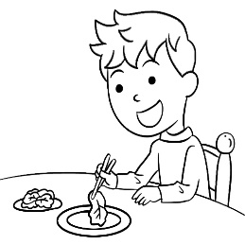 (B) 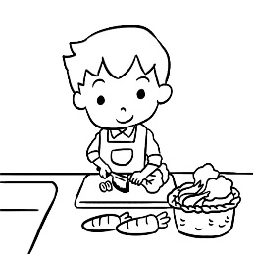 (C) 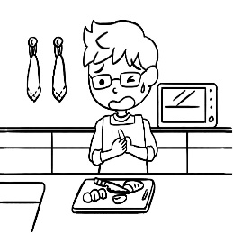
- (A) 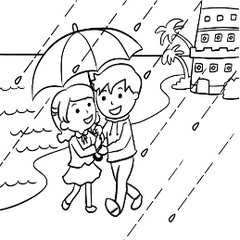 (B) 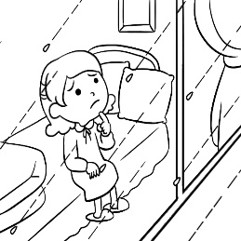 (C) 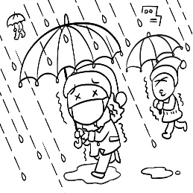
- (A)  (B)  (C) 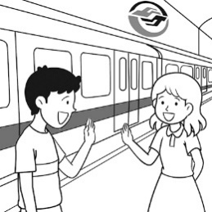
- (A) 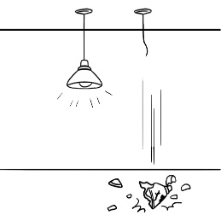 (B) 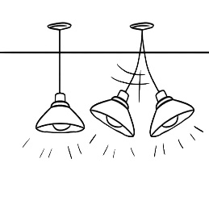 (C) 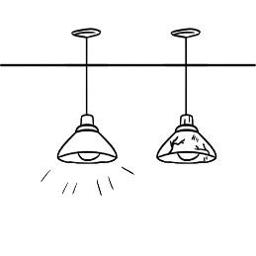
- (A) 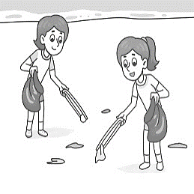 (B) 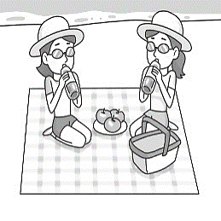 (C) 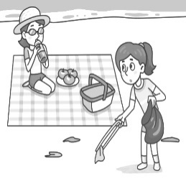
基本問答：每題均有三個選項，請依據所聽到的內容，選出一個最適合的回應 (每題2分)
- (A) You can’t hide there alone.
(B) I think you should be honest and tell her.
(C) Cover your head with your hands.
- (A) Yes, I tried the fish and it was delicious.
(B) Yes. We caught it in the deep ocean by ourselves.
(C) No. Someone gave me this picture as a birthday gift.
- (A) Correct. He’s the most famous writer in my country.
(B) You’re right. He is popular with teenagers.
(C) That’s true. Though he isn’t very famous, I enjoy reading his books.
- (A) The cake in the shape of a panda looks cute.
(B) They will no longer use eggs to make cakes.
(C) How much sugar should I add?
- (A) Thanks. You’re the best.
(B) Perhaps you should do it yourself.
(C) That’s enough. I can’t take it anymore.
言談理解：每題均有三個選項，請依據所聽到的對話與問題，選出一個最適當的答案(每題2分)
- (A) The girl’s mom is sick, so she needs medicine.
(B) The girl asks for help from her brother.
(C) The medicine’s taste is better than its smell.
- (A) The water is not deep.
(B) It’s dangerous for kids to swim in the river now.
(C) Swimming in it is unsafe for the woman.
- (A) She left her dog in the car alone.
(B) She broke the window and saved the dog.
(C) She shared a news story.
- (A) Throw away the cake.
(B) Finish most of the cake.
(C) Give the man the fruit on the cake.
- (A) She doesn’t want to clean the house for him.
(B) He brushes his teeth every two days.
(C) He is too popular with girls.

二、綜合語法 34% (每題2分)
16. Bella fell off her bike and got hurt badly yesterday. She can’t walk well now. Let’s take the _____ with her.
(A) shelf (B) elevator (C) fork (D) plates
17. Scott likes being _____ sometimes. He enjoys the music quietly in his own room.
(A) deep (B) abroad (C) alone (D) correct
18. Mission: Impossible is an American action movie. Tom Cruise is the _____ actor in this movie. I can’t wait to see the movie
Mission: Impossible – Dead Reckoning Part One this July 17th.
(A) land (B) sincerely (C) instead (D) leading
19. Some of the plastic straws may _____ in the ocean and in a turtle’s nose.
(A) as a result (B) stand for (C) make it up (D) end up
20. Turtles can’t ____ plastic bags _____ jellyfish, so they often eat these bags and die.
(A) break; down (B) hold; on (C) tell; from (D) push each other
21.The Olympic Games will be the biggest sports ____ in Paris in 2024.
(A) event (B) even (C) ever (D) enter
22. It’s time to _____ to save the ocean and the environment. We should use fewer plastic bags.
(A) hang out (B) enjoy yourself (C) take action (D) rub against
23. If students play interesting games in class, there ____ more fun in learning English.
(A) are (B) will (C) will be (D) will have
24. Although Ann and Paul sing well, ____ of my friends sings better than them.
(A) but one (B) but many (C) one (D) most
25. Not all of the fried chicken on the table ____ for you. Some of ____ for Bella.
(A) is; it is (B) are; them are (C) is ; they are (D) are; them are
26. Boys and girls, just help ＿＿＿ to all the food and drinks on the table. Let’s enjoy the party.
(A) ourselves (B) yourself (C) themselves (D) yourselves
27. _____ of the people in poor countries don’t have clean water to drink. They still need help.
(A) One (B) Both (C) Little (D) Most
28. Dad hurt ____ when he fixed my bike yesterday, and we sent ____ to the hospital right away.
(A) he; him (B) himself ; him (C) him ; he (D) himself ; he
29. Not only Ted but also Josh ＿＿＿ for long hours to make ＿＿＿ ready for the exam. Both of them are hard-working students.
(A) study; himself (B) study; themselves (C) studies; himself (D) studies; themselves
30. People got very excited when they saw Jensen Huang, Nvidia CEO, _____up suddenly at the night market in Taipei.
(A) shows (B) showing (C) were showing (D) to show
31. A: I bring my own chopsticks and spoon whenＩeat out. B: ____
(A) Really? It costs an arm and a leg.
(B) Why bother? It’s not convenient at all.
(C) Poor you. Don’t you have something more delicious?
(D) No way! Why don’t you use metal ones?
32. Rick: What’s wrong with Leo? He looked at me sadly this morning.
Ruby: He failed the final exam. Even worse, he just lost his dog last night.
Rick:_____
(A) Good for him. He won’t talk to himself anymore.
(B) No kidding. I followed your example.
(C) The missing dog would be the last straw for him.
(D) Don’t be angry. I see your point. (下一頁仍有試題)
三、克漏字26% (每題2分)
Dad : How was the baseball game last night, Lisa?
Lisa : Well, 33 of my friends liked it, but I don’t really enjoy it. In fact, I love basketball more.
I am a big fan of Jeremy Shu-how Lin.
Dad : I see. Then, how about your dinner at Kua-Aina,the famous burger restaurant?
Lisa : It was nice. 34 of the food there tasted great though most of 35 was expensive. 36 of us only ordered a burger
without drinks, and it cost NT$330.
Dad : Oh, man! It really cost a lot!
33. (A) most (B) much (C) both (D) every
34. (A) All (B) Many (C) One (D) Several
35. (A) them (B) it (C) they (D) that
36. (A) Every (B) Both (C) Every one (D) Little

Fun Facts about Jellyfish
Jellyfish live in water. Some of them live in fresh water, and 37 . All their bodies are nearly transparent. Although the word ”fish” is in their name, they are in fact not fish. They are animals without backbones.
Most jellyfish don’t hurt people. Some, however, are very dangerous. Stings from the box jellyfish, for example, are very poisonous and can kill people in a few minutes. It’s better to 38 if you don’t know their species.

transparent 透明的 sting 叮咬poisonous 有毒的species種類
37. (A) most of them can’t swim
(B) all of them are from the ocean
(C) some of them look like plastic bags
(D) many of them live in the ocean
38. (A) be the last straw
(B) keep away from them
(C) take a long time to break down
(D) make it up

What is technology?
When you think of technology, what do you think of ? A telephone, or a camera? But what about a table or a chair? Would you consider that’s technology? Let’s investigate to find out. In the dictionary, technologies are things created by humans that can solve problems. All humans have basic needs such as getting water and having shelter. Technology is a way to 39 them easier.
40 going down to the lake to get water, human invented a way to bring it straight to our houses with indoor plumbing. Some technologies have wires and plug into the wall like tape recorders. Tape recorders help to 41 sound. Laptops help us get information. Some technologies do not have wires at all. Umbrellas help us keep dry in the rain and locks help us keep our things
42 . A pencil helps us write down information and a fork helps us to eat food. So let’s go back to our first question, is a chair or a table technology?
investigate 調查 shelter 庇護所 plumbing 管路wire 電線laptop 筆記型電腦
39. (A) have (B) let (C) get (D) make
40. (A) On the other hand (B) End up (C) Even worse (D) Instead of
41. (A) record (B) climb (C) correct (D) cover
42. (A) safe (B) save (C) scene (D) starry

Speaking Up for the Earth
Greta Thunberg, is from Sweden. She’s a(n) 43 activist.
Greta first learned about climate change in elementary school. She saw a video that showed extreme weather and flooding. Her teacher explained that these were because of climate change. This made Greta worried.
In August 2018, Greta Thunberg skipped school. She sat outside one of Sweden’s main government buildings with a 44 . It said “School Strike for Climate,” in Swedish. Greta was protesting. She was speaking out for the future of the planet. And she was doing it alone. The next day, one person joined Greta in her strike. “That was a big step, from one to two,” Greta told TIME. Then a few more joined her. Then came hundreds of people. Then came thousands. The young activist had sparked a movement.
Today, Greta gives speeches and meets with world leaders. She demands that people take action to protect Planet Earth. She has inspired millions of others to protest for 45 .

Sweden 瑞典 activist 行動份子 flooding 洪水 climate 氣候 extreme 極端
skipped school翹課 strike 罷工 protesting抗議 inspire鼓舞
43. (A) environmental (B) fashionable (C) disposable (D) comfortable
44. (A) scene (B) sign (C) metal (D) shake
45. (A) the past of our Earth (B) the age of the planet (C) the future of the Earth (D) the moment of the flooding
(背面仍有試題)

四、閱讀測驗 10% (每題2分)
Will we be able to go to space in the future? In the past, only astronauts could go onto spaceships. Now, companies in the USA are making spaceships and planning tours to space for people who have lots of money.
In the U.S., there are 3 companies that will soon have space tours. One of the companies is called Blue Origin. Their customers will spend 11 minutes in space. However, the ticket will cost 2.8 million US dollars. The company’s goal is to have 1 trillion people living in outer space.
Another company is Virgin Galactic. Customers can experience floating in space for 6 minutes. However, they need to go through training at NASTAR(the National Aerospace Training and Research Center). They will learn about how to stay safe in space.
The third company is SpaceX, which will send their customers to the International Space Station. SpaceX also plans to send people to the Moon and Mars.
astronaut 太空人 spaceship 太空船company 公司 customer 顧客 goal 目標trillion兆 float 漂浮 Mars 火星
46. Which is true about space tour?
(A) It takes 11 minutes to go to space from the Earth.
(B) SpaceX will send people to the International Space Station.
(C) Blue Origin will give people 2.8 million US dollars to go to space.
(D) Virgin Galactic owns the National Aerospace Training and Research Center.
47. Where can you probably find this reading?
(A) In the news.
(B) In the menu.
(C) In the cookbook.
(D) In the storybook.
48. What might be the best title?
(A) Life on the Moon
(B) Spaceships and Astronauts
(C) Space Stations Cost a Lot
(D) Fly me into space

ChatGPT: The Cool AI Robot That Talks Like Us
Imagine having a robot friend that could talk and help you with anything you need. Meet ChatGPT, a smart computer program created by OpenAI. It can chat, answer questions, and even help you with your homework. It's a helpful friend on your computer or phone.
ChatGPT is really good at using languages. It can learn and think like humans. This means ChatGPT can talk to you in a way that is easy and fun to understand. You can ask it questions, and it will give you answers that you can understand.
Open AI’s ChatGPT is not just for talking. It can help you with your homework, give you ideas for writing, and even make your video games more interesting. Teachers and students love ChatGPT because it can explain things in simple words.
ChatGPT is changing the way we use computers. Before, we had to learn how to talk to computers using special commands. These commands were special computer languages, and you had to study for a long time to understand them. But now, we just chat with computers like we do with our friends. This makes using computers more fun and enjoyable.
So, next time you need help or want to have a fun chat, remember that ChatGPT is here to help you. Just like Internet before and Google, ChatGPT is a new and exciting tool we can use for many things. The future of communication is exciting, and it's happening right now!

program 程式 provide 提供; simple 簡單的；powerful 強大的；human 人類；command 命令；communication傳達；通訊
49. Who created ChatGPT?
(A) Microsoft.
(B) Google.
(C) Open AI.
(D) Apple.
50. Which is Not true about ChatGPT?
(A) ChatGPT can answer questions in simple words.
(B) ChatGPT can help you with homework.
(C) ChatGPT is changing the way we use computers.
(D) ChatGPT explains things in difficult ways. (試題結束)

111-2-3 八年級 英語科－解答
1-5 CBBAC 6-10 BCCCA
11-15 BAAAC 16-20 BCDDC
21-25 ACCCA 26-30 DDBCB
31-35 BCAAB 36-40 CDBDD
41-45 AAABC 46-50 BADCD

新北市立溪崑國民中學111學年度第二學期第三次定期評量
八年級 英語科 聽力測驗稿

一、辨識句意：每題均有三張圖片，請依據所聽到的句子，選出符合描述的圖片
- 《腳本區》
CD: The man wanted to eat something, but he hurt himself when he was preparing food.
《題目區》
＿＿＿《答案區》
答案：C
難易度：中
題號：A04L5169
- 《腳本區》
CD: The woman watched the rain falling through the windows.
《題目區》
＿＿＿《答案區》
答案：B
難易度：中
題號：A04L5180
- 《腳本區》
CD: Paul and Mary are going to have a date. They will meet outside the metro station instead of the movie theater.
《題目區》
＿＿＿《答案區》
答案：B
難易度：難
題號：A04L6178
- 《腳本區》
CD: One of the lights fell down and broke into pieces during the earthquake.
《題目區》
答案：A
難易度：中
題號：A04L6174
- 《腳本區》
CD: Mary and Cathy had a picnic at the beach. Only one of them picked up the trash when they saw some there.
《題目區》《答案區》
答案：C
難易度：中
題號：A04L6211
二、基本問答：每題均有三個選項，請依據所聽到的內容，選出一個最適合的回應
- 《腳本區》
CD: I broke Betty’s favorite glass. Do you have a safe place for me to hide myself?《答案區》
答案：B
難易度：難
題號：A04L5080
- 《腳本區》
CD: Wow. This jellyfish is beautiful. Did you draw it by yourself?
《題目區》
答案：C
難易度：難
題號：A04L6063
- 《腳本區》
CD: Very few people know the writer, right?
《題目區》
答案：C
難易度：難
題號：A04L6065
- 《腳本區》
CD: If you want to make the cake taste better, you should add some sugar.
《題目區》《答案區》
答案：C
難易度：中
題號：A04L6203
- 《腳本區》
CD: Don’t bother doing the dishes, Sophie. I’ll do it.
答案：A
難易度：中
題號：A04L6201
三、言談理解：每題均有三個選項，請依據所聽到的對話與問題，選出一個最適當的答案
- 《腳本區》
CD: B: Hey! I heard you crying. What’s wrong?
G: Can I hide under your bed for just one minute, please? I’m hiding from Mom.
B: Did you do something wrong again?
G: No. Mom’s asking me to take medicine. The medicine not only smells bad but also tastes terrible.
Q: Which is true?
答案：B
難易度：中
題號：A04L5100
- 《腳本區》
CD: W: Is it safe to swim in the river now?
M: It’s hard for you to do so because the water isn’t deep enough.
W: Really?
M: It’s the dry season, so the water is only knee-deep.
W: Wow. So, my kids can have fun here.
M: Sure. Just don’t leave them alone, and always watch them carefully.
Q: Which is true about the river?《答案區》
答案：A
難易度：中
題號：A04L5108
- 《腳本區》
CD: W: Lauren almost killed her dog by leaving it in the car today.
M: What? How?
W: It was very hot. The car windows were closed. The dog wasn’t able to open the doors of the car by itself, so it got sick.
M: Is her dog safe now?
W: Luckily, someone walked by and broke the window to save it. It is safe and is taking a rest in Lauren’s house now.
Q: What did Lauren do?《答案區》
答案：A
難易度：難
題號：A04L5206
- 《腳本區》
CD: W: Jason, didn’t you put the cake in the fridge last night?
M: Oops! I forgot.
W: Now I have to put it in the trash can.
M: Don’t waste it. The fruit on it smells OK. We can still eat it.
W: No. Please don’t do that.
Q: What is the woman going to do?答案：A
難易度：難
題號：A04L6095
- 《腳本區》
CD: W: I’m breaking up with Jim.
M: Why?
W: He doesn’t like to clean his house and himself. He doesn’t take a shower or brush his teeth every day.
M: I can’t believe it. He looks great, and all of the girls like him.
W: You’re right. Too many girls like him, and he enjoys that. I can no longer stand it, either.
M: Well, it sounds like the last straw.
Q: Why does the woman want to break up with Jim?《答案區》
答案：C
難易度：中
題號：A04L6096

