新北市立溪崑國民中學111學年度第二學期第一次定期評量 英語科 試題卷
九年級 班 座號 姓名
一、聽力測驗
- (A)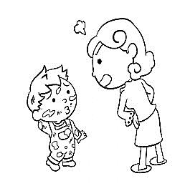 (B)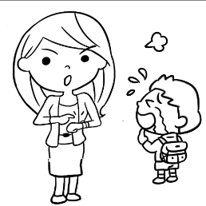 (C)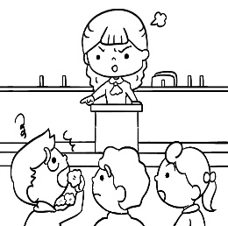
- (A)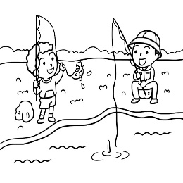 (B)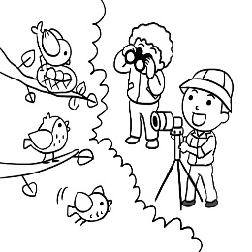 (C)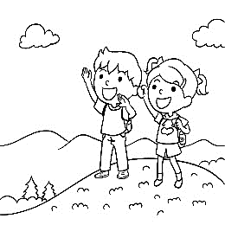
- ＿＿＿
(A)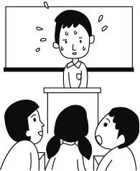 (B)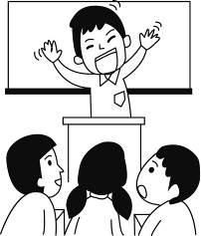 (C)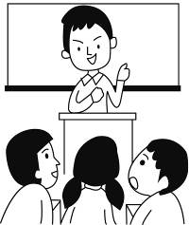
- ＿＿＿
(A)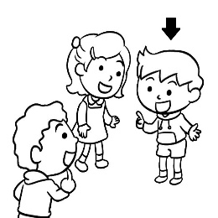 (B)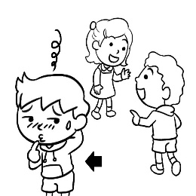 (C)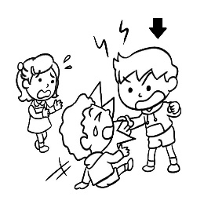
- ＿＿＿
(A)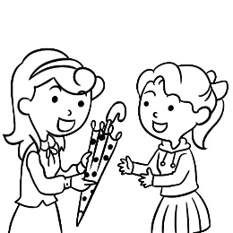 (B)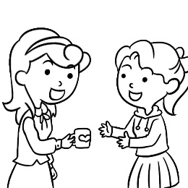 (C)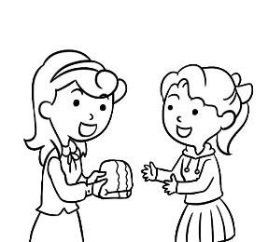
二、基本問答：每題均有三個選項，請依據所聽到的內容，選出一個最適合的回應
- (A) I’m so proud of you.
(B) You should tell him as soon as you find out the truth.
(C) You should check again before you hand in your report next time.
- (A) Yes, as soon as you spot an error.
(B) Yes, as long as you list the source.
(C) Yes, as long as you don’t smoke here.
- (A) That’s terrible. Why did she trust him?
(B) That’s terrible. Why did she do that?
(C) That’s terrible. Why did her husband attack her?
- (A) Sorry, I will change the umbrella for you.
(B) So do I. Don’t forget to bring it back to me.
(C) Neither do I. I got this one from Enid.
- (A) Sorry, I’m a stranger here myself.
(B) Sorry, I didn’t know you felt that way.
(C) Sorry, I ran into heavy traffic near the train station.
三、言談理解：每題均有三個選項，請依據所聽到的對話與問題，選出一個最適當的答案
- (A) Because the teacher spotted many errors in the boy’s report.
(B) Because the information in the boy’s report wasn’t from a trusted source.
(C) Because the teacher found that the boy copied from Ashely’s report.
- (A) Because he isn’t a trusted person. (B) Because he is one of their neighbors. (C) Because he often smokes.
- (A) The woman will eat in another restaurant, and so will the man.
(B) The woman will leave for another restaurant, but the man won’t.
(C) Both the man and the woman will keep waiting in the restaurant.
- (A) Bonding humor. (B) Put-down humor. (C) Hate-me humor.
- (A) She doesn’t want to meet any of her friends.
(B) She doesn’t like to talk to people she doesn’t know.
(C) She doesn’t want to be with the man the whole time.
二、綜合選擇
- A _____ knife does an excellent job of cutting food. If your knife is not that good. It cannot make clean cuts.
(A) clear (B) sharp (C) main (D) trust
- Jenny tried to share housework, but she ______ doing all the work by herself.
(A) gave up (B) put down (C) ended up (D) took off
- Alex began collecting anime doll (公仔) at the age of twenty. Since then, he has spent lots of time and money on this ______.
(A) hobby (B) festival (C) neighbor (D) package
- My grandma plants flowers on the _______ and that makes our house look beautiful from the outside.
(A) blanket (B) bakery (C) basket (D) balcony
- ____ hard day after day , Daisy is getting better at playing the piano little by little.
(A) Practice (B) Practicing (C) To practice (D) By practicing
- I will never forget the people and the food _______ my trip to Kenting full of surprises.
(A) that was made (B) that made (C) which made (D) which was made
- For the past fifteen years, Ms. Lin ________ in CK junior high school. But she’ll leave the job next month.
(A) has taught (B) taught (C) is teaching (D) teaches
- Of the five girls, Sherry looks the friendliest. She smiles more warmly than _______.
(A) the others (B) others (C) the other (D) anyone
- While Allen ______ the newspaper, his children were playing by the pool.
(A) is reading (B) read (C) was reading (D) reads
- This machine _______ learners memorize more words.
(A) is used to help (B) used to be helped (C) used to help (D) is used to helped
- Tonight Tracy won’t leave the office ________ I finish the work.
(A) when (B) until (C) while (D) after
- I think all ______ you need now is to do more exercise every day.
(A) which (B) what (C) who (D) that
- ______ you don’t like the present from Iren, you still need to thank her.
(A) Because (B) If (C) Although (D) After
- I’d like to make a plan for a trip, so I need to make sure if you _____ free time next weekend.
(A) will have (B) have (C)had (D) have had
- You have to wear uniform in class, and _____.
(A) they have, too (B) so do they (C) they haven’t, either (D) neither do they.
- Mrs. Martin __________ Tokyo for about twenty years. She really loves this city.
(A) has gone to (B) has been to (C) has gone in (D) has been in
- Nancy got hurt in a car accident. She has to stay at home for several weeks. But _______ she feels better, she will come back to school.
(A) when (B) if (C) as long as (D) as soon as
- My aunt was not quite able to see the small letters, and ______.
(A) neither was my uncle (B) so was my uncle (C) my uncle couldn’t, neither (D) my uncle was, too
- Derek didn’t understand what the word “signed” meant in the reading.
… still feel hungry, he signed to the waitress that he wanted another bowl of noodles. He looked it up in the dictionary and found more than one meaning. What does “sign” mean here?
(A) To give an order by using body language. (B) To make a list. (C) To pay the money. (D) To write his name.
- The brave girl knocked out a man who tried to _______ her on her way home yesterday.
(A) borrow (B) prepare (C) drop (D) attack
- Claire got up ______ late _____ she missed the school bus this morning.
(A) too ; to (B) enough ; to (C ) so ; that (D) too ; that
- Sun Moon Lake, which is a popular _____ in Taiwan, is famous for its beautiful scenery.
(A) spot (B) sidewalk (C) source (D) stranger
三、題組
Yesterday, I watched Jurassic Park, a popular movie in 1993, again. It is about a park full of different kinds of dinosaurs on an island. Where were those dinosaurs from? Some crazy men created them with the “cloning technology.” Cloning animals did happen in real life. A frog was successfully cloned in 1952, and over 20 kinds of animals have been cloned since then. Dolly, the sheep was the most famous one of them.
Dolly was born in 1996, and she gave birth to six lambs in total.
Unfortunately, she lived only 6.5 years although a sheep can usually live around 11-12 years. She began to get sick very often because she has been taking a lot of medicine. Finally, she died in 2003. Cloning didn’t appear to be very successful. However, she still gave scientists hope to clone ancient animals, like mammoths, a kind of large elephant or dinosaurs. Some scientists even try to clone humans. Are they crazy? They are trying to break the rules of nature, which may bring a lot of problems we have never thought of. Have they forgotten the fact Dolly showed us that cloned animals have shorter lives? Are we happy when we live on a planet which is full of clones? Besides, how terrible and scared we can be when dinosaurs run after us like those in Jurassic Park!
Scientist 科學家; ancient 古代的; rule 規則; clone 生物複製; lamb 小羊

- What do we know about “clones” from the reading?
(A) We can see real dinosaurs in an island park. (B) Dolly was the first cloned animal in the world.
(C) Cloned animals are weaker than any other one. (D) Scientists try to help iced land by cloning sheep.
- What does them mean in the reading?
(A) The frogs. (B) The animals. (C) The dinosaurs. (D) The crazy men.

I’ve seen more families looking at their phones when they are eating. I’m not the only one. A restaurant has also noticed the problem and decided to give free kids’ meals if parents give up their smartphones when they eat there. Some people think the restaurant do this because it wants to become famous; others say they won’t give up their smartphones for any reason.
As a mother, I try to take care of both my work and my children. I know that I’m on my smartphone a lot. Often it’s for a good reason, but still, no one likes to be less important than the phone. Last Saturday, I took my daughter out to dinner. As we talked, I noticed two parents with their two children. The children focused on their smartphone games only. Their parents were also tapping on their smartphones, and there was not conversation at all.
Conversations play an important role in parenting. My children are still young, but they are starting to be more interested in the world around them. Conversations are starting to become more important. I will ask my children more questions. If I don’t, I’ll never learn about their thoughts and their lives.
In a word, I like the restaurant’s great idea. I think parents should give up their phones and enjoy conversations with their children instead.

focus 專注於 parenting 養育小孩

- Which of the following is the best title for the reading?
(A) Smartphones Make Real-life Conversations Better
(B) Restaurant Gives Kids Free Meals If Parents Give Up Their Phones
(C) Smartphone Use at Home – Good for Kids, Good for Parents?
(D) Parents Should Ask Their Children to Spend Less Time on Phones
- What does the writer use to show that conversation is important to parenting?
(A) Newspaper stories. (B) Examples in history. (C) Stories of her parents. (D) Her own experience.
- Which of the following is true about the writer?
(A) She uses her smartphone a lot. (B) She doesn’t have a job right now.
(C) She thinks parents can use their phones at dinner. (D) She doesn’t like the idea of free kid’s meals.
Are you tired of living a busy city life? Where are you going to spend your vacation? In the mountains or by the sea? Why not try something different?
For years, LIFEExpert has been taking people to experience country life. This year, we will take you to experience some amazing farming at Cash’s tomato farm, Red Diamond Tomato Farm (RDTF).
Cash’s tomatoes are the most popular at the CX Supermarket. That’s why LIFEExpert chooses RDTF to be the perfect place for you to see how he grows tomatoes so well. Cash will tell you what he does on the farm every day and when he waters his plant children. At the end of the camp, LIFEExpert will send each of you a box of RDTF’s best chosen tomatoes.
During the 3-day camp, no one from LIFEExpert will stay there. However, LIFEExpert prepares a nice B&B near Cash’s farm for you. You can enjoy the clear sky with lots of stars at night there. The owner of the B&B, Davis, will give you a hand any time you need help.
At noon on the last day, Cash’s wife will cook a large tomato meal for you. If you are interested in those dishes, you can have a talk with Cash and his wife. After lunch, LIFEExpert’s bus will take you home at 14:30.
DON’T MISS THE BEST CHANCE. SIGN UP NOW:
https://www.LIFEExpert2022.com.

- What would you NOT learn if you join LIFEExpert’s “2021 Fun Farming Camp”?
(A) How the farmers do for their fruit. (B) What the farmers do for their fruit.
(C) Why the farmers do for their fruit. (D) When the farmers do for their fruit.
- What does LIFEExpert do for the campers?
(A) LIFEExpert prepares a nice hotel in the city for the campers at night.
(B) A member of LIFEExpert will show the campers around the fruit farm.
(C) A member of LIFEExpert will stay at the B&B during the campers’ visit.
(D) LIFEExpert is good at guiding campers to experience life in the country.
- What can the campers do on the last day of the camp?
(A) They can get a good gift from the farmers.
(B) They can choose any tomatoes on the farm.
(C) They can have a nice lunch cooked by Cash’s wife.
(D) They can choose whether they will leave or not.

When I use social media, a lot of interesting news stories 46 on my page. As soon as I see a surprising headline, I will quickly share it with all my friends. I feel it’s something that they should know right away, too. I 47 that many times without reading the whole new story first. However, this has got me into trouble with my friends. They said that most of the news stories 48 , and that they didn’t want to see them. They also told me to check the news stories to make sure they came from reliable sources. That way, I wouldn’t keep spreading information that was wrong or had no truth to it.
One of my good friends, Iris, got really mad about what I was doing. She said she would keep me as a social media friend 49 I didn’t share any more fake news. I don’t want to lose her or any of my friends, so I will do 50 .

- (A) give up (B) show up (C) deal with (D) hand in
- (A) did (B) was doing (C) have been do (D) have done
- (A) I sent were fake (B) what I sent them was fake (C) which I sent was fake (D) that I sent them were fake
- (A) as long as (B) while (C) though (D) because
- (A) which she said (B) that she says (C) what she said (D) how she says

111-2-1 九年級 英語科－解答
1 | 2 | 3 | 4 | 5 | 6 | 7 | 8 | 9 | 10
B | B | A | A | C | C | B | B | C | A
11 | 12 | 13 | 14 | 15 | 16 | 17 | 18 | 19 | 20
C | A | A | B | B | B | C | A | D | D
21 | 22 | 23 | 24 | 25 | 26 | 27 | 28 | 29 | 30
B | A | A | C | A | B | D | C | A | B
31 | 32 | 33 | 34 | 35 | 36 | 37 | 38 | 39 | 40
D | D | A | A | D | C | A | C | B | B
41 | 42 | 43 | 44 | 45 | 46 | 47 | 48 | 49 | 50
D | A | C | D | C | B | D | D | A | C

新北市立溪崑國民中學111學年度第二學期第一次定期評量
九年級 英語科 聽力測驗稿
一、辨識句意：每題均有三張圖片，請依據所聽到的句子，選出符合描述的圖片
- 《腳本區》
CD: The boy was in trouble because he was late for school again.
《題目區》
(A)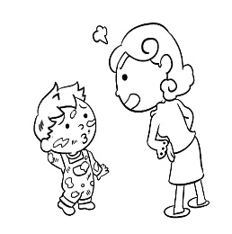 (B) (C)
《答案區》
答案：B
- 《腳本區》
CD: My cousins are looking at something far away with special tools.
《題目區》
(A) (B) (C)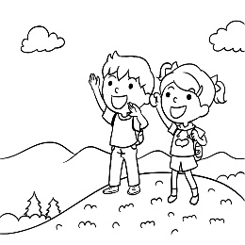
《答案區》
答案：B
- 《腳本區》
CD: The student is telling a joke to his classmates, but he is too shy to speak out in class.
《題目區》
＿＿＿
(A) (B) (C)
《答案區》
答案：A
- 《腳本區》
CD: My brother has a great sense of humor. Everyone feels happy when they are with him.
《題目區》
＿＿＿
(A) (B) (C)
《答案區》
答案：A
- 《腳本區》
CD: (W:) When I found out I forgot my bath towel, a friend kindly lent me one.
《題目區》
＿＿＿
(A) (B) (C)
《答案區》
答案：C
二、基本問答：每題均有三個選項，請依據所聽到的內容，選出一個最適合的回應
- 《腳本區》
CD: Mr. Smith told me that I made lots of errors in my history report.
《題目區》
(A) I’m so proud of you.
(B) You should tell him as soon as you find out the truth.
(C) You should check again before you hand in your report next time.
《答案區》
答案：C
- 《腳本區》
CD: Can I put the information I found on the Internet in my report?
《題目區》
(A) Yes, as soon as you spot an error.
(B) Yes, as long as you list the source.
(C) Yes, as long as you don’t smoke here.
《答案區》
答案：B
- 《腳本區》
CD: Have you watched today’s news? Our neighbor tried to hurt her husband with a sharp knife.
《題目區》
(A) That’s terrible. Why did she trust him?
(B) That’s terrible. Why did she do that?
(C) That’s terrible. Why did her husband attack her?
《答案區》
答案：B
- 《腳本區》
CD: Can I use your umbrella? I don’t have mine with me.
《題目區》
＿＿＿
(A) Sorry, I will change the umbrella for you.
(B) So do I. Don’t forget to bring it back to me.
(C) Neither do I. I got this one from Enid.
《答案區》
答案：C
- 《腳本區》
CD: Excuse me. Which way is the train station?
《題目區》
＿＿＿
(A) Sorry, I’m a stranger here myself.
(B) Sorry, I didn’t know you felt that way.
(C) Sorry, I ran into heavy traffic near the train station.
《答案區》
答案：A
三、言談理解：每題均有三個選項，請依據所聽到的對話與問題，選出一個最適當的答案
- 《腳本區》
CD: B: What’s wrong, Mom?
W: I got a call from your teacher. She said that your Chinese report was almost the same as Ashley’s. Why is that?
B: I guess that’s because the information we found was from the same sources.
W: I don’t think that’s the truth. Do your report again by yourself and stop being lazy!
Q: Why did the teacher call the mother?
《題目區》
(A) Because the teacher spotted many errors in the boy’s report.
(B) Because the information in the boy’s report wasn’t from a trusted source.
(C) Because the teacher found that the boy copied from Ashely’s report.
《答案區》
答案：C
- 《腳本區》
CD: M: I’ve become friends with Allen, who lives next door.
W: You’d better stay away from him because he lies sometimes.
M: I don’t think so. We chatted happily while we were smoking in the yard.
W: I’m glad you have a new friend, but just don’t give him any money.
Q: Why does the woman tell the man to stay away from Allen?
《題目區》
(A) Because he isn’t a trusted person.
(B) Because he is one of their neighbors.
(C) Because he often smokes.
《答案區》
答案：A
- 《腳本區》
CD: M: I can’t believe it. This restaurant is still full of people after two p.m.
W: I’m so hungry. I can’t wait any longer.
M: Neither can I. Let’s go to another restaurant.
Question: What will the man and woman do?
《題目區》
＿＿＿
(A) The woman will eat in another restaurant, and so will the man.
(B) The woman will leave for another restaurant, but the man won’t.
(C) Both the man and the woman will keep waiting in the restaurant.
《答案區》
答案：A
- 《腳本區》
CD: M: What happened to Ted? He seemed unhappy when I saw him walk out of the meeting room.
W: Gary told a joke, and that made Ted feel unhappy.
M: How come?
W: Because Gary laughed at him for being too heavy.
M: Well… That’s not polite. Besides, no one has the right to tell jokes that hurt another person.
W: I hate that, too.
Q: Which humor style did Gary use?
《題目區》
＿＿＿
(A) Bonding humor.
(B) Put-down humor.
(C) Hate-me humor.
《答案區》
答案：B
- 《腳本區》
CD: M: There is a party at Jason’s place this Saturday. Do you want to go with me?
W: I don’t really like parties. The music is loud, and there are always many strangers. I don’t feel comfortable talking to strangers.
M: A stranger is just a friend you haven’t met yet. Come on. It will be fun.
W: All right. But you have to stay with me the whole time, OK?
M: You have my word. See you at the party.
Q: Why doesn’t the woman want to go to the party?
《題目區》
＿＿＿
(A) She doesn’t want to meet any of her friends.
(B) She doesn’t like to talk to people she doesn’t know.
(C) She doesn’t want to be with the man the whole time.
《答案區》
答案：B

