新北市立溪崑國民中學111學年度第二學期第一次定期評量 英語科 試題卷
八年級 班 座號 姓名
【聽力測驗】共三大題
一、辨識句意：選出符合描述的圖片(每題2分，10%)

- (A) 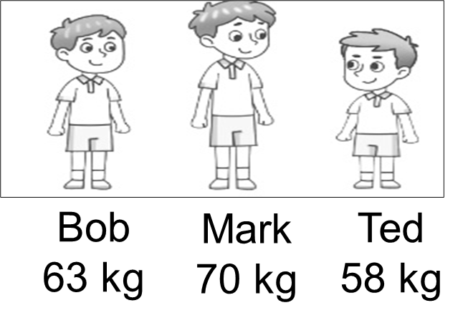 (B)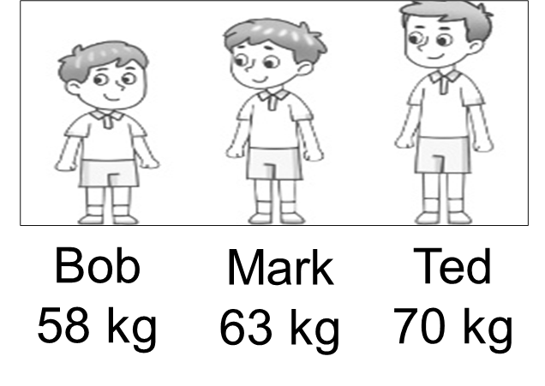 (C) 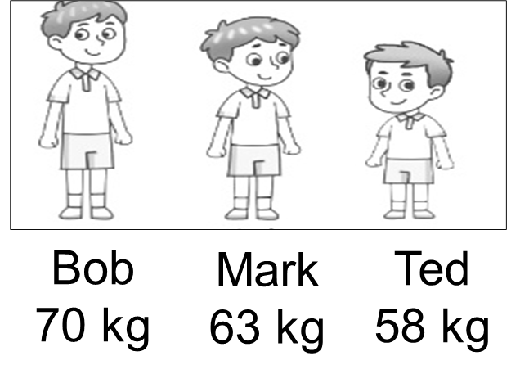

- (A)  (B) 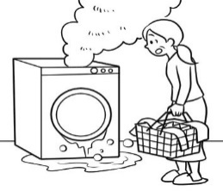 (C) 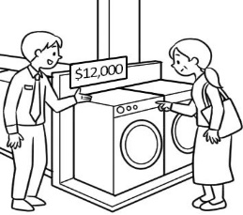

- (A) 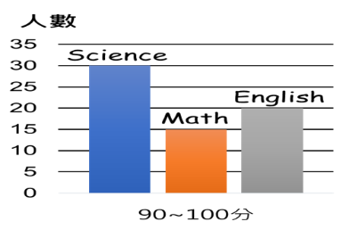 (B)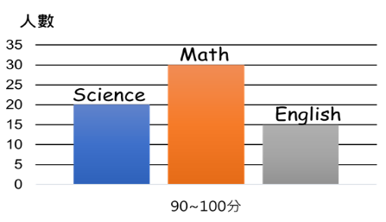 (C) 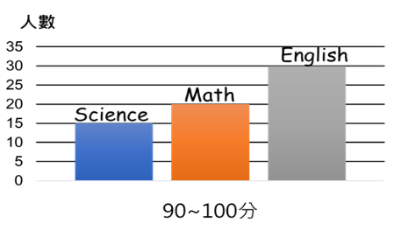

- (A) 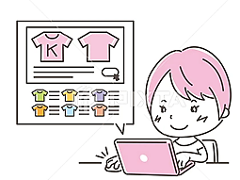 (B) 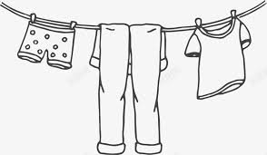 (C) 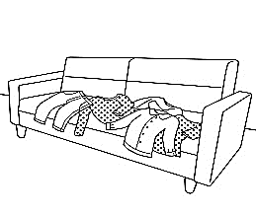

- (A) 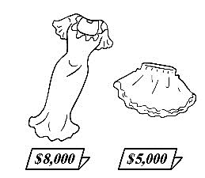 (B) 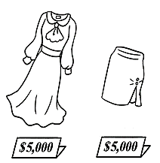 (C) 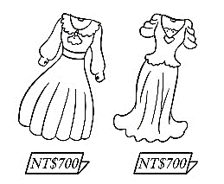

二、基本問答：請依據所聽到的內容，選出一個最適合的回應(每題2分，10%)
6. (A) They aren’t useful to me anymore.
(B) They bring back so many memories.
(C) I can use them to record my children’s voices.

7. (A) Right. She is thinner than before.
(B) Right. She is getting heavier.
(C) Right. She seldom wears skirts.

8. (A) Yeah, the air is fresh here.
(B) I don’t agree. The park is full of people.
(C) You’re right. There’s trash everywhere.

9. (A) It used to be, but now it is not.
(B) Yes, it is smaller than before.
(C) Yes, it is the oldest in town.

10. (A) Yes. I’m heavier than my brother.
(B) I think so. It is lighter than my old one.
(C) Of course not. He is the heaviest in my family.
三、言談理解：請依據所聽到的對話與問題，選出一個最適當的答案(每題1分，5%)
11. (A) A lot of trash. (B) Too much food. (C) A bigger refrigerator.
12. (A) A clerk. (B) A waiter. (C) A fan of fast fashion.
13. (A) Clothes. (B) Shoes. (C) Food.
14. (A) He left it in the washing machine.
(B) He forgot it somewhere.
(C) It was broken because he washed it.
15. (A) It’s warmer than that in Tainan.
(B) It’s hotter than that in Tainan.
(C) It’s colder than that in Tainan.
----------------------------------------------------------------------------------------------------------------------------------------------------
四、閱讀：(16~21題2分，22~24題1分，共15%)
(16~18)
Mary Anderson was an inventor. She lived about 100 years ago. Back then, when it rained or snowed, drivers had to get out of their cars to clean their windows.
Mary had a great idea. She invented a new way to clean car windows. It was a rubber blade that swung back and forth across the window. The blade scraped off water and snow.
This blade was the first windshield wiper. It worked like the wipers on cars do today. But it did not move by itself. Drivers made it move by turning a handle inside the car.
rubber 橡膠 blade 刀片 scrape off 刮除 windshield 擋風玻璃 handle 把手
16. What is this story mainly about?
(A) 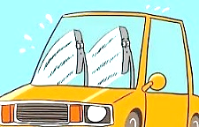 (B) 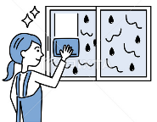 (C) (D) 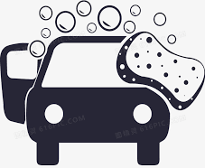
17. Why did Mary invent the windshield wiper?
(A) to help wash cars
(B) to help new drivers
(C) to help get out of their cars
(D) to help drivers see when it rained or snowed
18. How do wipers work today?
(A) The driver gets out of the car to use them.
(B) The wipers swing back and forth inside the car.
(C) Drivers turn a handle outside the car.
(D) The wipers move by themselves.
(19~21)
Benefits of Recycling
Don’t throw away your paper or plastic. You can use it again in new products. This is recycling, and it has many benefits.
First, it saves resources. People cut down trees for new paper. So recycling paper can save trees. Also, recycling reduces pollution. When you recycle plastic, it won’t pollute water or land. Also, factories will make less new plastic. This also reduces smoke in the air!
product 產品 benefit 好處 resource 資源 reduce 減少
19. What is recycling?
(A) cutting down trees (B) polluting water and land (C) making plastic (D) using things again
20. How can we save trees?
(A) recycle paper (B) make less plastic (C) throw away trash (D) smoke more in the air
21. If factories make less new plastic, they create less in the air.
(A) resources (B) smoke (C) forest (D) paper
(22~24)
Festivals in Thailand
Each year, Thailand celebrates the Thai New Year with the world’s biggest water fight called Songkran. This water splashing festival takes place from the 13th to the 15th of April every year. Its purpose was to wash all of the bad luck away and gives everyone a fresh start for the New Year. It’s a festival celebrated not only in Thailand but in other countries as well, like Myanmar(緬甸), Cambodia(柬埔寨), and Vietnam(越南).
Thailand also has two very popular lantern festivals: Loy Krathong and Yi Peng. They are celebrated on the day of the full moon in November. Loy Krathong is celebrated across Thailand, while Yi Peng is only celebrated in northern Thailand, especially in the city of Chiang Mai(清邁). The main difference between them is the type of lanterns used. During Loy Krathong, people can see lanterns floating with candles and flowers on a river. And during Yi Peng, there are many paper lanterns floating in the evening sky, just like Taiwan’s Lantern Festival in February.
splash 灑 purpose 目的 celebrate 慶祝 northern 在北部的 especially 尤其是difference 區別 float 漂浮
22. Which one is NOT celebrated only on the day of the full moon?
(A) Songkran. (B) Loy Krathong. (C) Yi Peng. (D) Mid-Autumn Festival.
23. Which is true?
(A) Chiang Mai is in the south of Thailand.
(B) People celebrate Songkran from January 13 to January 15.
(C) When you visit Thailand in February, you can see lanterns in the air.
(D) People can also see Songkran in countries near Thailand.
24. The following is from Ben’s diary. Which festival may Ben go to Thailand this year?
(A) The Thai New Year. (B) Songkran. (C) Loy Krathong. (D) Yi Peng.
Thailand is a country full of surprises. Last year, we had a water fight on the street in Thailand. The water really cooled us all off. This year, my mom is planning to take me to more of Thailand’s festivals. I wanted to go to more water fights, but Mom said we have to go to visit her friend in the south of Thailand this November.
五、克漏字：(每題2分，22%)
(25~29) Facts about FIFA World Cup in Qatar 2022
After four long years of waiting, football fans could enjoy the most important event in football—The World Cup. It took place in the Middle East for the first time, and there are some other fun facts about it.
1. The 25 World Cup
For the 2022 World Cup, the Qatar government 26 about $229 billion building new stadiums, a new train line, and hotels. The cost is almost five times the combined amount on the FIFA football events from 1990 to 2018.
2. The most commutable
Qatar is, in fact, much 27 than the host of the World Cup 2018, Russia. Since the size of the country is not big, 28 from one place to another here is not a big trouble for travelers. Another interesting fact is the two farthest stadiums of Qatar—Al Bayt and Al Wakrah—are only 90 miles apart.
3. Air-conditioned stadiums
Unlike previous events, the World Cup 2022 was played in November and December. This is because the 29 in June and July in Qatar can reach 40 to 50℃. There is a solar-powered cooling system in every stadium to keep players and fans cool.
government 政府 billion 十億 combined amount 合併的數量 host 主辦國 stadium 體育館 solar-powered 太陽能的
25. (A) most expensive (B) cheapest (C) lowest price (D) least expensive
26. (A) cost (B) spent (C) took (D) paid
27. (A) small (B) less small (C) smallest (D) smaller
28. (A) move (B) moving (C) moved (D) to moving
29. (A) software (B) file (C) planet (D) temperature
(30~35)
Facebook 30 more popular than Instagram, but that is now history. From a study in the USA in May, 2018, 72% of 743 teenagers used Instagram. On the other hand, only 51% of them used Facebook. So, Facebook is losing teenagers to Instagram.
Why are teenagers leaving Facebook 31 Instagram? First, many parents use Facebook, not Instagram. So, when teenagers share things on Instagram, their parents won’t know about it. Second, Facebook is more a medium for people to share information, and Instagram is more a place to make friends. Facebook is fine for many adults because they usually just want to share news 32 one another. For teenagers, however, keeping up to date is 33 meeting new friends, so they like to use Instagram. Third, a lot of teenagers like Instagram better because they enjoy
34 their stories through beautiful pictures and videos. Facebook users usually use 35 words to share their stories and feelings.
medium 媒體 adults 成人
30. (A) use to be (B) used to be (C) is used to being (D) is used to be
31. (A) for (B) to (C) than (D) from
32. (A) to (B) with (C) by (D) as
33. (A) as important as
(B) easier and more convenient than
(C) more important than
(D) less important than
34. (A) share (B) to share (C) sharing (D) shared
35. (A) more (B) less (C) fewer (D) much
六、單題：(每題2分，20%)
36. Today, their Instagram page has over 650,000 fans, and the number keeps !
(A) grow (B) to grow (C) growing (D) grew
37. Of all the subjects, science is for me. I never get good grades in it.
(A) more difficult (B) as hard as (C) the most difficult (D) the easiest
38. Their customers left hundreds of clothes in their store, and they didn’t want to .
(A) throw away them (B) throw them away (C) take their place (D) agree with them more
39. The jeans look fashionable. Where did you get ? I want , too.
(A) one; one (B) ones; them (C) it; one (D) them; ones
40. Amy is of the two girls.
(A) beautiful (B) more beautiful (C) the more beautiful (D) the most beautiful
41. John’s smartphone is different from mine. smartphone is red, and is black.
(A) My; he (B) Mine; his (C) My; him (D) My; his
42. Taipei is bigger than in Taiwan.
(A) any city (B) any other city (C) all cities (D) all the cities
43. It is a book and, what is more, not an expensive one.
(A) poor (B) comfortable (C) actually (D) useful
44. Lisa didn’t finish her milk, so she put it back into the .
(A) refrigerator (B) memory (C) style (D) radio
45. It’s too dark, and I can’t see anything. Can you the light?
(A) put on (B) take off (C) turn off (D) turn on

【其他手寫題, 請在答案卷上作答】

新北市立溪崑國民中學111學年度第二學期第一次定期評量 英語科 答案卷
八年級 班 座號 姓名
七、手寫填空 & 翻譯題 (18%)
1. John 比 Kevin 瘦，但是他們一樣高。
John is Kevin, but he is as tall him.
2. Kate 比她去年還要重得多，所以她的舊洋裝對她來說已經太小了。
Kate is much than she last year, so her old dress is
too for her.
3. 沒有任何事物比家人更重要。(2分)

4. 藉由賦予舊衣新生命，我們將會製造較少量的垃圾。(2分)

5. Joe 過去經常早上去慢跑，但他現在只是步行30分鐘。(4分)

6. Nick 用他的新手機來拍照、錄影、上網和玩遊戲。(4分)

111-2-1 八年級 英語科－解答
一~三、聽力(共25%)
1-10 CBCAA BBCAC
11-15 CAABC (1分)
四、閱讀(共15%)
16-18 ADD 19-21 DAB
22-24 ADC (1分)
五、克漏字(共22%)
25-29 ABDBD 30-35 BABDCA
六、單題 (共20%)
36-40 CCBDC 41-45 DBDAD
七、手寫題(共18%)
1. thinner ； than ； as
2. heavier ； was ； small
3. Nothing is more important than family.
4. By giving new life to old clothes, we will make less trash.
5. Joe used to go jogging in the morning, but now he just walks for 30 minutes.
6. Nick uses his new smartphone to take photos, record videos, surf the Internet, and play games.

新北市立溪崑國民中學111學年度第二學期第一次定期評量
八年級 英語科 聽力測驗

一、辨識句意：每題均有三張圖片，請依據所聽到的句子，選出符合描述的圖片 CBCAA
1. Bob is the tallest and the heaviest of the three.
2. The washing machine is out of order. Jane needs someone to help her fix it.
3. The science test is the hardest of the three.
4. All the clothes on the page look great. It’s hard to decide.
5. The dress and the skirt weren’t cheap. The skirt cost five thousand dollars, and the dress was even more expensive.
- (A) (B) (C)

- (A) (B) (C)

- (A) (B) (C) 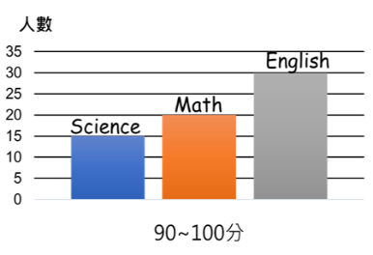

- (A) 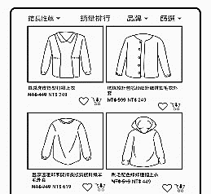 (B) 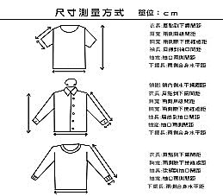 (C)

- (A) 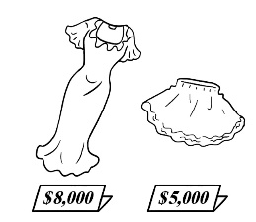 (B) 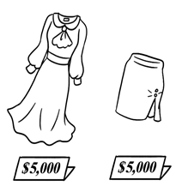 (C) 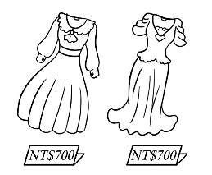

二、基本問答：請依據所聽到的內容，選出一個最適合的回應 BBCAC
6. Why do you keep these old letters and cards from your friends?
(A) They aren’t useful to me anymore.
(B) They bring back so many memories.
(C) I can use them to record my children’s voices.
7. Judy wore size medium before, but now she wears size large.
(A) Right. She is thinner than before.
(B) Right. She is getting heavier.
(C) Right. She seldom wears skirts.
8. The park is much dirtier than before.
(A) Yeah, the air is fresh here.
(B) I don’t agree. The park is full of people.
(C) You’re right. There’s trash everywhere.
9. Is Johnson Movie Theater the biggest one in town?
(A) It used to be, but now it is not.
(B) Yes, it is smaller than before.
(C) Yes, it is the oldest in town.
10. Are you as heavy as your brother?
(A) Yes. I’m heavier than my brother.
(B) I think so. It is lighter than my old one.
(C) Of course not. He is the heaviest in my family.

三、言談理解：請依據所聽到的對話與問題，選出一個最適當的答案 CAABC
11.
W: Hey, don’t throw away that food!
M: Come on. It’s not good to eat now, and there are too many things in the refrigerator.
W: Maybe we just need a bigger refrigerator.
M: That won’t work. You’ll just put more food in the new one. (Sigh)
Q: What does “the new one” mean?
11. (A) A lot of trash. (B) Too much food. (C) A bigger refrigerator.

12.
M: May I help you?
W: Yes. I bought this skirt last night, but the color was wrong.
M: What color did you need?
W: I needed a white skirt, but you gave me a blue one.
M: I’m sorry. Please wait a minute, and I’ll change that for you.
W: Thank you.
Q: Who is the woman talking to?
12. (A) A clerk. (B) A waiter. (C) A fan of fast fashion.

13.
M: This is Kiki Store. How may I help you?
W: Hi, I left my bag in the fitting room in your store this morning.
M: Is this Ms. Stone?
W: Yes, I am. How do you know?
M: We checked the bag and found your ID. You can come to get it now.
Q: What might Kiki store sell?
13. (A) Clothes. (B) Shoes. (C) Food.

14.
M: Could you give me a call?
W: What for? You’re already here.
M: I can’t find my smartphone, but it must be in the apartment.
W: Could it be in the desk drawer?
M: It isn’t there. I also checked the fridge.
W: I see.
[Phone ringing...]
M: Ha! There it is. When I put the jacket in the clothes basket, I forgot to check its pockets.
Q: What happened to the man’s smartphone?
14. (A) He left it in the washing machine.
(B) He forgot it somewhere.
(C) It was broken because he washed it.

15.
W: How are you doing in Tokyo?
M: Great. By the way, the weather here is much colder than that in Tainan. It snows a lot.
W: Wear more clothes when you go out. Also, turn on the heater to stay warm when you’re in the house.
M: Thank you. I will.
Q: What’s the weather like in the man’s place?
15. (A) It’s warmer than that in Tainan.
(B) It’s hotter than that in Tainan.
(C) It’s colder than that in Tainan.

