新北市立溪崑國民中學111學年度第二學期第一次定期評量 英語科 試題卷
七年級 班 座號 姓名
第一大題 聽力測驗(1-15題，共25分)
第一部分 根據聽到的內容，選出正確的圖片(1-5題，每題2分)
( ) 1. | (A) | 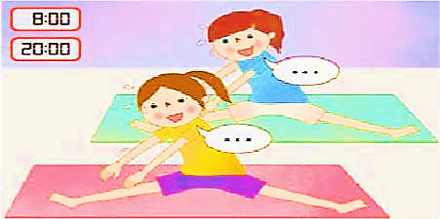  (B) | (C)
 | 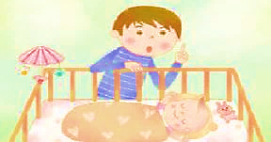 |  | 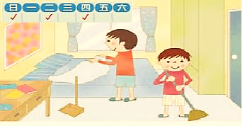

( ) 2. | (A) | (B) | (C)
 |  | 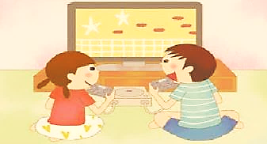 | 

( ) 3. | (A) | (B) | (C)
 |  | 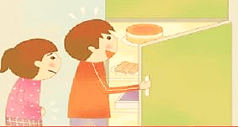 | 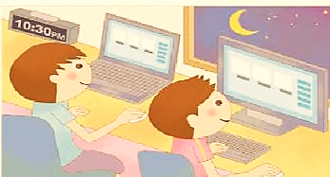

( ) 4. | (A) | (B) | (C)
 | 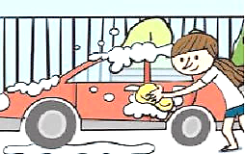 |  | 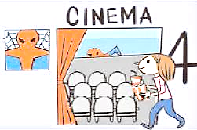

( ) 5. | (A) | (B) | (C)
 |  | 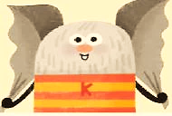 | 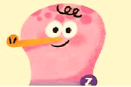

第二部分 根據聽到的內容，選出最適當的回應句或問句 (6-10題，每題2分)
( ) 6. (A) She is fine. (B) She is 13 years old. (C) She’s 160 centimeters tall.
( ) 7. (A) He is a born teacher. (B) He doesn’t have many students. (C) He puts his all into every game.
( ) 8. (A) I’m usually with my family. (B) I take a shower twice a day. (C) Me, too. It really helps a lot!
( ) 9. (A) But I can’t help it. (B) Who can help me? (C) Can I eat the cake?
( ) 10. (A) He hurts his classmates. (B) Every day. (C) He changes into Mr. Hyde.

第三部分 根據聽到的內容與問題，選出最適合的答案 (11-15題，每題1分)
( ) 11. (A) Her dog. (B) Some food. (C) A camera.
( ) 12. (A) Susan’s daughter. (B) Susan’s cat. (C) Susan’s friend.
( ) 13. (A) Play Frisbee. (B) Walk their dog. (C) Listen to music.
( ) 14. (A) They are English teachers. (B) They are happy housewives. (C) They work at a night school.
( ) 15. (A) Jeremy Lin is the woman’s favorite basketball player.
(B) Jeremy Lin and his parents are from Taiwan.
(C) Jeremy Lin practices basketball every day.

第二大題 綜合測驗 (16-34題，每題2分，共38分)
( ) 16. Joseph practices playing the piano 8 hours a day, and he plays it very well. He is a(n) ________ musician.
(A) excellence (B) hard work (C) outstanding (D) different
( ) 17. The man looks cute. He has a small nose, and his _____ are fat and thick, just like two sausages(香腸) on his
face.
(A) mouth (B) eyes (C) ears (D) lips
( ) 18. George is not a difficult person. He is usually quiet, but if you ask him questions or ask him for help, he will give
you a hand. He has his sweet _______.
(A) candy (B) home (C) side (D) face
( ) 19. Mr. White always goes to work before nine and is _______ late for work.
(A) never (B) sometimes (C) seldom (D) often
( ) 20. When I am free, I always go out and play _______.
(A) a guitar (B) a kite (C) my cellphone (D) basketball
( ) 21. Tom: Let’s play tennis together after school. Evan: Sorry, not today. I’m _______. Maybe next time.
(A) early (B) like it (C) tired (D) study
( ) 22. Max: What’s your height? Eva: __________.
(A) It’s a kite. (B) 51 kilograms. (C) I like swimming. (D) About 180 centimeters.
( ) 23. My mom’s birthday is coming. I’d like to ______ a cake for her.
(A) do (B) cook (C) make (D) play
( ) 24. A: Please go away! I don’t want to see you.
B: I am so sorry about all the trouble I make. What can I do to _______?
(A) change into it (B) take over it (C) make up for it (D) help it
( ) 25. Linda wants to go to a good college(大學), so she _______ her studies.
(A) puts her all into (B) makes up for (C) stands out (D) is happy with
( ) 26. Taipei 101 is a great place to go to. You can go shopping or eat delicious food there. My wife and I go there ____.
(A) usually (B) always (C) every time (D) very often
( ) 27. A: What ______ you and your friends _____ after school? B: We play board games together.
(A) are ; doing (B) can ; do (C) are ; doing (D) do ; do
( ) 28. Leo ______ every day.
(A) miss his school bus (B) flys to Japan (C) hurries to his office (D) studys English
( ) 29. A: I think Mrs. Lin is a cat person. B: Does she have many cats? A: Sure she ______.
(A) have (B) has (C) does (D) do
( ) 30. A: Your hair is so long and thick. _______ do you wash your hair?
B: Every other week. You know, it takes a lot of time to wash my hair and dry it.
(A) How come (B) How tall (C) How often (D) How many
( ) 31. A: It’s good to be a morning person. If you get up early, you’ll have time to do many things before you go to work
or school. B: ________
(A) That’s all right. (B) I can’t help it. (C) You must fight. (D) You can say that again.
( ) 32. A: What does your father do in his free time? B: ______
(A) He’s working from home. (B) He stands out every time. (C) He is happy. (D) He surfs the Net.
( ) 33. A: The light of Peter’s house is on, and the door is open. B: _______ He is in Japan with his family now.
(A) Too bad! (B) I can’t help it! (C) How come? (D) Why not?
( ) 34. A: How often do you wash your dog? B: ______
(A) I have a cute one. (B) I love it very much. (C) I wash it every week. (D) I take a shower twice a day.

第三大題 克漏字測驗 (35-39題，每題2分，共10分)
Salesperson: | Mr. and Mrs. Lin, let me show you the best apartment(公寓) around here. It has three bedrooms, one large kitchen, and two bathrooms.
Mr. Lin: | 35. How wonderful! I can make cakes or cookies in my free time.
Salesperson: | Let’s take a look. It’s big and beautiful.
Mrs. Lin: | Dear, 36. . Can we just get it?
Mr. Lin: | But we don’t need three bedrooms.
Mrs. Lin: | We will! Our children can use the other two bedrooms. Also, there is 37. in front of the apartment. We can play table tennis together there. Isn’t it wonderful?
Mr. Lin | Let me think about it.
Salesperson: | 38. , but don’t keep me waiting for too long. It’s a very popular apartment.
Mr. Lin: | How much is the apartment?
Salesperson: | It’s NT$30,000,000.
Mr. Lin: | That’s a lot of money!
Salesperson: | Yes, it is. But think about this. There is an MRT station, a school and a park …
Mr. Lin: | 39. I don’t think I can buy a house with so much money. Thanks for your time.

( ) 35. (A) Three bedrooms! (B) A large kitchen! (C) Two bathrooms! (D) An apartment!
( ) 36. (A) everyone is busy (B) we need a car (C) I can work from home (D) the apartment is great
( ) 37. (A) a garden (B) a playground (C) a gym (D) a tennis court
( ) 38. (A) Don’t worry (B) Sure (C) Give me a break (D) Over there
( ) 39. (A) Amazing! (B) Excuse me . (C) How come? (D) Sorry.

第四大題 閱讀測驗 (40-50題，每題1分，共11分)
(40-42)
ChatGPT is a computer program that can talk to people using words and sentences. It's kind of like having a pen pal or a friend who can speak with you in English. It's really good at understanding what people are saying, even if they make mistakes or use words in a different way. It's trained to understand English really well, and it can help people learn new words and practice their English skills by having conversations with them. If you want to practice your English or just , you can ask ChatGPT a question or start a conversation, and it will try its best to understand and respond in a way that makes sense to you.
program 程式 pen pal筆友 even if 即使 mistake 錯誤 train 訓練 skill 技巧 conversation對話 respond 回應 make sense 有意義

( ) 40. According to the text(文本), what is ChatGPT?
(A) A machine(機器). (B) A computer program. (C) A pen pal. (D) A mistake.
( ) 41. What can be in the blank (空格) in line 6?
(A) make a report(報告) (B) find a friend (C) talk to someone (D) play a game
( ) 42. How can ChatGPT help people practice their English skills?
(A) By playing games. (B) By asking questions. (C) By watching videos. (D) By having conversations

(43-44)
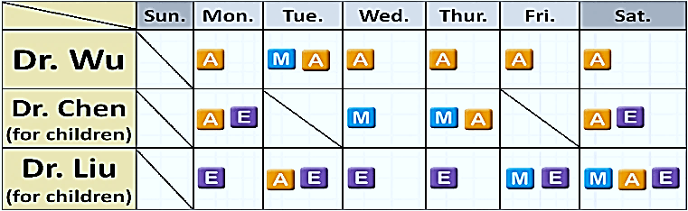
No. 1 Dentists
M = morning / 9:00-12:00
A = afternoon / 14:00-17:00
E = evening / 18:00-21:00

( ) 43. How often does Dr. Wu work at No. 1 Dentists?
(A) He seldom works there. (B) He works there every day.
(C) He doesn’t work there often. (D) He usually works there in the afternoon.
( ) 44.
Ann： My tooth hurts.
Betty： You can go to No. 1 Dentists. Dr. Chen is a good dentist. You can go see her.
Ann： OK. Let me see. I have to go to school every day from 9:00 to 17:00, and I have to go to a cram school every
weekend from 14:00-17:00. We always have family meeting at home on Saturday night.
When will Ann go to the No. 1 Dentists?
(A) Monday evening. (B) Tuesday evening. (C) Saturday morning. (D) Thursday afternoon.

(45-46)

Olivia： Where are you going?
Kevin： To my friend’s shop. She just opened a store. Here is the flyer for her
store.
Olivia： Let me see. (Olivia reads the flyer) I don’t get it. What is this? Your
friend charges a hug for NT$200?
Kevin： You’re right. Amy told me, by doing so, she could make money and help
people at the same time.
Olivia： Help people?
Kevin： Yes. Amy is a student. She studies psychology. She helps people by
listening to their problems and giving them support.
Olivia： Really? Can I go with you?
Kevin： Sure.

flyer 傳單 hug 擁抱 cure 治療 will 將 charge 收費 psychology 心理學 support 支持 alone 獨自

( ) 45. Who will go to Amy’s Shop?
(A) Tina. She has a high fever. (B) Ken. He has a lot of friends.
(C) Jenny. She lives alone in Taipei. (D) Leo. He never worries about anything.
( ) 46. What do we know from the reading?
(A) Amy is a doctor. (B) Amy gives people free hugs.
(C) Amy makes money by listening to people’s problems. (D) Olivia and Kevin need Amy’s help, so they go to her shop.

(47-50)
There are lots of different kinds of ants: carpenter ants, leaf-cutter ants, sweet ants, fire ants, and many more. They are different colors, too. They can be red, or brown, or black. Some are very, very small, and some are big. Ants are different, but they are all social creatures. They live in large groups called “colonies”. Some ant colonies are big and have millions of ants. There are different types of ants in the colony, and they each have different jobs. The queen makes eggs. Soldier ants protect the queen and the colony. They also gather food and attack other colonies if they need new places to live. Worker ants take care of babies, look for food, and build ant homes. Soldier and worker ants are female. Male ants’ only job is to mate with the queen in order to produce eggs.
Ants are busy little insects. It’s easy to see them moving quickly here and there. Sometimes you can see them carrying a small piece of something, or dragging part of a leaf somewhere. Sometimes you even see two ants helping each other carry the same crumb. But where are they going and what are they doing? Ants may seem to be just running around, but they are actually important parts of their ecosystem, their world under our feet. One thing ants do to help their ecosystem is to keep soil healthy. They dig through the soil very often to make spaces in it. Soil needs space inside it for air and water. Without air and water in soil, the small creatures that live in soil would not live. Ants also help bring nutrients to soil. When they bring food to their nests, they add nutrients to soil because they don’t eat everything they bring. Their leftovers stay in the soil and break down into nutrients for other creatures living in the soil.
 social 社會的 creature 生物 type 種類 protect 保護 gather 收集 attack 攻擊 female 雌性
mate 交配 produce 生產 crumb 碎屑 ecosystem生態系統 soil 土壤 dig 挖 nutrient 營養 leftover 廚餘

( ) 47. What does the author(作者) want to say in the first paragraph(段落)?
(A) The importance of ants to their ecosystem. (B) How ants keep soil healthy.
(C) The food ants bring to their nests. (D) The jobs for ants in a colony.
( ) 48. Which of the following answer supports(支持) “Ants are busy little insects” in the second paragraph?
(A) Ants move quickly from one place to another. (B) Male ants' only job is to mate with the queen.
(C) Some ants are very, very small, and some are big. (D) Ants can be red, or brown, or black.
( ) 49. According to the text, where can we find the ecosystem of ants?
(A) In the ocean. (B) In the air. (C) In the soil. (D) In the desert.
( ) 50. What is a main idea(主旨) of this text?
(A) Ants can be red, brown, or black. (B) Ants are important parts of their ecosystem.
(C) Soil needs space inside it for air and water. (D) Sometimes two ants help each other carry the same crumb.

第五大題 翻譯 (16%)
1. 另一方面，他們很不一樣。但是因為不斷努力，他們兩個都是頂尖球員。(4%)
On the _______ ________, they are very _________. But _________ hard work, they are both top players.
2. 你說得沒錯! (2%) You can __________ that __________.
3. 我一個月從圖書館借三次書。(…out…) (3%)
_________________________________________________________________________________
4. 在白天，我去工作並拯救生命。(3%)
_________________________________________________________________________________
5. 她總是在晚上遛狗，但我從來沒有。(4%)
_________________________________________________________________________________

新北市立溪崑國民中學111學年度第二學期第一次定期評量 英語科 答案卷
七年級 班 座號 姓名
第五大題 翻譯 (16%)
1. 另一方面，他們很不一樣。但是因為不斷努力，他們兩個都是頂尖球員。(4%)
On the _______ ________, they are very _________. But _________ hard work, they are both top
players.
2. 你說得沒錯! (2%) You can __________ that __________.
3. 我一個月從圖書館借三次書。(…out…) (3%)
_________________________________________________________________________________
4. 在白天，我去工作並拯救生命。(3%)
_________________________________________________________________________________
5. 她總是在晚上遛狗，但我從來沒有。(4%)
_________________________________________________________________________________

111-2-1 七年級 英語科－解答

1 | 2 | 3 | 4 | 5 | 6 | 7 | 8 | 9 | 10
B | A | C | C | A | C | A | C | A | B
11 | 12 | 13 | 14 | 15 | 16 | 17 | 18 | 19 | 20
C | B | B | B | C | C | D | C | A | D
21 | 22 | 23 | 24 | 25 | 26 | 27 | 28 | 29 | 30
C | D | C | C | A | D | D | C | C | C
31 | 32 | 33 | 34 | 35 | 36 | 37 | 38 | 39 | 40
D | D | C | C | B | D | C | B | D | B
41 | 42 | 43 | 44 | 45 | 46 | 47 | 48 | 49 | 50
C | D | D | A | C | C | D | A | C | B

第五大題 翻譯 (16%)
1. other hand different with (4%)
2. say again (2%)
3. I check out books from the library three times a month. (3%)
4. During the day, I go to work and save lives. (3%)
5. She always walks her dog at night, but I never do. (4%)

新北市立溪崑國民中學111學年度第二學期第一次定期評量
七年級 英語科 聽力測驗稿

聽力測驗
第一部分 根據聽到的內容，選出正確的圖片
1. My friends exercise after work twice a day.
2. Mr. and Mrs. White sometimes take a walk in the park.
3. They usually use the computer after ten.
4. Linda goes to the movies every week.
5. He has big eyes, a small nose, and thick lips.

第二部分 根據聽到的內容，選出最適當的回應句或問句
6. How tall is Zara?
7. Mr. Wayne is a great teacher. He is nice to his students, and his teaching is easy for students to understand.
8. I seldom feel tired after taking a hot shower.
9. Jack, don’t eat the cake. Let’s wait for Dad.
10. How often does your brother make trouble?

第三部分 根據聽到的內容與問題，選出最適合的答案
11.
Chris：What do you do on Saturdays, Tracy?
Tracy：I watch basketball games on TV with my dad on Saturdays.
Chris：Do you want to come to the game when I play for our school?
Tracy：No way! Are you on the school team?
Chris：Yes, and I have two tickets for the game next Saturday.
Tracy：Sure. It’s a big game!
Chris：Yes, it is. We will play at the Taipei Arena, so make sure you know the rules.
Tracy：What rules?
Chris：Here, check out the back of the tickets. No food or pets. So, don’t bring your dog with you.

Question: What can Tracy bring to the game?
12. Dad, this is Susan. I need your help again. Can you go to my house after dinner and feed my cat one more time? There is so much work to do, so I’m still in my office, and I can’t go home before 10. Mimi cries when she’s hungry. The cat food is in the living room, right under the TV. Thank you so much. Love ya!

Question: What is Mimi?

13. Hi, everyone. I’m Mike. I’m a busy boy, and my brother is, too. We walk our pet dog in the morning and evening. We listen to music in the afternoon, and we watch TV in the evening. We also play Frisbee with our dog at the park after meals. We are busy buy happy.

Question: What do the boys do twice a day?

14. Michelle and Audrey are housewives. They usually do housework during the day. Then they go to school to study English at night. They are good friends and have a great time every day.

Question: Which is true about Michelle and Audrey?

15. W: Sam, who is your favorite basketball player?
M: Jeremy Lin. He’s a great player.
W: Where is he from?
M: He’s from the USA, but his parents are from Taiwan.
W: I see. What does he do every day?
M: He practices every day.
W: It’s really hard work.
M: Yes, but he doesn’t mind.
Question: Which is true?

