新北市立溪崑國民中學106學年度第一學期第三次定期評量 英語科 試題卷
八 年級 班 座號 姓名
一、 聽力測驗:(每題兩分)
(一) 辨識句意：根據聽到的內容，選出符合描述的圖片或符合圖片的描述。

1. (Ａ) 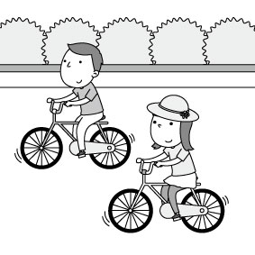 (B) 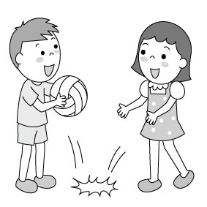 (C) 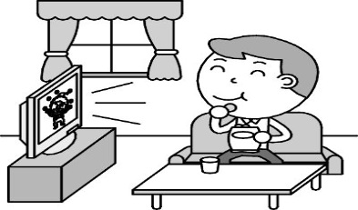

2. (Ａ) 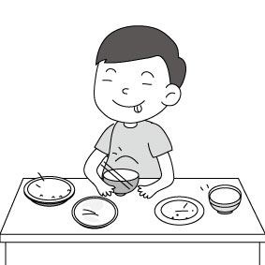 (B) 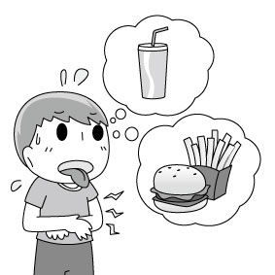 (C) 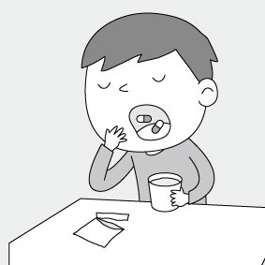

3. (Ａ) 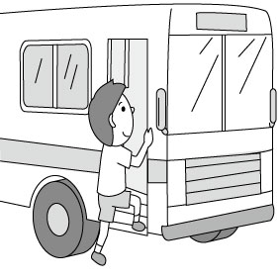 (B) 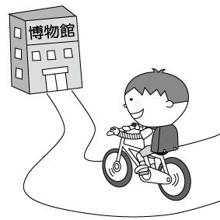 (C) 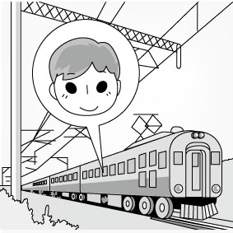

4. (Ａ) 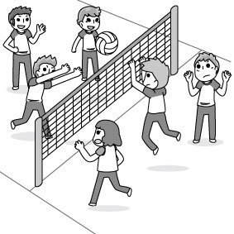 (B) 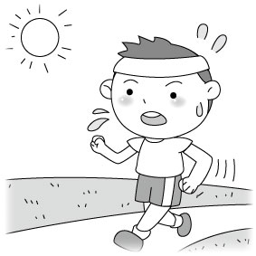 (C) 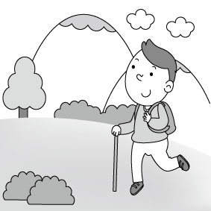

5. (Ａ) 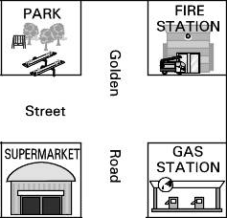 (B) 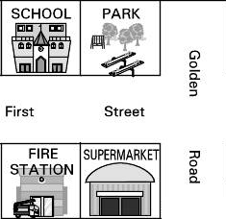 (C) 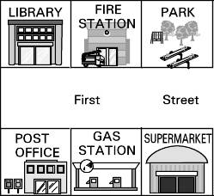
(二)基本問答：根據聽到的內容，選出一個最適合的回應或最適合的問句。
6. (Ａ) Yes, you can go to the railway station.
(Ｂ) Turn left on Second Street and walk down the street for about 5 minutes.
(Ｃ) The railway station is near a fire station.

7. (Ａ) I go to school with my brother every day.
(Ｂ) I go to school happily every day.
(Ｃ) I usually walk to school.

8. (Ａ) I like going fishing. It’s so much fun.
(Ｂ) Yes, like fishing.
(Ｃ) Going fishing could be fun, but I am not good at it.

9. (Ａ) Yes, the bank is behind the supermarket.
(Ｂ) Oh, Taiwan Bank is very big.
(Ｃ) It’s between a supermarket and a park.

10. (Ａ) Well, it is very heavy and beautiful.
(Ｂ) I don’t think so. It is hot now.
(Ｃ) I am not heavy. I am thin.

(三)言談理解：根據聽到的內容，選出一個最適合的答案。
11. (Ａ) Before the man and the girl get something to drink, they will go to the park first.
(Ｂ) The man and the girl will not go to the park.
(Ｃ) The man and the girl want to go to the supermarket, so they need to walk across the road.

12. (Ａ) On Thursday. (Ｂ) On Saturday. (Ｃ) On Friday.

13. (Ａ) She can’t drive a bike.
(Ｂ) She is under 18 years old.
(Ｃ) She can drive a car to school.

14. (Ａ) He feeds fish on the farm.
(Ｂ) He doesn’t enjoy his life on the farm.
(Ｃ) He is a farmer.

15.(Ａ) Make lunch. (Ｂ) Buy sweaters. (Ｃ) Buy pants.

二、 綜合測驗:(每題兩分)
16. Go straight ＿＿＿ 3 blocks and turn left. You will see a parking lot ____ your right.
(A) on; for (B) for; on (C) for; in (D) in; for

17. The of the camera is not really high. Can we take it, Mom?
(Ａ) taco (Ｂ) sock (Ｃ) price (Ｄ) color

18. A：＿＿＿ can we get to Brother’s Movie Theater? B：Go ____ this road. It’s between the school and the bank.
(A) How; along; (B) How; for (C) What; down (D) What; for

19. Playing baseball with my classmates is ________ . (Ａ) far (Ｂ) exciting (Ｃ) tired (Ｄ) delicious

20. Simon is poor, but he ＿＿＿ a lot of money ＿＿＿ the cellphone. (A) spent; for (B) spent; on (C) took; for (D) took; on

21. A：What does your sister plan to do next Sunday? B：She ＿＿＿ at home.
(A) study (B) is studying (C) studied (D) will study

22. There is no __________ near the movie theater. Let’s take the MRT there.
(A) parking lot (B) bank (C) map (D) playground

23. Larry likes the hat so much, so he ＿＿＿ a lot of money ___ it ____ his pocket money.
(A) spent; for, with (B) spent; with; for (C) paid; for; with (D) paid; with ; for

24. We can send letters, buy stamps and save money at a __________. (A) bank (B) post office (C) bookstore (D) police station
25. A：＿＿＿ will you go to Japan? B：I will go there _______.
(A) What; by plane (B) What; by a plane (C) How; by plane (D) How; by a plane

26. This sweater has a nice _______. It’ll look great ____ you. (Ａ) colors; in (Ｂ) color; in (Ｃ) colors; on (Ｄ) color; on

27. Ken goes to school ＿＿＿ every day because his school is near his home.
(A) by feet (B) by foot (C) on feet (D) on foot

28. It ＿＿＿ my mom 2 weeks _______ the housework. (A) took; doing (B)took; to do (C) spent; doing (D) spent; to do

29. My father likes ______ on Saturdays.
(A) going watching bird (B) going bird watching (C) to go watching bird (D) to go to watch bird

30. A：Are you ＿＿＿ play basketball tomorrow? B：Yes, I am. (A) go to (B) goes to (C) went to (D) going to

31. Edward 3 days in the park _____ for his dog.
(A) took; to look (B) took; looking (C) spent; to look (D) spent; looking

32. My goodnesss! My computer _________ last night. How will I do my homework this evening?
(Ａ) breaks up (Ｂ) breaks down (Ｃ) broke up (Ｄ) broke down

33. Lisa：What tomorrow morning? Tina：I’ll watch the baseball game with my brother.
(A) will you do (B) are you doing (C) did you do (D) were you doing

34. My grandfather is 85 years old, but he lives in the mountains, and often drives a jeep. He knows everything about mountain insects and plants. He is just _________.
(A) in the world (B) out of the world (C) on the world (D) out the world

35. The bicycle ＿＿＿ Steve much money. (A) spent (B) paid (C) took (D) cost

36. The little girl got _____ _____ the corner of the Lake Road and Second Street. She was so sad.
(A) lost; in (B) lost; on (C) missed; in (D) missed; on

37. I will buy some drinks first. I am so _____. (Ａ) hungry (Ｂ) exciting (Ｃ) healthy (Ｄ) thirsty

38. The coffee shop is across ＿＿＿ my house. (A) from (B) into (C) to (D) with

39. Jason had his car, so he didn’t need to _____ a train to Hualien . (A) take (B) fly (C) drive (D) ride

40. Excuse me. May I _____ the jeans? (Ａ) dress up (Ｂ) dress on (Ｃ) try on (Ｄ) try up

三、克漏字: (每題兩分)
To: Tinahuang@yafohome.com.tw
Subject: Your Notebook
Dear Tina,
I am Hugh. I __41___ the living room at three o’clock yesterday afternoon. I ___42___ a notebook ___43___ your name
__44__ it near the sofa in the living room. I know you will have an important exam next week. You were searching for (搜尋) it all the afternoon, right? Where is your home? Please tell me, and I ______45____ it back to you tomorrow night.
Simon
41. (Ａ) clean (Ｂ) am cleaning (Ｃ) was cleaning (Ｄ) will clean

42. (Ａ) was finding (Ｂ ) found (Ｃ) was looking for (Ｄ) looked for

43. (Ａ) with (Ｂ) on (Ｃ) at (Ｄ) for

44. (Ａ) for (Ｂ)with (Ｃ) off (Ｄ) on

45. (Ａ) give (Ｂ) am giving (Ｃ) am going to give (Ｄ) was giving

四、閱讀測驗:(每題兩分)
(一)
Several years ago, all cellphones were very expensive. Only rich people could own them. These days, most people can afford one and like to use it in many different ways. People make phone calls, take pictures, play games, and surf the Internet on their phones.
Using cellphones can make life convenient, but this also causes problems. For example, when cellphones ring in public places, like classrooms, movie theaters, and museums, people are bothered. And, driving and using cellphones at the same time can cause serious accidents. Also, the cost of keeping a cellphone is very high, especially for students. So cellphones are useful only when you use them wisely.
surf the Internet上網; afford買得起; causes引起; bothered打擾; accidents意外

46. How does the writer feel about cellphones?
(A) They are of no help at all.
(B) It is nice to use them in theaters.
(C) Using cellphones can improve（增進）people’s health.
(D) There are both good things and bad things about cellphones.

47. What does one mean? (A) Money. (B) A hand. (C) A museum. (D) A cellphone.
48. Which is true?
(A) Cellphones make life convenient.
(B) Today, cellphones are only for the rich.
(C) Only students can use cellphones in public places.
(D) Drivers avoid accidents when they use cellphones.
(二)
Most people think butterflies are beautiful. But butterflies are not just pretty to look at. They are also important for the environment. In fact, if you see butterflies, it is a sign that environment is healthy. Sadly, many butterflies are losing their homes. This is often because of people. But some people are giving butterflies a new home. At the Jiannan Butterfly Trail, people created a safe place for butterflies. Many butterflies live there. People planted many kinds of plants along the trail. These let butterflies lay their eggs, eat and live well.
Most butterflies lay their eggs on the leaves of plants. When the eggs hatch, the caterpillars eat a lot of leaves. There are plants and trees on the trail that caterpillars like. Adult butterflies need food, too. The plants along the trail have food for them, too. The Jiannan Butterfly Trail is a great place for butterflies. But it’s also a great place for people to visit.
Butterfly蝴蝶; environment環境; sign徵兆; trail小路，小徑; hatch孵化; caterpillar毛毛蟲

49. What can butterflies mean in the reading?
(Ａ)That you will be a happy day.
(Ｂ)That there are many leaves near you.
(Ｃ)That there are few houses in the area.
(Ｄ)That the environment is doing well.

50. Why are plants important?
(Ａ)Plants are colorful, like butterflies.
(Ｂ)Butterflies use plants to make home.
(Ｃ)Butterflies need plants to live.
(Ｄ)All insects lay their eggs on plants.

新北市立溪崑國民中學106學年度第一學期第三次定期評量
八年級 英語科 聽力測驗稿( )
一、 聽力測驗:(每題兩分)
(一) 辨識句意：根據聽到的內容，選出符合描述的圖片或符合圖片的描述。
1：John is going to stay home and watch TV.

2：I’m tired and hungry. Let’s get something for lunch.

3：He goes to school by bus every day.

4：Going jogging is a good way for you to keep healthy.

5：The fire station is next to the park.

(二)基本問答：根據聽到的內容，選出一個最適合的回應或最適合的問句。
6：How can I get to the railway station from here?

7：How do you go to school every day?

8：What do you like to do in your free time?

9：Excuse me. I’m new here. Where is Taiwan Bank, please?

10：Please wear a heavy jacket. It will be cold today.

(三)言談理解：根據聽到的內容，選出一個最適合的答案。
11：Girl: Dad, I am so thirsty. Can we stop to buy something to drink?
Man: Let’s walk to Welcome Supermarket. It’s just one block away. We need to walk across the road and it’s between the park and the bank. After buying drinks, we can rest in the park.
Q: Which is true?

12：Girl: Today is Thursday. The day after tomorrow will be my birthday. I’ll have a party at home. Will you come?
Boy: Why not? I’ll come and we’ll have fun together.
Girl: See you then.
Q: When will the girl have the birthday party?

13：Man: Hey, Mary! What are you doing? You can’t drive a car.
Girl: Look! I CAN drive a car. Why not?
Man: People under 18 can’t drive a car. You can only ride a bike or take a bus!
Q: Which is true about the girl?

14：Man: Hello, I am Hugh. My job is to feed goats, ducks, and chickens on the farm. I really love the life here. In my free time, I enjoy riding a bike along the river and drawing under the tree. Please come and visit the farm. It’s a good place for you.
Q: Which is true about Hugh?

15：Man: I will be free this morning. Will I need to prepare lunch for you?
Woman: No. Please buy 3 sweaters for Dad and two pairs of pants for Mom. Also, wash the car for me, please.
Q: What won’t the man do this morning?

PS: READ TWICE念兩遍
106-1-3 八年級 英語科－解答
一、聽力測驗
01~15 CBABC BCACB CBBCA
二、綜合測驗
16~30 BCABB DACBC DDBBD
31~40 DDABD BDAAC
三、克漏字:
41~45CBADC
四、閱讀測驗
46~50 DDADC

