新北市立溪崑國民中學106學年度第一學期第二次定期評量 英語科 試題卷
九年級 班 座號 姓名
一、聽力測驗(30%)
A.辨識句意：根據聽到的內容，選出符合描述的圖片。(10%)

A B C
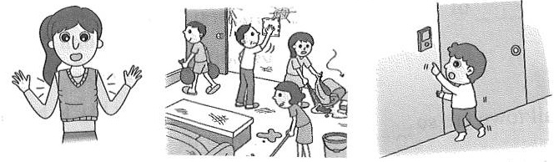

A B C
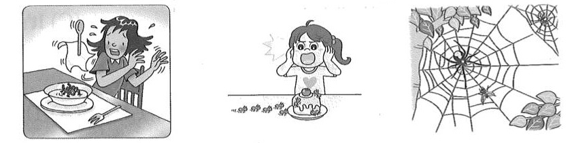

A B C
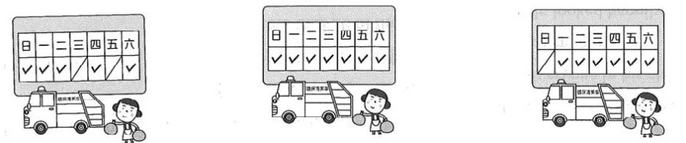

A B C
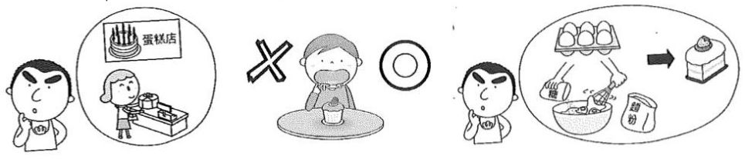

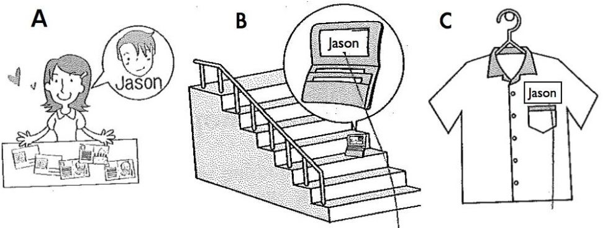
B.基本問答：根據聽到的內容，選出合適的回應。(10%)
- (A) No, I can’t fix the computer. (B) Yes, it was. It is now working again. (C) Yes, I can help you fix the computer.
- (A) I was too scared to say anything. (B) Being ugly isn’t a serious problem. (C) Get enough sleep, wash your face often and go to see a doctor.
- (A) Dad is too old to get angry. (B) It’s difficult to communicate with Dad. He never listens to what I say. (C) That’s because he ate the cake on the table.
- (A) Thanks, but I am full. (B) What does the horse meat taste like? (C) I have two hamburgers. Do you want one?
- (A) I bought the new cellphone two months ago. (B) Sure. You can use my cellphone. (C) No, I’ve never used this kind of cellphone.
C.言談理解：根據聽到的對話內容與問題，選出正確的答案。(10%)
- (A) A writer’s house. (B) A writer’s desk. (C) A writer’s book.
- (A) A man found a woman’s bag. (B) A man took a woman’s bag and ran away. (C) Peter didn’t call the police.
- (A) Sara always finishes work on time. (B) The woman tries to help Sara. (C) Sara’s boss is mad at her.
- (A) She sold the ring. (B) She told Andy she lost the ring. (C) The ring was given to Andy by the woman.
- (A) She doesn’t like dogs. (B) Her husband is scared of dogs. (C) She doesn’t have time to take care of them.
二、綜合測驗(40%)
- Nothing was thrown away by Leo except old school . (A) sights (B) mask (C) uniforms (D) leather
- Don’t you think that is important for job interviews? (A) sight (B) notice (C) smoke (D) appearance
- The waiters are asked to be , and they should always . (A) special; laugh (B) honest; cry (C) strong; honest (D) polite; smile
- The man many times not to smoke in the car.
(A) has told (B) was being told (C) told (D) has been told
- The bad guy is afraid of by the police.
(A) having caught (B) have been caught (C) catching (D) being caught
- He lives , so he has to fly to visit friends. (A) in the west; east (B) in west; east (C)in west; the east (D) in the west; the east
- The airport was shut down because of the (A) newspaper (B) lighter (C) typhoon (D) sight
- Tina: Why were you so late? Betty: I am sorry.
(A) I can’t agree more. (B) Count me in. (C) You can say that again. (D) I was caught in the traffic jam.
- Cathy just wants to know the chance to have an interview with Ben tomorrow.
(A) if she has (B) who will have (C) why will she have (D) when will she have
- Can you tell me you have heard the story at least three times.
(A) that; tell (B) if; told (C) what; told (D) if ; tell
- 選出正確句子: (A) The coat is so small that I can’t wear. (B) The soup is too hot for me to have it.
(C) Four-meters-high nets are set up to stop the butterflies from killing by the traffic. (D) Tell me whether to go.
- I don’t know if John tomorrow, but if he , you will be the first one know about it.
(A) comes; does; to (B)will come; does; to (C) will come; will; to (D) comes; will; X
- 選出正確句子: (A) Peter was seen listen to music by us on the street. (B) The boy was made mop the floor by Tina. (C) Whether it rains or not, I will go shopping this afternoon. (D) Can you teach me how to turn down others?
- That building is so weak , ?
(A) that no one can stay in; can it? (B) that no one can stay in; isn’t it
(C) to stay in; isn’t it (D) that no one can stay in it; isn’t it?
- I have no idea with my report. It was too difficult for me.
(A) who to do (B) how to do it (C) what to do (D) when to do
- Do you know ? (A) what is happened (B) why Mary goes to school without eat breakfast
(C) who to play with (D) if it rains tomorrow?
- Tell me how much money .
(A) were you given (B) you will give it away (C) you spent on it (D) did you get
- By which team the game tomorrow?
(A) did; win (B) is; going to be won (C) will; win (D) has; been won
- 選出正確句子: (A) If the team loses, people go home sadly, but the team will still be loved. (B) A computer was given her as a birthday gift. (C) For your health, you are supposed quit smoke. (D) The questions are not easy enough for us to answer them.
- Lily: Why didn’t you answer my phone last night? Betty: (A) Are you kidding? (B) Tell me where you were? (C) I don’t know what you said. (D) I was at the party. The music was so loud that I couldn’t hear the phone ring.
三、閱讀測驗(10%)
A
How much sleep do we need? We are all different. Some people need only three hours of sleep a night. Others need ten hours of sleep a night. Most Americans sleep an average of seven to eight hours a night. After age fifty, the average sleep time goes down to 6.5 hours a night.
Most people have a night when they can’t sleep. About one in three Americans has a problem with sleep. Many of them can’t fall asleep. The name of this problem is insomnia.
This is not a new problem. Many famous people in history had insomnia. Some of these people had special ideas to make them sleep. Benjamin Franklin, the famous inventor, had four beds. He moved from one to the other to fall asleep. King Louis XIV of France had 413 beds and hoped to fall asleep in one of them. Mark Twain, the famous author, had a different way. He lay on his side across the end of the bed.

- Benjamin Franklin, King Louis XIV of France and Mark Twain had . (A) four beds (B) four hundred and thirteen beds (C) a good time (D) insomnia
- Which is correct: (A) After age fifty, the average sleep time is 5.5 hours a day. (B) One in four Americans has a problem with sleep. (C) Mark Twain is a famous writer (D) Benjamin Franklin lay on his side across the end of the bed.
B
Louis Braille was born near Paris, France. He was a smart child and he liked to play with his father’s work tools. One day, when he was four, a sharp tool went into his left eye. An infection started and went to both eyes. A few weeks later, he was blind.
At age ten, Louis went to a school for blind children in Paris. One day, a French soldier, Charles Barbier, visited the school. Barbier invented a system of night-reading. The system used dots for the letters of the alphabet. Soldiers used this system in time of war. Barbier thought this system could help blind people to read.
Barbier’s system was difficult, but it gave Louis an idea. He made the system easier. By age fifteen, his new system was ready! He wanted blind schools to use his system, but the school didn’t want his system. Louis died in 1852 at age forty-three. Two years after he died, the blind school began to use his system.
Today we call the system Braille after Louis Braille. His system is used for all languages, and for math, science, writing music and computers for the blind.
infection感染
- Barbier’s system used for the letters of the alphabet. (A) tools (B) dots (C) sound (D) sight
- Louis Braille (A) invented a system of night-reading (B) visited soldiers (C) made Barbier’s system easier
(D) was blind because a sharp tool went into his right eye
- Which is correct:
(A) Louis Braille was blind when he was born.
(B) Barbier thought his system could help the blind people to play.
(C) Braille is used for all languages for the blind people
(D) Soldiers used Braille in time of war.

四 依提示改寫(4%)
- The fact was so terrible that my sister couldn’t believe it. ( 改…too…to)
- Did teenagers sing the song?(改為被動句)
五 翻譯(16%)
- 我記不得到目前為止被蜘蛛咬過多少次。(3%)
- 在那瞬間，他覺得很茫然，他不知道在不同國家工作是否是正確的選擇。(4%)
- 他讓我了解找到自己所擅長的事有多重要。(3%)
- 他再也不擔心了因為有自信比長得高更有吸引力。(3%)
- 他們是如此的熱心所以每年捐很多錢給育幼院。(3%)

新北市立溪崑國民中學106學年度第一學期第二次定期評量 英語科 答案卷
九年級 班 座號 姓名
四 依提示改寫(4%)
41 (2%)

42 (2%)

五 翻譯(16%)
43 (3%)

44 (4%)

45 (3%)

46 (3%)

47 (3%)

106-1-2九年級英語科－解答
一、聽力測驗(30%)
1-5. CCCCB
6-10. BCBCC
11-15. BBABB
二、綜合測驗(40%)
16-20 CDDDD
21-25 ACDBB
26-30 DBCDC
31-35 CCBAD
三、閱讀測驗(10%)
36-40 DCBCC
四 依提示改寫(4%)
41 The fact was too terrible for my sister to believe.
42 Was the song sung by teenagers?
五 翻譯(16%)
43 I can’t remember how many times I have been bitten by a spider so far.
44 At that moment, he felt very lost and he didn’t know whether it was a correct decision to work in a different country.
45 He makes me understand how important it is to find out what I am good at.
46 He is not worried any more because being confident is more attractive than being tall.
47 They are so warm- hearted that they donate a lot of money to the children’s home every year.

新北市立溪崑國民中學106學年度第一學期第二次定期評量
九年級 英語科 聽力測驗稿( )
一、聽力測驗(30%)
A.辨識句意：根據聽到的內容，選出符合描述的圖片。(10%)
- The boy is not tall enough to reach the door bell.
- Spiders build webs to catch insects for food.
- Garbage is not collected on Sundays
- The man is wondering how to make the cake.
- The wallet on the stairs belongs to Jackson.
B.基本問答：根據聽到的內容，選出合適的回應。(10%)
- The computer was fixed by your brother, wasn’t it? (A) No, I can’t fix the computer. (B) Yes, it was. It is now working again. (C) Yes, I can help you fix the computer.
- I have acne on my face. No one wants to make friends with me. Tell me what to do? (A) I was too scared to say anything. (B) Being ugly isn’t a serious problem. (C) Get enough sleep, wash your face often and go to see a doctor.
- Joan, Dad seems to be angry with you. Can you tell me what happened? (A) Dad is too old to get angry. (B) It’s difficult to communicate with Dad. He never listens to what I say. (C) That’s because he ate the cake on the table.
- I am so hungry that I can eat a horse. (A) Thanks, but I am full. (B) What does the horse meat taste like? (C) I have two hamburgers. Do you want one?
- Can you tell me how to turn off the new cellphone? (A) I bought the new cellphone two months ago. (B) Sure. You can use my cellphone. (C) No, I’ve never used this kind of cellphone.
C.言談理解：根據聽到的對話內容與問題，選出正確的答案。(10%)
- W: Hi, everyone. Please come closer so that you can see the desk. It has been in this room for over 100 years. It is the famous writer’s desk and many great books had been written at the desk.
Q: What is the woman talking about?
- A writer’s house. (B) A writer’s desk. (C) A writer’s book.
- W: Tell me what you saw last night, Peter.
M: I saw a man and a woman fight in front of the park. Then, the man took the woman’s bag.
W: Did you notice which way the man ran to?
M: Yes, he ran to Ocean Road. The woman got hurt, so I called the police first.
Q: What happened?
- A man found a woman’s bag. (B) A man took a woman’s bag and ran away. (C) Peter didn’t call the police.
- M: I heard that Sara didn’t finish the work again.
W: Again? But she always stays late in the office. How could this happen?
M: I don’t know. The only thing I know is that our boss is very angry at her.
W: Maybe she needs to be pushed. Let’s see how we can help her.
Q: Which is not true?
(A) Sara always finishes work on time. (B) The woman tries to help Sara. (C) Sara’s boss is mad at her.
- M: Where is the ring that I gave you? Did you sell it?
W: Oh, Andy. I won’t do that. I lost it in the swimming pool a few weeks ago.
M: What?
W: I liked it so much that I didn’t want to take it off when I swam. I am so sorry.
Q: Which is true?
- She sold the ring. (B) She told Andy she lost the ring. (C) The ring was bought for Andy by the woman.
- M: All your family members keep pets. Why don’t you have one?
W: I love dogs , but my husband stops me from keeping one.
M: Doesn’t he love dogs?
W: No. He is afraid of dogs. He was bitten by a dog before.
Q: Why doesn’t the woman keep pets?
(A) She doesn’t like dogs. (B) Her husband is scared of dogs. (C) She doesn’t have time to take care of them.

