新北市立溪崑國民中學106學年度第一學期第三次定期評量 英語科 試題卷
九年級 班 座號 姓名

一、聽力測驗 30%

A. 辨識句意：根據聽到的內容，選出符合描述的圖片或符合圖片的描述。
- (Ａ) 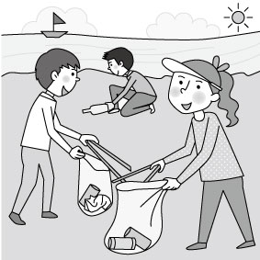 (Ｂ) 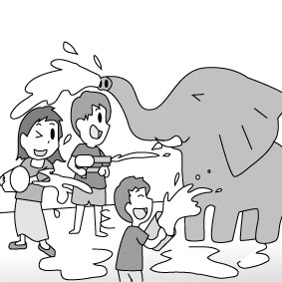 (Ｃ) 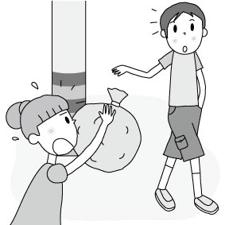
- (Ａ) 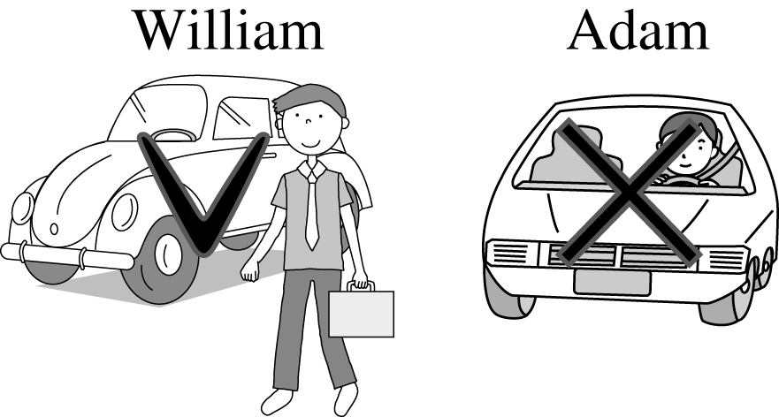 (Ｂ) 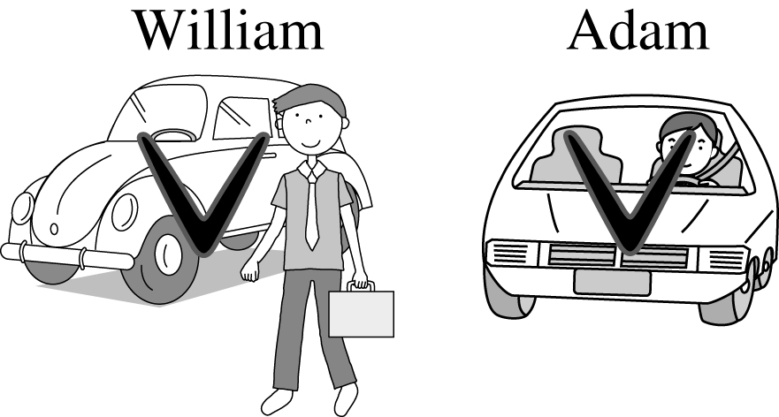 (Ｃ) 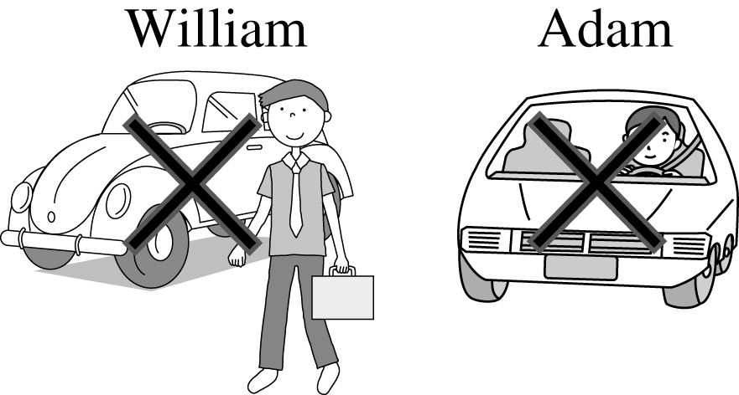
- (Ａ) 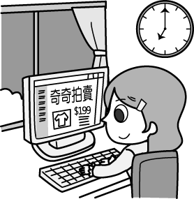 (Ｂ) 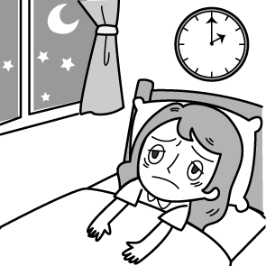 (Ｃ) 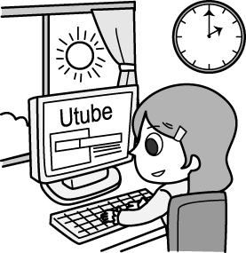
- (Ａ) 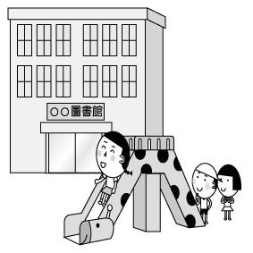 (Ｂ) 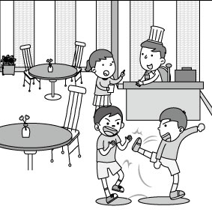 (Ｃ) 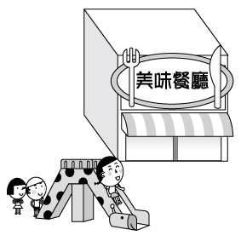
- 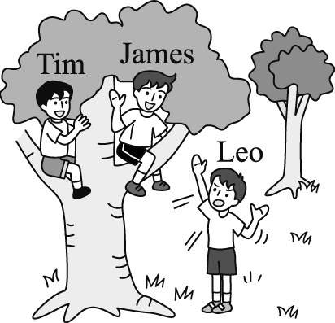

B.基本問答：根據聽到的內容，選出一個最適合的回應或最適合的問句。
- (Ａ) She’s good at badminton.
(Ｂ) She is wearing a white dress.
(Ｃ) She is Lynn’s sister, Rebecca.
- (Ａ) Me, either. However, I like indoor activities like playing chess.
(Ｂ) Swimming, jogging, and playing sports are good hobbies.
(Ｃ) Use your time wisely if you want to do outdoor activities.
- (Ａ) I’ll clean my room and tidy it up.
(Ｂ) Let me fix the floor problem.
(Ｃ) My room is on the second floor.
- (Ａ) No, he didn’t break anything of mine.
(Ｂ) Yes, I don’t like a boy who only cares about my appearance.
(Ｃ) No way! Sandra and Ryan have known each other since they were kids.
- (Ａ) I don’t like to tell stories to strangers.
(Ｂ) We can’t do that because we live in a five-story apartment.
(Ｃ) Wow! I’m really glad the story I told interests you.

C. 言談理解：根據聽到的內容，選出一個最適合的答案。
- (Ａ) She got a day off.
(Ｂ) She smiled at everyone she came across.
(Ｃ) She did something good to a child.

- (Ａ) She looks serious.
(Ｂ) She doesn’t smile.
(Ｃ) She lives next to David.

- (Ａ) Thirty years ago.
(Ｂ) Fifty years ago.
(Ｃ) Sixty years ago.

- (Ａ) She is the woman’s boss.
(Ｂ) She is the man’s wife.
(Ｃ) She is Kevin’s wife.

- (Ａ) The girl is looking at a web page.
(Ｂ) The boy knows nothing about Greg Smith.
(Ｃ) They are going to fix the garbage problem.

二 綜合測驗 70%
- We tried making pizza at school last week. But it wasn’t _____, we’ll try again this week.
(A) polite (B) successful (C) hard-working (D) helpful
- My brother is crazy about toy cars. He has ______ more than fifty toy cars in his box.
(A) collected (B) corrected (C) touched (D) prepared
- There is much ______ in our house. There will be no problem for you to stay.
(A) air (B) ground (C) space (D) floor
- The boys ___ the table and do the dishes after dinner every day.
(A) pick up (B) turn down (C) get on (D) tidy up
- David : I finally passed the swimming test. Vivian : Oh really? ______
(A) Just kidding. (B) You said it. (C) Good for you. (D) A piece of cake.
- ______ they get the latest news, they will take action right away.
(A) As soon as (B) As for (C) What if (D) So far
- Cathy : Mr. Wang seldom has breakfast at home with his wife.
Betty : _________ Mr. Lee.
(A) So has (B) So does (C) Neither has (D)Neither does
- Studying is important, and _____.
(A) so have fun is (B) so having fun is
(C) so is having fun (D) so does have fun
- The girl ___ a yellow dress helped us clean the classroom.
(A) in (B) on (C) to (D) at
- The song ____ sounds great! Was it written by Jay Chou?
(A) that you are listening (B) which are playing
(C) A-mei is singing (D) is sung by A-mei
- Mary is very satisfied with the report which _____ her about two weeks to finish.
(A) spend (B) cost (C) paid (D) took
- It’s sweet _____ Jane to help her classmates with English homework.
(A) for (B) with (C) of (D) on
- A: Who is the woman _______ Alex is talking to ? B: That’s Ms. Lin, his English teacher.
(A) that (B) who (C) where (D) which
- Did Bob buy the book ______ ?
(A)which he is interested (B) which interests him
(C)which he is interesting (D) which he is interesting to
- Do you know the woman ____?
(A) that Vivian is talking with (B) she wears a heavy coat
(C) was singing at the party (D) who are talking on the cellphone
- The postman Derek is talking to is my uncle.
(A) My uncle tells me that Derek is a postman.
(B) The postman is Derek’s uncle.
(C) Derek is talking to my uncle.
(D) My uncle is talking to the postman.
- I really want to stay in a hotel _________.
(A) that there is a big swimming pool (B) which provides free breakfast
(C) where are fewer customers (D) where has a beautiful view
- Which is correct?
(A) Jack likes birds, so his mom wants to buy another as his present.
(B) One of the questions in the math test is easy; others are difficult.
(C) Some of the students in the classroom are reading, but the others are sleeping.
(D) Mr. Brown has two foreign students in his class. One is from Korea, and another is from Japan.
- Which is correct?
(A) Play on-line games for too much time is bad for your eyes.
(B) Think carefully before you make any decisions, or you’ll be sorry for it.
(C) Buy a new car, you have to make lots of money.
(D) Eating enough fruit and vegetable help you keep healthy.
- The song which is popular with teenagers made Jolin _______.
(A) to be famous (B) becoming famous (C) to famous (D) a famous singer
- Peter seemed _____ very tired after school, so he went to bed without eating dinner.
(A) to be (B) has been (C) being (D) he is
- The dog couldn’t find its owner. It must _______.
(A) lost (B) lose (C) got lost (D) be lost
If you ask a Taiwan student what “Black Friday” is , you probably get the answer like “Friday the thirteenth.” However, that is not the case. In fact, the day after Thanksgiving is called Black Friday in the United States. But why? In Western countries, the color black often means something bad and terrible. So is Black Friday really a bad day? NO. Black Friday is the first shopping day for the Christmas holidays. It is usually one of the busiest shopping days of the year. It is called “black” because businesses hope to be in the black on this day! To get more people to spend money, many stores open as early as 5 a.m. For the first shopping hours, stores have special sales on popular products. Therefore, each year in the cold winter people try to get some of the best deals as soon as the shops and malls open. It is not surprising that the stores want their customers to buy those on sale and of course many other things. If the buyers spend much more money than they plan to, it is surely a very good Black Friday.

customer 顧客 product 產品 deal 划算

- What is the main idea of this reading?
(A) Telling people how to get the best deals in stores.
(B) Telling people what Black Friday is.
(C) Bad things are happening on Friday the thirteenth.
(D) Shopping holiday in the United States.
- What does the idiom “in the black”?
(A) To turn things from bad to worse.
(B) To get the best deals.
(C) To make the customers feel terrible.
(D) To make a lot of money.
- Which is true according to the article?
(A) In Western countries, the color black often means something popular.
(B) Americans can shop for the gifts at a low price on Black Friday.
(C) Most stores have special sales only after Christmas holidays.
(D) Stores in the United States open at five p.m. on Fridays.

Feeding the homeless is not the only thing that keeps this girl 41 . She also 42 her free time 42 small houses for the homeless. Her first house was a small wooden one 43 provided about 3 square meters of living space. It was big enough for a person to 44 comfortably. “It just doesn’t seem right 45 . I think everyone should have a place to live.” She said in a news report.

- (A) be busy (B) being busy (C) to busy (D) busy
- (A) spent; building (B) spent; to build (C) spends; building (D) spends; to build
- (A) X (B) who (C) whom (D) which
- (A) fall off (B) hand in (C) lie down (D) pick up
- (A) that there have homeless people (B) that it has homeless people
(C) there have homeless people (D) that there are homeless people

Kevin was a young man 46 worked in Taipei. He enjoyed fishing, but he didn’t have a chance to practice it. One summer he decided to take a few days off and spend his holiday in a beautiful place in the mountains where there were a lot of streams. “I should 47 have some good fishing there, “ he said to himself.
The first morning after he arrived, he walked to the nearest stream with his fishing-rod. He saw and old man 48 beside the water, so he asked him 49 it was a private stream. The old man answered that it was not, so Kevin then said to him, “Well, then it won’t be a crime if I catch some fish here, 50 ?”
“Oh, no,” answered the old man, “ it won’t be a crime, but it will surely be a miracle.”

stream 溪流 fishing-rod 釣魚竿 private 私有的 crime 犯罪 miracle 奇蹟

- (A) who (B) which (C) whose (D) X
- (A) can (B) be able to (C) may (D) must
- (A) to stand (B) stood (C) standing (D) stands
- (A) X (B) that (C) which (D) whether
- (A) don’t I (B) will it (C) isn’t it (D) will I

新北市立溪崑國民中學106學年度第一學期第三次定期評量
九年級 英語科 聽力測驗稿( )
1. The girl helps save the Earth, and the boy does, too.
2. William never drives to work, and neither does Adam.
3. Belle woke up at 2 a.m. and didn’t have a sound sleep.
4. The restaurant provides a playground for children to play.
5. Look at picture. Which is true?

6. Who is the girl in white?
7. I don’t like to do outdoor activities, Jack.
8. Your room is so dirty and your clothes are all over the floor.
9. Jason told me you broke up with Ryan, Sandra. Is it true?
10. Please tell me the interesting story you told me last weekend again, Mom.

11. M: You look very happy. Anything good happened today?
W: Oh. I gave my seat to a child. Her mom gave a big smile and said, “Thank you.”
Q: Why did the woman feel happy?
12. M: Is the girl with long hair called Jessica? She looks serious.
W: The girl next to David? Yes, she is. She seldom smiles, so she looks serious.
Q: What is true about Jessica?
13. M: This is the house in which I have lived for thirty years. It was built by my father fifty years ago.
I really don’t want to sell it.
W: Honey, you don’t have to. Let’s fix it and repaint it. I think we can still live in it for another thirty years.
M: Thanks, Lisa. You’re really sweet.
Q : How long ago was the house built?
14. W: The man who I said hi to is my boss, Kevin.
M: He looks nice and kind.
W: Yes, he does.
M: Do you know the woman who stands near the door?
W: No. Who is she?
M: She is Kevin’s wife.
W: Are you serious?
Q: Who is the woman that stands near the door?
15. B: What are you looking at ?
G: A fan page of an amazing guy.
B: How amazing? Tell me more about it.
G: His name is Greg Smith, and…
B: Wait! Is he the one who is trying to fix the ocean’s garbage problem?
G: You’re right! He has done a lot to make the world a better place.
Q: Which is true?

106-1-3 九年級 英語科－解答
1 | 2 | 3 | 4 | 5 | 6 | 7 | 8 | 9 | 10
A | C | B | C | A | C | A | A | B | C
11 | 12 | 13 | 14 | 15 | 16 | 17 | 18 | 19 | 20
C | A | B | C | A | B | A | C | D | C
21 | 22 | 23 | 24 | 25 | 26 | 27 | 28 | 29 | 30
A | D | C | A | C | D | C | A | B | A
31 | 32 | 33 | 34 | 35 | 36 | 37 | 38 | 39 | 40
C | B | C | B | D | A | D | B | D | B
41 | 42 | 43 | 44 | 45 | 46 | 47 | 48 | 49 | 50
D | C | D | C | D | A | B | C | D | B

