新北市立溪崑國民中學106學年度第一學期第二次定期評量 英語科 試題卷
八年級 班 座號 姓名
一、辨識句意：根據聽到的內容，選出符合描述的圖片(每題2分)
1. (A) 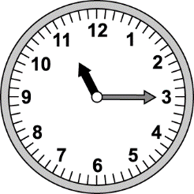 (B) 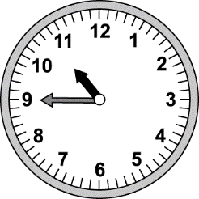 (C) 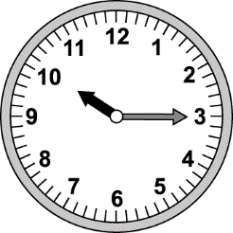
2. (A) 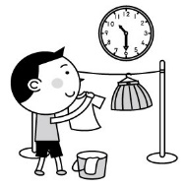 (B) 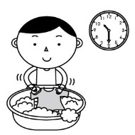 (C) 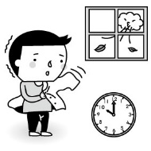
3. (A) 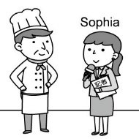 (B) 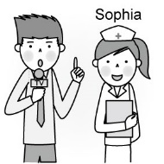 (C) 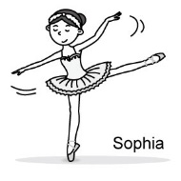
4. (A) 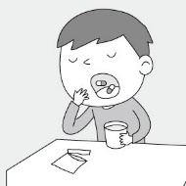 (B) 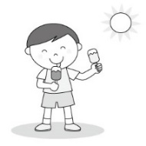 (C) 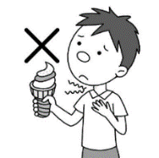
5. (A) 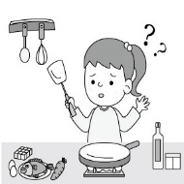 (B) 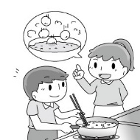 (C) 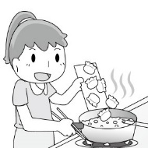
二、基本問答：根據聽到的內容，選出一個最適合的回應句(每題2分)
6. (A) Sorry, I was taking a nap, so I missed your call.
(B) I looked for my ring, but I couldn’t find it.
(C) Why didn’t you call me after that?
7. (A) The watch is mine. I wore it at dinner.
(B) I found a watch under the sofa. Is it Mark’s?
(C) I didn’t see it. It may be somewhere in the living room.
8. (A) I plan to teach English in a junior high school.
(B) I listen to English songs and read English novels.
(C) I am not good at English, so I have to learn more.
9. (A) I enjoy reading comic books like you.
(B) I like this movie very much.
(C) I love dancing.
10. (A) She usually goes to the doctor.
(B) She exercises and eats healthy food.
(C) She can eat, run, and play sports.
【背 面 有 題】
三、言談理解：根據聽到的對話，選出最適合的答案(每題2分)
11. (A) Their weekend plans. (B) Their parents’ jobs. (C) Their future jobs.
12. (A) Lisa has a headache. (B) Lisa took some medicine. (C) Lisa needs to go to a doctor now.
13. (A) He takes out the garbage. (B) He washes the clothes. (C) He does the dishes.
14. (A) Breakfast. (B) Lunch. (C) Dinner.
15. (A) A TV reporter. (B) A waiter. (C) An actor.

四、閱讀測驗：(每題2分)；共16%
(一)
（Line 1） How many roads must a man walk down
Before you call him a man
How many seas must a white dove sail
Before she sleeps in the sand

（Line 5） How many times must a man look up
Before he can see the sky
How many ears must one man have
Before he can hear people cry

（Line 9） The answer, my friend, is blowing in the wind
The answer is blowing in the wind

--By Bob Dylan
dove 鴿子 sail 飛行 sand 沙子

16. What is the tone of the poem?
(A) Nervous. (B) Exciting. (C) Easy. (D) Questioning.
tone 語調
poem 詩
rhymed 押韻
17. Which pair of words are NOT rhymed?
(A) Lines 1 and 5: down, up. (B) Lines 2 and 4: man, sand.
(C) Lines 6 and 8: sky, cry. (D) Lines 9 and 10: wind, wind.
18. What does the writer try to say at line 1 and 2?
(A) If people need to be healthy, keep exercising.
(B) People have to keep walking for a lifetime.
(C) Hard work can make people stronger.
(D) It is hard to count how far people can go.
19. What does it mean “ The answer is blowing in the wind.”?
(A) There is not a right or wrong answer.
(B) The answer is lost and never comes back.
(C) Only the writer’s friend knows the answer.
(D) “Wind” is the best answer to the questions.

【請 續 下 頁】
(二)
2017 Summer Universiade in Taipei
The Summer Universiade is the biggest sporting event ever hosted in Taiwan. The motto of the event is “For You. For Youth.” The mascot of the games is Bravo, a Formosan black bear. It was adopted to represent hope as the athletes make their dreams come true.
The 29th Summer Universiade was held in Taipei from August 19 to August 30, 2017. The Universiade is an international sporting event, organized for university athletes by the International University Sports Federation (FISU). The name of the world university games, “Universiade,” comes from the words “University” and “Olympiade.” Since 1959, the Universiade has been organized by the FISU every two years in different cities. In 2011, Taiwan defeated Brazil and won the right to host the 2017 Summer Universiade.
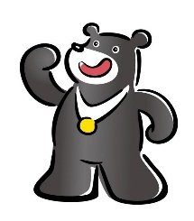

The Universiade consists of 22 sports, including billiards, tennis, badminton, weight-lifting, and so on. Over just 12 days, 12,000 young athletes from 150 nations participated in the game. They have striven for glory in arenas across northern Taiwan. Their passion in the pursuit of excellence has been a moving performance.

The 30th Summer Universiade will be held in Napoli, Italy. Let’s see if Taiwanese athletes will keep making new world records in the next Summer Universiade.
There’s no doubt that Taipei Universiade has been a success. They turned this “mission impossible” into a “mission accomplished” which has given the citizens of Taipei more confidence and made them braver about trying to win. “To let the world see Taiwan” is no longer just a slogan but a reality. And Taipei, the city in transformation, shows his confidence as Taiwan moves forward into the future.
For people in Taiwan, outstanding performaces contribute to a strong finish at this event, 26 golds, 34 silvers, and 30 blondes. Taiwanese athletes have never won so many medals at an international competition and crossed so many sports. For many athletes from other countries, Taiwan has been a new experience, and Taipei has definitely offered them some memories to take home.
organized 舉辦 host 主辦 motto 座右銘 mascot 吉祥物 adopted 被採用 represent 代表 consist of 包括有 participate 參與 strive for glory 為了榮耀而奮鬥 arena 競技場
pursuit of excellence 追求卓越 contribute to 促成 accomplished 完成 transformation 轉變
Reference-- National Geographic Link--https://www.youtube.com/watch?v=eQFL5DZrZ7s

20. What does the word “defeated” mean in the first paragraph?
(A) To win. (B) To lose. (C) To hurt. (D) To skip.
21. When and where will the next Summer Universiade be held?
(A) In Italy in 2021. (B) In Napoli in 2019. (C) In Brazil in 1959. (D) In Taipei in 2017.
22. What is the greatest influence on Taiwanese people during the Taipei Universiade?
(A) A minor sporting event.
influence 影響
minor 次要的
(B) A mission impossible.
(C) A slogan only.
(D) An increase in confidence.
23. What is the most important goal of the Taipei Universiade?
(A) To let the world see Taiwan.
(B) To make the mascot Bravo famous.
(C) To watch young athletes strive for glory.
(D) For You. For Youth.
五、綜合測驗：(每題2分)；共24%
24. A-ga is a(n) at Kenting. He brings letters or packages to people five days a week.
(A) police officer (B) mail carrier (C) fisherman (D) factory worker
25. My brother is only at the age of sixteen. He is not to ride a motocycle.
(A) big enough (B) young enough (C) enough old (D) old enough
26. The mother is worried; her baby has a high and is coughing.
(A) fever (B) stomachache (C) throat (D) headache
27. Jack is looking for a new job. He has a(n) at ten tomorrow morning.
(A) change (B) company (C) interview (D) wedding
28. Please tell Bob for me. I still want to stay for a while. He can go home first.
(A) to wait (B) not to wait (C) waiting (D) don’t wait
29. It’s important for us enough sleep every day.
(A) getting (B) got (C) get (D) to get
30. A: Does Mary get up before ten on weekends? B: No. She doesn’t get up eleven.
(A) past (B) until (C) to (D) for
31. A: How can I become a good tennis player like Lu Yen-hsun?
B: That’s not hard.
(A) Just keep practicing. (B) We’re a team, remember?
(C) Do it now. (D) You need to keep a diary.
32. The movie is with people of all ages. Even a six-year-old kid likes it a lot.
(A) popular (B) special (C) healthy (D) enough
33. Oh my! Why is there so much trash under your chair? Clean it up now.
(A) popular (B) special (C) everywhere (D) enough
34. Jay: Who talking and laughing at that time?
Jolin: Peter and Cathy .
(A) was ; were (B) were ; were (C) are ; are (D) is ; are
35. Kevin was sick his terrible eating habits.
(A) because (B) thanks to (C) all over (D) because of
六、依提示作答：(每題2分)；共10%
36. We laughed at the poor boy. (用be sorry for…)
37. Is it 10:45 a.m.? (用Is it a….the morning? 改寫)
38. It’s wonderful to take a hot bath on a cold day. (用Ving…開頭)
39. the hairdresser / enjoy / eat junk food (依提示字順序造句)
40. My husband was hanging the clothes then. (依畫線部分造原問句)
七、翻譯：共20% 41-43題請注意空格順序!!
41. 積習難改。 (1) (2) (3) hard. (3%)
42. 這位女演員喜歡在Instagram上跟她的粉絲們分享她的照片。 (3%)
This (1) likes to (2) her photos (3) her fans on Instagram.
43. 對老師們來說記住(背誦)學生們的名字是不難的。(4%)
(1) students’ names (2) not d (3) (4) teachers.
44. 吃藥搭配茶或咖啡都是錯的。 (It’s …) (3%)
45. 你上次看到我的手機是在甚麼時候? (3%)
46. Kevin 計畫從現在起規律吃三餐以及一週運動三次。(4%)

新北市立溪崑國民中學106學年度第一學期第二次定期評量 英語科 答案卷
八年級 班 座號 姓名
六、依提示作答：(每題2分)；共10%
36
37
38
39
40

七、翻譯：共20% (每格1分) 41-43題請注意空格順序!!
41
42
43
44
45
46

106-1-2 八年級 英語科－解答
一~三：聽力測驗
1-10 BAACA ACBCB
11-15 CBBAC
四：閱讀測驗
16-19 DACA 20-23 ABDA
五：綜合測驗
24-25 BD 26-30 ACBDB
31-35 AACAD
六：提示作答 (每題2分)
36. We were sorry for laughing at the poor boy.
37. Is it a quarter to eleven in the morning?
38. Taking a hot bath on a cold day is wonderful.
39. The hairdresser enjoys eating junk food.
40. What was your husband doing then?
七：翻譯 (每格1分)
41 | Old | habits |  | die
42 | actress | share |  | with
43 | Memorizing | is | difficult |  | for
44 | (3%)It’s wrong to take (the) medicine with tea or coffee.
45 | (3%)When did you last see my cellphone?
46 | (4%)Kevin plans to have/eat regular meals  and exercise three times a week from now on.

新北市立溪崑國民中學106學年度第一學期第二次定期評量
八年級 英語科 聽力測驗稿( )
一、辨識句意：根據聽到的內容，選出符合描述的圖片
1. It’s a quarter to eleven. Time for bed. B L4
(Ａ) (Ｂ) (Ｃ)
2. The boy was hanging the clothes at half past ten. A L4
(Ａ) 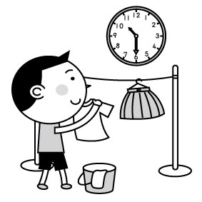 (Ｂ) 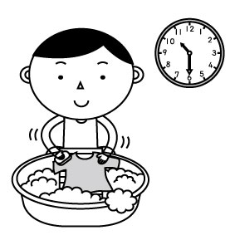 (Ｃ) 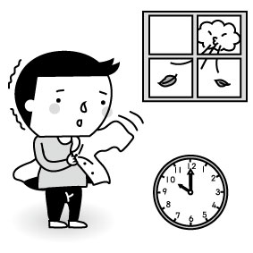
3. Sophia wants to be a reporter. A L5
(Ａ) 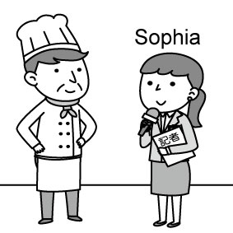 (Ｂ) 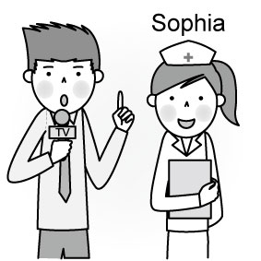 (Ｃ) 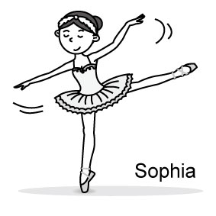
4. It’s wrong to eat ice cream when having a sore throat. C L6
(Ａ) 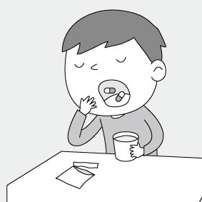 (Ｂ) 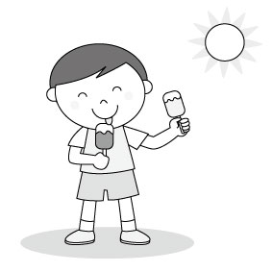 (Ｃ) 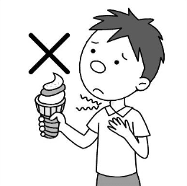
5. Cooking is difficult for the little girl. A L6
(Ａ) 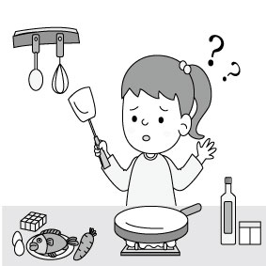 (Ｂ) 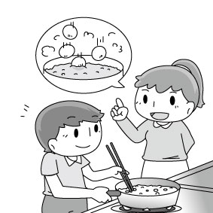 (Ｃ) 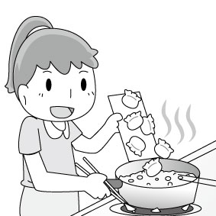

二、基本問答：根據聽到的內容，選出一個最適合的回應句
6. Jack, I called you at seven last night, but you didn’t answer. What were you doing at that time? A L4
A) Sorry, I was taking a nap, so I missed your call.
B) I looked for my ring, but I couldn’t find it.
C) Why didn’t you call me after that?
7. I put my watch on the table this morning, but now I can’t find it. Any ideas? C L4
A) The watch is mine. I wore it at dinner.
B) I found a watch under the sofa. Is it Mark’s?
C) I didn’t see it. I may be somewhere in the living room.
8. Your English is quite good. How did you do it? B L5
A) I plan to teach English in a junior high school.
B) I listen to English songs and read English novels.
C) I am not good at English, so I have to learn more.
9. I enjoy watching movies and playing basketball. How about you? C L5
A) I enjoy reading comic books like you.
B) I like this movie very much.
C) I love dancing.
10. Your grandma is ninety-seven years old, but she is very healthy. How does she do it? B L6
A) She usually goes to the doctor.
B) She exercises and eats healthy food.
C) She can eat. run, and play sports.
三、言談理解：根據聽到的對話，選出最適合的答案
11. G: What do you want to be in the future, John? C (L5)
B: I want to be a mail carrier. What about you, Linda?
G: I want to be a doctor that takes care of children, just like my mom.
Q: What are they talking about?
A) Their weekend plans.
B) Their parents’ jobs.
C) Their future jobs.

12. B: What’s wrong with Lisa? She looks pale. B (L6)
G: She has a stomachache, so she needs to take a rest now.
B: Did she see a doctor?
G: Yes. She also took some medicine, but her stomach still hurts.
Q: Which is true?
A) Lisa has a headache.
B) Lisa took some medicine.
C) Lisa needs to go to a doctor now.
13. G: Did you do housework every day? B (L4)
B: Not really. I take out the trash every other day and do the laundry once a week.
Q: What does the man do once a week?
A) He takes out the garbage.
B) He washes the clothes.
C) He does the dishes.
14. G: I’m hungry. Is there anything to eat? A (L6)
B: It’s only half after nine. Isn’t it too early for lunch?
G: Hmmm…I didn’t have breakfast today.
B: Hey! Eating breakfast is important for your health. Here. Have an apple.
Q: Which meal did the woman skip?
A) Breakfast.
B) Lunch.
C) Dinner.
15. B: I memorize a lot of lines when I work. I often play different roles on the stage. Sometimes people interview me, and many people clap for me. I really like my job. Thank you very much.
Q: What does the man do? C (L5)
A) A TV reporter.
B) A waiter.
C) An actor.

