新北市立溪崑國民中學106學年度第一學期第二次定期評量 英語科 試題卷
七年級 班 座號 姓名
第一部分: 聽力測驗 30%
一、辨識句意：每題均有三張圖片，請依據所聽到的句子，選出符合描述的圖片(10%)
- (A) 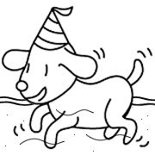 (B) 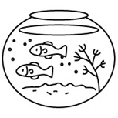 (C) 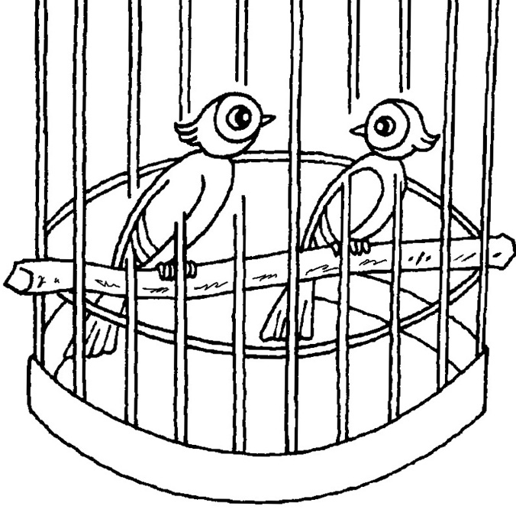
- (A) 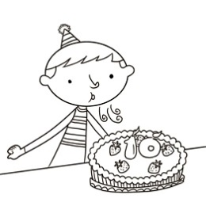 (B) 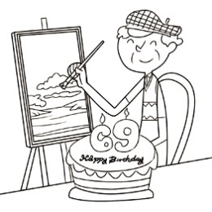 (C) 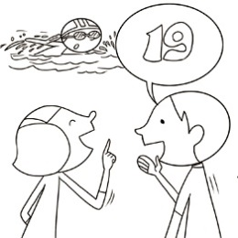
- (A) 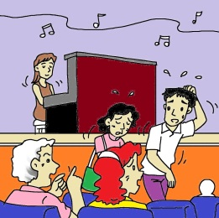 (B)  (C) 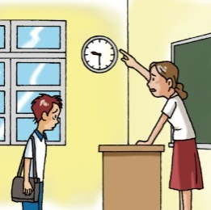
- (A) 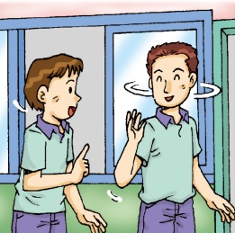 (B) 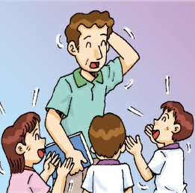 (C) 
- (A) 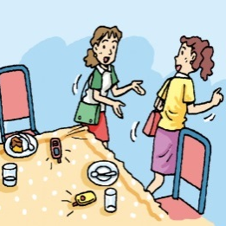 (B) 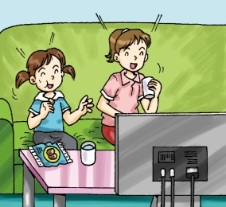 (C) 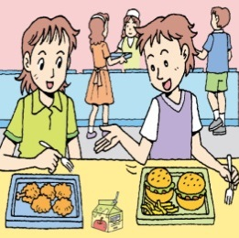
二、基本問答：每題均有三個選項，請依據所聽到的內容，選出一個最適合的回應(10%)
- (A) No. I am a student.
(B) No. I am sixteen.
(C) No. I’m from Canada.
- (A) No, he is thin.
(B) No, he is heavy.
(C) My father is a thin man.
- (A) Yes, but her books are not so popular here.
(B) No, she is not famous for her special voice.
(C) Well, she is a beautiful woman from France.
- (A) Those people are Mr. and Mrs. Lee’s sons.
(B) You’re right. They are too heavy and too ugly.
(C) Well, those singers are here for our son’s birthday.
- (A) OK. Let’s talk.
(B) Take this with you.
(C) Hurry. The show is on.
三、言談理解：每題均有三個選項，請依據所聽到的對話與問題，選出一個最適當的答案(10%)
- (A) The UK.
(B) Canada.
(C) The USA.
- (A) He is famous in France.
(B) He is famous in the UK.
(C) He is a famous swimmer.
- (A) He is the woman’s favorite teacher.
(B) He is the woman’s favorite singer.
(C) He is the woman’s favorite song writer.
- (A) Jerry’s robot is trash.
(B) Jerry’s robot is on the seat.
(C) Jack is Jerry’s brother.
- (A) Don’t be late.
(B) Don’t stand up.
(C) Don’t make noise.
第二部分:綜合測驗 20%
( )16、A: Is that old your teacher?
B: No. She is my aunt, Stella.
(A) son (B) actor (C) lady (D) sir
( )17、Machael is an boy. He is really cute, and we all love him.
(A) one year old (B) one-year-old (C) eight years old (D) eight-year-old
( )18、A:Is her ? B:No, it’s not so good.
(A) voice beautiful (B) a beautiful voice (C) beautiful a voice (D) beautiful voice
( )19、Mrs.Wu: a good boy,Terry. Terry: Yes, Mrs.Wu.
(A) Do (B) Please (C) Be (D) Is
( )20、Which is right?
(A) Chocolate is my teacher favorite food. (B) They are from the UK. (C) The song writer is from USA.
(D) His favorite food are hamburgers.
( )21、Which is NOT right?
(A) Jack , please be quiet. (B) Tina, follow the rules, please. (C) Please don’t turn on the TV , Tim.
(D) Let’s don’t leave our trash here.
( )22、A: your uncle,Tom, from France? B: . He’s from India.
(A) Are ; Yes (B) Is ; No (C) Are ; No (D) Is ; Yes
( )23、Is Jay Chou ? Yes, he is.
(A) a good song writer (B) good a song writer (C) a song good writer (D) good song writers
( )24、The movie is . Please turn your cellphone and be quiet.
(A) over ; of (B) on ; off (C) over ; on (D) on ; of
( )25、Let’s during the talent show and enjoy it.
(A) don’t eat or drink (B) not eating and drinking (C) be eat or drink (D) not eat or drink
第三部分:克漏字選擇10%
Tom: Welcome to our show, Tina. Where are you from?
Tina: 26 . It is a beautiful country with cherry blossoms in spring , and is always very clean and tidy.
Tom: Yes, it is. 27 , are cartoons really popular there?
Tina: No, not really. But my son’s favorite cartoons are all about Hayao Miyazaki .
Tom: You have a son, Tina? You are so young. 28
Tina: Twelve. He’s a smart boy.
Tom: 29 , is he here today?
Tina: Yes. Look! He’s 30 .
country國家 cherry blossoms櫻花 Hayao Miyazak宮崎駿

( ) 26、(A)The USA (B) Japan (C) France (D) The ROC
( A) 27、(A) By the way (B) Hurry up (C) Wait for me (D) Stand in line
( B) 28、(A) Where is he from? (B) How old is he? (C) Who is his father? (D) What is his name?
( ) 29、(A) No wonder (B) Not really (C) On (D) So
( ) 30、(A) sit down (B) turn off (C) over there (D) very late
第四部份:閱讀測驗10%
(一)
Good morning , boys and girls. Welcome to our new class . I’m your teacher, Mr.Huang. These are our class rules.
1. Do not talk when the teacher is talking.
2. Keep your hands, feet, and books to yourself.
3. Raise your hands to speak or leave your desk.
4. Wait patiently for your turn to share.
5. Keep your desk clean.
6. Hand in your homework on time with your name on it.
7. No running in the classroom or hallways.
Please follow the rules , do your best and enjoy your new semester!
yourself你自己 patiently耐心地 hallways走廊 semester學期 on time準時
( )31、This is mainly about . mainly 主要地
(A) the rules for the bus
(B) the books in the class
(C) the rules for the class
(D) Mr.Huang’s homework
( )32、What is NOT right in the class?
(A) Keep the desk clean.
(B) Talk when the teacher is talking.
(C) Hand in homework on time.
(D) Wait for your turn.
( )33、What is it in rule 6 ?
(A) Homework. (B) Your turn.
(C) Your desk. (D) Time.
(二)
Danny is in a hurry. He invites his friend , the dinosaur to his birthday party. “I am six years old today.”said Danny. “Will you come to my birthday party?” “I will be delighted,” said the dinosaur. Danny rides the dinosaur out of the museum.On the way, they pick up Danny’s friends. “Today I am a hundred years and one day old,”said the dinosaur.”Then it can be your party, too.”said Danny. The children and the dinosaur help Danny’s father hang up balloons. They eat the cake and sing the birthday song. The children sit down to rest. “Please don’t put your feet on the sofa,”said Danny.The dinosaur puts his feet out the window. Everyone enjoys the food and the party.
invite 邀請 said說 dinosaur恐龍 rest 休息
( )34、What is the meaning(意義) of “delighted” ? (A) Quiet. (B) Sorry. (C) Ugly. (D) Happy.
( )35、Which is right about the story?
(A) Danny is a hundred years and one day old. (B) Danny and the dinosaur are good friends.
(C) The children can put their feet on the sofa. (D) The dinosaur doesn’t like the party.

第五部分:非選擇題30%(✽以下答案請寫在答案卷上✽)
- 依提示回答4%
1、My brother is thirty , and my sister is twenty-seven years old. (依畫線部分造原問句)
2、Students are quiet in the classroom.(以祈使句並加入please改寫)
(二)翻譯填空及整句翻譯26%(1~4題每格1分,5~8題每句4分)
- 他們是可愛的北極熊。
They are cute (1) (2) .
2、他又矮又瘦,但他是個很好的游泳者。
He is short and (3) , but he is a good (4) .
3、Gary 的姊姊14歲,而他的母親40歲了。
Gary’s sister is (5) years old , and his mom is (6) .
4、注意聽!請不要把垃圾留在電影院中。
(7) ! Please don’t (8) the trash in the (9) (10) .
5、加拿大以它的楓樹葉聞名嗎?
6、我和我的雙胞胎哥哥上學遲到。
7、這不是我們去機器人工廠的公車。
8、讓我們遵守規則並且排好隊吧!

------試題結束-----

新北市立溪崑國民中學106學年度第一學期第二次定期評量 英語科 答案卷
七年級 班 座號 姓名
第五部分:非選擇題30%(✽以下答案請寫在答案卷上✽)
- 依提示回答4%

1、

2、

(二)翻譯填空及整句翻譯26%((1~4題每格1分,5~8題每句4分)
1、
1 | 2
2、
3 | 4
3、
5 | 6
4、
7 | 8 | 9 | 10

5、

6、

7、

8、

106-1-2 七年級
第一部分: 聽力測驗 30%
1~5 BBABA 6~10 CBACC
11~15 CBBCA
第二部分:綜合測驗 20%
16~20 CDACB 21~25 DBABD
第三部分:克漏字選擇10%
26~30 BABDC
第四部份:閱讀測驗10%
31~33 CBA 34~35 DB
第五部分:非選擇題30%(✽以下答案請寫在答案卷上✽)
- 依提示回答4%
1.How old are your brother and sister?
2.Students, be quiet in the classroom,please.
( Students, please be quiet in the classroom. )
(二)翻譯填空及整句翻譯26%((1~4題每格1分,5~8題每句4分)
1、
1 polar | 2 bears
2、
3 thin | 4 swimmer
3、
5 fourteen | 6 forty
4、
7 Listen | 8 leave | 9 movie | 10 theater
5、Is Canada famous for its maple leaves?
6、My twin brother and I are late for school.
7、This isn’t our(the) bus to the robot factory.
8、Let’s follow the rules and stand in line!

新北市立溪崑國民中學106學年度第一學期第二次定期評量
七年級 英語科 聽力測驗稿( )

一、辨識句意：每題均有三張圖片，請依據所聽到的句子，選出符合描述的圖片
- 《腳本區》
CD: These are my pets. They are good swimmers.
《題目區》
(A) (B) (C)
《答案區》
答案：B
- 《腳本區》
CD: This is Richard Thomas. He is sixty-nine years old.
《題目區》
(A)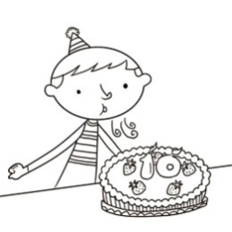 (B)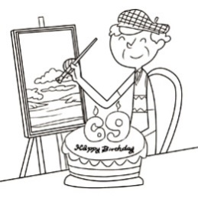(C)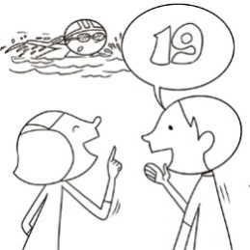
《答案區》
答案：B
- 《腳本區》
CD: The man and the woman are late for the show.
《題目區》
(A)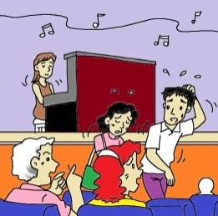 (B)(C)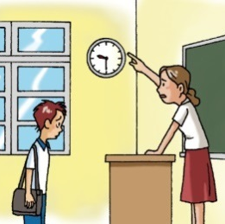
《答案區》
答案：A
- 《腳本區》
CD: Michael is very popular with young students.
《題目區》
(A) (B)(C)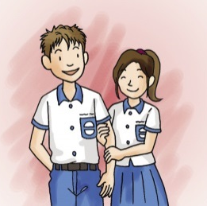
《答案區》
答案：B
- 《腳本區》
CD: The young ladies leave their cellphones on the table.
《題目區》
(A) (B)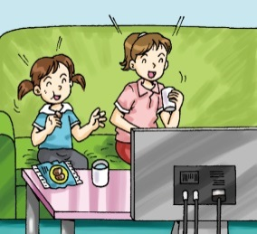(C)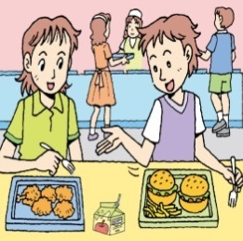
《答案區》
答案：A
二、基本問答：每題均有三個選項，請依據所聽到的內容，選出一個最適合的回應
- 《腳本區》
CD: Where are you from? Are you from the USA?
《題目區》
(A) No. I am a student.
(B) No. I am sixteen.
(C) No. I’m from Canada.
《答案區》
答案：C
- 《腳本區》
CD: Is your brother a thin man?
《題目區》
(A) No, he is thin.
(B) No, he is heavy.
(C) My father is a thin man.
《答案區》
答案：B
- 《腳本區》
CD: Is the writer famous?
《題目區》
(A) Yes, but her books are not so popular here.
(B) No, she is not famous for her special voice.
(C) Well, she is a beautiful woman from France.
《答案區》
答案：A
- 《腳本區》
CD: Who are those women in our living room?
《題目區》
(A) Those people are Mr. and Mrs. Lee’s sons.
(B) You’re right. They are too heavy and too ugly.
(C) Well, those singers are here for our son’s birthday.
《答案區》
答案：C
- 《腳本區》
CD: Wait for me!
《題目區》
(A) OK. Let’s talk.
(B) Take this with you.
(C) Hurry. The show is on.
《答案區》
答案：C
三、言談理解：每題均有三個選項，請依據所聽到的對話與問題，選出一個最適當的答案
- 《腳本區》
CD: Man: Look! These are my new shoes. They’re from the USA. LeBron James has the same shoes.
Woman: I want the same shoes, too. I like LeBron James.
Man: Sorry, the shoes are too big for girls.
Question: Where are the man’s shoes from?
《題目區》
(A) The UK.
(B) Canada.
(C) The USA.
《答案區》
答案：C
- 《腳本區》
CD: Man: Who is the man in the poster?
Woman: That’s Michael, a singer from France.
Man: Is he famous?
Woman: Well... he is famous in the UK, but not in France.
Question: What is right about Michael?
《題目區》
(A) He is famous in France.
(B) He is famous in the UK.
(C) He is a famous swimmer.
《答案區》
答案：B
- 《腳本區》
CD: Man: This young man is cool. His voice is beautiful. Who is he?
Woman: His name is Richard Huang. He’s my favorite singer.
Man: Is he a song writer, too?
Woman: No, he isn’t.
Question: Who is Richard Huang?
《題目區》
(A) He is the woman’s favorite teacher.
(B) He is the woman’s favorite singer.
(C) He is the woman’s favorite song writer.
《答案區》
答案：B
- 《腳本區》
CD: Woman: Hey, Jack! Take your trash with you. Don’t leave it under the seat.
Boy: But, Mom, that’s not trash. It’s Jerry’s robot.
Woman: Then please take it to your brother.
Question: What is right?
《題目區》
(A) Jerry’s robot is trash.
(B) Jerry’s robot is on the seat.
(C) Jack is Jerry’s brother.
《答案區》
答案：C
- 《腳本區》
CD: Woman: Listen, students! Don’t stand up from your seat, and don’t talk. OK?
Boys & Girls: Yes, Ms. Lee.
Woman: Good. Let’s see the movie now.
Question: What is NOT Ms. Lee’s rule in the theater?
《題目區》
(A) Don’t be late.
(B) Don’t stand up.
(C) Don’t make noise.
《答案區》
答案：A

