新北市立溪崑國民中學106學年度第一學期第一次定期評量 英語科 試題卷
九年級 班 座號 姓名
一 聽力測驗30%

A. 辨識句意：根據聽到的內容，選出符合描述的圖片。10%
1. (Ａ) 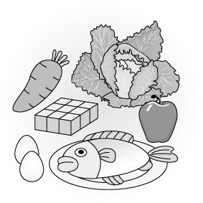 (Ｂ) 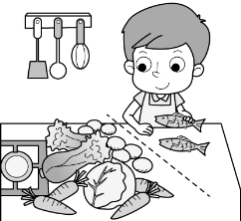 (Ｃ) 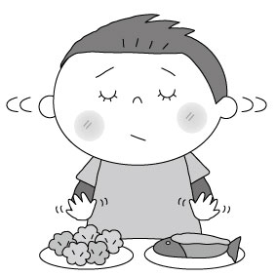
2. (Ａ) 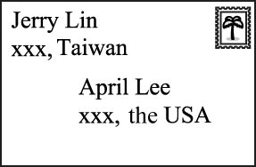 (Ｂ) 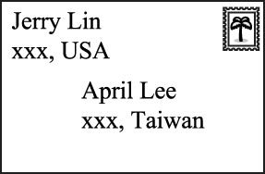 (Ｃ) 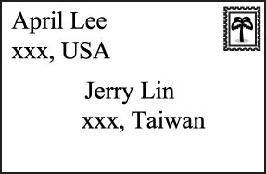
3. (Ａ) 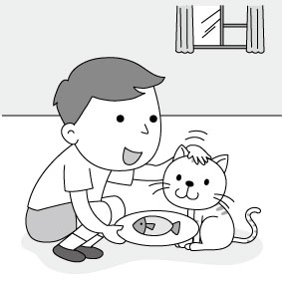 (Ｂ) 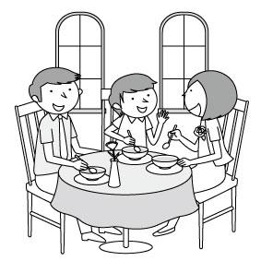 (Ｃ) 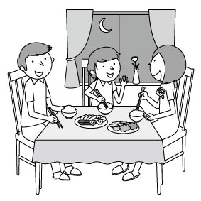
4. (Ａ) 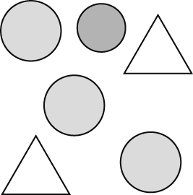 (Ｂ) 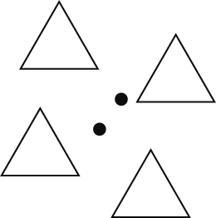 (Ｃ) 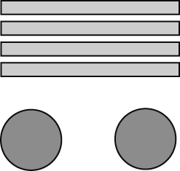
5. (Ａ) 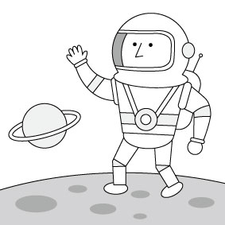 (Ｂ)  (Ｃ) 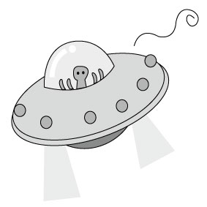

B. 基本問答: 根據聽到的內容，選出合適的回應10%
06. (Ａ) No, not yet. (Ｂ) No, she didn’t like the gift. (Ｃ) Yes, his mom has bought him a watch.
07. (Ａ) Can I? I’ve never visited it before, and I really want to go.
(Ｂ) I bought a Hakka umbrella last year in the museum.
(Ｃ) Of course. Hope to hear from you in a short time.
08. (Ａ) It didn’t work sometimes. But I still love it. (Ｂ) Thank you. I studied hard day and night.
(Ｃ) That’s not possible. The computer is useful.
09. (Ａ) I’ve never been short. (Ｂ) You’re the tallest person in the world.
(Ｃ) I’m five feet and six inches tall.
10. (Ａ) Don’t you agree with me? (Ｂ) Really? Thanks for your help.
(Ｃ) Oh, it’s for my new play. I will play an evil king in it.
C. 言談理解: 根據聽到的對話內容與問題，選出正確的答案10%
11. (Ａ) They are in the man’s birthday party. (Ｂ) The woman’s name is Riley.
(Ｃ) The oil paper bags are wonderful wedding gifts to the man.
12. (Ａ) The sound of “clock” is unlucky in Chinese. (Ｂ) It’s too expensive. (Ｃ) We don’t know.
13. (Ａ) There is only one color in the picture. (Ｂ) They don’t trust the picture.
(Ｃ) They should always trust their eyes.
14. (Ａ) The woman is afraid of ghosts. (Ｂ) Sam is not excited about the ghost stories.
(Ｃ) The woman shared some ghost stories.

15. (Ａ) To teach Alice to make a pumpkin lantern. (Ｂ) To let Alice make dinner for his mother.
(Ｃ) To ask Alice to finish the pumpkin lantern for him.
二 綜合測驗（40％）
16. A: What ___shirt do you wear? B: Large. (A) measurement (B) size (C) yard (D) kilometer
17. Remember to put the stamps on the ___ before you mail it. (Ａ) leather (Ｂ) miss (Ｃ) comb (Ｄ) envelope
18. Alice has no friends here in New York, ____? (Ａ) doesn’t she (Ｂ) hasn’t Alice (Ｃ) has Alice (Ｄ) does she
19. It’s really nice __ you to send a pretty postcard__ me. (A) of; to (B)for; for (C) to; of (D) in; about
20. There’s lots of snow in Japan in winter, ___? (Ａ) is it (Ｂ) is there (Ｃ) isn’t it (Ｄ) isn’t there
21. Annie has kites in many different ___, but the round one is her favorite. (Ａ) wishes (Ｂ) luck (Ｃ) oil (Ｄ) shapes
22. Your sister will leave for Taichung later,____ she? (Ａ) isn’t (Ｂ) won’t (Ｃ) doesn’t (Ｄ) hasn’t
23. A: How have you ___ at the new company? B:_____. (Ａ) are; A piece of cake (Ｂ) been; So far so good
(Ｃ) X; Not my cup of tea (Ｄ) isn’t; I can’t help it
24. My mom usually listens to the radio ___ in the morning. (Ａ) square (Ｂ) program (Ｃ) sense (Ｄ) circle
25. A: ____ you ___ something before dinner? B: Yes, I ate a bun a half hour ago. (Ａ) Will; eat (Ｂ) Have; eaten
(Ｃ) Were; eating (Ｄ) Would; eat
26. A: Did the news _____ you? B: Yes, I was ___ it. (Ａ) surprising to; surprised at (Ｂ) surprised at; surprising to
(Ｃ) surprise; surprised (Ｄ) surprise; surprised at
27. It's ____for some plants to live without water for weeks. (Ａ) everyday (Ｂ) wooden (Ｃ) possible (Ｄ) useful
28. Jack is ____playing the guitar, so he’s very popular with his friends. (Ａ) excellent at (Ｂ) tired of (Ｃ) married to
(Ｄ) poor at
29. During the parades, adults proudly _____ their crazy costumes. (Ａ) hear from (Ｂ) get to (Ｃ) dress up (Ｄ) show off
30. My son always ____his eyes to the TV after school, Monday through Friday. (Ａ) glues (Ｂ) trusts (Ｃ) tricks (Ｄ) scares
31. The tall man over there is our new baseball coach, _____? (Ａ) is he (Ｂ) is there (Ｃ) isn’t he (Ｄ) isn’t there
32. Tim likes the USA very much. He ____there several times. (Ａ) will be in (Ｂ) has been to (Ｃ) has been (Ｄ) has gone to
33. Bill: Would you like to play soccer with me? Dara: No, thanks. ____ it for three hours already. I’m ____now.
(Ａ) I’ve played; tired (Ｂ) I’m playing; tiring (Ｃ) I play; tire (Ｄ) I’ll play; exciting
34. Josh and Lisa have been friends for a long time ___ they knew each other, ____? (Ａ) before; has he (Ｂ) since; haven’t they (Ｃ) for; did she (Ｄ) that; did they
35. Mom seldom let me play too many computer games when I was little, ____? (Ａ) didn’t she (Ｂ) wasn’t I (Ｃ) did she
(Ｄ) was I

三 閱讀選擇 10%
If you are looking for some kind of exercise to help you lose weight and feel better about yourself, cycling is a good choice. You can easily fit cycling into your life because it can be used for transportation. In other words, it can save you money and make you fit. As a low-impact exercise, cycling puts less pressure on the joints than running, and it can still burn calories effectively.
Before you hit the road, do not forget to put on your helmet. Being safe is the most important thing! Make sure your tires and brakes are in good shape. When you are cycling in the evening, remember to wear a yellow or bright jacket. Also, you should turn on the lights on the front and the back of your bike on cloudy or rainy days. You don’t want to get in trouble on your way to school, office or home.
Give it a try! It’s easier than you think. Once you get used to cycling, you will enjoy it. You can easily go to any places you want with a good bike and helmet. Feel the cool wind in your hair. It is great!
cycling 騎腳踏車 fit 適合的；健康 transportation 交通運輸 low-impact 低傷害的 joint 關節 calorie 卡路里 effectively 有效率地 helmet 安全帽 brake 煞車
36. Why is cycling a low-impact exercise?
(A) Because it is a green exercise. (B) Because it puts less pressure on the joints.
(C) Because it saves more time. (D) Because it costs less money.
37. What does “in good shape” mean?
(A) Getting old. (B) Being friendly. (C) Working well. (D) Getting broken.
38. What do you need most to keep safe when you ride your bike after dark?
(A) Bright clothes. (B) Sharp brakes. (C) A big hat. (D) Hot drinks.
KNSH Times – March 6, 2016
The United Nations has been sharing World Happiness Report since 2012, and the report of 2016 is finally here, before World Happiness Day on March 20th. Everyone is excited to see which country among the 165 countries in the world is the happiest this year.
Some people even thought that happiness is a better measure of human welfare than the measures of education, health, and income. It also helps remind the governments of how people feel, and what people are expecting from them, and they would have a better chance to come up with friendlier policies.
This year, Denmark（丹麥）is back at the top. Switzerland（瑞士）is right behind it, and then closely followed by Iceland（冰島）. Denmark has won the title three times since the report started in 2012, and it lost to Switzerland only once. Iceland was right after Switzerland last year.
We learn some facts from this report. People in the happiest countries are more likely to have longer lives, have more social supports, and have more freedom to make life choices, and so on. But people in the least happy countries are in a totally different story. They live shorter lives. Many of them are poor. And they have fewer choices.
The report is also sending important messages. It tells people that being a happy country doesn’t mean it has to make lots of money. If people are generous and like to share, they are more likely to feel happy. For example, in Norway（挪威）, it is not an unusual sight to see people painting each other’s house although they can certainly pay someone else to do that, or can surely ask for money after the job is done. However, they don’t do that. They simply share. This is also why Norway made it to fourth on the list of the world’s happiest countries this year again.
the United Nations 聯合國 happiness 幸福 measure 測量方式 welfare 福利 policy 政策 totally 完全地
certainly 毫無疑問地
39. Which is the true ranking of the World’s Happiest Countries in 2016? ranking 排名
(A) 1. Switzerland 2. Denmark 3. Norway 4. Iceland
(B) 1. Denmark 2. Iceland 3. Switzerland 4. Norway
(C) 1. Switzerland 2. Iceland 3. Norway 4. Denmark
(D) 1. Denmark 2. Switzerland 3. Iceland 4. Norway
40. What do we know about the World Happiness Report?
(A) It is done by the local governments in Denmark, Switzerland, Iceland, and Norway.
(B) The more income a country makes, the happier the people in the country will be.
(C) The least happy countries are more likely to have less freedom of choice.
(D) This report is important to governments because they are sending messages to the people by it.

四 提示作答 6%
1. I have been a policeman for ten years.(造原問句)
2. He is scared of speaking English in front of the class.(用動名詞當主詞改寫句子)
3. The costume party was boring to some children. (用some children當主詞改寫句子)

五 翻譯 14%
1. 我們的眼睛協助我們的腦獲取資訊以瞭解我們身邊周遭的世界。
2. 為了保險起見，你可以請你的表哥付你一元來買這對紙傘。
3. 在台灣許多人相信鬼會在農曆七月出現。
4. 他們直到裝滿「不給糖就搗蛋」的袋子才會回家。(2分)

新北市立溪崑國民中學106學年度第一學期第一次定期評量 英語科 答案卷
九年級 班 座號 姓名
四 提示作答 6%

1.
2.
3.

五 翻譯 14% (第四題兩分，其他四分)
1.
2.
3.
4.
106-1-1 九年級 英語科－解答

一 ～三大題
01-05 BBBCC 06-10 AABCC
11-15 CAABC 16-20 BDDAD
21-25 DBBBB 26-30 DCADA
31-35 CCABC 36-40 BCADC

四 提示作答 6%
1. How long have you been a policeman ?
2. Speaking English in front of the class is scary to him.
3. Some children were bored with the costume party.

五 翻譯 14% (第四題兩分，其他四分)
1. Our eyes get information for our brain to make sense of the world around us.
2. Just to play it safe, you can ask your cousin to pay you one dollar
for the pair of paper umbrellas.
3. Many people in Taiwan believe that ghosts come out
in the seventh lunar month.
4. They don't go home until they fill up their trick-or-treat bags. (2分)

新北市立溪崑國民中學106學年度第一學期第一次定期評量
九年級 英語科 聽力測驗稿( )
- 辨識句意：根據聽到的內容，選出符合描述的圖片。

1.請參考 Unit 1 A5010942

：Mr. Wang separated the fish from the vegetables.
2. Unit 1 A5010952
：W: Jerry mailed a letter to me from the USA. I’m so happy to hear from him.
3. Unit 1 A5010954
：Chinese people like to have meals at round tables because “round” means perfect.
4. Unit 2 A5021002
：There are four rectangles and two circles.
5. Unit 3 A5031066
：It looks like something from another planet.

- 基本問答：根據聽到的內容，選出一個最適合的回應或最適合的問句。
6.：請參考 Unit 1 A5010964
：Have you decided on the gift for Mom?
7. Unit 1 A5010969
：Patrick, we’re going to Meinong Hakka Cultural Museum this weekend. Would you like to go with us?
8. Unit 2 A5021020
：Your brain is as smart as a computer.
9. Unit 2 A5021030
：You are very different, Amber. You were short before, but you are even taller than I am now. How tall are you?
10. Unit 3 A5031085
：Why are you wearing a costume? You look funny.

- 言談理解：根據聽到的內容，選出一個最適合的答案。
11.請參考 Unit 1 A5010977
：W: Thank you for inviting me to your wedding, Mark.
M: Thank you for coming. Riley and I love your wedding gift very much. The oil paper bags are excellent.
W: I’m glad to hear that.
Q: Which is true?
12. Unit 1 A5010986
：W: What gift are you going to send Ms. Huang on Teacher’s Day, Sam?
M: It’s a clock.
W: I don’t think it’s a good idea. Because the word for “clock” sounds like “over” in our language.
Q: Why can’t Sam give Ms. Huang a clock on Teacher’s Day?
13. Unit 2 A5021038
：W: It’s quite difficult to trust it, isn’t it?
M: You’re right. I saw two different colors in the picture. But they are the same color.
W: We are all tricked by our eyes.
Q: Which is true?
14. Unit 3 A5031098
：W: Today is Ghost Festival. We should share some ghost stories.
M: Please don’t. I’m not interested in ghost stories. They’re boring to me.
W: Oh, Sam. Are you afraid of ghosts?
M: Of course not!
Q: Which is true?
15. Unit 3 A5031105
：M: Dear Alice,
There is a pumpkin on the table. I cut a large hole on the top of the pumpkin, and took out the seeds. Then, Mom told me to shop for the dinner. Please finish it for me. Thanks a lot.
Frank
Q: Why did Frank leave the note to Alice?

