新北市立溪崑國民中學106學年度第一學期第一次定期評量英語科試卷
八年級 班 座號 姓名
一 聽力：30％(每題2分)
(一) 根據聽到的內容，選出最適合的回應
1. (A) I watched a baseball game on TV. (B) I walk my dog every evening.
(C) Yes, I did my homework last night.
2. (A) Yes, I hated the days so much. (B) Not really. There were too many tests.
(C) No, I didn’t. I didn’t go to school.
3. (A) Did you bring the binoculars with you? (B) The full moon and the stars are beautiful.
(C) Me too. We always have the Moon Festival picnic together.
4. (A) You are so kind. (B) Poor you! (C) That’s a good idea.
5. (A) No. It’s mine. (B) Yes, it is blue. (C) No, it’s Tim’s.

(二) 辨識句意:根據聽到的內容，選出符合描述的圖片
6. (A) 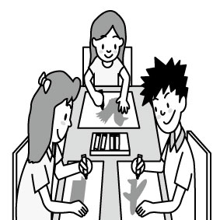 (B) 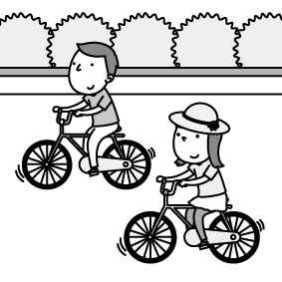 (C) 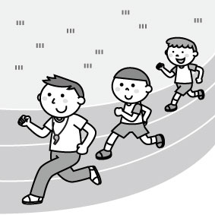

7. (A) 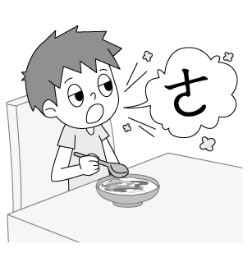 (B) 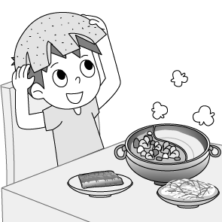 (C) 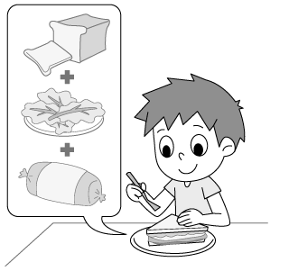

8. (A) 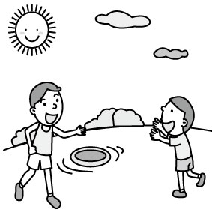 (B) 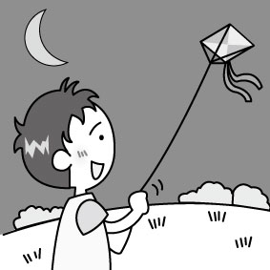 (C) 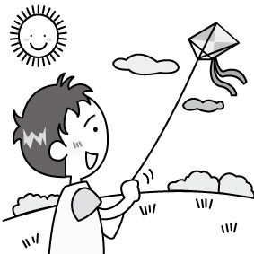

9. (A) 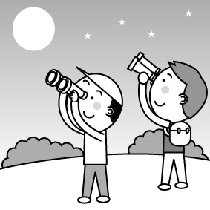 (B) 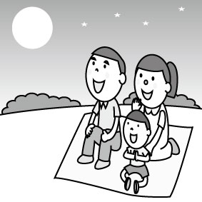 (C) 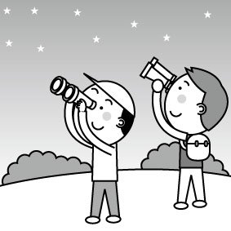

10. (A) 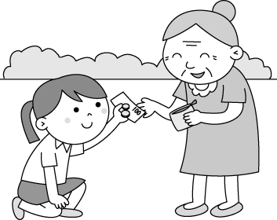 (B) 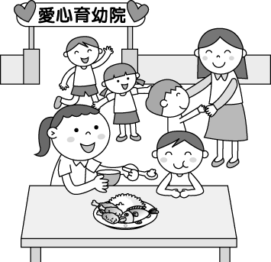 (C) 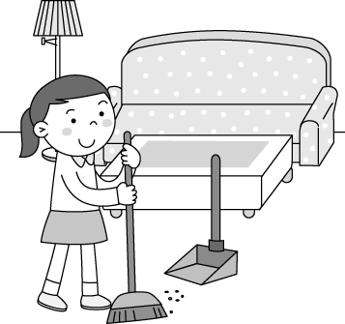

(三) 根據對話內容與問題，選出最適合的答案
- (A) Ben didn’t enjoy his vacation. (B) Ben is talking about his vacation plans.
(C) Ben visited Korea during his vacation.
- (A) Gina has a new English teacher. (B) Gina didn’t like the English class.
(C) Gina enjoyed her first day back at school a lot.
13.(A) Cindy is not good at singing. (B) Cindy didn’t talk to the man after the contest.
(C) Cindy did well on the karaoke contest.
14.(A) It’s a new vest. (B) It’s too smll for him. (C) He doesn’t like it.
15.(A) She had a great time dancing and singing. (B) She made a card.
(C) She went to a church and had great food.
二 綜合選擇(選出最適合的答案)：40％(每題2分)
16.Thanks _______ my new English teacher, I have new hope _______ English.
(A) for; to (B) to; in (C) to; about (D) to; for
- Teacher: Please finish the _______ in class in ten minutes. Students: Yes, Miss Wang.
(A) question (B) lesson (C) worksheet (D) deck
- The story about the goddess of the moon is so _______. I like it very much.
(A) easy (B) expensive (C) favorite (D) interesting
- My friend, Jason, put his cap on the seat and _______ out.
(A) go (B) went (C) goes (D) going
- _______ Melody was very busy last Friday, _______ she didn’t go to Jenny’s birthday party.
(A) Because; X (B) X; because (C) So; X (D) Because; so
- Tim: Don’t touch the cellphone. It’s not _______. Derek: Then, where is mine?
(A) your (B) ours (C) his (D) yours
- How ________ the old man is! He always brings many books and toys to children’s homes.
(A) special (B) generous (C) true (D) different
- You like history at school. How about the other ________ ?
(A) science (B) shows (C) subjects (D) plans
- Our classroom is big, but theirs ________.
(A) isn’t (B) are (C) aren’t (D) is
- Alex: Did your mom ________ the cake for you? Eric: No, she ________ me the cake.
(A) bought; made (B) made; bought (C) give; bought (D) make; bought
- We did not go on a picnic last weekend ________ the heavy rain.
(A) thank for (B) because of (C) because (D) because it
- Life in the kitchen is never ________, but Tim still wants to be a great cook like Miss Fu.
(A) different (B) special (C) magic (D) easy
- Tina was very hungry, _______ she didn’t want to eat anything.
(A) so (B) because (C) but (D) and
- Mary: ________ Eric: It was nice. I loved it very much.
(A) Where did you go for your vacation? (B) What did you do during the vacation?
(C) When did you take your vacation? (D) How did you like your vacation?
- She ________ her puppy Money. Isn’t that wonderful?
(A) performed (B) sent (C) gave (D) named
- ________ Why is he crying like that?
(A) Good boy! (B) Poor Ben! (C) You bet! (D) Poor you!
- My classmates had a birthday party for me yesterday. That ________ me!
- surprised (B) showed (C) learned (D) thought
- There is ________ wrong between Alex and Teresa. They never talk to each other. What happened?
- anything (B) everything (C) nothing (D) something
- Tony ________ a lot every day last week.
- is eating and sleeping (B) eats and sleeps (C) eat and sleep (D) ate and slept
35.The students don’t like math very much. Let them learn _______ games.
- won (B) through (C) picked (D) enjoyed
三 閱讀理解：10％(每題2分)
(一)
Geese hear very well. They can hear little noises. They crackle loudly at strange sounds. On a farm they make good watch dogs.
People have many stories about geese. One very old story tells how geese once saved the city of Rome. About A.D. 390, tribes from the north had come down to attack Rome. The tribes had made a camp outside the old city walls.
Late one night, the geese of the city began to crackle. They woke the leader of Rome. He rushed out to see what was the matter. The enemy tribes were climbing the walls. The leader shouted. Geese crackled. People yelled. The Romans drove the enemy away from their walls. Thanks to the geese, the city was saved from the enemy tribes.

goose鵝/複數: geese crackle咯咯叫 tribe種族 enemy敵人

- The main idea about the story is ________.
(A) watch dogs (B) geese as pets (C) enemy tribes attacking Rome (D) geese saving Rome
- What do geese do when they hear strange sounds?
(A) They crackle very loudly. (B) They become dogs.
(C) They will climb the walls. (D) They fight with enemy.
- Which of the following is NOT true?
(A) One night geese woke up the leader of the Rome.
(B) The Romans lost the battle (戰役) with the enemy tribes.
(C) The geese saved the city.
(D) Geese can hear very well.

背面尚有題目
(二)
Edible Roots
Would you like to eat a root? You probably already have. People and animals eat many kinds of roots. Most roots that people eat are usually called root vegetables. A root vegetable is what we call veggies that grow underground.
A carrot is one type of root vegetable. It is the orange, edible root of the carrot plant. Many people like to put it in salads or eat it right out of the ground. The turnip is another root vegetable. It is a member of the cabbage family. Turnips are usually eaten boiled, steamed, roasted, fried, pickled, or even raw.
Although some people do not consider potatoes to be a veggie, they are a root vegetable. People like to eat them mashed, boiled, and fried.

edible可食的 veggie蔬菜turnip 大頭菜 raw生的 consider 考慮 mashed 糊狀的

mashed 糊狀的

mashed 糊狀的

39.What is this story mostly about?
(A) What edible means. (B) Carrots are orange.
(C) Root vegetables people eat. (D) A potato is not a vegetable.
40. What are root vegetables?
(A) Vegetables that grow underground.
(B) Vegetables that you can eat.
(C) Vegetables that have different colors.
(D) Vegetables that most people like.
以下為非選擇題，請在答案卷上作答 20%
四 依提示作答:6％（每題2分）
- My mom bought me the toys. (把畫線部分改為代名詞)
- Did Amy catch the first bus this morning? (先肯定簡答,再詳答)
- They ate a lot of pomelos.
The pomelos were yummy. (以so當連接詞來合併左邊兩個句子)

五 翻譯:14％ (填空每個空格1分)
- 別叫醒Rick。他正在沙發上睡得很熟。
Don’t ________ up Rick. He’s ________ a ________ sleep on the sofa.
- Evans: 在門上的背心是誰的?
Anna: 是我姐姐的。我上星期天給她的。
Evans: ________ vest is it on the door?
Anna: It’s my ________. I ________ it ________ her last Sunday.
- Mr. Kao 捐贈了多少雙手套給那些貧窮的小孩呢? 3%
- 今天下午Tina 騎著腳踏車去溪崑(Xi Kun)國中並在那裡遇見一些同學。(... a bike…) 4%

試題結束!

新北市立溪崑國民中學106學年度第一學期第一次定期評量英語科―答案卷
八年級 班 座號 姓名
非選擇題20%
四 依提示作答:6％（每題2分）

五 翻譯14% (填空每格1分)
4.

5.

6. ( 3分)
7. ( 4分)

試題完! Good Luck!

106學年度第一學期第一次定期評量八年級英語科解答

一、聽力測驗30% (每題2分)
1~5 ABCAC 6~10 CACAB 11~15 CABBA
二、綜合選擇(選出最適合的答案) 40% (每題2分)
16~20 DCDBA 21~25 DBCAD 26~30 BDCDD 31~35 BADDB
三、閱讀理解：10％ (每題2分)
36~38 DAB 39~40 CA
四、依提示作答6% (每題2分)
1. My mom bought them for me.

2. Yes, she did. She caught the first bus this morning.

3. The pomelos were yummy , so they ate a lot (of them).
五、翻譯14% (填空每格1分)
4.
wake | in | sound
5.
Whose | sister’s | gave | to

6. How many pairs of gloves did Mr. Kao donate to those poor kids? (3分)
7. Tina rode a bike to Xi Kun Junior High School and met some classmates
there this afternoon. (4分)
新北市立溪崑國民中學106學年度第一學期第一次定期評量―八年級英語科聽力稿

錄音稿：
（一）根據聽到的內容，選出最適合的回應
1. What did you do yesterday evening?
2. Did you enjoy your days in junior high school?
3. I love Moon Festival because the family can get together on this day.
4. M: I just gave all my money to the poor woman.
5. Eric, there’s a baseball cap on the table. Is it yours? 答案：(A) (B) (C) (A) (C)

（二）辨識句意:根據聽到的內容，選出符合描述的圖片
6. The students had much fun in PE class.
7. Andy made a burp during the meal.
8. The boy flew a kite at the park in the afternoon.
9. B: We used the binoculars to watch the full moon on the Moon Festival.
10. It’s so kind of Susan to help the children. 答案：(C) (A) (C) (A) (B)

- 根據對話內容與問題，選出最適合的答案
11. G: Did you have fun in Korea, Ben?
B: Yes, it was my favorite time during the winter vacation.
Q: Which is true about Ben?

12. M: How was your first day back at school, Gina?
G: Not much fun, but I loved my new English teacher’s first class. It was interesting.
M: Good for you.
Q: Which is true about Gina?

13. W: Something happened to Cindy.
M: I saw her yesterday. She didn’t talk to me because she was sad.
W: She didn’t do well on the karaoke contest.
M: Poor Cindy. She’s good at singing.
Q: Which is true?

14. W: Did you get a new vest? Why did you donate the old one? Don’t you like it?
M: Well, I am a little fat now, so it’s too small for me.
W: Oh, I see.
Q: Why did the man donate the vest?

15. W: Dear Kevin,
Thanks to you, I had a wonderful Christmas. I ate great food and I sang and danced a lot. I made the card for you. Maybe I can visit you someday and thank you in person.
Catherine
Q: What did Catherine do on Christmas?
答案： (C) (A) (B) (B) (A)

