新北市立溪崑國民中學 105學年度第二學期 第三次定期評量 英語科試卷
八年級 班座號 姓名

一、 聽力測驗:(每題兩分)
1.辨識句意：根據聽到的內容，選出符合描述的圖片或符合圖片的描述。
- (Ａ) 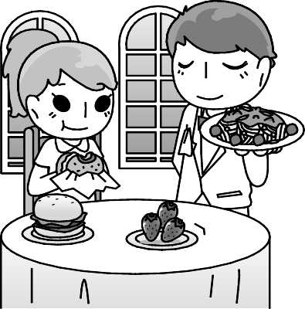 (Ｂ) 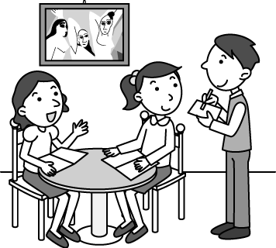 (Ｃ) 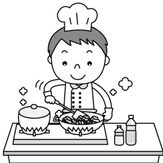
- (Ａ) 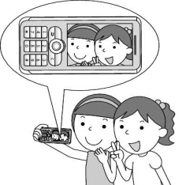 (Ｂ) 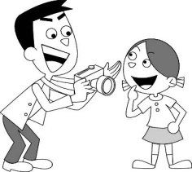 (Ｃ) 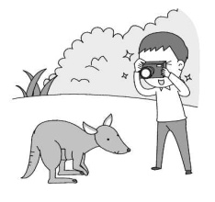
- (Ａ) 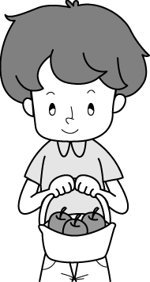 (Ｂ) 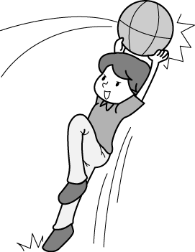 (Ｃ) 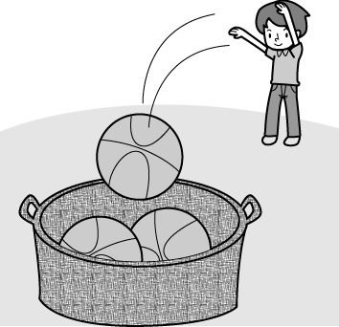
- (Ａ) 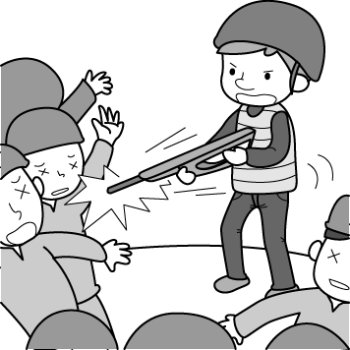 (Ｂ) 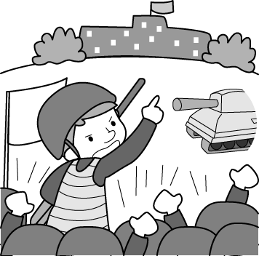 (Ｃ) 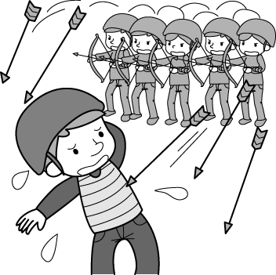
- (Ａ) 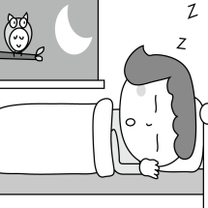 (Ｂ) 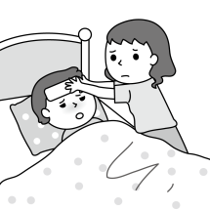 (Ｃ) 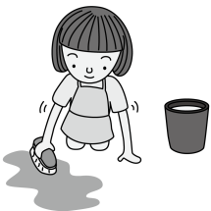

2.基本問答：根據聽到的內容，選出一個最適合的回應或最適合的問句。
- (Ａ)Sure. Here you are. (Ｂ)We don’t have fish soup on the menu. (Ｃ) Yes. We have fried fish with French fries.
- (Ａ) Why not? (Ｂ) How exciting! (Ｃ) Great. I like to get close to nature.
- (Ａ) That’s so evil of you to do so. (Ｂ) It touched my heart. (Ｃ) I think so too.
- (Ａ) Yes. I have a question. (Ｂ) You should ask questions in class. (Ｃ) Please answer the question.
- (Ａ) A dictionary is good for you to learn English well.
(Ｂ) I can’t carry it because it’s too heavy for me.
(Ｃ) There is no easy way to learn English.

3.言談理解：根據聽到的內容，選出一個最適合的答案。
- (Ａ) Because she didn’t like fast food.
(Ｂ) Because she didn’t like eating meat.
(Ｃ) Because she couldn’t cut the meat with the knife.
- (Ａ) In the morning. (Ｂ) In the afternoon. (Ｃ) In the evening.
- (Ａ)The boys are treating the dog badly.(Ｂ)The boys are careful with the dog.(Ｃ)The boys have to pay for the dog.
- (Ａ) She couldn’t run fast. (Ｂ) She had a cold. (Ｃ) She forgot to rest and drink water.
- (Ａ) The boy often gets good grades on English quizzes.
(Ｂ) Doris makes word cards and carries them with her.
(Ｃ) Doris reads the new words loudly several times.

二、 綜合測驗:(每題兩分)
16. Junior high school students are too young to _______ in the national election(選舉).
(A)save | (B)vote | (C)throw | (D)answer
17. We decided to keep Mimi as our pet. Now it is a new _________in my family.
(A)member | (B)dragon | (C)ham | (D)point
18. There are many kinds of drinks on the ________. I'd like to try something special.
(A)grade | (B)dictionary | (C)map | (D)menu
19. It's bad for you to be under too much stress. Why don't you ___________ by doing some more exercise?
(A)set fire to it | (B)let it out | (C)give it up | (D)look it up
20. The princess _______ an arrow at the evil dragon, and then it died.
(A)shoot | (B)shot | (C)bow | (D)bowed
21. Train to Busan is a 2016 Korean ____ horror(恐怖) film which talks about a group of people fighting their way through the viral(病毒) outbreak sweeping the country.
(A)zombie | (B)straw | (C)fan | (D)king
22. My parents ______ to come to my graduation party because they were busy working.
(A)touched | (B)understood | (C)marked | (D)failed
23. Never make the same _________, or you may get into trouble.
(A)grade | (B)voice | (C)mistake | (D)group
24. You should eat less and exercise _____ for thirty minutes every day if you want to get in shape before summer.
(A) at least | (B)at last | (C)in the end | (D)by the way
25. Don't worry about him. He's not sick. He's just in a food _________.
(A)coma | (B)pollen | (C)lemonade | (D)trip
26. I forgot to bring my homework _______ I checked my book bag the night before.
(A)although | (B)if | (C)but | (D)because
27. Two of ________.
(A)his ears are big | (B)the buns on the table is yummy
(C)them are from Japan | (D)soldiers are waiting in ambush
28. Having long hair is becoming more and more popular with most young people, and I want to ____________.
(A) be long enough | (B)get longer than mine | (C)be one of them | (D)have one on my own
29. When my grandparents _______ to Taipei next weekend, we _________ them to have a big dinner.
(A)came, took | (B)comes, take | (C)come, will take | (D)will come, take
30. To save the energy, remember _______ off the power _______ you use the computer.
(A)turning, if | (B)to turn, before | (C)turning, when | (D)to turn, after
31. My mother is not good at cooking, but she spends ________ of her free time ________ cooking programs.
(A)many, reading | (B)much, watching | (C)most, to read | (D)all, watch
32. A: I heard that you _______ shopping yesterday. What did you buy?
B: I bought a new pair of sneakers and they didn't _________ a lot.
(A)went, cost | (B)go, pay | (C)go, spend | (D)went, take
33. _______ of the food at the fancy restaurant ________ delicious.
(A)Many, tastes | (B)Some, are | (C)Much, taste | (D)Most, is
34.The policeman shone a _______ at the man and told him _______ move.
(A)flashlight, not to | (B)video, X | (C)chopstick, from | (D)problem, to
35. My sister and I like dancing a lot. _______ of us ______ to be dancers someday.
(A)One, wants | (B)Most, want | (C)Both, want | (D)All, want
36. When I _____ Ethan's bedroom door, I saw him _______ to himself.
(A)past, talk | (B)looked up, talked | (C)marked, to talk | (D)passed, talking
37. No one thought David would drop out of school. So when he _______, everyone was surprised and called him
to ask_______ he needed help.
(A) does, because | (B) did, if | (C)is, before | (D)was, after
38. Xiao Zhen is a 16-year-old teenager with special abilities. Although she is told that it is her destiny(命運),
________ her powers truly help others and wants to be normal(正常的).
(A)but she believes | (B)but she doesn't believe | (C) she believes | (D) she doesn't believe
39.選出錯誤的句子
(A)If you don't know the answer to a question, come back to it later.
(B) He sang when he feels happy.
(C)Josh didn't see a doctor although he had a terrible headache.
(D) You parents will be very happy if you use time well.
40.選出正確的句子
(A)There are three students in the classroom. Both of them are studying.
(B)Each of we in my class likes surfing the Net.
(C)How much of the food at the restaurant did you try?
(D)When Derek got home, I'll tell him the bad news.

三、克漏字: (每題兩分)
A.
Dave tried the reading tips on an English article. First, he 41 and took a look at the pictures. Second, he 42 and tried to find out the answers to the questions in the sentences. When he saw a new word, he guessed its meaning. Last, he 43 again. These reading tips helped him learn better.
41.(A) read its title (B)took a quiz (C)came up with an idea (D)set an example
42.(A)made sentences (B)wrote down a story (C)asked himself questions (D)talked about the main idea
43.(A) took notes (B) looked up new words (C)looked for some questions (D)went over the article
B.
The school band had a party at Yummy Steak House this afternoon. Some of the students brought their flutes and violins. They played a few songs, and 44 sang with the music. All of the food 45 delicious, and everyone had a great time 46 . Many of them stayed at the steak house until it was dark.
44.(A)other (B)others (C) the other (D)the others
45.(A) are (B)is (C)was (D)were
46.(A)eat and talk (B)to eat and talk (C)eating and talking (D)eating and talked

四、閱讀測驗:(每題兩分)
A.
About 95% of the children play video games, watch TV, chat with their friends or play on the computer during their free time, but only 5% of the children tend to enjoy reading. Here are some important tips for you to enjoy reading.
＊Set up your purpose
An example of establishing a good purpose is, "Experience the character's feelings when you read" or " Try to understand what you don't know about this subject."
＊Read in comfort
Have a nice place to read. Quiet and comfortable places will help you focus on the book. If you are in a noisy place, the small matters around you may bother you a lot. Also, make sure your place has a lot of light so you'll be able to see the words clearly.
＊Read for fun
Make sure you choose a book that's just right for you. If you like sci-fi stories, choose the books about science fiction. Don't force yourself to read something you don't like at all. If the book you read is not right for you, you may lose interest in the book and won't want to finish it.
＊Read every day
Reading makes you a lot smarter. Don't just read every once in a while. Read every day; otherwise you may forget about it and not keep on reading.
Now, visit the local library or shop at a bookstore to get a book you are interested in.
47. What is the reading about?
(A) The ways to enjoy reading. | (B) The tips of memorizing words.
(C) About 95% of the children like reading | (D)Reading on a noisy street is good.
48. Which is true?
(A)Reading makes you less smart.
(B)Choose a dark and quiet place when you read.
(C)If you like fantasy, get a book about fairy tales or fantasy.
(D)Read something you are not interested in, and you will improve your reading.

B.
The Kite Runner is a very popular book by Khaled Hosseini. The story talks about a young boy, Amir. He grew up in Afghanistan and saw his country change because of the Taliban government. Amir remembers how great his country was when he was a child, but it slowly became a dangerous and sad place. Amir, like many Afghans, moves away to America and grows up with his family.
However, he must go back to Afghanistan to save the child of his best friend, Jassan. The child is a slave to the Taliban. Amir must be brave when he goes back to his homeland.
The title of the Kite Runner comes from the kite flying contests in Afghanistan. During the contest, the kites would fight each other and cut each other's strings. The last kite in the air will be the winner. After a kite is cut, it will fly away, and the children will run to find it. When Amir was little, he teamed up with his friend, Hassan, for the kite flying contest, and they won the first prize.
 Afghanistan 阿富汗 Taliban government 塔利班政府 homeland 家鄉 slave 奴隸 string(s)線
49. Why must Amir go back to his homeland ?
(A)To win the kite flying contest for Hassan.
(B)To save his best friend's son.
(C)To show how brave he is.
(D)To fight for his family.
50. What can we learn from the reading?
(A)Amir's family is still in Afghanistan.
(B)Amir and Hassan won first place for the kite flying contest in the USA.
(C)The child of Hassan is a slave to the Taliban.
(D)The Kite Runner is a famous fighter.

新北市立溪崑國民中學105學年度第二學期第三次定期評量―八年級英語科聽力稿

辨識句意：根據聽到的內容，選出符合描述的圖片或符合圖片的描述。
1.
解析：音軌：請參考 Unit 7 A4071370
錄音稿：The waiter is taking orders.
2.
解析：音軌：請參考 Unit 7 A4071374
錄音稿：W: I told the man to take a picture for me.
3.
解析：音軌：請參考 Unit 8 A4081428
錄音稿：The boy shot the balls into the basket.
4.
解析：音軌：請參考 Unit 8 A4081426
錄音稿：He led many soldiers to attack a small country.
5.解析：音軌：請參考 Unit 9 A4091488
錄音稿：G: Although I felt tired last night, I still helped Mom do a lot of housework.

基本問答：根據聽到的內容，選出一個最適合的回應或最適合的問句。
6.
解析：音軌：請參考 Unit 7 A4071382
錄音稿：Is there any fish on the menu?
7.
解析：音軌：請參考 Unit 8 A4081444
錄音稿：I decided not to go camping this week.
8.
解析：音軌：請參考 Unit 8 A4081447
錄音稿：Hurting the animals is doing something mean.
9.
解析：音軌：請參考 Unit 9 A4091494
錄音稿：Does anyone have any questions?
10.
解析：音軌：請參考 Unit 9 A4091510
錄音稿：I want to go to the bookstore to buy an English-English dictionary because I want to learn English better.

言談理解：根據聽到的內容，選出一個最適合的答案。
11.
解析：音軌：請參考 Unit 7 A4071406
錄音稿：M: Why didn’t you eat the beef in your plate?
W: I’m tired of meat.
Q: Why didn’t the woman eat the beef?
12.
解析：音軌：請參考 Unit 7 A4071409
錄音稿：M: What are you eating? It smells great.
W: Toast with butter. I usually have it for breakfast. And you? What’s your breakfast?
M: I had a fish sandwich with a glass of orange juice today.
Q: What is the time of the day?
13.
解析：音軌：請參考 Unit 8 A4081466
錄音稿：W: Look! Those bad boys are attacking the poor dog. Let’s stop them.
M: Before they do that, they never think about it carefully. They have to pay for their action.
W: You can say that again.
Q: Which is true?
14.
解析：音軌：請參考 Unit 8 A4081470
錄音稿：B: How do you feel after you took the medicine?
G: I couldn’t be better! My nose isn’t running, my cough stops, and I don’t have a sore throat.
B: Sounds great! But you still have to take a rest and drink much water.
Q: What happened to the girl before she felt better?
15.
解析：音軌：請參考 Unit 9 A4091530
錄音稿：B: I often fail English quizzes because I can’t memorize new words easily. Doris, do you have any good ways?
G: Yes, I do. Maybe I can share with you. I always make word cards and carry them with me.
B: That is a good way. What else do you do?
G: I read the new words out loud many times. Listening to your own voice will help you memorize them a lot and you won’t forget them so easily.
B: Thanks. I’ll give it a try right away.
Q: Which is not true?

105-2-3 八年級 英語科－解答

- B | - B | - C | - B | - C
- C | - A | - C | - A | - A
- B | - A | - A | - B | - A
- B | - A | - D | - B | - B
- A | - D | - C | - A | - A
- A | - C | - C | - C | - D
- B | - A | - D | - A | - C
- D | - B | - D | - B或D | - C
- A | - C | - D | - D | - C
- C | - A | - C | - B | - C

