新北市立溪崑國民中學105學年度第二學期第二次定期評量英語科試卷
九年級 班 座號 姓名
一 聽力測驗
- 辨識句意：根據聽到的內容，選出符合描述的圖片。
- (Ａ)  (Ｂ) 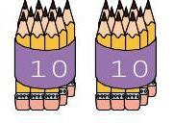 (Ｃ) 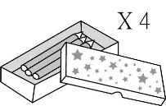
- (Ａ) 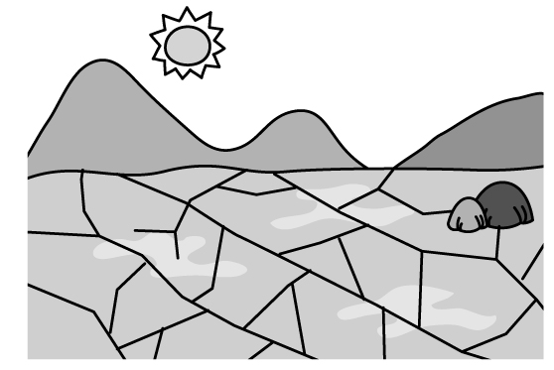 (Ｂ) 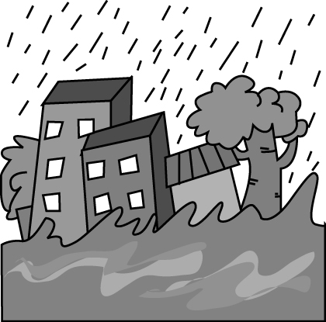 (Ｃ) 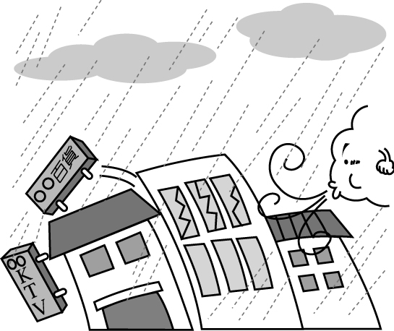
- (Ａ) 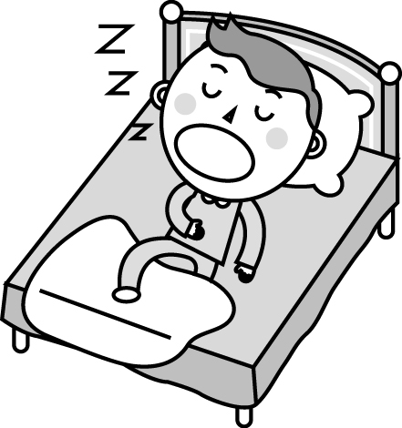 (Ｂ) 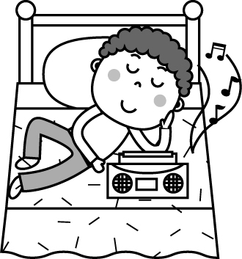 (Ｃ) 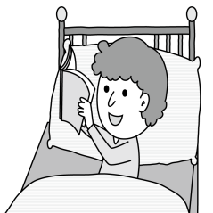
- (Ａ) 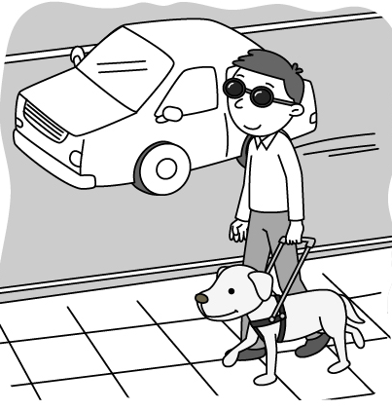 (Ｂ) 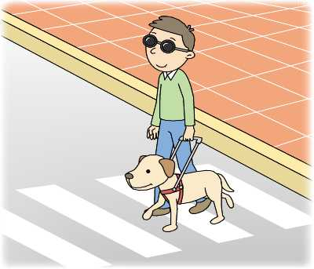 (Ｃ) 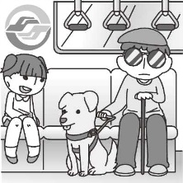
- (Ａ) 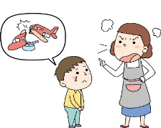 (Ｂ) 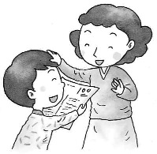 (Ｃ) 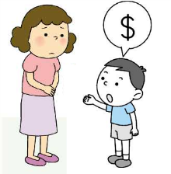

B. 基本問答：根據聽到的內容，選出一個最適合的回應或最適合的問句。
- (A) I don’t know what to do, either.
(B) I’ll count sheep or drink some hot tea.
(C) Because there are 16 sunrises in a day.
- (A) I’ll keep it in my mind.
(B) I won’t change my mind.
(C) It’s so kind of you.
- (A) Like what ?
(B) You never know.
(C) I can’t deal with it myself.
- (A) 313 centimeters.
(B) Over 100 million copies.
(C) In 1955.
- (A) It’s the biggest park in town.
(B) By bus. It’s the cheapest way.
(C) We are fine.

C. 言談理解：根據聽到的內容，選出一個最適合的答案。
- (A) The woman let the man eat her hamburger.
(B) The woman stole a hamburger for the man.
(C) The woman sold her hamburger to the man.
- (A) Visit Jacky.
(B) Attend a meeting.
(C) Find a job at a hotel.
- (A) Help with his homework.
(B) Help to call his teacher, Ms. Hsu.
(C) Don’t get mad at him.
- (A) Comic books.
(B) A flashlight and a first aid kit.
(C) Change, a blanket, and warm clothes.
- (A) The man will leave for work later.
(B) The man saw his daughter floating in the air.
(C) The man is at a place where everything floats.
二. 綜合測驗
- When she found out he was already married, she was ______.
(A) magic (B) dead (C) heartbroken (D) low
- Learning the language is the _____ to understand its culture.
(A) change (B) base (C) go-bag (D) sidewalk
- The whole village was _____ after the storm last night.
(A) tidied up (B) wiped out (C) burned down (D) set up
- You _________ let her ____ into the kitchen. She will burn the house to the ground.
(A) had better not to ; come (B) had better not ; come (C) had better ; to come (D) had better to ; comes
- Though Janet has lived in Singapore for ten years, she ____ hot weather there.
(A) isn’t used to (B) getting used to (C) didn’t use to (D) used to
- I heard Michael ____ by a ball a few days ago, and that made him very angry.
(A) hit (B) has hit (C) was hit (D) was hitting
- The boy who was badly hurt _____ to the hospital right away last night.
(A) taken (B) be taken (C) has taken (D) was taken
- If you can balance your studies and club activities, your time in school would be _______.
(A) more interested (B) much more interesting (C) much interested (D) much more interested
- ______ when I have free time makes me feel happy.
(A) Playing badminton (B) To play badminton, (C) Play badminton (D) By playing badminton
- It may not _____ to meet someone ____ only chats with you on line.
(A) have fun; whom (B) be fun; whom (C) have fun; who (D) be fun; who
- One of the women _____ Leo is taking pictures of ____ like my grandma.
(A) who; look (B) whose; look (C) X; looks (D) she; looks
- Lucy is a ____ swimmer than her sisters. She swims ____ of the three.
(A) more slowly; the most slowly (B) slow; the slower
(C) slower; most slowly (D) the more slowly; the slowest
- Not all my classmates love the song. Only two of them love it, and ______ hate it.
(A) the others (B) the other (C) another (D) others
- Something terrible ____ when Kevin was on his way to school.
(A) was happened (B) happens (C) happened (D) is happened
- Nana: How long does it _______ you to study English every day?
Lily: I _____ one hour _______ it every day.
(A) spend; spend; to study (B) take; take; to study (C) spend; take; studying (D) take; spend ; studying
- Jolin’s hand _____ because she ___ herself with scissors.
(A) hurt; was cut (B) was hurt; cut (C) hurt a lot; cut (D) got hurt; was cut
- Do you know who ________ ?
(A) is the boy wearing a blue jacket (B) the boy wearing a blue jacket is
(C) the boy is wearing a blue jacket (D) the boy wearing a blue jacket
- Our teacher ______ us to study English for two hours every day. She says that it can help us learn better.
(A) has (B) asks (C) makes (D) lets
- Which is correct?
(A) We see the house where the Brown Family live in.
(B) Who is the girl that is standing at the school gate?
(C) Kevin, that we met on the bus, is Emily’s brother.
(D) Do you know the girl about that we just talked.
- Which is correct?
(A) I watched many people to dance and to play music at Time Square.
(B) This is his first time to drive on the country road.
(C) Reading novels are interesting for us.
(D) There is going to be snow a lot in New York next year.
- Which is correct?
(A) In the library, you can read books which you interest.
(B) I’ll never forget December 31 which we first met. You looked so cute and nice to me.
(C) The book they are interested in is very popular with teenagers.
(D) Here is the park which the students play yesterday morning.
三 題組
(37-42)
More than fifty years ago, people had 37 knowledge about outer space. After the first human was sent into space,however, people got to know more about it and wanted to travel there. Traveling to space may sound exciting, but do you know 38 to live in space?
The place where astronauts work is called a space station. 39 a space station isn’t easy. For example, getting sleep can be difficult for some astronauts because there are 16 sunrises and sunsets in a day. To fall asleep, 40 just count sheep, but 40 have to take medicine. When 41 sleeping, they need 41 their sleeping bags to the walls to keep themselves 42 around.
37. (A) little (B) any (C) lots of (D) few
38. (A) how it is like (B) how is it (C) what is it like (D) what it is like
39. (A) Live on (B) Living on (C) By living on (D) To living on
40. (A) all; other (B) some; the other (C) all; the others (D) some; others
41. (A) X; to be tied (B) they are; tying (C) X ; to tie (D) they are; tie
42. (A) not float (B) not to float (C) from not floating (D) from floating
(43-45)
Jason stands in front of his bedroom mirror and puts yellow-brown makeup on his face to make his skin look perfect. Then he uses a black pencil to make his eyebrows thicker and clearer. “Having a clean face makes you look smarter and creates an image that you can handle yourself well,” the 24-year-old college student said. “When I wear makeup, it makes me more confident.” Jason’s efforts to paint the perfect face are common in South Korea. This country has become the male makeup capital of the world. South Korean men spent $495.5 million on skincare last year, according to the market company Euromonitor International. That makes it the largest market for men’s skincare in the world, even though there are only about 19 million men in South Korea. Amorepacific, South Korea’s biggest cosmetics company, says the total sales of men’s cosmetics in South Korea this year will be more than $885 million.
In South Korea, male beauty has become “a market of social success” and men usually take the time and effort to pamper their skin because they think “appearance is power.” Therefore, in a Seoul café, it is easy to find that a young woman takes some lipstick out of her bag and puts it on her male friend’s lips when they talk.
makeup 化妝品 eyebrow 眉毛 capital 首都 cosmetics 化妝品 Seoul首爾
43. What may be the best title of this article?
(A) How Can South Koreans Become Pretty?
(B) In South Korea, Appearance Is Not Everything
(C) The Success of South Korea’s Biggest Cosmetics Company
(D) Men in South Korea Wear Makeup
44. According to the article, which is true?
(A) There are over 20 million men in South Korea.
(B) It’s not common to see South Korean men wear makeup.
(C) South Korea is the largest market for men’s skincare in the world.
(D) South Korean women don’t want men to buy makeup.
45. What does pamper mean in the article?
(A) To make something look scary.
(B) To take care of something very well.
(C) To make something become popular.
(D) To show something around carefully.
(46-50)
Below is what Josie wrote in her diary.
Mon., September 21
I wore a pink blouse and a blue skirt to work. I just bought the blouse at Mary’s Department Store yesterday. It started a big sale yesterday and the sale will go for one month. However, Robin spilled（濺）his coffee at my blouse this morning. He was talking to a woman who just started to work today and didn’t notice that I was walking to him. He said that he would take care of it.
Tue., September 22
I wore my favorite boots to work today. I walked so fast that I fell on the ground this afternoon. Luckily, no one saw it, and my leg didn’t hurt a lot, either.
Wed., September 23
I wore my sneakers to work today because it was a rainy day. I didn’t want my boots to get wet. However, I didn’t notice that my sneakers had a small hole, so I went to Mary’s Department Store right after work. Then I bought a new pair for a song. It was cheaper than I had thought.
Thu., September 24
Today is the hottest day of the month. I wore a red T-shirt and green shorts to work. I also played badminton with my students in their PE class. Students were surprised that I played better than them.
Fri., September 25
Today is the last day of the week. I wore my new sneakers because I was planning to go shopping with Cathy after work. The Moon Festival is around the corner. I bought some mooncakes for my family and some things for the barbecue this Sunday－the Moon Festival.

46. What does for a song mean?
(A) For free. (B) At a high price. (C) At a low price. (D) In a fast way.
47. Where does Josie work?
(A) She works at school. (B) She works at a restaurant.
(C) She works at a coffee shop. (D) She works at a department store.
48. What day is the day before the Moon Festival?
(A) Wednesday. (B) Sunday. (C) Friday. (D) Saturday.
49. How often did Josie wear sneakers to work this week?
(A) Once. (B) Twice. (C) Three times. (D) Four times.
50. Which is true ?
(A) Robin spilled tea at Josie. (B) Josie bought a new pair of sneakers on a rainy day.
(C) Josie is good at playing basketball. (D) Josie got hurt because she wore sneakers.

新北市立溪崑國民中學105學年度第二學期第二次定期評量―九年級英語科聽力搞

1. Laura bought two dozen pencils for her daughter.
2. A lot of houses were washed away during the big typhoon.
3. To fall asleep soon, Mark reads books before going to bed.
4. The blind man is walking on the sidewalk.
5. Ed asks his mom for some change.
6. What do you do if you can’t fall asleep?
7. Here’s NT800, and keep your change.
8. I don’t think most earthquakes are that strong.
9. How many Guinness World Records books have been sold so far?
- How are we going picnicking?
11. W: Here, it’s my hamburger. You can have a bite.
M: I feel a little hungry.
Q: Which is true?
12. W: Sam, have you found a place to stay for the meeting in Taipei?
M: Not yet. I’ve been on the phone all day trying to find a room.
But every hotel I called said sorry to me.
W: Do you remember Jacky? He works at a hotel that is 30 minutes
from the meeting place. Maybe you can ask him for help.
M: Sounds nice. I’ll call him right now.
Q: What will the man do in Taipei?
13. B: Mom, it’s almost midnight, but I haven’t finished my homework.
Can you help me with it?
W: No, I told you to finish it earlier, but you didn’t listen. So deal with it yourself.
B: Please, Ms. Hsu will get so mad at me tomorrow.
W: Sorry, I can’t help you. I’m going to bed. Good night!
B: I’m so dead!
Q: What help did the boy want from his mother?
14. M: Look! It’s my Go-bag. I put a flashlight, some change, a radio,
comic books, and a first aid kit. What else should I pack in it?
W: You should put warm clothes, a blanket, food, and water,
but please don’t put any comic books in it.
M: Why not ? I will feel bored when the earthquake comes!
Q: What shouldn’t the man put in his Go-bag?
15. G: I’m tired, Dad. I want to go to bed now.
M: Well, because everything floats here, we don’t sleep in a bed.
We need to tie ourselves to the wall while sleeping.
G: That’s cool!
Q: Which is true?
105-2-2九年級英語科－解答
1 | 2 | 3 | 4 | 5 | 6 | 7 | 8 | 9 | 10
A | B | C | A | C | B | C | B | B | B
11 | 12 | 13 | 14 | 15 | 16 | 17 | 18 | 19 | 20
A | B | A | A | C | C | B | B | B | A
21 | 22 | 23 | 24 | 25 | 26 | 27 | 28 | 29 | 30
C | D | B | A | D | C | C | A | C | D
31 | 32 | 33 | 34 | 35 | 36 | 37 | 38 | 39 | 40
C | B | B | B | B | C | A | D | B | D
41 | 42 | 43 | 44 | 45 | 46 | 47 | 48 | 49 | 50
C | D | D | C | B | C | A | D | B | B

1-50每題 2 分

