新北市立溪崑國民中學105學年度第二學期第二次定期評量英語科試卷
八年級 班 座號 姓名
一、聽力測驗30 %
A.請依據圖片內容，選出最適當的答案10%
1. (A) (B) (C)
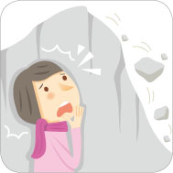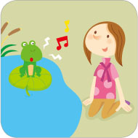
2. (A) (B) (C)

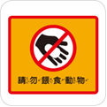

3. (A) (B) (C)

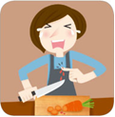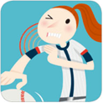

4. (A) (B) (C)

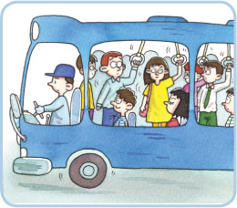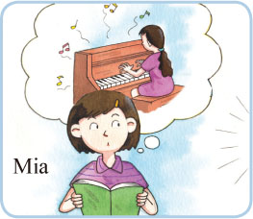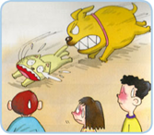
5. (A) (B) (C)

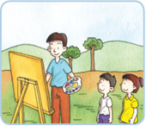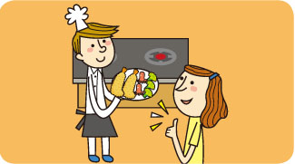

B. 基本問答: 請依據所聽到的句子，選出一個最適合的答案。10 %
6. (A) We shouldn't carry our own chopsticks and spoons.
(B) In order to save money, we have to carry our own spoons and chopsticks.
(C) We should carry our own chopsticks and spoons to protect the earth.
7. (A) Ariel is the fastest runner of all.
(B) Kate can run faster than Ariel.
(C) Kate is the fastest runner of all.
8. (A) Jenny's dad can't cook.
(B) Jenny's dad is a bad cook.
(C) Jenny's dad is a better cook than her mother.
9. (A) Simon took my place.
(B) Simon jumped the farthest.
(C) Simon jumped farther than Leo.
10. (Ａ) Sure, I see the sun rise.
(Ｂ) Yes. They are so big. Let’s leave here.
(Ｃ) Yes. They are giant rocks.

C. 言談理解:請依據所聽到的對話內容，選出一個最適合的答案。10 %
11. (A) The woman is having a terrible headache.
(B) The man is going to take the woman to the hospital.
(C) The man told the woman to see a doctor right away.
12. (A) Hebe is talking excitedly about the race.
(B) Hebe tried her best and won the running race.
(C)Hebe is the number one runner to the girl, too.
13. (A) He listened to the radio.
(B) He went to a talk show.
(C) He watched TV.
14. (A) She asked the man to sweep the floor.
(B) She asked the man to eat less meat.
(C) She asked the man to turn off the light.
15. (A) She hurt her shoulder.
(B) She had a bad headache.
(C) She ate too much and had a stomachache.

二、綜合選擇 40 %
16. Ms. Yen, can I go to the student health ? I just hurt my right leg.
(Ａ) neck (Ｂ) center (Ｃ) team (Ｄ) ground
17. John during the relay race and could not keep running.
(Ａ) cheered me up (Ｂ) took my place (Ｃ) tripped and fell (Ｄ) tried his best
18. Please speak to those children with hearing problems so that（為了）they can read your lips more easily and understand better. (Ａ) slowly (Ｂ) quietly (Ｃ) politely (Ｄ) quickly
19. I think the road ends here; it won’t go any . Shouldn’t（不應該）we turn back?
(Ａ) closer (Ｂ) farther (Ｃ) faster (Ｄ) longer
20. Mark: We can’t enter the house. I can’t find my key! Bill: Is it possible（可能的）that you it
in the car?
(Ａ) caught (Ｂ) changed (Ｃ) found (Ｄ) left
21. Destiny: Who’s that handsome over there? Luisa: Oh, he’s my cousin, Miguel.
Destiny : Can we go say hi to him? Luisa: Why not?
(Ａ) recorder (Ｂ) gray (Ｃ) guy (Ｄ) actress
22. My mother me send an e-mail to my sister in the USA yesterday.
(Ａ) had (Ｂ) told (Ｃ) asked (Ｄ) wanted
23. Roy: Why didn’t you eat your cake? Kay: I’m still full. Can I it for later?
Roy: Sure.
(Ａ) pass (Ｂ) save (Ｃ) shoot (Ｄ) stop
24. I have to catch the bus right now, I’ll miss（錯過）my grandpa’s birthday party.
(Ａ) and (Ｂ) because (Ｃ) or (Ｄ) until
25. Don't let children on the busy streets. It's dangerous.
(A) play (B) to play (C) played (D) playing
26. Josh: Mom, I’m so nervous. I want to win the talent contest, but I don’t sing as well as...
Mom: Just . Winning is not that important.
(Ａ) try your best (Ｂ) get to the finish line (Ｃ) take my place (Ｄ) agree with me
27. Paula felt . She felt someone her body in the dark.
(Ａ) angry; touch (Ｂ) angry; touched (Ｃ) angrily; touched (Ｄ) angrily; touch
28. Kevin: What do you do in your free time? Amy: I go swimming a lot. Almost（幾乎）every day.
Kevin: Wow! That’s a good . It keeps you healthy.
(Ａ) business (Ｂ) chance (Ｃ) dream (Ｄ) habit
29. Jocky likes English the because he never does well on English tests.
(Ａ) best (Ｂ) least (Ｃ) more (Ｄ) less
30. Sally: Why did John look at that time?
Beth: He looked at everyone around him because he lost race of the year.
(Ａ) sad; sadly; the most important (Ｂ) sadly; sad; the more important
(Ｃ) sadly; sadly; most importantly (Ｄ) sad; sad; more importantly
31. Destiny, my American friend in Taiwan, has learned（已學習到）to use well and can eat beef（牛肉）noodles the way most Taiwanese people do. (Ａ) chopsticks (Ｂ) forks (Ｃ) knives (Ｄ) spoons
32. The cat got excited when（當…）it saw the boy the birds.
(Ａ) catches (Ｂ) catching (Ｃ) to catch (Ｄ) caught
33. My mom told me to take care of in England. She worried that I couldn’t eat or sleep well there.
(Ａ) me (Ｂ) myself (Ｃ) her (Ｄ) herself
34. Teachers told us to clean up our classroom. They didn’t want to see any on the floor.
(Ａ) seat (Ｂ) space (Ｃ) medicine (Ｄ) garbage
35. The picture on the wall is not as as it was ten years ago. It has changed（已改變）from white to gray.
(Ａ) bright (Ｂ) heavy (Ｃ) sure (Ｄ) young
三、克漏字選擇 4 %
A.
Mrs. Lin: A-fa! It’s twelve o’clock already! Are you going to stay in bed all day long?
A-fa: Mom, it’s Sunday! And we don’t have any homework this weekend.
Mrs. Lin: That’s great! Then you can (36) after lunch, can’t you?
A-fa: OK, but I think I should be paid for that. How about ten dollars for cleaning my room and ten for taking out the garbage?
Mrs. Lee: No problem. But I cleaned your room and took out the garbage yesterday. I think I should
(37) , too. Now, come on! Get up!

36. (Ａ) study English (Ｂ) play the piano (Ｃ) clean the house (Ｄ) go out for a walk
37. (Ａ) get 20 dollars (Ｂ) wait for 20 days (Ｃ) lose 20 kilograms (Ｄ) get up 20 minutes earlier
B.
John: Ouch!
Sherry: (38) ? Are you all right?
John: I cut my finger and broke my nail.
Sherry: You are bleeding. You hurt your finger (39) . You need to rest your finger for a few days.
John: Oh, no! I can't play the guitar on Monday.
38. (A) What happened? (B) How do we get there?
(C) What do you do? (D) What time is it?
39. (A) worse (B) bad (C) better (D) badly
四、閱讀測驗 6 %
Do you have a weight problem? Do you exercise regularly but still can't lose weight, or even worse, get hurt? (40)
Set a good plan
(41) , but you may also get hurt from exercising too much. Usually, it would be good to exercise three times a week, 30 to 60 minutes each time. If you want to exercise for more days a week, be sure to take at least one day off. Ask your doctor and exercise coach for advice to find the right exercises for you. (see picture 42)
What exercise comes to mind when talking about losing weight? Jogging, biking, or swimming? If weight training is not one of your answers, then you are missing something very important. Weight training helps grow muscle, and muscle helps you lose weight even when you are not doing anything at all. So, if you want to lose weight faster, don't forget weight training.
Exercise before a meal
Exercising before your main meal helps you lose more fat. But remember, if the meal is much bigger than your regular one, you will still get heavier. These tips are not difficult. Give them a try and exercise smart!
weight 重 training 訓練 muscle 肌肉
40.(A) Maybe you should ask a doctor for advice.
(B) What is your excuse for not doing exercise?
(C) Always remember to warm up before you exercise.
(D) If your answer is yes, here are some important tips for you.
41.(A) Many people eat healthy food to lose weight
(B) No exercise can reduce fat in only arms or legs
(C) A good coach can help you set the right exercise plan
(D) Exercise helps you lose weight and become healthier
42.(A) Use your muscle
(B) Do weight training
(C) Pick the right exercise
(D) Go jogging or swimming
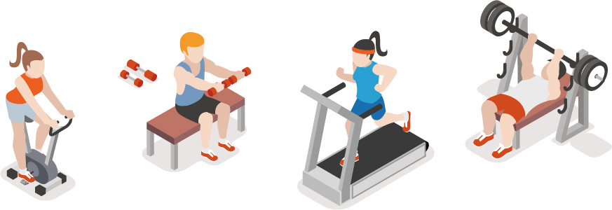( picture 42)
五、依提示改寫句子8 %
43. Peter is a good basketball player on the school team.（加入 well 改寫句子）
44. Oliver rolled the Easter egg more quickly than Roy. / Roy rolled the Easter egg more quickly than Danny.
（以Danny 開頭，用副詞最高級合併。）
45. My mother asks us to eat in the dining room. （用have改寫句子）
46. Leo and I made some hamburgers. / No one helped them. （用反身代名詞合併句子）

六、翻譯12 %
47.我聽到Sandy正在她的房間彈吉他。(3分)
48.我們應該養成使用自備購物袋的習慣。(3分)
49. Nick膝蓋嚴重受傷且需要休息幾天。(3分)
50.他們同時浸泡著溫泉並欣賞太陽下山。(3分)

試題結束，請再仔細檢查。

新北市立溪崑國民中學105學年度第二學期第二次定期評量英語科―答案卷
八年級 班 座號 姓名
五、依提示改寫句子 8 %
43.
44.
45.
46.

六、翻譯 12 %
47.
48.
49.
50.

新北市立溪崑國民中學105學年度第二學期第二次定期評量八年級英文科聽力測驗。本聽力測驗分ABC三部份，每題會唸兩次，請仔細聽完句子後，選出最佳答案。 (請用中等速度，每題唸兩次，題目間隔3秒，大題間隔5秒)
聽力測驗開始
A.請依據圖片內容，選出最適當的答案。
- Alice saw the rocks rolling down.
- People mustn't feed animals here.
- Amy hurt her shoulder.
- They saw a big dog running after a cat.
- The kids watched the man paint a picture.
B. 基本問答:請依據所聽到的句子，選出一個最適合的答案。
- We should make it a habit to carry our own spoons and chopsticks to save our earth.
- Sam runs faster than Kate and Ariel runs faster than Sam.
- Jenny's dad cooks better than her mom.
- Who jumped the farthest on the sports day?
- The wind is strong. Do you see the wave getting higher?
C. 言談理解:請依據所聽到的對話內容，選出一個最適合的答案。
- M: You don't look good. What's the matter?
W: My stomach hurts very much. Can you take me to the hospital?
M: Of course. I'll drive you there right away.
12. B: Why is Hebe crying so sadly? What's wrong?
G: She tried her best, but she still lost the running race.
B: Winning is not everything. She's already the number one runner to me.
G: I couldn't agree with you more.
13. W: Did you sleep well last night? I heard you open your bedroom door.
M: I couldn't sleep, so I went to the living room.
W: I also heard you watching TV.
M: That was the radio. I was listening to a talk show then.
Question: What did the man do last night?:
14. W: Could you help me sweep the floor?
M: Sure! But I am busy now. Could you wait a second?
Question : What does the woman ask the man to do?
15. Mom: What's the matter with you, Laura?
Laura: I ate too much and had a bad stomachache.
Mom: You need to go to a doctor.
Laura: I can't. I need to practice long jump for the competition the day after tomorrow.
Mom: That's too bad. You have to rest for a few days.
Laura: Oh, no! I need someone to take my place.
Question :What is wrong with Laura?
聽力測驗結束!

105-2-2八年級英語科－解答
一、1-5.ABBCA , 6-10. CACBB, 11-15. BCAAC 30%
二、16-20. BCABD, 21-25. CABCA, 26-30. AADBA, 31-35. ABBDA, 36-39. CAAD 44%
三、40-42. DD 42.送分 6%
四、依提示作答: 8 %
43. Peter plays basketball well on the school team.
44. Danny rolled the Easter egg the most slowly of the three (boys) / of all the (boys).
45. My mother has us eat in the dining room.
46. Leo and I made some hamburgers by ourselves.
五、翻譯: 12 %
47. I heard Sandy playing the guitar in her (bed)room.
48. We should make it a habit to use our own shopping bags.
49. Nick hurt his knee badly and needed / have to (take a) rest for a few days.
50. They soaked in the hot spring and watched the sun set / go down at the same time.

