新北市立溪崑國民中學105學年度第二學期第二次定期評量英語科試卷
七年級 班 座號 姓名
一、聽力：30％(每題2分)
(一) 根據聽到的內容，選出最適合的回應
- (A) It’s from July to August. (B) It’s on April 15. (C) It’s May 10.
- (A) Great! What do you want to eat? (B) What food do you sell? (C) Sure, I am full after breakfast.
- (A) I don’t need any drinks. (B) I need a bag of sugar and two cans of cola. (C) I don’t have any money.
- (A) Don’t worry. I have ten at home. (B) You need four or six eggs. (C) I don’t like cake.
- (A) January is the first month. (B) Mary is the last one! (C) It’s December.

(二) 辨識句意:根據聽到的內容，選出符合描述的圖片
6. (Ａ) (Ｂ) (Ｃ)
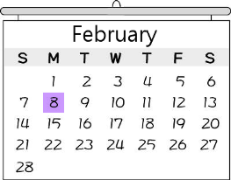 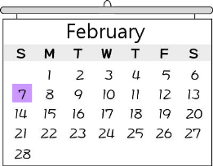 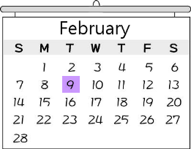
7. (Ａ) (Ｂ) (Ｃ)
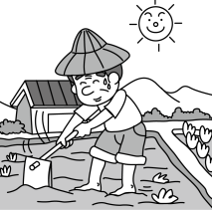 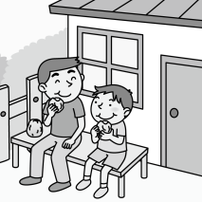 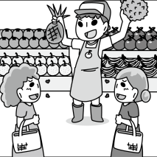
8. (Ａ) (Ｂ) (Ｃ)
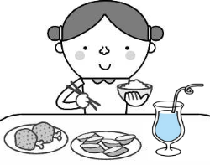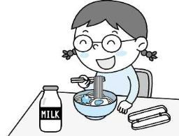

9. (Ａ) 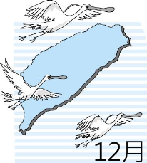 (Ｂ) 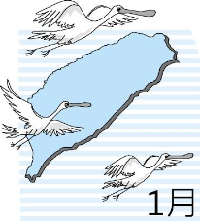 (Ｃ) 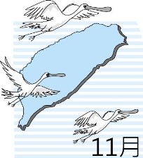
10. (Ａ) (Ｂ) (Ｃ)
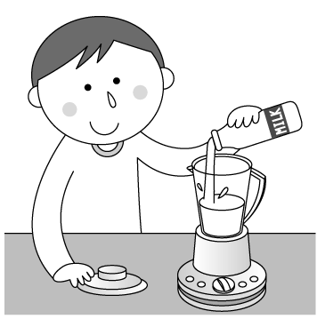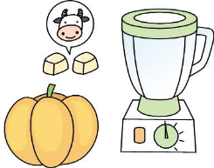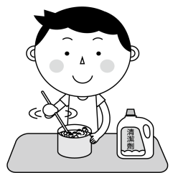

(三) 根據對話內容與問題，選出最適合的答案
- (A) The man is making apple pies. (B) The man doesn’t like pies. (C) The man doesn’t have apples.
- (A) A rice ball. (B) A sandwich. (C) Milk.
- (A) The man needs a glass of water. (B) The woman has lemon tea. (C) The man wants a glass of cola.
- (A) The woman doesn’t want to eat anything. (B) The tea is fifty-five dollars.
(C) The woman wants to have some tea and an apple pie.
- (A) The woman has rice every day. (B) The man eats rice every day. (C) The woman cooks rice for the man.
二、綜合選擇(選出最適合的答案)：30％(每題2分)
- It’s time for dinner. Let’s eat at Lisa’s Kitchen. I have two ________ for free beef noodles.
(A) gifts (B) bowls (C) tickets (D) coupons
- The birthday of the ROC is on _______ tenth.
(A) July (B) February (C) October (D) March
- Mother’s Day is ________ May 14 ________ this year.
  - in; X (B) in; in (C) on; in (D) on; X
- My family are going to the movie, The Boss Baby. Would you like to go with _______?
(A) her (B) me (C) them (D) us
- There are two comic books on the desk. _______ do you like?
(A) Where (B) What (C) How (D) Which
- The fried chicken on the plate _______ yummy. Let’s eat _______.
(A) is; it (B) are; them (C) are; some (D) is; them
- Tim: What do you eat for breakfast? May: I like ________.
(A) a fruit salad (B) some sandwich (C) hot dog and banana (D) some juice and eggs
- How about sugar? _______ do you want?
  - How much (B) Which (C) How many (D) What
- Today is my brother’s _______ birthday.
(A) the twenty-five (B) twenty-five (C) twenty-fifth (D) the twenty-fifth
- Wow, many toy cars! Do you have _______ toy cars?
  - two hundreds (B) hundred of (C) two hundred (D) two hundreds of
- Jason: What’s the date today ? Eric: _______.
(A) It’s on July 20. (B) It’s in May. (C) It’s January 15. (D) It’s Tuesday.
- Father’s Day in Japan is _______ third Sunday _______ June.
  - the; of (B) on the; of (C) on the; this (D) X; in
- The smartwatch is very _______. I can’t buy it.
  - nice (B) expensive (C) yummy (D) pretty
- Mom, don’t worry _______ the money. Here _______ our pocket money. You can use it.
(A) for; is (B) about; are (C) X; is (D) about; is
- A: How many candles _______ the cake? B: There is one.
(A) are there in (B) are there on (C) is there at (D) is there on
三、克漏字選擇：8％(每題2分)
How Do You 31 Blueberry Milk Shake?
What do you need? What do you do?
- Some blueberries First, put the blueberries and milk 32 a blender.
- A glass of milk Second, put the blueberry ice cream in it.
- A small cup of blueberry ice cream Third, blend 33 thirty seconds.
What do you get?
You get a 34 of blueberry milk shake!

- (A) Cook (B) Drink (C) Make (D) Buy
- (A) in (B) on (C) with (D) to
- (A) with (B) to (C) it (D) for
- (A) cups (B) plate (C) glass (D) bag
四、閱讀理解：12％(每題2分)
(一)
Derek: Mom, where are you?
Mrs. Lin: I’m here on the balcony with your sister.
Derek: Are you busy now?
Mrs. Lin: No, not really. I’m watering the flowers. Why?
Derek: I need your help. Can you come to the kitchen?
Mrs. Lin: Sure. I’m coming.
***************************
Mrs. Lin: What’s wrong?
Derek: I want to make strawberry juice, but the blender doesn’t work!
Mrs. Lin: Let me see… Ha! You forget to plug it in!
Derek: Ha! How foolish I am!
balcony 陽台 plug in 插上..插頭

- Where is Derek?
(A) On the balcony. (B) In the kitchen. (C) In the living room. (D) In a fruit stand.
- Which is true?
(A) Mrs. Lin is making strawberry juice in the kitchen. (B) Mrs. Lin can fix(修理) the blender.
(C) Derek is trying to make juice by himself (自己). (D) Derek is on the balcony with Mom.
- Which is Not true?
(A) Mrs. Lin isn’t busy. (B) Derek’s sister is on the balcony.
(C) Derek needs his mother’s help. (D) The blender is broken(壞了).

(二)
Chou’s Kitchen

Fish set meal NT$ 150 Apple juice NT$ 40
Chicken set meal NT$ 120 Orange juice NT$ 40
Pork set meal NT$ 100 Coffee NT$ 50
Fish NT$ 100 Green tea NT$ 30
Chicken NT$ 70 Ice cream NT$ 40
Pork NT$ 50
- If people order set meals, they can have free drink and ice cream.
- If five people come, one is free. if 假如

- What does “it” refer to?
(A) A movie. (B) Live news on TV. (C) A baseball game. (D) A TV show.
- Which one is true?
(A) Ted is a baseball player. (B) Lisa doesn’t like to play baseball.
(C) Lisa finished watching the movie. (D) Ted’s math is better than Lisa’s.

38. What’s Chou’s Kitchen?
(A) A department store. (B) A restaurant. (C) A supermarket. (D) A school.
39. Amy usually(通常) orders a chicken, a glass of apple juice, and a cup of ice cream.
If she orders a chicken set meal, how much can she save(節省)?
  - NT$ 40 (B) NT$ 50 (C) NT$ 20 (D) NT$ 30
- Frank and four of his classmates order five pork set meals. How much should they pay?
  - NT$ 400 (B) NT$ 500 (C) NT$ 200 (D) NT$ 250

以下為非選擇題，請在答案卷上作答 20%

五、依提示作答: 5％
第1-3題 將括弧內的字用代名詞的-主格、所有格或受格改寫。(每題1分)
- Alex and Tina are ________ (Vicky and Tim’s) parents.
- May loves ________ (her father) a lot.
- Do you like ________ (your birthday card)?
- There are two bottles of water in Jenny’s bag. (依畫線部分造原問句) 2%

六、翻譯: 15％
- 星期日是一週的第一天嗎? 3%
- 我們吃一盤水餃和魚湯當晚餐吧。 4%
- 你的妹妹喜歡哪一個,咖啡、紅茶或奶茶呢? 4%
- 媽媽一年365天都在照顧我們,但是我們只有在母親節表達我們的謝意。4%

試題結束!

新北市立溪崑國民中學105學年度第二學期第二次定期評量英語科―答案卷
七年級 班 座號 姓名
非選擇題20%
五、依提示作答: 5％ (1-3每題1分)
1. ________________ 2. ________________ 3. ________________

4. ( 2分)

六、翻譯: 15%
5. ( 3分)
6. ( 4分)

7. ( 4分)

8. ( 4分)

試題結束! Good Luck!

新北市立溪崑國民中學105學年度第二學期第二次定期評量―七年級英語科聽力稿

錄音稿：
（一）根據聽到的內容，選出最適合的回應
1. When is our school’s birthday?
2. Let’s go out for lunch today.
3. I’m going to Denny’s shop. What do you need?
4. I’m making a cake, but there are no eggs at home.
5. What is the last month of the year?
答案：(B) (A) (B) (A) (C)
（二）辨識句意:根據聽到的內容，選出符合描述的圖片
6. The ball game is on the second Monday of February.
7. The man works at a fruit stand.
8. Sandy is having some noodles and juice.
9. The birds fly to Taiwan in November.
10. The boy puts some milk in a blender.

答案：(A) (C) (B) (C) (A)
- 根據對話內容與問題，選出最適合的答案
11. (Chopping sound)
W: Are you making pumpkin pies?
M: No. I’m making apple pies. I don’t like pumpkins.
Q: Which is true?

12. M: Do people in Taiwan have rice for breakfast?
W: Well, only some eat rice for breakfast. I have a rice ball and soy milk for breakfast. How about you?
M: I have a sandwich.
Q: What does the woman have for breakfast?

13. W: I have some green tea and cola. Do you want some?
M: Of course. A glass of cola, please.
W: Here you are.
Q: Which is true?

14. W: Can I have some tea, please?
M: Sure. It is fifty dollars.
W: I want an apple pie, too.
Q: Which is true?

15. M: I eat three bowls of rice every day. How about you?
W: I don’t like rice. I don’t eat any.
Q: Which is true?
答案： (A) (A) (C) (C) (B)

105學年度第二學期第二次定期評量七年級英語科解答

一、聽力測驗：30% (每題2分)
1~5 BABAC
6~10 ACBCA
11~15 AACCB
二、綜合選擇：(選出最適合的答案) 30% (每題2分)
16~20 DCD (19.C或D) D
21~25 ADACC
26~30 CBBDB
三、克漏字選擇：8％ (每題2分)
31~34 CADC
四、閱讀理解：12％ (每題2分)
35~37 BCD 38~40 BDA
五、依提示作答：5%
1. their 2. him 3. it (每題1分)
4. How much water is there in Jenny’s bag? 2%

六、翻譯：15%
5. Is Sunday the first day of the week? 3%
6. Let’s have a plate of dumplings and fish soup for dinner. 4%
7. Which does your sister like, coffee, black tea, or milk tea? 4%

8. Mom takes care of us 365 days a year, but we show our thanks only on Mother’s Day. 4%

