新北市立溪崑國民中學105學年度第二學期第一次定期評量英語科試卷
九年級 班 座號 姓名
一 聽力測驗
辨識句意
- (Ａ) 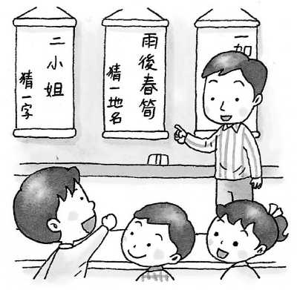(Ｂ) 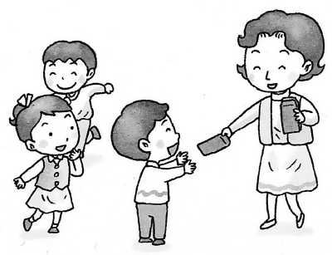 (Ｃ) 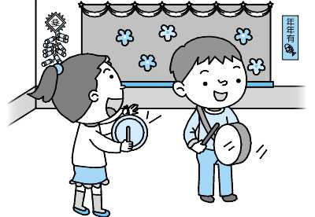
- (Ａ) 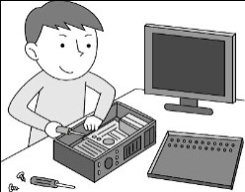 (Ｂ) 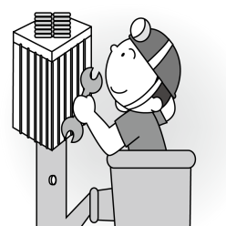 (Ｃ) 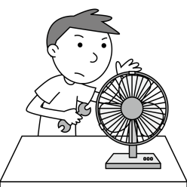
- (Ａ) 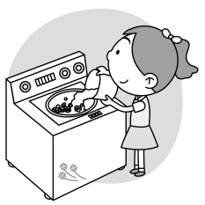 (Ｂ) 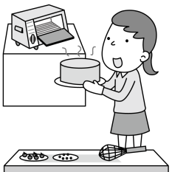 (Ｃ) 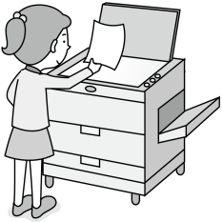
- (Ａ) 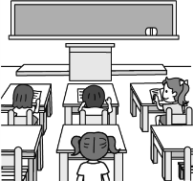 (Ｂ) 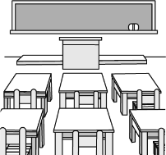 (Ｃ) 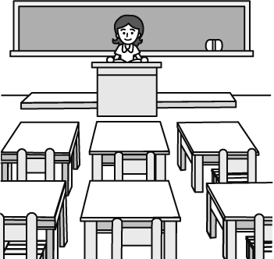
- (Ａ) 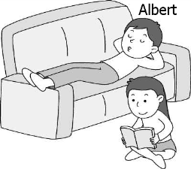 (Ｂ) 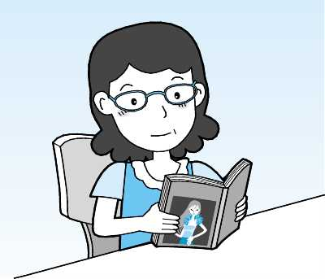 (Ｃ) 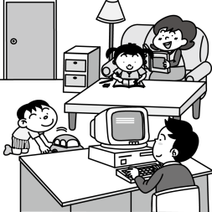
基本問答
- (A) No worries. I’m fine.
(B) Sorry, I was caught in the traffic.
(C) I’ll bring some drinks for the party.
- (A) No. Have a seat.
(B) No. It is taken already.
(C) No. Sit down, please.
- (A) Sometimes. And I can deal with them well.
(B) Actually, I usually feel stressed out.
(C) I always finish my work on the dot.
- (A) The show is neither today nor tomorrow.
(B) I will have the chance to interview either the actor or the actress.
(C) Not only I but also he was surprised at the amazing performance.
- (A) About NT$600 for each.
(B) Usually 30 to 45 minutes.
(C) Maybe five miles or more.
言談理解
- (A) The woman likes Janet’s class.
(B) The man is interested in Janet’s class.
(C) The man always talks to the woman in Janet’s class.
- (A) Before she got to the station, the last bus had gone.
(B) She thought she had to stay home watching TV.
(C) She never had a chance to have any fun.

- (A) Jill.
(B) Patrick.
(C) Neither Jill nor Patrick.
- (A) Either the man or the woman had fun today.
(B) Not only the man but also the woman had a good day.
(C) Neither the man nor the woman’s day went well today.
- (A) The woman.
(B) The baby.
(C) The man
二 綜合測驗 (16-32)
- Mr. Lin often tells us to study hard and not to _____ on a test.
(A) check (B) change (C) review (D) cheat
- The ______ looked angary because her boss asked her to finish all the work before going home.
(A) secretary (B) kid (C) actor (D) stranger
- The workers stayed late every night last month in order to finish the work ______ of time.
(A) above (B) full (C) later (D) ahead
- _____ to see them get along so well with one another.
(A) I have surprise (B) I am surprise (C) It is surprise to me (D) It’s a surprise for me
- Adam didn’t go to the movies, ______. We don’t both like to watch movies.
(A) and I didn’t, either (B) but I did (C) and I wasn’t, either (D) but I was
- Jane is going fishing tomorrow. She wants to know _____ the weather will be fine.
(A) that (B) what (C) whether (D) how
- David saw a little girl cry in the park. He _____ there with her before her mother came. It was so nice of him !
(A) stay (B) stays (C) has stayed (D) had stayed
- Jane: Can you tell me when Bill ______ tomorrow ?
Mary: I don’t know. But when he _____, I’ll call you.
(A) comes; comes (B) will come; comes (C) will come; will come (D) comes; will come
- Let me help you carry this heavy box, _____ ?
(A) won’t you (B) OK? (C) will you (D) shall we ?
- Amy : Which does your mom like, tea or coffee?
Tony: She likes _____ tea ______ coffee. She thinks both of them are bad for our health.
(A) either; or (B) neither; nor (C) both; and (D) neither; but
- Derek saw a boy hit by a car when he ______ for the traffic lights.
(A) had waited (B) has waited (C) was waiting (D) waiting
- Cindy knows Amanda well. They _________ good friends for twelve years.
(A) are (B) been (C) had been (D) have been
- Who he is ______ unknown, but I really want to thank him for saving my life.
(A) is (B) having been (C) X (D) does
- It was three days ago ____ a little boy told _____ some eggs by his mother went missing. He was last seen _____ in front of the market.
(A) that; to buy; playing (B) while; and bought; play (C) when; buying; to play (D) after; buy; play
- _____ going shopping, Dad asked me if Mom would eat at home tonight. He wanted to know what he should buy for the dinner.
(A) Without (B) Before (C) By (D) Until
- ________ our basketball school team won the game, we cheered in excitement.
(A) As much as (B) As far as (C) As good as (D) As soon as
- 努力用功，總有一天你會美夢成真。
(A) Studying hard, and you will make your dream come true someday.
(B) To study hard, and your dream will come true some day.
(C) By study hard, your dream will come true some day.
(D) Study hard, and you will make your dream come true someday.

三、題組

(33-37)
Something has been bugging Ethan lately. He wants to study art but his mom doesn’t agree. She asks Ethan to be a(n) (33) at a computer company in the future. In fact, Ethan has a (34) in art and wants to create beautiful things with his hands one day. But his mom doesn’t think (35) an artist is a good idea. On the contrary, Amy’s parents respect her decision (36) she thinks carefully. They think that if teenagers make their own decisions, they learn to be responsible for themselves. Ethan is (37) than Amy, is he?
- (Ａ) waiter (Ｂ) clerk (Ｃ) engineer (Ｄ) cook
- (Ａ) talent (Ｂ) interest (Ｃ) stress (Ｄ) chemical
- (Ａ) to being (Ｂ) not to be (Ｃ) be (Ｄ) being
- (Ａ) as much as (Ｂ) as long as (Ｃ) as soon as (Ｄ) as far as
- (Ａ) lucky (Ｂ) more luckily (Ｃ) less lucky (Ｄ) luckier
(38-42)
Many people believe ___38_____ sharks are usually terrible killers in the sea. ___39____, most of them do not eat or bite people.
Sharks __40___ on earth for ages, so they __41___ a very long history already. Most sharks never really sleep, and they have to __42____ in their lives. As we know, three sharks die every second. So we shouldn’t be afraid of sharks so much. We should try our best to protect them.

- (A) whether (B) what (C) that (D) which
- (A) At last (B) At first (C) By the way (D) In fact
- (A) lived (B) have lived (C) live (D) are living
- (A) will have (B) had (C) have had (D) had had
- (A) keep to swim (B) stop swimming (C) stop to swim (D) keep swimming
(43-45)
Have you seen Kate Moss on TV or in magazine before? It’s possible that you have because she is one of the top models in the world now.
Kate was discovered when she was only 14 years old. At that time, she had just finished her trip to New York and was waiting at the airport to go back to the UK. Two years later, her photos appeared in a popular magazine. She caught everyone’s eye with her special style.
Unlike other top models in the 1990s, Kate was young and short, almost 10 cm shorter than others. Besides that, she was very thin; you might even say she was too thin. Many people thought she was sick or she ate almost nothing. Kate once told the reporter that those ideas were nonsense and what she looked like was how she always was.
Kate is still eye-catching even when she is not working. She always dresses nicely even if she is just going out to buy a cup of coffee. Many women like to dress like her, so Kate began designing clothes in 2007. With her hard work, she soon became the most well-known and richest model in the world.
model 模特兒 discover 發現 design 設計

- What did NOT make Kate Moss different from other top models in the 1990s?
(A) She wasn’t tall enough.
(B) She was good at designing.
(C) She wasn’t as heavy as others.
(D) She was just a teenager.
- What may “nonsense” refer to ? (refer to 意指)
(A) Something that is not true.
(B) Something that is real.
(C) Something that is interesting.
(D) Something that is not fun.
- What do we know about Kate from this reading ?
(A) She keeps herself thin by eating little food.
(B) She was in a magazine for the first time when she was 14.
(C) She dresses beautifully only when she is working.
(D) She makes money by designing clothes and working as a model.
(46-47)
I have read many books and have also seen many movies about Egypt. The first movie I watched was called “The Mummy” The movie was the mummy of a king. Such the movies about the mummy were usually made inside a king’s tomb. Egyptians believed that entering the tombs will bring bad luck. That’s also one of the reasons why the mummy movies are so appealing . Although I like watching the movies about Egypt, but I haven’t had the chance to visit Egypt. I believe I will go there in the future.
Egypt 埃及 egyptians 埃及人 mummy 木乃伊

- Ｗhat does that mean if you say that’s “something appealing”?
(A) Something you would get interested in.
(B) Something you hate to see again.
(C) Something you don’t want to know.
(D) Something you need to understand.
- Which is true?
(A)A possible title (可能的標題)for this reading is “ My Favorite Country.”
(B)”The Mummy “ was a movie talking about the history of an Egyptian king.
(C)The writer has dreamed about going to Egypt since he saw the movies.
(D) Everyone should be careful when they see the mummy movies.
(48-50)
An American company is developing a Carbot, which is a car that can drive itself. This robot car can start, steer, and ship, all without a person driving it. The car’s computer gives the Carbot information about speed limits and maps of where to drive. The Carbot uses lasers and video cameras to see other cars. It also uses these things to see people crossing the street, so it can avoid hitting them.
The people working to develop the Carbot say that a robot car is safer than a car with a human driver because computers won’t get distracted by things such as using a cellphone or MP3 player. Also, computers can react to things more quickly than humans. So far, during testing of this new type of technology on the street, there has been only one accident involving the Carbot, and it wasn’t even the Carbot’s fault! Another car with a human driver (who was not paying close attention) hit Carbot while the Carbot was correctly stopped at a red light.
Just think of all the things you could do in a car if it could drive for you. You could surf the web and do some online shopping, text your friends, or just relax and enjoy the scenery, all without having to worry about keeping an eye on the road or keeping your hands on the steering wheel.
steer 駕駛 distracted 精神不集中的 react 做出反應 fault 錯誤 involve 包含

48. What is a Carbot ?
(A) Any car that is the color black.
(B) A bus.
(C) A new laptop
(D) A robot car that is being developed
49. Which is a benefit(益處) of having a Carbot ?
(A) You don’t have to do your homework anymore.
(B) You have to pay close attention to the road when in a Carbot.
(C) You will never get into an accident when in a Carbot.
(D) You can just relax and enjoy the scenery when in a Carbot.
50. What is NOT true about the Carbot?
(A) It can steer by itself.
(B) It can fly.
(C) It uses lasers and video cameras to see people crossing the road.
(D) It may be safer than a car with a human driver.

新北市立溪崑國民中學105學年度第二學期第一次定期評量―九年級英語科聽力搞
1 | B: Ann, what did you do last night?  G: I joined a riddle party.
2 | My father works as a engineer who fixes computers or TVs.
3 | The copy machine is very useful. It saves us a lot of time.
4 | Nobody is in the classroom except the teacher.
5 | When Albert got home, his mom was reading in the study.
6 | What’s taking you so long ?
7 | Is this seat free?
8 | Do you often try to do more than one thing at a time, Sarah?
9 | How did you and your husband like the show?
10 | Do you know how long it takes to bake a cake.
11 | M: Janet’s class is always boring.  W: Speak for yourself.  Q: Which is true?
12 | M: Why didn’t you join the concert last night? It was very wonderful and all at the gym were going wild!  W: Well, I got to the station too late, so I missed the last bus to Blue Town. I had to watch TV at home.  M: Too bad! You missed a good chance to have fun!  Q : Why didn’t the woman go to the concert?
13 | M: Do you know who will win the singing contest this time?  W: I believe that first place will go to either Jill or Patrick.  M: Well, I think Jill will win because she performs better than Patrick.  Q: Who does the man think will win first place?
14 | M: Today isn’t my day.  W: It’s not mine, either.  Q: Which is true?
15 | M: When I was making a shopping list, the phone suddenly rang. However, I missed the call.  W: It was me. I called you to make sure that you can buy milk for our baby.  M: Don’t worry about it. I bought it this afternoon.  Q: Who bought the milk?

105-2-1九年級英語科－解答

1 | 2 | 3 | 4 | 5 | 6 | 7 | 8 | 9 | 10
A | A | C | C | B | B | B | A | C | B

11 | 12 | 13 | 14 | 15 | 16 | 17 | 18 | 19 | 20
A | A | A | C | C | D | A | D | D | B

21 | 22 | 23 | 24 | 25 | 26 | 27 | 28 | 29 | 30
C | D | B | C | B | C | D | A | A | B

31 | 32 | 33 | 34 | 35 | 36 | 37 | 38 | 39 | 40
D | D | C | A | D | B | C | C | D | B

41 | 42 | 43 | 44 | 45 | 46 | 47 | 48 | 49 | 50
C | D | B | A | D | A | C | D | D | B

