新北市立溪崑國民中學105學年度第二學期第一次定期評量英語科試卷
八年級 班 座號 姓名
一 聽力：30％(每題2分)
- 根據聽到的內容，選出最適合的回應
- (A) Today is Sunday. Let’s go to a movie. (B) It’s better than yesterday. (C) I like fall. The weather is cooler.
- (A) Erica is very tall. (B) Jessie is taller than Erica. (C) Jessie is the shortest of all.
- (A) Yes, he looks happy. (B) He likes to play basketball very much. (C) He looks like his mom.
- (A) Yes, it’s getting colder. (B) Thank you and have a nice day. (C) I’d like to take a look at these cellphones.
- (A) The pears are. (B) The grapes are as sweet as the pears. (C) The bananas are sweeter than the the guavas.

(二) 辨識句意:根據聽到的內容，選出符合描述的圖片

6. (Ａ) 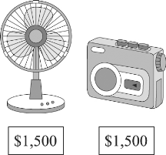 (Ｂ) 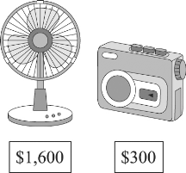 (Ｃ) 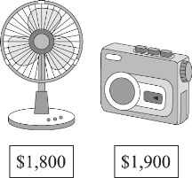
7. (Ａ)  (Ｂ) 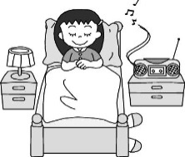 (Ｃ) 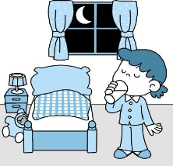
8. (Ａ) 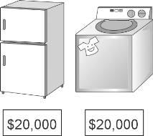 (Ｂ) 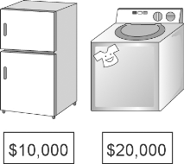 (Ｃ) 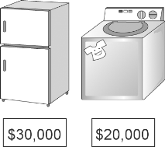
9. (Ａ)  (Ｂ) 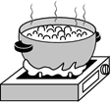 (Ｃ) 
10. (Ａ) 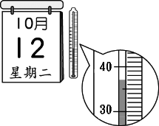 (Ｂ) 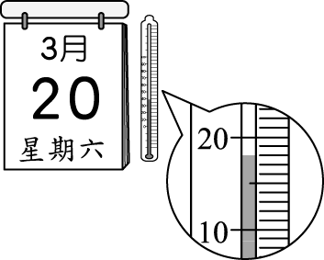 (Ｃ) 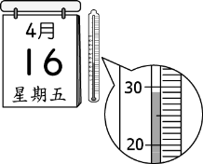

- 根據對話內容與問題，選出最適合的答案
- (A) They will take a train to the museum. (B) It’s easy to buy the train tickets on the Internet. (C) They are going to take a bus to the museum.

- (A) The girl’s. (B) The boy’s. (C) We don’t know.
- (A) Ted. (B) Jason. (C) David.
- (A) He is going to wash his car. (B) Take a bath for Lucky. (C) Keep the woman clean.
- (A) Have an Easter egg hunt. (B) Paint eggs and have a party. (C) Go to church after lunch.
二 綜合選擇(選出最適合的答案)：40％(每題2分)
- Mom: Can you take the pork out of the ________ ? Boy: Ok, Mom.
(A) CD player (B) washing machine (C) radio (D) refrigerator
- Tim: How did you _______ Mother’s Day? May: We made Mom a cake and had a big dinner.
(A) run (B) celebrate (C) set up (D) edit
- Jason: Is there any _______ Wi-Fi here? I need to send an e-mail. Clerk: Yes, I will help you.
(A) free (B) fresh (C) own (D) bouncy
- It’ll take time to ________ all the pictures to your Facebook to show people.
(A) pour (B) roll (C) receive (D) upload
- Don’t get so _______. Just be as cool as a cucumber.
(A) useful (B) popular (C) excited (D) heavy
- English is _______ than Chinese.
(A) much easier (B) difficult (C) very easy (D) more easier
- Eric is ________ of the two boys. (A) the tallest (B) tallest (C) taller than (D) the taller
- New smartwatches are a lot more useful than old _________.
(A) ones (B) them (C) one (D) others
- The salad _________. Don’t eat it, or you will have a stomachache.
(A) smells bad (B) sounds terrible (C) looks delicious (D) tastes yummy
- Taipei is the biggest city in Taiwan.
(A) No city in Taiwan is bigger than Taipei. (B) Taipei is bigger than any other city in Taiwan.
(C) Taipei is bigger than any city in Taiwan. (D) Taipei is bigger than all the cities in Taiwan.
- The air in the city is getting _________ because there are too many cars and motorcycles.
(A) more worse (B) worse and worse (C) bad and bad (D) worst and worst
- Lily, your mom looks so young. You two look _______ like sisters than mother and daughter.
(A) more (B) much (C) less (D) better
- A: Do you have the MP3 player? B: No, I don’t have _______.
(A) ones (B) the one (C) one (D) it
- Of all the novels, I like Harry Potter ________.
(A) better (B) the better (C) more (D) best
- Which is ________, the smartphone, the CD player, or the radio?
(A) cheaper (B) the cheaper (C) cheapest (D) the cheapest
- I grow many kinds of ________, and the yellow ones are the sweetest of all.
(A) seeds (B) buns (C) bands (D) tomatoes
- Mr. Wang is the ________ man in this small town.
- most happiest (B) most famous (C) younger (D) more popular
- John: ________ does it ________? Ann: Vinegar.
- What; taste like (B) How; feel (C) What; smell (D) How; look like

- The Lin family has many family ________ on weekends and holidays.
(A) videos (B) products (C) activities (D) yards
- Lida has the longest hair _______.
- than all the other students in the class (B) than Mary (C) of the two girls (D) in her class
三 閱讀理解：10％(每題2分)
(一)
Peter’s mother was very angry this morning when she saw Peter’s school report card. His mother asked him to do the dishes, mop the floor, and clean up all of the bedrooms. Besides, Peter was grounded this weekend. Peter was so sad, because he couldn’t go to play basketball with his classmates. Here is Peter’s school report card.
School Report Card
Name: Peter Huang
Chinese 96 English 92 Math 50 Science 60
Social Studies 90 Art 80 Music 85 PE 90
Comments: Peter has a great talent for languages. And he always tries to follow the rules of our class. However, he needs to do more exercises on math. I believe he will be getting better and better.
Home Teacher
Miss Connie Chen

- What does “grounded” mean?
(A) Someone who does well on the tests. (B) Someone who has to watch out the floor.
(C) Someone who is not allowed(允許) to go out. (D) Someone who is mopping the floor.
- Which is true?
- Peter does well in all tests this semester. (B) Peter’s English is much better than his math.
(C) Peter is good at science. (D) Peter is so nice that he likes to help his mom do the housework.
(二)
Ted: May I watch the baseball game?
Lisa: No way. I am watching the movie!
Ted: But you’re watching the movies all the time. I seldom watch TV. It should be my turn, shouldn’t it?
Lisa: I don’t care. It’s the most exciting part. Don’t touch my TV.
Ted: Come on! The movie will be replayed again and again. You’ll have many chances to watch it. But the live game is played only once.
Lisa: It will be replayed, too!
Ted: It’s totally different! After you know who won the game, you won’t feel excited at all! By the way, if I can’t watch it now, don’t ask me to teach you math anymore!
Lisa: What!! Fine, I quit. Here you are.

- What does “it” refer to?
(A) A movie. (B) Live news on TV. (C) A baseball game. (D) A TV show.
- Which one is true?
(A) Ted is a baseball player. (B) Lisa doesn’t like to play baseball.
(C) Lisa finished watching the movie. (D) Ted’s math is better than Lisa’s.
40. What does the word, “quit” mean?
(A) Hurry up. (B) Watch out. (C) Give up. (D) Set up.
以下為非選擇題，請在答案卷上作答 20%
四 依提示作答:6％（每題2分）
- Jack and Frank are fatter than Denny. (用Denny…of the three. 改寫)
- Mr. Smith sounded happy on the phone. (依畫線部分造原問句)
- The strawberries are NT$300.
The papayas are NT$150. (以The strawberries….用比較級來合併左邊兩個句子)

五 翻譯:14％ (填空每個空格1分)
- 那位有名的歌手像蜜蜂一樣忙。
The famous singer is ________ ________ ________ a bee.
- 你想要用現金付費買它們嗎?
Would you like to ________ ________ them ________ ________?
- 這男孩的短褲比那女孩的髒。3%
- 歡迎你來體驗採摘最新鮮水果的喜悅。4%

試題結束!

新北市立溪崑國民中學105學年度第二學期第一次定期評量英語科―答案卷
八年級 班 座號 姓名
非選擇題20%
四 依提示作答:6％（每題2分）

五 翻譯14% (填空每格1分)
4.

5.

6. ( 3分)
7. ( 4分)

試題完! Good Luck!
新北市立溪崑國民中學105學年度第二學期第一次定期評量―八年級英語科聽力稿
錄音稿：
（一）根據聽到的內容，選出最適合的回應
1. How is the weather today?
2. Who is taller, Jessie or Erica?
3. Who does the boy look like?
4. How may I help you, ma’am?
5. Which fruit is the sweetest of the three? 答案：(B) (B) (C) (C) (A)
（二）辨識句意:根據聽到的內容，選出符合描述的圖片
6. The fan is not as cheap as the tape recorder.
7. G: I enjoy listening to the radio before I sleep.
8. The refrigerator is more expensive than the washing machine.
9. Watch out! Don’t get close to the boiling water.
10. It was the coldest month of the year. 答案：(B) (B) (C) (B) (B)
- 根據對話內容與問題，選出最適合的答案
11. W: Let’s go to Mess Museum by train. It’s faster than bus.
M: It really is, but it will cost us much more. And it’s more difficult to buy the tickets on the Internet.
W: All right. I’ll buy the bus tickets.
Q: What do we know from the dialogue?
12. B: Wow, you got a new smartphone.
G: Yes. It’s my birthday present from my uncle.
B: Isn’t it expensive?
G: No. It only cost him $2000.
B: What? It’s even cheaper than mine.
Q: Whose smartphone is cheaper, the boy’s or the girl’s?
13. B: In our class, David has a lot of toy cars, but Jason has more than him.
G: I don’t think so. Jason has about five hundred cars, but my cousin, Ted, has more than one thousand toy cars at home. His father is a worker to make toy cars.
Q: Who has the most toy cars?
14. M: Lucky looks so dirty. How often do you wash it?
W: Once a week. But last week I was too busy, so I didn’t take a bath for it.
M: Well, I’m free now. I want to make him clean.
Q: What is the man going to do next?
15. B: What are you going to do on Easter?
G: We’re going to paint eggs. After that, we’ll go to the church.
B: Won’t you have an Easter egg hunt?
G: Why not? It’s the most interesting activity on Easter for us. We can’t wait for it.
Q: Which is the most interesting activity on Easter for the girl? 答案： (C) (A) (A) (B) (A)
105學年度第二學期第一次定期評量八年級英語科解答
一、聽力測驗30% (每題2分)
1~5 BBCCA
6~10 BBCBB
11~15 CAABA
二、綜合選擇(選出最適合的答案) 40% (每題2分)
16~20 DBADC
21~25 ADAAB
26~30 BA C(或D) DD
31~35 DBACD

三、閱讀理解：10％ (每題2分)

36~37 CB 38~40 CDC
四、依提示作答6% (每題2分)
1. Denny is the thinnest of the three.

2. How did Mr. Smith sound on the phone?

3. The strawberries are more expensive than the papayas.
五、翻譯14% (填空每格1分)
4.
as | busy | as
5.
pay | for | in | cash

6.The boy’s shorts are dirtier than that girl’s. (3分)
7.You are welcome to experience the joy of picking the freshest fruit. (4分)

