新北市立溪崑國民中學105學年度第二學期第一次定期評量英語科試卷
七年級 班 座號 姓名
一、聽力測驗 20%
A.辨識句意：根據聽到的內容，選出符合描述的圖片。
- (Ａ) 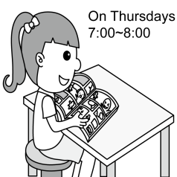 (Ｂ) 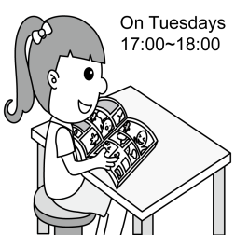 (Ｃ) 
- (Ａ)  (Ｂ) 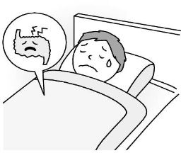 (Ｃ) 
- (Ａ) 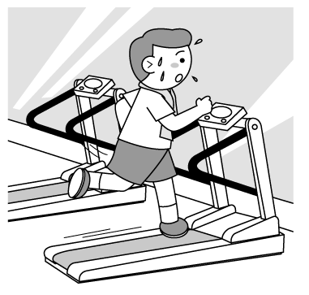 (Ｂ)  (Ｃ) 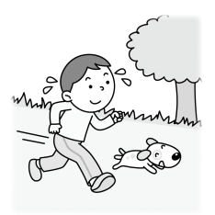

B.基本問答：根據聽到的內容，選出一個最適合的回應。
4. (Ａ) Amy.
( B ) John.
( C ) Jenny.
5. ( A ) The boy is very strong.
( B ) They are going to play basketball every day.
( C ) The boy changes into a writer.
6. (Ａ) OK! Let’s surf the Net now.
(Ｂ) I can surf the Net for thirty minutes, too.
(Ｃ) I don’t surf the Net. I play with my dog after dinner.
7. (Ａ) For about two days.
(Ｂ) I love basketball, so I play it from Monday to Friday.
(Ｃ) I play it from seven to nine.

C.言談理解：根據聽到的內容，選出一個最適合的答案。
8. (Ａ) They study together.
(Ｂ) They help people.
(Ｃ) They play tennis.
9. (Ａ) The girl is working in her office.
(Ｂ) The man is Susan’s son.
(Ｃ) The girl doesn’t go to work every Friday.
10. (Ａ) The boy can’t go to the baseball game.
(Ｂ) There is a baseball game this Sunday afternoon.
(Ｃ) The boy is playing baseball now.

(背面仍有試題 請翻頁繼續作答)
二、文意字彙 10%
11. Adele is a very f s singer. She has a talent for music.
12. Stephen Curry is a basketball player in the NBA. He loves basketball, and he p es basketball every day.
13. Jeremy Lin is a basketball player and he’s 191 c rs tall.
14. Look! Tim is doing a m c. His dog in the box is a bird now.
15. The old woman can’t r r her son’s phone number.
16. A: What are you doing? B: I don’t like yellow, and I’m p g the chair white.
17. A: Is my school bag in the classroom? B: No, there isn’t a g in the classroom.
18. Michael isn’t from Japan. He speaks English, and he’s from A a.
19. My little brother is only 3 years old. He can c t from one to fifty now.
20. That is h d work for Cindy, but she doesn’t mind.

三、語法測驗30%
21. Tracy studies English every day and she can ______ good English. (A) speak (B) speaks (C) speaking
(D) is speaking
22. A: Does Max go to the gym every Friday?
B: No. He ____ that only on Wednesdays. (A) goes (B) does (C) can go (D) doesn’t go
23. Listen! Lisa _____songs. She sings at a concert. We like her songs. (A) can sing (B) sings (C) singing (D) is singing
24. Andrey Jones, the hero ____ from Ted’s book, _____ my favorite. (A) is; is (B) is; X (C) X; X (D) X; is
25. The boy ____ a kite, not surfing the Net. (A) is flying (B) flies (C) fly (D) is fly
26. Their parents are not at home. They play computer games ___ six hours today.(A) during (B) for (C) at (D) on
27. He can write short stories, and I ____, too. (A) do (B) am (C) can (D) can’t
28. This mask is too small, and Jerry can’t put on the mask. It can’t _____Jerry’s mask.(A) is (B) be (C) do (D) are
29. A: Does your brother exercise in the gym every weekend?
B: Yes, he exercises in the gym______. (A) on weekends (B) this weekend (C) on this weekend
(D) on weekend
30. A: Does Jessie _____ a new cat now?
B: Yes, she plays with it after school every day. Look! The cat ______ dinner now.
(A) is having ; has (B) have; is having (C) has; is having (D) has; has
31. Roger loves baseball very much. He has _______ baseball cards. (A) three hundreds (B) four hundred of
(C) two hundred of (D) hundreds of
32. Andy: Who ____ big blue eyes?
Leo: My little sister, Amy,____.
(A) has , have (B) have, does (C) has , does (D) has, has
33. Rita: Who’s the man over there?
Lisa: He’s my uncle.
Rita: _____?
Lisa: He’s a teacher.
(A)What does he do (B) How is he doing (C)What is he doing (D) What can he do
34. Amy: Hello, this is Amy. Is Meg there, please?
Doris: ________ Please call back later.
(A) Sorry, Meg isn’t at home.
(B) This is Meg speaking.
(C) Sure, I am Meg.
(D) Sorry. You have the wrong number.
35. Justin likes basketball, and he plays _____ basketball with his cousins every day. (A) X (B) the (C) a (D) this (仍有試題, 請繼續作答)
四、克漏字選擇 10%
Mom: Hey! 36 is ready.
Mark: I’m coming, Mom.
Mom: 37 your hands, 38 sit down for your dinner.
36. (A) The dinner (B) A dinner (C) Dinner (D) Dinners
37. (A) Washing (B) Brush (C) Put on (D) Wash
38. (A) then (B) but (C) and then (D) does then

Kate: Do you have a blog?
Tony: No. How about you?
Kate: I have a blog.
Tony: Really? What 39 you write about in your blog?
Kate: I write about my little rabbit. I also draw my rabbit and me in my blog.
Tony: 40 you the “Kate Rabbit” on the Internet?
Kate: Yes, it’s me! blog 部落格
39. (A) do (B) are (C) can (D) does
40. (A) Do (B)Are (C) Can’t (D) Don’t

五、閱讀測驗 10%
41. 根據表格內容，回答下列問題
○ = can  ╳ = can't |  |  |  | 
Peter | ○ | ○ | ○ | ○
Brad | ╳ | ○ | ○ | ○
Sandy | ○ | ○ | ╳ | ╳
41. X can draw and jump rope but can't play the guitar. Who is X?
(A) Peter and Brad. (B) Peter. (C) Sandy. (D) Brad.

42.
Dear Amy,
Do you like water sports? Kenting is a good place for water sports. Kenting is in the southest of Taiwan. The beach is beautiful and people enjoy the sun. Many people go there for surfing and swimming in summer. You can take your family to Kenting during the summer. It is fun. Miss you.
Love, Meg
42. What do many people go to Kenting for in summer?
(A) Jogging. (B) Playing basketball. (C) Painting.(D) Surfing and swimming.(背面仍有試題,請翻頁繼續作答)
43~44.The students want (想要) to join a club(社團).
 | heavy | tall | run | jump
basketball |  | ✽ | ✽ | ✽
soccer | ✽ |  | ✽
baseball | ✽ |  | ✽
tennis |  | ✽ | ✽
Jimmy is a tall boy. He can jump high and run.
Mark is a heavy boy. He can run.
Emily is a tall girl. She can run.
Lucy is a heavy girl. She can jump.
Judy is a tall girl. She can jump high and run.

43. Who should (應該) join the basketball club? (A) Lucy. (B) Mark. (C) Emily. (D) Jimmy.
44. What club can Mark join?
(A) The soccer club. (B) The tennis club. (C) The basketball club. (D) He can’t join any clubs.

45.
Many people like to run and they like to run a race. The most famous race is Marathon. More and more people join the Marathon. There are more than 800 Marathons all over the world.
Before a race, most runners train. Runners with less experience run too fast at the beginning, and they are too tired to finish. Runners need to run at a steady pace for the whole race. During the race, water is very important, so runners can stay healthy and strong.
Some people run for fun, and some people run for helping others. They raise money for charity. They have the money to help poor and sick people.
race 比賽 train 訓練 steady 規律的 pace 步調
raise 募款 most 最
45. What is a charity run?
(A) A race that gets into trouble.
(B) A race to be strong.
(C) A race that helps people.
(D) A race to do tricks.

六、依提示作答與翻譯 20% (每一題4分)
46.Tina isn’t washing her face now, but Ivy is. (把畫線部分改為every morning,做適當改寫)
47.那邊那個有名的歌手有漂亮的眼睛和可愛的鼻子。
48.他家只有一台電腦。在白天，他不能玩很長時間的電腦。
49. A: 我還可以做甚麼其他的事情呢? B: 你可以幫我搬運這些東西嗎?
50.在才藝競賽中, 主持人能把一朵花變成一隻兔子。

新北市立溪崑國民中學105學年度第二學期第一次定期評量英語科―答案卷
七年級 班 座號 姓名
二、文意字彙 10%

11. | 12. | 13. | 14. | 15.
16. | 17. | 18. | 19. | 20.

六、依提示作答與翻譯 20% (每一題4分)
46.

47.

48.

49.

50.

新北市立溪崑國民中學105學年度第二學期第一次定期評量―七年級英語科聽力搞

一、聽力測驗
A.辨識句意：根據聽到的內容，選出符合描述的圖片。
1. The girl reads comic books from five to six in the evening.
2. The boy can’t paint, but he can play the guitar.
3. The man is running with his dog in the park now.
B.基本問答：根據聽到的內容，選出一個最適合的回應。
4. A: Hello, this is Meg. May I speak to Amy, please?
B: Sorry, Amy and Jenny are at school. This is Amy’s brother, John. Please call back later.
A: Thank you.
Q: Who’s talking to Meg on the phone?
5. A: How can I change into a strong man?
B: Let’s play basketball together every day. And you can be strong.
Q: Which is true?
6. I surf the Net for an hour after dinner every day. How about you?
7. What days do you play basketball after school?
C.言談理解：根據聽到的內容，選出一個最適合的答案。
8. W: I’m Audrey. Michelle is my classmate. We play tennis on Monday and Tuesday. We study together on Wednesday, Thursday, and Friday. On the weekend, we change into Magic girls and help the people at the park.
Q: What do Audrey and Michelle do every weekend?
9. M: What are you doing, Susan?
G: I’m making some cookies for the party.
M: Don’t you go to work today?
G: No, Grandpa. I don’t go to work on Fridays.
M: I see.
Q: Which is true?
10. A:Hello, Ted. There’s a baseball game this Saturday evening. Can you go with me?
B: Sorry, I can’t.
Q: Which is true?

105-2-1七年級英語科－解答
一、聽力測驗 20%
1-5 BACBB
6-10 CBBCA
二、文意字彙 10%
11. famous 12. practices 13. centimeters 14. magic 15. remember
16. painting 17. anything 18. America 19. count 20. hard
三、語法測驗 30%
21-25 ABDDA
26-30 BCBAB
31-35 DCAAA
四、克漏字選擇 10%
36-40 CDCAB
五、閱讀測驗10%
41-45 DDDAC
六、依提示作答與翻譯 20% (每一題4分)
46. Tina doesn’t wash her face every morning, but Ivy does.
47. That famous singer over there has beautiful/pretty eyes and a cute nose.
48. He has only one computer at home.
(或There is only one computer at his home.)
During the day, he can’t play computer games for a long time.
49. A:What else can I do? B:Can you help me carry these things?
50. At the talent contest, the host can change a flower into a rabbit.

