新北市立溪崑國民中學105學年度第一學期第三次定期評量英語科試卷
九年級 班座號 姓名

第1--- 10題 每題1 分, 其餘2分

第一部分 聽力測驗20%

一、辨識句意：根據聽到的內容，選出符合描述的圖片。
- (Ａ) 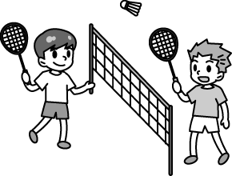(Ｂ) 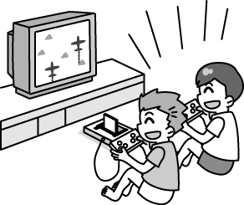(Ｃ) 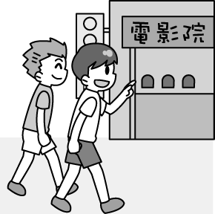
- (Ａ)  (Ｂ) 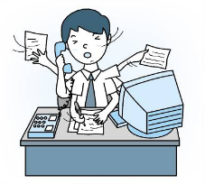 (Ｃ) 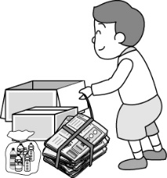
- (Ａ) 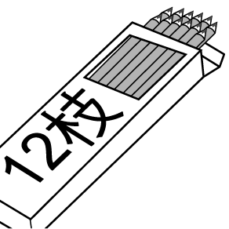(Ｂ) 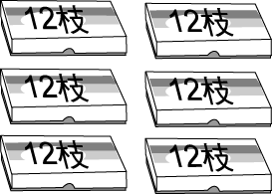 (Ｃ) 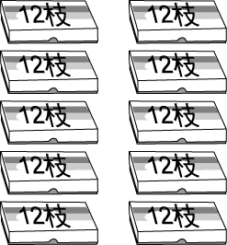

- (Ａ) 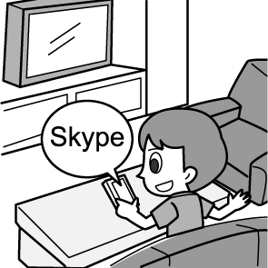 (Ｂ) 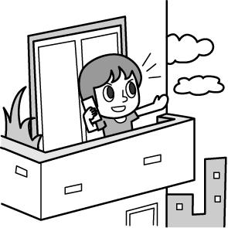 (Ｃ) 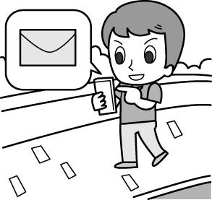

- (Ａ) 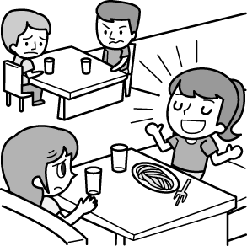 (Ｂ) 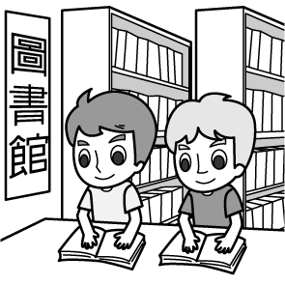 (Ｃ) 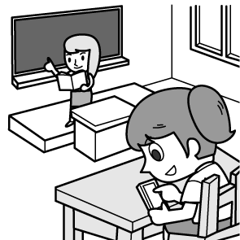

二、基本問答：根據聽到的內容，選出一個最適合的回應。
6. (Ａ) Let’s dig in.
(Ｂ) With pleasure.
(Ｃ) My dream has come true.
7. (Ａ) Painting helps me relax.
(Ｂ) I’ll take painting as my career.
(Ｃ) After I visited the art museum at age 16.
8. (Ａ) Yes, she’s on vacation.
(Ｂ) Sorry. She’s off today.
(Ｃ) Sure, she’ll visit your website right away.
9. (Ａ) Is that Jenny?
(Ｂ) No, never.
(Ｃ) I don’t like the pink skirt.
10. (Ａ) He saw a stranger.
(Ｂ) He entered his name.
(Ｃ) He pushed his classmate.

三、言談理解：根據聽到的內容，選出一個最適合的答案。
11. (Ａ) She looks serious.
(Ｂ) She doesn’t smile.
(Ｃ) She lives next to David.
12. (Ａ) Because he is little.
(Ｂ) Because it is very cold.
(Ｃ) Because it will snow more heavily.
13. (Ａ) Their parents.
(Ｂ) Nobody.
(Ｃ) Both of them.
14. (Ａ) The boy’s and the girl’s mothers.
(Ｂ) The boy’s father and the girl’s mother.
(Ｃ) The boy’s mother and the girl’s father.
15. (Ａ) The woman is asking Tim if she should meet her friends on the Net.
(Ｂ) Tim tells the woman that it’s dangerous to meet strangers who she knows online.
(Ｃ) Tim has never chatted with someone online before.

第二部分 綜合測驗54%
16. My sister often practices English by talking online with people from _____ countries.
(A) dull (B) simple (C) stamp (D) foreign
17. After several months of hard work, Jack decides to take a trip and _____.
(A) collect (B) relax (C) garden (D) bake
18. You should _____ your hand if you have any questions in class.
(A) rise (B) heat (C) sharp (D) raise
19. It’s not _____ to laugh at others.
(A) dangerous (B) stupid (C) honest (D) polite
20. ______ the traffic rules, you won’t get a ticket from the police.
(A) To follow (B) Follow (C) What if you follow (D) By following
21. Maggie has two cousins, and _____.
(A) so have I (B) I have, too (C) so do I (D) I don’t, either
22. M: When I was a junior high school student, I seldom went to a movie with my friends.
W: _____.
(A) I wasn’t, either (B) I was, too (C) So did I (D) Neither did I
23. Roy: Decorating a Christmas tree is boring to me. I don’t like it at all.
Bob:_____.
(A) Me, too (B) I don’t, either (C) Neither am I (D) I do, either
24. M: The young lady’s invited to Mr. Trump’s welcome party.
W: _____ .
(A) So are we (B) So have we (C) So did we (D) We did, too
25. The dog _____ a long tail _____ to Larry.
(A) has ; belongs (B) with ; is belonged (C) has ; belonged (D) with ; belongs
26. The famous restaurant _____ open to the public all year round, but now it’s closed on Chinese New Year.
(A) is used to (B) used to be (C) used to being (D) is used to be
27. The woman doesn’t mind _____ the cuts when she works because she can make money _____ her family of seven.
(A) getting ; by raising (B) to get ; to raise (C) to get ; raising (D) getting ; to raise
28. The children who _____ playing with the dog _____ so happy
(A) are ; look (B) is ; looks (C) is ; is (D) are ; looks
29. Son: Mom, don’t worry! I’ll give you a call _____ I _____ Rich.
(A) if ; found (B) until ; will find (C) as soon as ; find (D) as long as ; will find
30. Those _____ exercise every day can keep in good health.
(A) who does (B) that do (C) who do (D) which does
31. My sister, Ann, told me that though Simon was the richest man in our town, he was the last man_____ she would marry.
(A) who (B) that (C) whom (D) whose
32. The handsome boy_____ lives in the new apartment.(選錯的)
(A) that I spoke to (B) I spoke to (C) to whom I spoke (D) to that I spoke
33. The young lady _____ is our new teacher.( 選錯的 )
(A) in red (B) between Mike and his brother (C) with a round big face (D) on a purple vest
34. 選出錯誤的句子
(A) Any woman that listens to him is a fool.
(B) People that care about others are always popular .
(C) This is the most interesting story that I have ever heard.
(D) Who knows the person that can draw very well?
35. In the library, you can read books which _____.
(A) you interest (B) is interesting to you (C) you are interested (D) interest you
36. You, _____ my best friend, should help me this time.
(A) who is (B) who are (C)that is (D) whom are
37. The fruit _____ in this supermarket is very expensive.
(A) sold (B) which are sold (C) we bought from (D) that sells
38. _____ we can do every day is sit inside and study. (選錯的)
(A) All that (B) What (C) All (D)Which
39. Dad went to Canada, _____ he planned to stay for a few days.
(A) which (B) that (C) where (D) what
40. The reporter Tony is talking to is my aunt.
(A) The reporter is Tony’s aunt .
(B) My aunt is talking to the reporter.
(C) Tony is talking to my aunt.
(D) My aunt is talking to Tony, the reporter.
41. 選出正確的句子
(A) Actor Morgan Freeman became tired of talking about the movie he is famous .
(B) I’d like to visit the church my parents got married twenty years ago .
(C) Goodbye, my dear friend. I will remember the time when we have spent together.
(D) Sandy is washing the shoes her uncle sent to her from Japan.
42. Please keep this in mind: _____ you have done to others will come back to you one day.
(A) that (B) what (C) who (D) when

第三部分 克漏字選擇10%
Hank is an American (43) is a famous blogger. He started his blog, (44) is called “The Style Guy” in 2008. Hank wrote about fashion in the blog. He gave his opinion about (45) it means to be beautiful. After a short time, it became one of the most famous blogs on the Net. He said (46) he will keep (47) because fashion is his life.
43.(A) where (B) which (C) who (D) whom
44. (A) where (B) which (C) who (D) that
45. (A) which (B) that (C) who (D) what
46. (A) what (B) that (C) which (D) who
47. (A) write (B) writing (C) to write (D) written

第四部份 閱讀測驗16%
( 一 )
Humans have dreamed of robots doing our work for hundreds of years. However, now that it’s happening, it may turn out to be more of a nightmare.
The idea works in theory: robots do all the work so we have more time to relax. But in practice it’s totally different. When a robot replaces a human worker, that worker simply loses his or her job. There is no time to relax, just a frantic search for a new job. And you had better find one the robots can’t do—yet.
Human workers will soon be replaced on a large scale. One study says that 45% of jobs in the United States will be done by robots by 2030. Robots may soon be working as nurses , teachers, clerks, cleaners, and even writers. In fact, computers have already “ taken over ” the writing of some new articles. Perhaps even this article was written by a robot!
human 人類 nightmare噩夢 replace 替代 theory理論 frantic瘋狂的 scale比率

48.What is the main idea of this article?
(A) Robots can be a teacher. (B) Humans are better than robots.
(C) The robots are coming. (D) Robots are dangerous.
49. According to the article, which is not true?
(A) Computers are already writing some articles.
(B) Humans have dreamed of robot workers for centuries(世紀).
(C) There are already robot nurses.
(D) A study says 45% of US work will be done by robots by 2030.
50.Which is likely(可能地) not a reason why robots are replacing human workers?
(A) They need power. (B) They work longer. (C) They are cheaper. (D) Thety are faster.
51.What is “ it ” ?
(A) A job. (B) A worker. (C) The nightmare of robot workers. (D) The dream of robot workers.
52. What does it mean when the writer says that computers have “taken over” writing new articles?
(A) They have helped humans do the job. (B) They have taken control of the job from humans.
(C) They have fought with humans for the job. (D) They have tried to do the job but have failed.

( 二 )
Pearl and June were good friends and spent most of their time together. They were both very old and they worried about their health. Most of the time they talkeded about nothing else.
They worried about their food. Was it clean? Would it give them stomach pains? They worried about the weather. Was it too cold and wet? Would it give them pains in their bones? They worried about pollution in the air. Would it give them pains in their chests and throats? They worried about being hurt in a car accident, killed in an airplane crash, getting sick, and so on. All they could think about was being ill or hurt.
One day they went on a train journey together. “ We’ll need some food,” Pearl said. “ We’ll buy some bananas,” June said. “ They are good to eat and always clean.” So they bought two bananas to eat on train.
It was not long before they were hungry. Pearl took out the bananas and gave one to June. Then she peeled the skin of her banana and took a large bite of it. At that moment the train went into a tunnel. Everything went black. “ Don’t eat your banana,” Pearl shouted at June. “ Mine has made me go blind .”
crash墜毀 peel 剝皮 tunnel 隧道
53.What did the two old ladies talk about most of the time?
(A) Themselves. (B) Other people. (C) Healthy food. (D) Dangerous drivers.
54. Pearl ate her banana ______
(A) after they came out of the tunnel. (B) at the station.
(C) before June ate hers. ( D) before she was hungry.
55. Pearl thought that the banana _____
(A) would be good for June. (B) would made her hungry.
(C) would make her ill. (D) stopped her from seeing.

105-1-3 九年級英語科―解答
01-10 ACABA BCBAC
11-20 ACCAA DBDDD
21-30 CDBAD BDACC
31-40 BDDBD BADCC
41-50 DBCBD BBCCA
51-55 DAACD

- 辨識句意：根據聽到的內容，選出符合描述的圖片或符合圖片的描述。
1.答案：(Ａ)
解析：音軌：請參考 Unit 7 A5071309
錄音稿：Playing badminton is so much fun.
2.答案：(Ａ)
解析：音軌：請參考 Unit 8 A5081387
錄音稿：Mr. Cruise supports his family by collecting newspaper, boxes, and bottles.
3.答案：(Ａ)
解析：音軌：請參考 Unit 9 A5091444
錄音稿：Tony bought a dozen pencils.
4.答案：(Ａ)
解析：音軌：請參考 Unit 9 A5091448
錄音稿：Roger is talking on the phone on the balcony.
5.答案：(Ａ)
解析：音軌：請參考 Unit 9 A5091455
錄音稿：It’s not polite to speak loudly in public places.
- 基本問答：根據聽到的內容，選出一個最適合的回應或最適合的問句。
1.答案：(Ｂ)
解析：音軌：請參考 Unit 7 A5071332
錄音稿：Could you bring me some popcorn?
2.答案：(Ｃ)
解析：音軌：請參考 Unit 7 A5071342
錄音稿：When did you take up painting as a hobby?
3.答案：(Ｂ)
解析：音軌：請參考 Unit 8 A5081395
錄音稿：May I speak to Joanne, please?
4.答案：(Ａ)
解析：音軌：請參考 Unit 8 A5081421
錄音稿：I know that girl who is wearing a pink skirt over there.
5.答案：(Ｃ)
解析：音軌：請參考 Unit 9 A5091474
錄音稿：Why did the teacher get mad at him?
- 言談理解：根據聽到的內容，選出一個最適合的答案。
1.答案：(Ａ)
解析：音軌：請參考 Unit 7 A5071358
錄音稿：M: Is the girl with long hair called Jessica? She looks serious.
W: The girl next to David? Yes, she is. She seldom smiles, so she looks serious. Let’s talk to her.
Q: What is true about Jessica?
2.答案：(Ｃ)
解析：音軌：請參考 Unit 8 A5081423
錄音稿：M: Wow! The ground is covered with snow. There will be more snow in the evening.
W: Jack is still at school. Let’s drive him home right now.
M: OK! Let’s go!
Q: Why do they have to pick Jack up?
3.答案：(Ｃ)
解析：音軌：請參考 Unit 7 A5071351
錄音稿：M: I like to eat fried rice.
W: So do I.
M: Maybe we can try that new restaurant together next time.
Q: Who likes to eat fried rice?
4.答案：(Ａ)
解析：音軌：請參考 Unit 7 A5071355
錄音稿：M: My mother can’t cook, so I always eat out.
W: Neither can my mother, but my father is a great cook. I can eat delicious food every night.
M: How wonderful!
Q: Who can’t cook?
5.答案：(Ａ)
解析：音軌：請參考 Unit 9 A5091499
錄音稿：W: Tim, do you think it is stupid to meet someone who I only met online?
M: Well, I used to enjoy chatting with people online, but I think it is boring because I can’t really know the person who I’m talking with.
W: I see.
Q: Which is true?

