新北市立溪崑國民中學105學年度第一學期第三次定期評量英語科試卷
七年級 班座號 姓名

一、 聽力測驗26%

A.辨識句意：根據聽到的內容，選出符合描述的圖片。

- (Ａ) 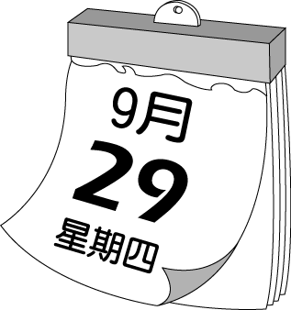
(Ｂ) 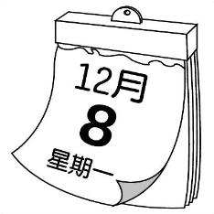
(Ｃ) 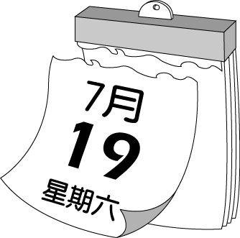

- (Ａ) 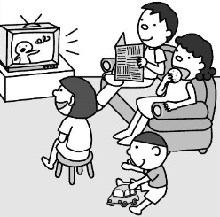
(Ｂ) 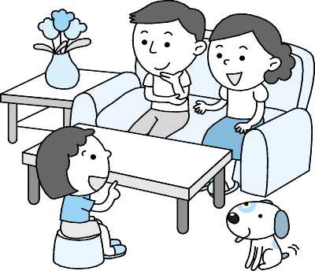
(Ｃ) 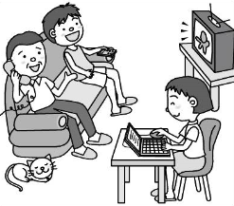

- (Ａ) 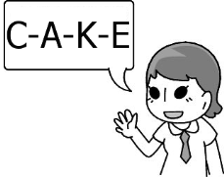
(Ｂ) 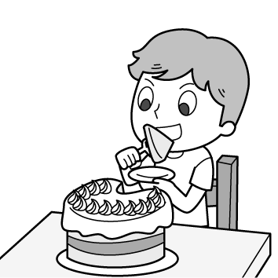
(Ｃ) 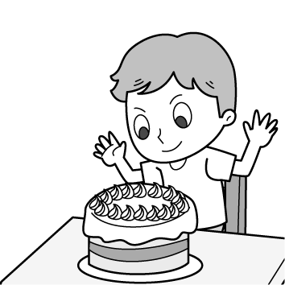

- (Ａ) 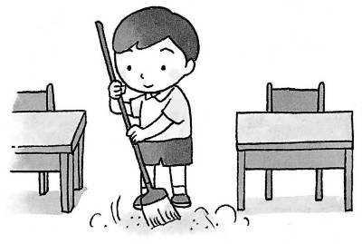
(Ｂ) 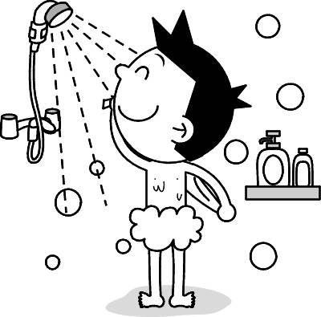
(Ｃ) 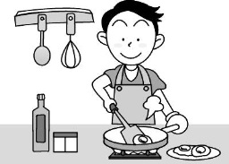

5. (Ａ) 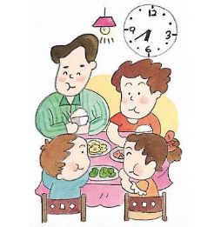
(Ｂ) 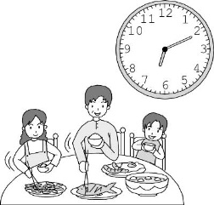
(Ｃ) 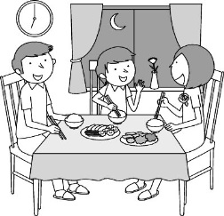

B.基本問答：根據聽到的內容，選出一個最適合的回應。
6. (A) Let’s not litter, eat, or drink on the bus.
(B) Really? Let’s listen to the driver.
(C) They are nice to the bus driver.
7. (A) Oops! Sorry.
(B) Wait! Let’s run.
(C) Don’t drink.
8. (A) Yes, they are cooking in the kitchen.
(B) No, they are making Christmas cards in the living room.
(C) Yes, they are doing homework in the classroom.
9. (A) Isn’t she crying in the park?
(B) Is she having a good time?
(C) Let’s go help the girl.
10. (A) Ok!Ok! I am ready. Let’s go!
(B) No, it’s at seven o’clock.
(C)What? Isn’t it six o’clock? (背面仍有試題, 請繼續作答)
C.言談理解：根據聽到的內容，選出一個最適合的答案。
11. (A) It’s 7:30.
(B) It’s 8:00.
(C) It’s 8:30.
12. (A) She’s watching TV.
(B) She’s studying in her bedroom.
(C) She’s talking on the phone.
13. (A) It’s on Friday.
(B) It’s on Monday.
(C) It’s on Saturday.

二、 語法選擇 48%
14. Meg’s brother, John, _______ very nice to his classmates. (A) is (B) are (C) be (D) to
15. _____ nice to Mr. Bus and don’t eat _____. (A) Be; on the bus (B) Please; at the bus (C) Please; on the bus
(D) X ; in the bus
16. A: Is she Meg or Amy? B: ____. (A) Yes, she is Meg (B) No, she is Amy (C) She is not Meg (D) She is Amy
17. A: Is it eleven fifty- eight? B:That’s right. It’s _____. (A) two to eleven (B) two after eleven
(C) eight to twelve (D) two to twelve
18. Amy: Who ______ the gift next to the door? Tina: John and Meg are. (A) wrapping (B) is wrap
(C) are wrapping (D) is wrapping
19. Let’s go to the concert_____. (A) on this weekend (B) this Saturday (C) on the evening (D) Monday afternoon
20. At the birthday party, there are many students _____. (A) singing and shout (B) dance and sing
(C) jump up and down (D) shouting and singing
21. _____, open the window behind you. (A)Please (B)don’t (C)Amy (D) Be
22. Amy: Are there any kangaroos near here? Meg: Yes, _____.(A) follow me (B) let’s run (C) don’t litter
(D) my goodness
23. It’s ____ four o’clock in the morning. My grandparents are sleeping in their bedroom. (A) on (B) at (C) in
(D) X
24. The doll is my _____ toy , and my brother is playing ____ it. (A) favorite ; X (B) lucky; at (C) free; on
(D) favorite; with
25. Linda: My favorite singer is ______. Please _____ quiet and sit down.
(A) on TV; be (B) on the TV; be (C) in TV; be (D) in the TV; X
26. Mr. Wang: Never _____ with your brothers. Leo: I see, Mr. Wang. (A)not fight (B) don’t fight (C) fight
(D) fighting
27. Please_____, Amy. (A) not shout there (B) no touch the phone (C) look the gifts (D) don’t play near the slide
28. Let me_____ a Christmas gift for my brother and _____ it in the stocking. (A) wrap; put (B) wrapping; putting (C) wraping; puting (D) make; hang
29. Listen! The baby is_____ in the bedroom. _____ to the bedroom and _____.
(A) cry; Come; help (B) crying; Coming; helping (C) crying; Coming; helping (D) crying; Come; help
30. Amy: Billy’s concert is _____. Are you free this weekend?
Meg: _______
Amy: Let’s go together.
(A) in Sunday evening; Not again. (B) in Saturday night; Yes, I am.
(C) at six p.m.; My goodness. (D) on Saturday evening; Yes.
31. Tony: What time is the concert? Josh: ______
(A) Isn’t it ten fifty? (B) It’s at six in this evening. (C) It’s on seven eleven. (D) Isn’t it at seven p.m.?
32. Jack: Hi, Billy. _____ to the movie tomorrow.
Billy: No, I have some homework. _____ homework together with me?
(A) Let’s going; What about do (B) Let’s go; How about doing
(C) Let’s going; How about doing (D) Let’s go; How about do
(仍有試題, 請繼續作答)
33. Amy: Are you ready ____ the concert?
Meg: What time is the concert? I am busy ,and I am still making dinner now.
Amy: It’s ____ six p.m. Can you go together? (A) X; at (B) for; at (C) for; X (D ) to; at
34. Billy: Welcome to my birthday party tonight. _____
(A) Please singing and dancing at the party.
(B) Everyone is blowing kisses.
(C) Let’s shout or litter.
(D) Have a good time, everyone.
35. 選出正確的句子
(A) Don’t shout or run at the bus.
(B) Don’t litter and shout in the museum.
(C) Don’t shout or litter in the park.
(D) Don’t litter and run in class.
36. 選出正確的句子
(A) A: Who is roasting a turkey? B: Is Dad.
(B) Don’t be nervous.
(C) Meg is making a Christmas card at there.
(D) Let me do a good student.
37. 選出正確的句子
(A) Please not touching the mummy.
(B) Don’t shout on your classmates.
(C) Don’t talk on the cellphone in class.
(D) Let’s don’t run or shout in the museum.

三、 克漏字測驗 14%
Amy: Look at the jacket. It’s so great.
Meg: Yes. Let 38 try it on.
(Five minutes later. 5分鐘之後 )
Meg: No, the jacket is too big for me.
Amy: Really? Sorry, it’s for 39 . There are some small jackets over there.
Meg: No wonder. (難怪)
Amy: 40 shout. There are many people around here.
Meg: I’m sorry.
38. (A) I (B) X (C) me (D) we
39. (A) man’s (B) men (C) child (D) woman
40. (A) Not (B) Please (C) Be (D) Don’t

Tonight is 41 Christmas Eve. My mom is busy 42 a turkey. My dad is cleaning the house. My classmates are 43 to my house. We are watching TV in the living room. Every boy and every girl in my house
44 having a good time.

41. (A) X (B) on (C) at (D) in
42. (A) roast (B) roasting (C) make (D) fighting
43. (A) going (B) coming (C) waving (D) ready
44. (A) be (B) are (C) is (D) X (背面仍有試題, 請繼續作答)
四、 閱讀測驗 12%
time | Sunday | Monday-Thursday | Friday | Saturday
18:00—  18:55 | BCC News | Cute Pets | Hello Bear | BBC News
19:00—  19:55 | Best books | My Family | BBC News | My Family
20:00—  20:50 | Best books | You and Me | Popular Music | My Family
21:00—  21:50 | Popular Music | You and Me | Popular Music | Cute Pets
45. It’s nine thirty in the evening. Cute Pets is on TV. What day is it?
(A) Sunday.
(B) Tuesday.
(C) Saturday.
(D) Friday.
46. Popular Music is _______
(A) at nine o’clock on Sunday evening.
(B) at eight on Saturday evening.
(C) at nine on Friday afternoon.
(D) from nine twenty to nine fifty on Saturday.

Taylor Swift is a popular singer. She is tall and beautiful. Her hair is blonde, and her eyes are brown.
She is from the USA. Taylor Swifts can sing and write songs. Meg and John are her fans. They listen to Taylor Swift’s songs on the weekends. Her concert is at 6:30 p.m. tonight. Meg is taking pictures of Taylor Swift and John is blowing kisses to Taylor. What are their friends doing? They are jumping up and down. Everyone is having a good time. ( blonde 金黃色的 fans 迷 )
47.What’s wrong about Taylor Swift?
(A) Her hair is blonde.
(B) She is from Japan.
(C) The concert is at six thirty p.m.
(D) Meg and John are happy at her concert.
48. Meg and John listen to Taylor Swift’s music on_____.
(A) Monday
(B) Tuesday
(C) Friday
(D) Sunday

Ted is a driver. He usually travels around the world. Now, he is back to Taipei at 7:00 p.m. on Monday, November 20. Please look at the clocks. They tell the time in different cities.
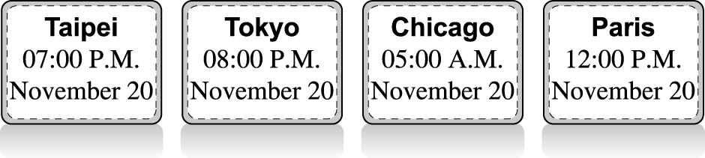 travel(s) around the world 環遊世界
November 十一月different cities 不同的城市
49. Ted is back to Taiwan ________
(A) on Monday evening. (B) at seven in the morning. (C) at eight in the evening. (D) on Tuesday night.
50. What time is it in Chicago when(當) it is 11:00 p.m. in Taipei? (A) It’s 4:00 p.m. (B) It’s 8:00 a.m.
(C) It’s 9:00 a.m. (D) It’s 12:00 p.m.
105-1-3 七年級英語科―解答
1-5 CAACA
6-10 AABCA
11-15 ACCAA
16-20 DDDBD
21-25 CADDA
26-30 CDADD
31-35 DBBDC
36-40 BCCBD
41-45 ABBCC
46-50 ABDAC

新北市立溪崑國民中學105學年度第一學期七年級第三次段考英語科
聽力測驗―聽力稿
一、 聽力測驗
A.辨識句意：根據聽到的內容，選出符合描述的圖片
1.A:What day is the welcome party? B:It’s on the weekend.
2.Amy is watching TV and her mom is eating cookies.Her brother is
playing.
3.Please spell “cake.”
4.What is the man doing? He’s making dinner for his family.
5.It’s six forty and they are having dinner.

B.基本問答：根據聽到的內容，選出一個最適合的回應。
6.The bus is dirty. The bus driver is not happy.
7.Hey, boys. We’re in the museum. Please be quiet.
8.Where are Meg and Amy? Are they doing homework in their bedroom?
9.Look! There is a girl crying in the park. She is very sad.
10. The concert is at seven p.m. It is six thirty p.m. now. What time are you
ready for it?

C.言談理解：根據聽到的內容，選出一個最適合的答案。
11. M:Amy, where are you going?
W: I am going to the park to play basketball there.
M:Really? Can we meet there later?
W:Okay, how about 8 o’clock?
Q: What time is it now?
12. M: What are you doing, Grandma?
W: I am watching TV.
M: How about Amy? Is she doing homework in her room?
W: No, she is talking with her friend, Jerry,on the phone in the living
room.
Q: What’s Amy doing now?
13.M: Where is Jenny?Is she studying Chinese in her bedroom?
W: No, her Chinese class is on the weekend. It’s Thursday today. She is studying English now.
Q:What day is Jenny’s Chinses class?

