新北市立溪崑國民中學105學年度第一學期第二次定期評量英語科試卷
九年級 班座號 姓名

一、聽力測驗30%(一題2分)

(一)、辨識句意：根據聽到的內容，選出符合描述的圖片或符合圖片的描述。
- （ ）(Ａ) 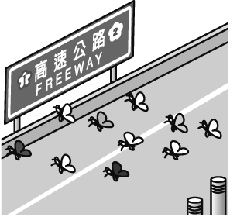 (Ｂ) 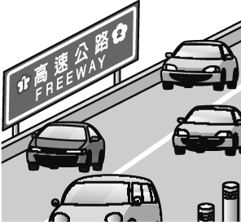 (Ｃ) 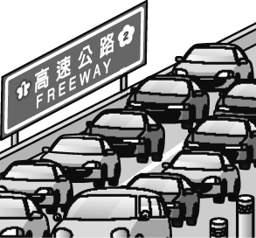
- （ ）(Ａ) 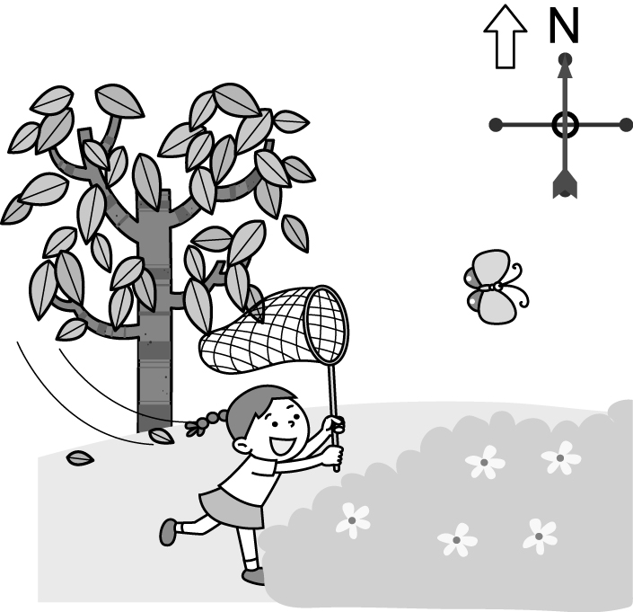 (Ｂ) 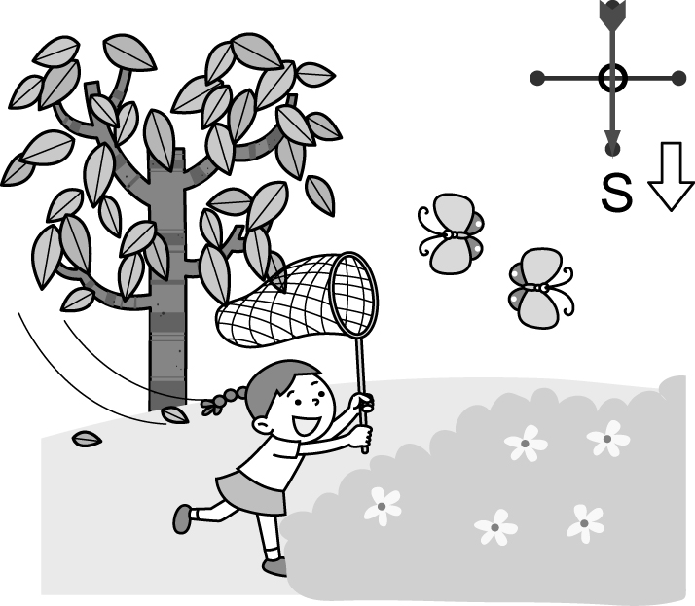 (Ｃ) 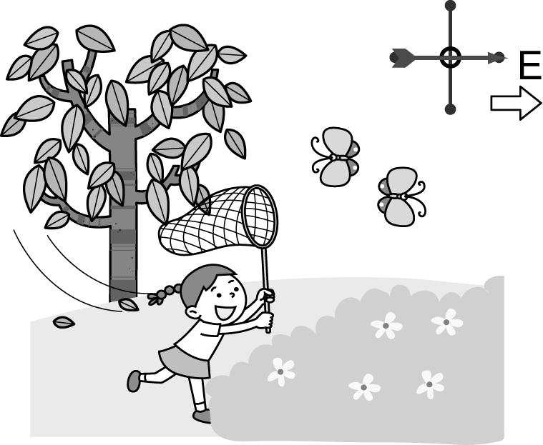
- （ ）(Ａ) 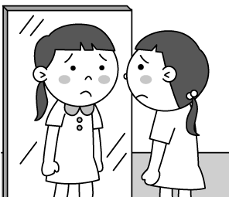 (Ｂ) 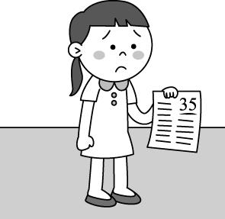 (Ｃ) 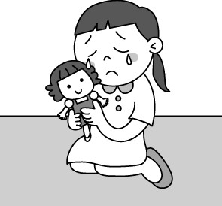
- （ ）(Ａ) 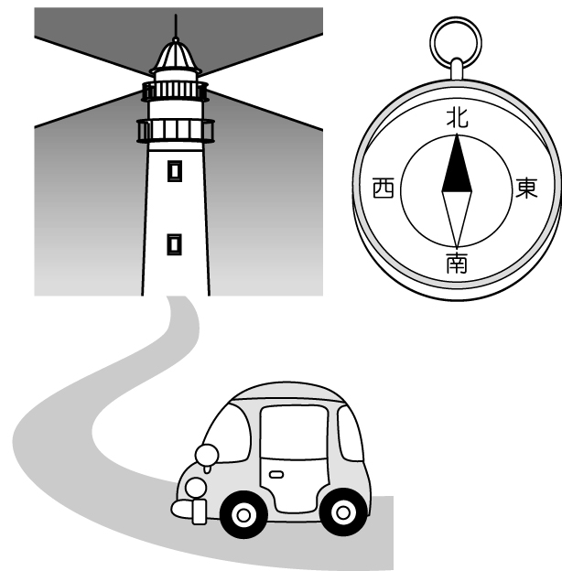 (Ｂ) 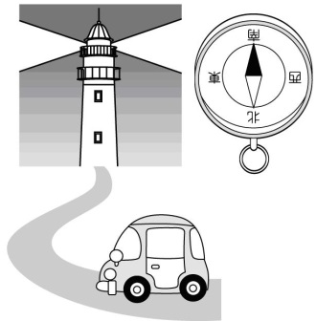 (Ｃ) 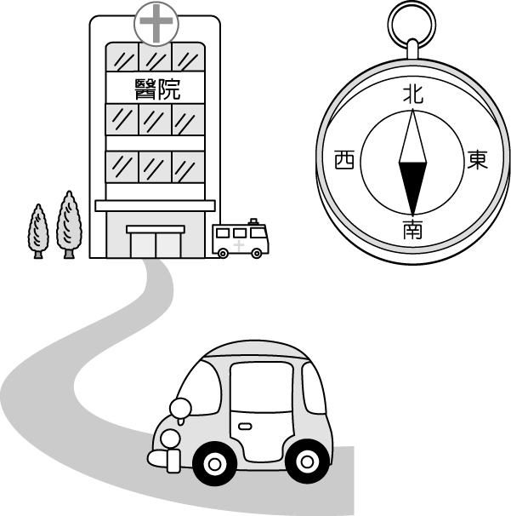
- （ ）(Ａ) 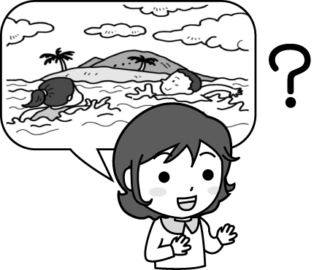 (Ｂ) 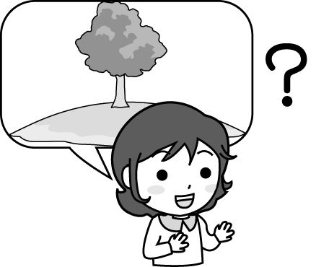 (Ｃ) 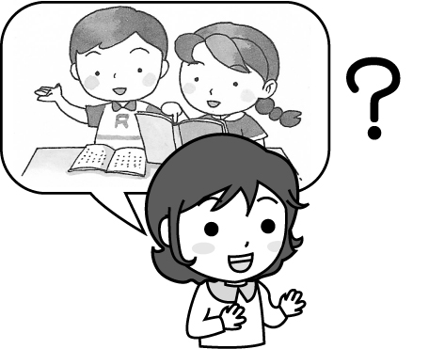

(二)、基本問答：根據聽到的內容，選出一個最適合的回應或最適合的問句。
- （ ）(Ａ) Theyfed it an hour ago .
(Ｂ) It was fed near the river.
(Ｃ) It was fed by the old man.
- （ ）(Ａ) It’s on the north of the island.
(Ｂ) They fly south every winter.
(Ｃ) They found some ants every winter.
- （ ）(Ａ) Yes. We have a restaurant here.
(Ｂ) It’s on the left side of the bank.
(Ｃ) This restaurant has a long interesting history.
- （ ）(Ａ) Sure.I’d love to help you.
(Ｂ) The box becomes heavier.
(Ｃ) The box is very light.
10. （ ）(Ａ) No, I don’t have any problems with teenagers.
(Ｂ)The teenagers like to ask questions.
(Ｃ) I think they are friendship and appearance. My daughter usually talks to me about them.

(三)、言談理解：根據聽到的內容，選出一個最適合的答案。
- （ ）(Ａ) He was caught by the police.
(Ｂ) He was caught in the traffic.
(Ｃ) He was caught by his boss.
- （ ）(Ａ) Wash his face as many times as he can.
(Ｂ) Go to the doctor once a week.
(Ｃ) Drink a lot of water.
- （ ）(Ａ) He shouted at a police officer.
(Ｂ) He drove too fast.
(Ｃ) He stopped the police officer.
- （ ）(Ａ) He is too young to drive.
(Ｂ) He is too old to drive.
(Ｃ) He is not young enough to drive.
- （ ）(Ａ) To his grandma’s place.
(Ｂ) To his uncle’s farm.
(Ｃ) To Lanyu.
二、單選題30%(一題2分)
16. ( ) Garbage is not every Wednesday in New Taipei City .
(Ａ) built (Ｂ) taken (Ｃ) collected （Ｄ) gone
17. ( ) When he ask you to tell a lie for him , be sure to him .
(Ａ) turn; off (Ｂ) turn; down (Ｃ) give; up (Ｄ) work; out
18. ( ) Our new classmate looks ; he is afraid to talk to others.
(Ａ) shy (Ｂ) serious (Ｃ) lonely (Ｄ) glad
19. ( ) Jeff: Have a cigarette. Mark: No, thanks. I’ve _________ smoking .
(Ａ) quiet (Ｂ) uniform (Ｃ) started (Ｄ) quit
20. ( ) These pictures _______ by my parents before I left home.
(A) take (B) was taken (C) will be taken (D) were taken
21 . ( ) Why is all my money ? I remembered putting it on my desk last night.
(Ａ) built (Ｂ) flown (Ｃ) tracked (Ｄ) gone
22. ( ) There’s _________ I can do for you if you still don’t want to tell me what’s on your mind.
(Ａ) everything (Ｂ) nothing (Ｃ) other things (Ｄ) something
23. ( ) My bicycle got broken and I need to buy a new one. Do you know ?
(A) how much it costs (B) how long it took (C) how could that happen (D) how to fix it
24. ( )We _________ in the mountains and couldn’t find our way home.
(A) lost (B) have been lost (C) were lost (D) were losing.
25. ( ) Julie didn’t come to school today. I wonder .
(A) What she happened to (B) whethershe catch a cold or not
(C) when will she come back to school (D) if she was sick
26. ( ) May feels so lonely. She doesn’t know _________ .
(A) who to talk (B) what to do it (C) where to go (D) how to do
27. ( ) I don’t know if he ___________ his homework tomorrow.
(A) will finish (B) finish (C) has finished (D) finished
28. ( ) Kelly is asking me ___________.
(A) what time it is (B) how much is the book (C) where are we going (D) how old is the dog
29. ( ) The Love River _________ up already. Now it is clean and smells good.
(A) is cleaned (B) was cleaned (C) will be cleaned (D) has been cleaned

30. ( ) Which one is right?
(A) Tom is heard sing loudly in his bedroom.
(B) Who was the car driven yesterday?
(C) Does anyone know who broke the window?
(D) Should the eggs been stored in the refrigerator?
三、克漏字測驗10%(一題2分)
Vivian is an eighth grader. She (３１) sad for two weeks because her best friend, Ruth, was angry with her. She doesn’t know (３２) , so she asked Vicky for help. Vicky told Vivian that she could (３３) Ruth a note first. Then Ruth would understand (３４) , and perhaps they could work out the problem together. Besides, Vicky also taught Vivian how to make more friends. Since Vivian is shy, she should change herself. She should try to (３５) to anyone, and she will make more new friends soon.
31. ( ) (Ａ) is (Ｂ) has been (Ｃ) were (Ｄ) will be
32. ( ) (Ａ) how to fix it (Ｂ) how old she is (Ｃ) what to do (Ｄ) what to wear
33. ( ) (Ａ) catch (Ｂ) drop (Ｃ) wrote (Ｄ) gave
34. ( ) (Ａ) how Vivian felt (Ｂ) where Vivian went (Ｃ) which Vivian chose (Ｄ) how much Vivian got
35. ( ) (Ａ) stay up (Ｂ) hurry up (Ｃ) open up (Ｄ) dress up
四、閱讀測驗10%(一題2分)
I heard of a story a few days ago. It was so cool th at I want to share with you . Tom is a bus driver, and he became a hero for everyone since the day he was reported by TVBS news. However he said,”I’m not a hero. I did what everyone would do.”
On a rainy day, there was a flood (洪水) on the road because of the typhoon. Tom drove very slowly and carefully on the road. Suddenly, he saw a man walkingon the road with his motorcycle.His motorcycle was broken. Tom was afraid that the man would be flowed away(流走) by the flood. He stopped his bus and let the man and his motorcycle get on the bus.Tom took the man to a safe place and let him get off without charging him. Someone on the bus recorded the story and sent it to the reporter.
The reporter found Tom and asked him to say something. Tom said “Everyone should give a hand to those who are in need. Then, our world will be better and better”
36. ( ) In the reading, who is the hero?
(A) The reporter. (B) The bus driver. (C) The man with the motorcycle. (D) The passenger.(乘客)
37. ( ) What does “charging” mean?
(A) To call the police. (B) To save him. (C) To ask him to pay. (D) To use his cellphone.
38. ( ) Who recorded the story?
(A) The bus driver. (B) The reporter. (C) Someone on the bus. (D) The man with motorcycle.
39. ( ) Which is true?
(A) The man was flowed away by the flood at last.
(B) The bus driver sees himself as a hero.
(C) The weather was cool and windy on that day.
(D) There was a flood on the road.
40. ( ) What did Tom’s words mean?
(A) The world is getting better and better.
(B) Everyon should send their hand to people if they want the world to be better.
(C) If we always help people who are in need, our world will become better and better.
(D) Help people in need, and you will be a hero.
五、填入正確動詞形式5%(一格1分)
41.You were lucky enough __________ (win) the firs prize.
42. The door and the windows should ____________ (check) carefully before the typhoon hits.
43. I thought he was __________ (lie). He didn’t tell me the truth.
44. The baby was ______________ (wake) up by the phone.
45. The park ___________ (build) in 2000, wasn’t it?
六、依題示改寫句子及翻譯15%(46~48一題2分，49~51一題3分)
46. Why didn’t Janet pass the English test? （句首加入I don’t know...）
＿＿＿＿＿＿＿＿＿＿＿＿＿＿＿＿＿＿＿＿＿＿＿＿＿＿＿＿＿＿＿＿＿＿＿＿＿＿
47. The math exercises are very easy. I can finish them in ten minutes. （用... so... that... 合併成一句）
＿＿＿＿＿＿＿＿＿＿＿＿＿＿＿＿＿＿＿＿＿＿＿＿＿＿＿＿＿＿＿＿＿＿＿＿＿＿
48.John was cleaning his room then. (改被動語態)
＿＿＿＿＿＿＿＿＿＿＿＿＿＿＿＿＿＿＿＿＿＿＿＿＿＿＿＿＿＿＿＿＿＿＿＿＿＿
49.她似乎在生我的氣，卻不告訴我怎麼一回事。
＿＿＿＿＿＿＿＿＿＿＿＿＿＿＿＿＿＿＿＿＿＿＿＿＿＿＿＿＿＿＿＿＿＿＿＿＿＿
50. 我想知道這本書是不是你的?
＿＿＿＿＿＿＿＿＿＿＿＿＿＿＿＿＿＿＿＿＿＿＿＿＿＿＿＿＿＿＿＿＿＿＿＿＿＿
51. 台灣是好幾千種動物的家。
____________________________________________________________________________

新北市立溪崑國民中學105學年度第一學期第二次定期評量英語科答案卷
九年級 班座號 姓名

五、填入正確動詞形式5% (一格一分)
41 |  | 42 |  | 43
44 |  | 45

六、依題示改寫句子及翻譯15%(46~48一題2分，49~51一題3分)
46
47
48
49
50
51

B5L5國民中學 英語科 題目卷(詳解) 年 班 座號： 姓名：
- 辨識句意：根據聽到的內容，選出符合描述的圖片或符合圖片的描述。
- （ ）
(Ａ) (Ｂ) (Ｃ)
答案：(Ｃ)
解析：音軌：請參考 Unit 4 A5041122
錄音稿：The traffic on the highway is heavy.
- （ ）
(Ａ) (Ｂ) (Ｃ)
答案：(Ａ)
解析：音軌：請參考 Unit 4 A5041128
錄音稿：The butterflies are going to the north in early autumn.
- （ ）
(Ａ) (Ｂ) (Ｃ)
答案：(Ａ)
解析：音軌：請參考 Unit 5 A5051182
錄音稿：Jenny doesn’t like her appearance.
- （ ）
(Ａ) (Ｂ) 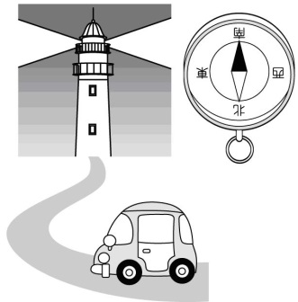(Ｃ)
答案：(Ｂ)
解析：音軌：請參考 Unit 6 A5061251
錄音稿：Please drive south and you will see the large lighthouse.
- （ ）
(Ａ) (Ｂ) (Ｃ)
答案：(Ａ)
解析：音軌：請參考 Unit 6 A5061253
錄音稿：G: I’m wondering whether we met at the small island before.
- 基本問答：根據聽到的內容，選出一個最適合的回應或最適合的問句。
- （ ）(Ａ) It was fed an hour ago.
(Ｂ) It was found near the river.
(Ｃ) It was kept by the old man.
答案：(Ａ)
解析：音軌：請參考 Unit 4 A5041138
錄音稿：When did they feed the dog?
- （ ）(Ａ) It’s in the north of the town.
(Ｂ) They fly south every winter.
(Ｃ) I noticed some ants under the trees.
答案：(Ｂ)
解析：音軌：請參考 Unit 4 A5041146
錄音稿：Where do wild geese go every winter?
- （ ）(Ａ) Sorry. We don’t have a restroom here.
(Ｂ) Go straight for two blocks. It’s on the left.
(Ｃ) This restaurant has a long interesting history.
答案：(Ｂ)
解析：音軌：請參考 Unit 5 A5051207
錄音稿：Please tell me where the restaurant is.
- （ ）(Ａ) Why not? I can help you.
(Ｂ) I’d like to become heavier.
(Ｃ) The box is very wonderful.
答案：(Ａ)
解析：音軌：請參考 Unit 6 A5061272
錄音稿：I’m wondering if you can help me move the heavy box.
- （ ）(Ａ) No, I don’t have any problems with teenagers.
(Ｂ) Perhaps it’s common for a teenager like you to ask the question.
(Ｃ) I think they are friendship and appearance. My daughter usually talks to me about them.
答案：(Ｃ)
解析：音軌：請參考 Unit 5 A5051223
錄音稿：Do you know what the two common problems for teenagers are, Simon?
- 言談理解：根據聽到的內容，選出一個最適合的答案。
- （ ）(Ａ) He was caught by the police.
(Ｂ) He was caught in the traffic.
(Ｃ) He was caught by his boss.
答案：(Ｂ)
解析：音軌：請參考 Unit 4 A5041166
錄音稿：W: Why were you late for work this morning?
M: I was caught in the traffic.
W: I see. You should leave home earlier tomorrow.
Q: Why was the man late for work this morning?
- （ ）(Ａ) Wash his face as many times as he can.
(Ｂ) Go to the doctor once a week.
(Ｃ) Drink a lot of water.
答案：(Ｃ)
解析：音軌：請參考 Unit 5 A5051232
錄音稿：B: I really feel down because of the acne.
W: Don’t worry about it. Wash your face in the right way, ask the doctor for advice about your skin problem, and drink a lot of water every day.
B: I see.
Q: What is the woman’s advice for the boy’s skin problem?
- （ ）(Ａ) He shouted at a police officer.
(Ｂ) He drove too fast.
(Ｃ) He stopped the police officer.
答案：(Ｂ)
解析：音軌：請參考 Unit 5 A5051239
錄音稿：M: Do you know what happened to me last night?
W: No.
M: I was stopped by a police officer.
W: Why?
M: Because I drove too fast.
W: Did he give you a traffic ticket?
M: Of course he did.
Q: Why did the man get a traffic ticket?
- （ ）(Ａ) He is too young to drive.
(Ｂ) He is too old to drive.
(Ｃ) He is not young enough to drive.
答案：(Ａ)
解析：音軌：請參考 Unit 6 A5061286
錄音稿：W: Did you tell him that he is not old enough to drive?
M: No, I didn’t.
W: Please make sure you tell him.
Q: Why can’t the boy drive?
- （ ）(Ａ) To his grandma’s place.
(Ｂ) To his uncle’s farm.
(Ｃ) To Lanyu.
答案：(Ｃ)
解析：音軌：請參考 Unit 6 A5061299
錄音稿：M: Betty, I’m wondering if you will go to Lanyu with me next weekend.
W: Well, I haven’t decided yet. Paul invited me to his uncle’s farm, and my mother would like me to visit my grandma. I’ll tell you about my final decision by next Tuesday, Nick.
M: OK!
Q: Where is Nick going next weekend?

105-1-2九年級英語科―解答
一、聽力測驗30%(一題2分)
1-5 C A A B A 6-10A B B A C 11-15BCBAC

二、單選題30%(一題2分)
16-20 C B A D D 21-25 DBACD 26-30 CAADC

三、克漏字測驗10%(一題2分)
31-35 B C B A C

四、閱讀測驗10%(一題2分)
36~40 B C C D C
五、填入正確動詞形式5% (一格一分)
41 | to win | 42 | be checked | 43 | lying | 44 | woken | 45 | was built
六、依題示改寫句子及翻譯15%(46~48一題2分，49~51一題3分)
46 | I don’t know why Janet didn’t passthe English test.
47 | The math exercises are so easythat I can finish them in ten minutes.
48 | John’s room wasbeing cleaned by him then.
49 | She appearsto be angry with me, but she won’t tell me what’s wrong.
50 | I wonderif/whether the bookbelongs to you.
51 | Taiwan is hometo thousandsof animals.

