新北市立溪崑國民中學107學年度第一學期第三次定期評量 英語科 試題卷
八年級 班 座號 姓名
一 聽力測驗 30%
(一)辨識句意：每題均有三張圖片，請依據所聽到的句子，選出符合描述的圖片
- (A)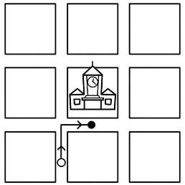 (B)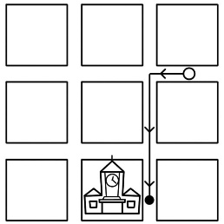 (C)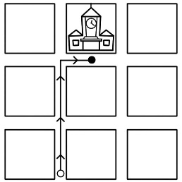
- (A)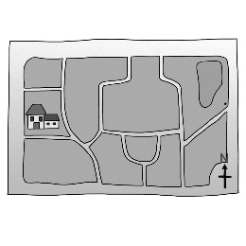 (B)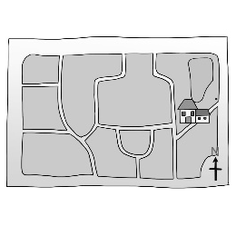 (C)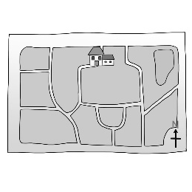
- (A)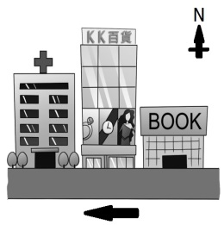 (B)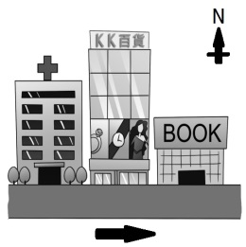 (C)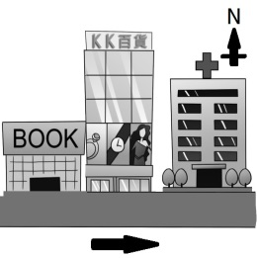
- (A)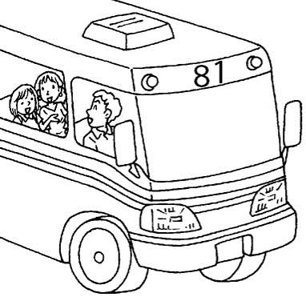 (B)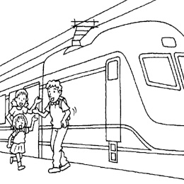 (C)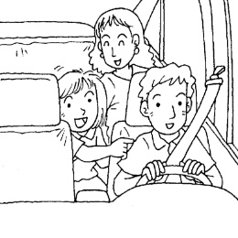
- (A)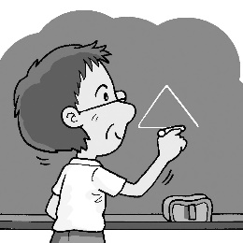 (B)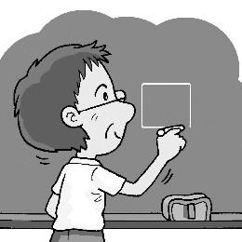 (C)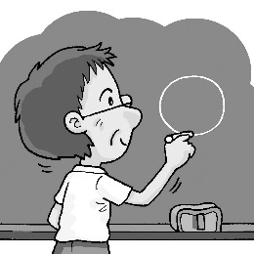
(二)基本問答：每題均有三個選項，請依據所聽到的內容，選出一個最適合的回應
- (A) Yes, you can use the app on my smartphone.
(B) Yes, just turn right, and you can see it.
(C) No, I don’t have a map with me.
- (A) No, it’s next to a bookstore.
(B) Yes, it’s across from a bank.
(C) No, it’s in back of a department store.
- (A) It’s usually hot and dry. People like to go swimming then.
(B) I like to go swimming in August.
(C) Summer is the season to go swimming.
- (A) No. It was snowy and cold last winter.
(B) Yes. It’s fun. Can we have Kenny with us?
(C) Yes. Going camping isn’t interesting to me at all.
- (A) Sure. Walk west for three blocks and then turn right.
(B) Which station should I get off?
(C) Take the Green Line at Theater Station for five stops.
(三)言談理解：每題均有三個選項，請依據所聽到的對話與問題，選出一個最適當的答案
- (A) It’s near a big department store.
(B) Cross the street and walk straight for one block.
(C) In front of the city hall.
- (A) The man’s new secretary is a smart guy.
(B) The man’s new pad(平板) is very useful.
(C) The man isn’t good at work.
- (A) It’s July now, and it’s the rainy season.
(B) The mother doesn’t want to be with her son.
(C) The boy can’t go out because it’s rainy.
- (A) The man and the woman are on a train.
(B) The man and the woman are going to visit the setting of a successful movie.
(C) The man doesn’t like the movie, KANO, at all.
- (A) The woman is showing the man around.
(B) The tower is far, so the man and the woman will take a bus there.
(C) The tower is in the middle of the city.
二 綜合測驗 50%
16. Ms. Wu : What’s your plan for the _____ ?
Eric : I want to be an art teacher.
(A) tower (B) joy (C) model (D) future
17. Maggie didn’t have hamburgers for dinner, but she had beef noodles _____.
(A) either (B) instead (C) soon (D) inside
18. The _____ over the river is famous. Many people stand on it and take photos.
(A) angle (B) map (C) cyclone (D) bridge
19. With the help of _____ , life becomes easy.
(A) technology (B) sight (C) view (D) clerk
20. Mr. Yen is a _____ businessman. He makes a lot of money, but he doesn’t have much time for his family.
(A) natural (B) common (C) successful (D) straight
21. A: Excuse me . I’m looking for the department store.
B: Turn left _____ the post office, and then go straight. It’s _____ your left.
(A) on ; on (B) at ; on (C) at ; at (D) on ; at
22. A: Who made you _____ the dishes?
B: It’s Mom. She asked me _____ the dishes.
(A) do ; do (B) do ; doing (C) do ; to do (D) to do ; do
23 When I visit London, I want to see Big Ben_____.
(A) in person (B) some day (C) on time (D) around the corner
24. It’s the season _____ grapes now.
(A) picking (B) pick (C) to pick (D) picks
25. _____ after she walked around the Met all day yesterday.
(A) Vivian lost her feet
(B) Vivian got strong arms
(C) Vivian enjoyed riding with his family
(D) Vivian got museum feet
26. Look! This is the _____ for the movie, Aquaman.
(A) angle (B) country (C) balcony (D) setting
27. A: _____ did your husband go to the supermarket this morning ?
B: _____ MRT.
(A) Where ; Riding (B) How ; By (C) How ; Take (D) Why ; In
28._____ the weather _____ in autumn?
(A) How’s ; like (B) What’s ; X (C) What’s ; like (D) How ; X
29. My brother _____ Tainan to visit my grandparents this weekend.
(A) is going to go (B) is going to (C) will go (D) is going
30. A: Won’t Lily have a party tomorrow?
B: _____ In fact, she held the party yesterday.
(A) No, she won’t. (B) No, she will. (C) Yes, she will. (D) Yes, she won’t.
31._____ this app and you can talk to the secretary “Sally”.
(A) Use (B) Using (C) To use (D) By using
32. A: Did you see the woman walking _____us?
B: No. Anything wrong?
(A) across (B) cross (C) between (D) past
33. A: Look! The London Eye!
B:Yes. Let’s _____ and enjoy a bird’s-eye view of London.
(A) ride it on (B) to ride it on (C) ride on it (D) riding on it
34. The weather here in June changes a lot.
Sometimes , _____ rain in the morning but it becomes fine in the afternoon.
(A) it (B) it is (C) they have (D) there is
35. There _____ a strong typhoon this Saturday, so we’ll have no school on that day.
(A) is going to have (B) will have (C) will be (D) is
36. A:Will Frank cook steak for us at the party?
B: _____ That’s his specialty.
(A) Perhaps he won’t. (B) He will do it some day. (C) He will go without me. (D) He sure will.
37.Father plans to go mountain climbing next week. He _____ in the mountains for three days.
(A) is going to (B) will be (C) will go (D) is going
38.My cousin, Billy, enjoys _____ in his free time.
(A) going skiing (B) go skiing (C) to go skiing (D) go ski
39.選錯誤的句子
(A) Isn’t it snowing a lot now?
(B) The weather will be snowy in N.Y. tomorrow.
(C) They will have lots of snow in this city this summer.
(D) There’s snow a lot around here today.
40.選錯誤的句子
(A) We went to Grandma’s home in Mom’s car.
(B) Dad takes a bicycle to work every day.
(C) We usually go to the town on a bus.
(D) Bill drove Tracy home last night.

三 閱讀測驗 20%
(1)
Fred: Hey, Lisa, do you want to go bike riding with me?
Lisa: I’d better not. __41___
Fred: Where are you going to study?
Lisa: Today I’ll probably go to the library. Or maybe I’ll go to a park.
Fred: You can study at a park? __42___
Lisa: No, it’s usually quiet.
Fred: I’ve never thought of studying at a park.
Lisa: __43___ It helps give me new ideas.
Fred: That’s interesting. I usually study in my room. I’ve always studied there. __44___
Lisa: No need. You’re used to studying at home, so keep doing it. My teacher said that you should keep
the best study habits. If you always change your habits, you may not do anything well.
Fred: But you always change the place you study.
Lisa: Of course. __45___
41. (A) I need to study.
(B) I want to ride my bike.
(C) I’m hungry.
(D) What do you want to do?
42. (A) How quiet is it?
(B) What do you do there?
(C) Isn’t it loud? loud 吵鬧的
(D) Where is it?
43. (A) I never go to the library.
(B) I like to study in different places.
(C) Where do you want to go bike riding?
(D) How long do you study every day?
44. (A) What time is it?
(B) Is that strange?
(C) We have a big test tomorrow.
(D) Maybe I should try somewhere else.
45. (A) It’s my habit!
(B) I like to study in the same place every day.
(C) I always study at the library.
(D) I’m just like you!

(2)Bus Routes
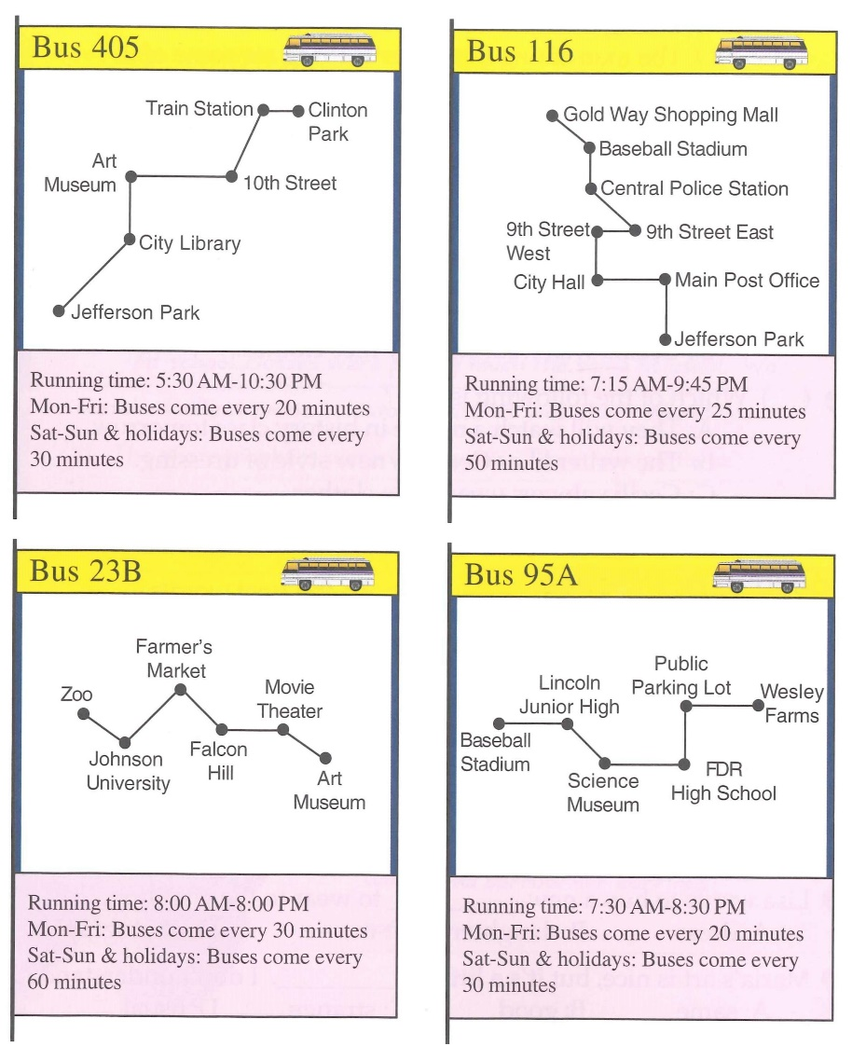
route 路線 stadium 體育館 more 較多
46.To get from Jefferson Park to the baseball stadium, _____.
(A) you can choose between two different buses
(B) you have to travel six stops
(C) you travel from the north to the south part of town
(D) you have to change buses at the central police station
47. Route 95A _____.
(A) has buses running every 30 minutes on weekdays
(B) starts at a parking lot
(C) stops at two schools on its route
(D) shares a bus stop with Route 405
48. Which of the following is true?
(A)It’s four stops from the junior high school to the high school.
(B) there are more buses on weekends than weekdays.
(C) The farmer’s market is the next stop after the movie thearer.
(D) Two buses stops at the art museum.
(3)
Tsunamis are some of the most terrible types of natural disasters. They mostly affect coastal areas around the “ Ring of Fire ”. That’s an area around the Pacific Ocean with a large number of volcanoes. Countries like Peru and Japan are often hit by tsunamis.
A tsunami is a large wave that hits the ocean shore. It’s not the same as the normal waves we see at the beach. Tsunami waves are created when the ocean floor moves. This can be caused by a volcano, earthquake, or other events. After such an event, groups of waves move outward. They travel very quickly( up to 700 kilometers per hour) and are very wide ( usually more than 100 kilometers).
tsunami 海嘯 disaster 災害 coastal 沿岸的 area 區域 volcano 火山 shore海岸 cause導致 event 事件
49. What is the “ Ring of Fire ”?
(A) A type of volcano.
(B) A large Tsunami.
(C) Another name for the Pacific Ocean.
(D) An area with a lot of volcanoes.
50. Which of the following is not a cause of tsunamis?
(A) Earthquakes.
(B) Wind.
(C) An event that makes the ocean floor move.
(D) Volcanoes.

107-1-3 八年級 英語科－解答
01.CABCB 06.ACABC 11.ABCBC 16.DBDAC
21.BCACD 26.DBCBA 31.ADCDC
36.DBA 39.D(或C) B
41.ACBDA 46.BCDDB

新北市立溪崑國民中學107學年度第一學期第三次定期評量
八年級 英語科 聽力測驗稿
一、辨識句意：每題均有三張圖片，請依據所聽到的句子，選出符合描述的圖片
- 《腳本區》
CD: Go straight for two blocks and turn right. Then, you can see the train station on your left.
《題目區》
(A)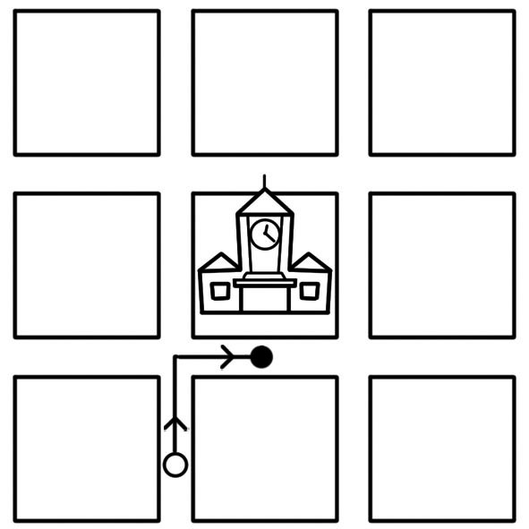 (B)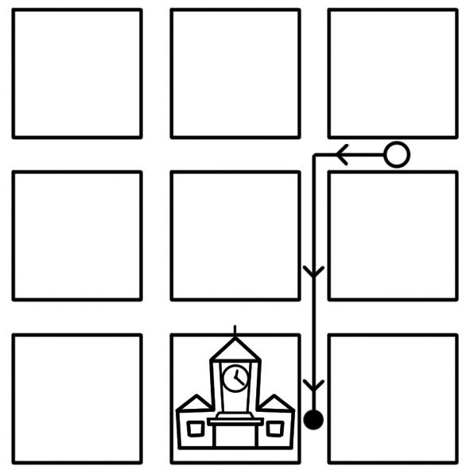
(C)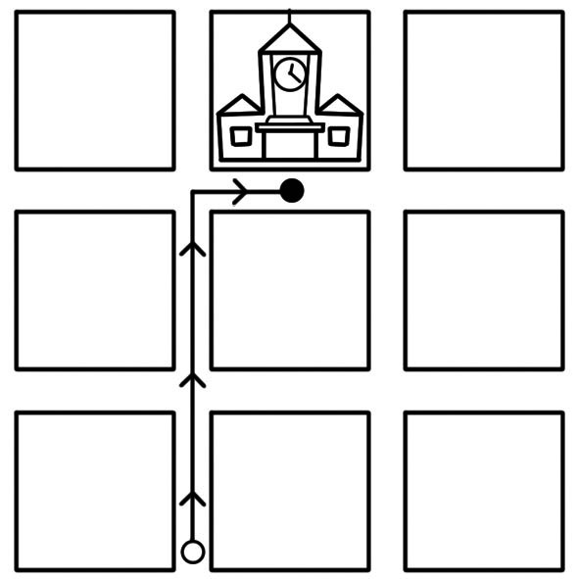
《答案區》
答案：C
- 《腳本區》
CD: Mr. Li’s house is in the west of the city.
《題目區》
(A)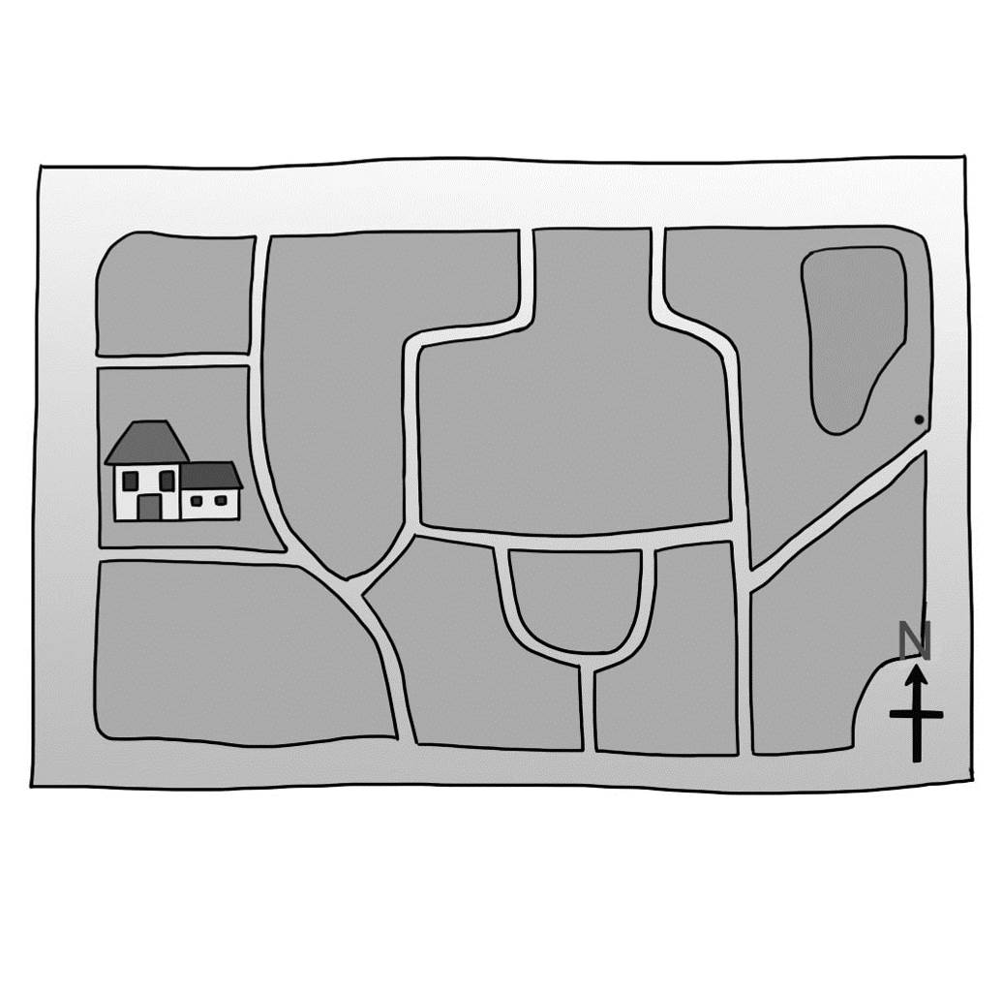 (B)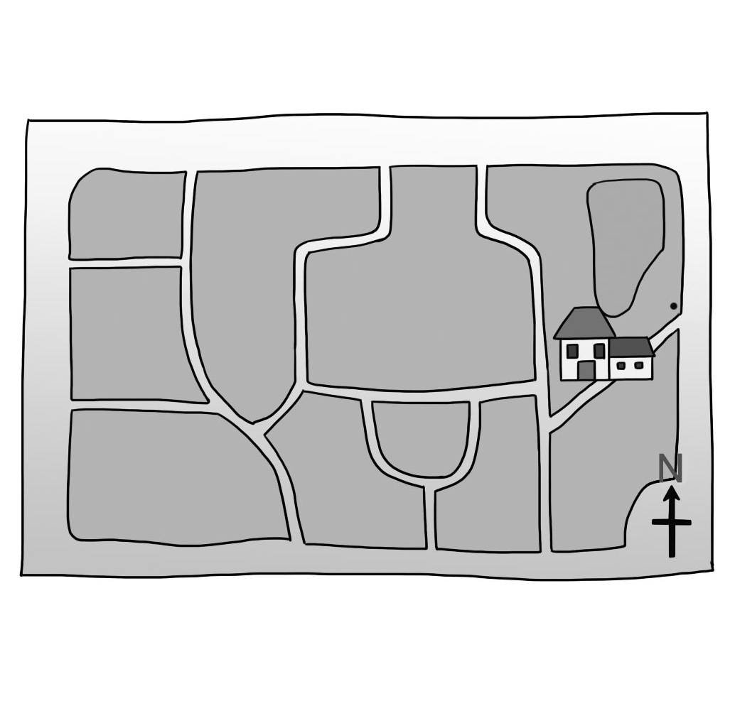
(C)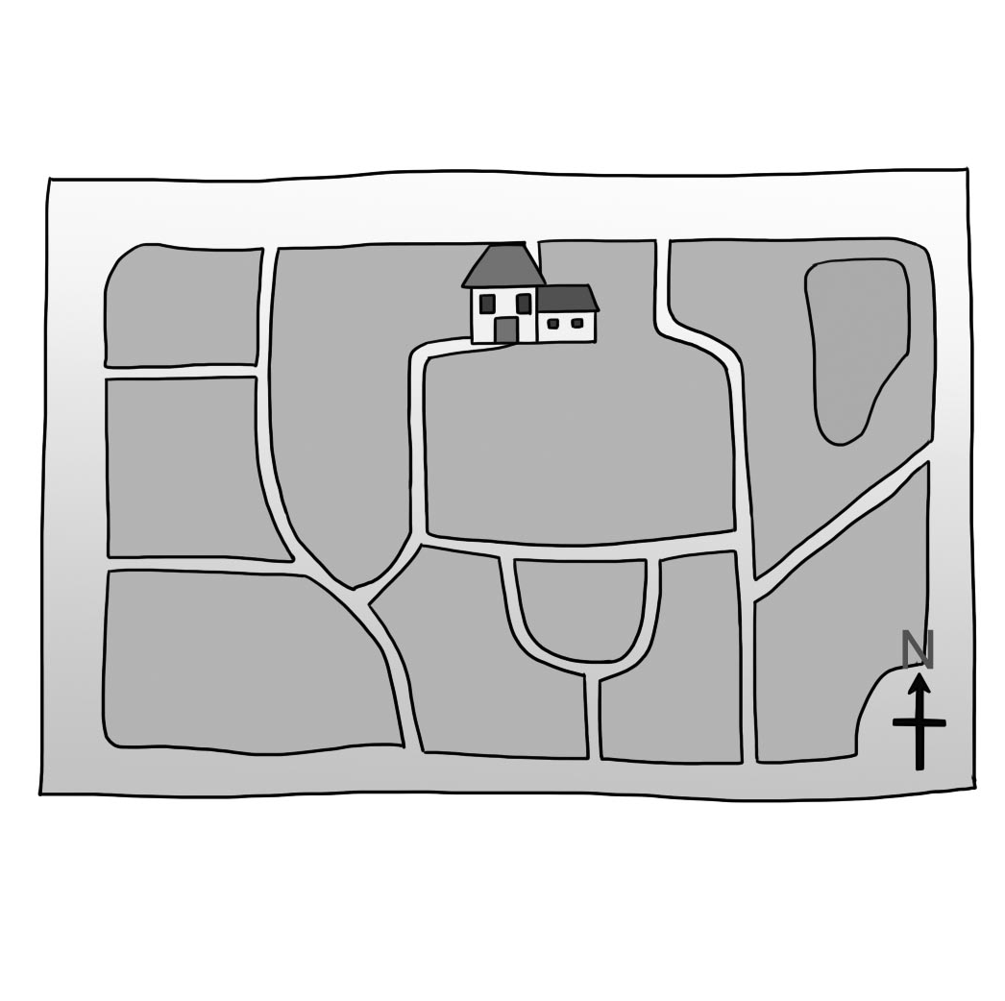
《答案區》
答案：A
- 《腳本區》
CD: After you walk past a hospital, keep walking east. Then, you can see the bookstore on your left.
《題目區》
(A)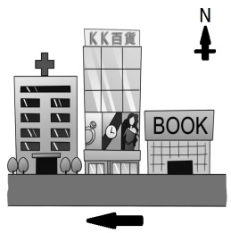 (B)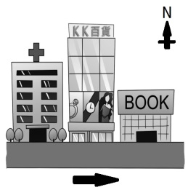
(C)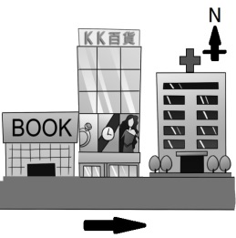
《答案區》
答案：B
- 《腳本區》
CD: (Girl:) My dad took us for a ride in his new car.
《題目區》
(A) (B)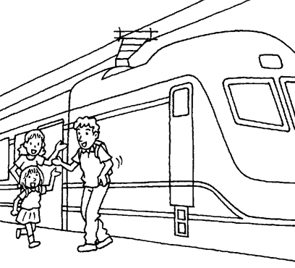
(C)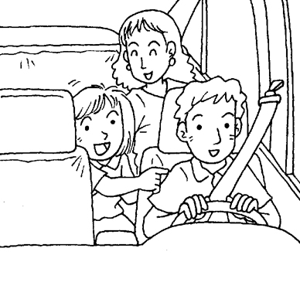
《答案區》
答案：C
- 《腳本區》
CD: Our math teacher drew a square at the beginning of the class.
《題目區》
(A)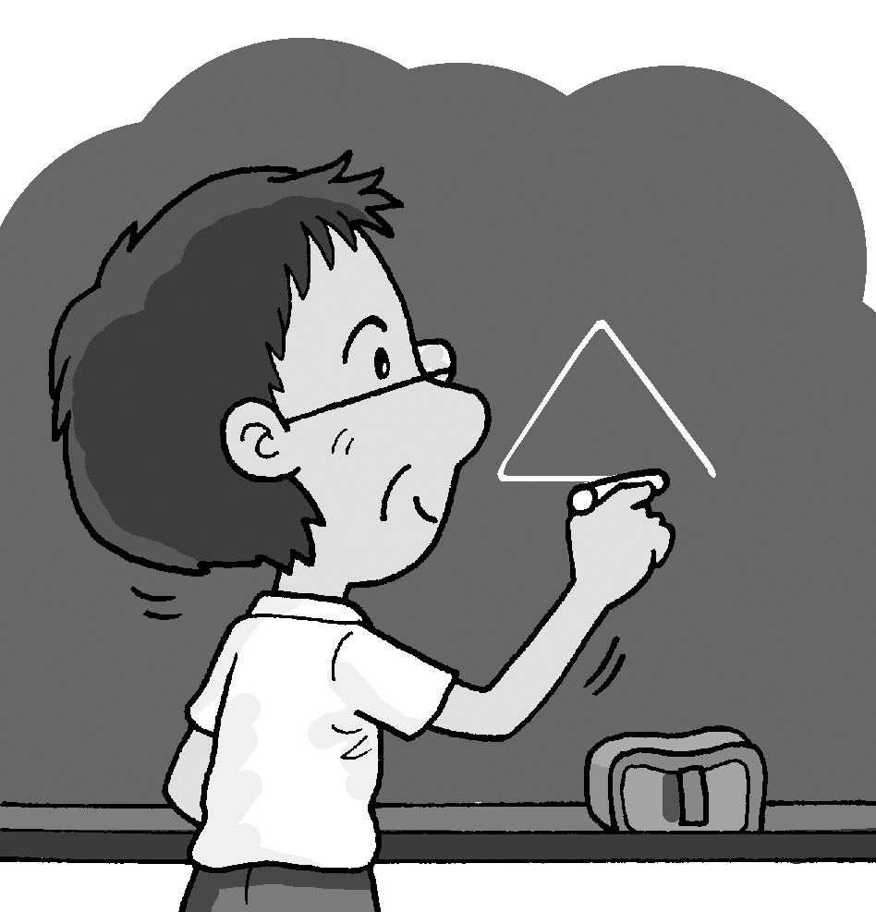 (B)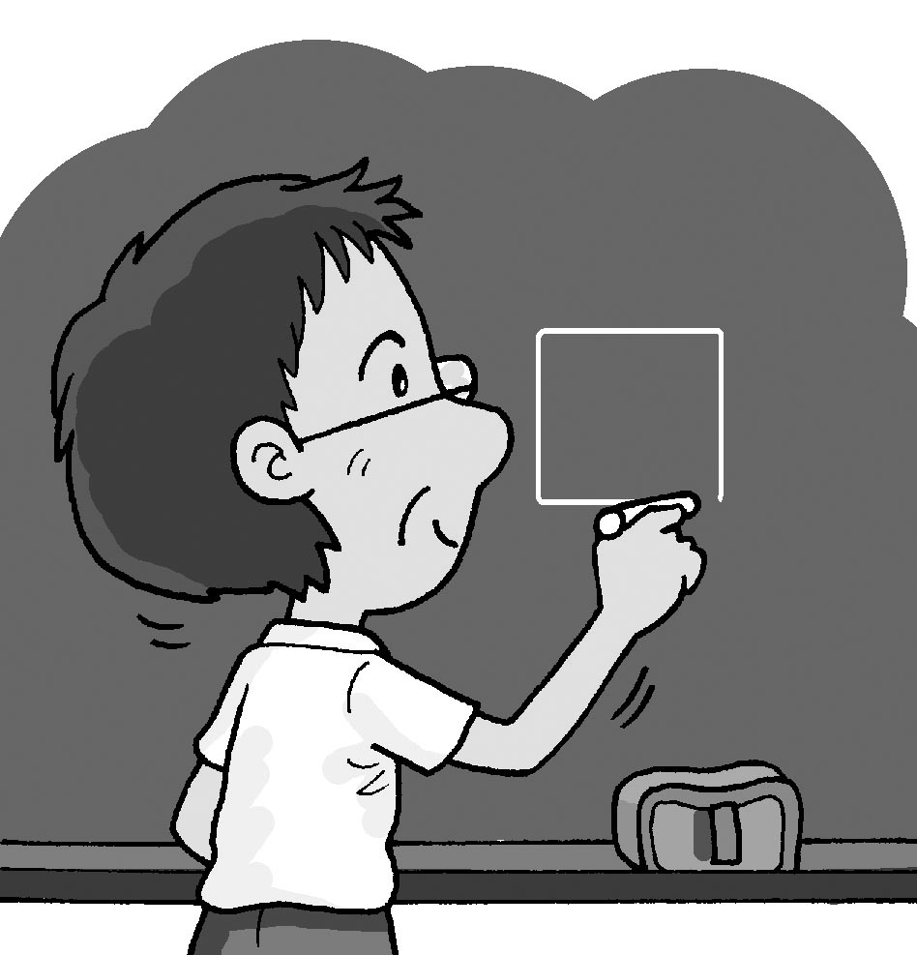
(C)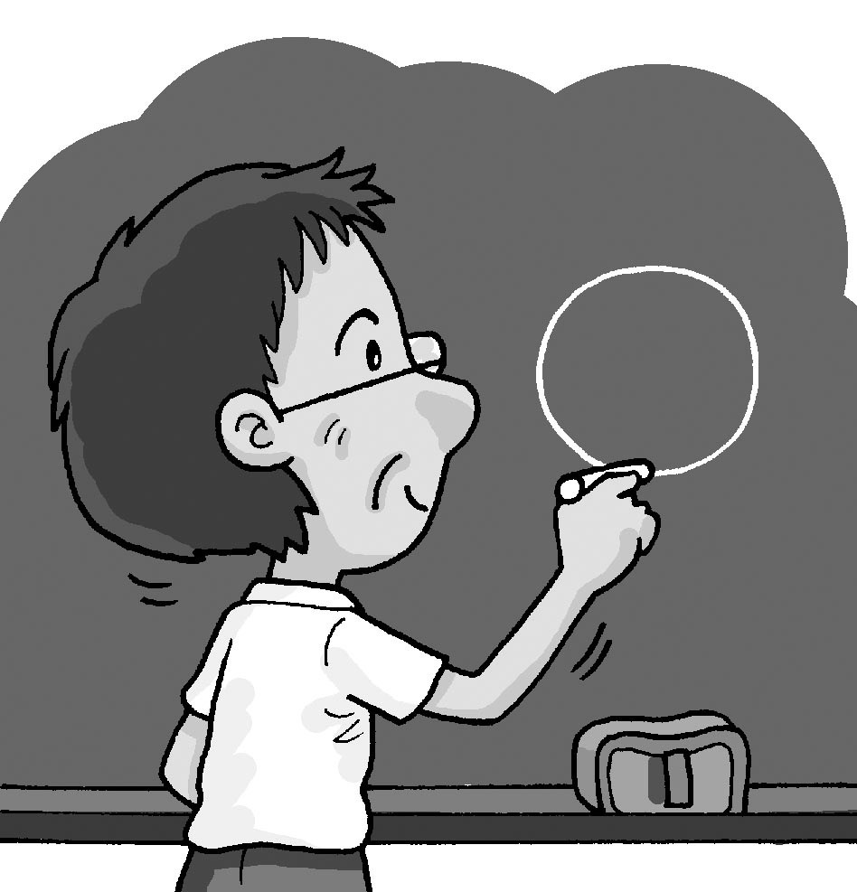
《答案區》
答案：B
二、基本問答：每題均有三個選項，請依據所聽到的內容，選出一個最適合的回應
- 《腳本區》
CD: Excuse me. Can I check the map with your smartphone?
《題目區》
(A) Yes, you can use the app on my smartphone.
(B) Yes, just turn right, and you can see it.
(C) No, I don’t have a map with me.
《答案區》
答案：A
- 《腳本區》
CD: Is the supermarket between a bookstore and a bank?
《題目區》
(A) No, it’s next to a bookstore.
(B) Yes, it’s across from a bank.
(C) No, it’s in back of a department store.
《答案區》
答案：C
- 《腳本區》
CD: How’s the weather in your hometown in August?
《題目區》
(A) It’s usually hot and dry. People like to go swimming then.
(B) I like to go swimming in August.
(C) Summer is the season to go swimming.
《答案區》
答案：A
- 《腳本區》
CD: Do you want to go camping with me in the end of this winter?
《題目區》
(A) No. It was snowy and cold last winter.
(B) Yes. It’s fun. Can we have Kenny with us?
(C) Yes. Going camping isn’t interesting to me at all.
《答案區》
答案：B
- 《腳本區》
CD: Excuse me, how can I get to the museum by subway?
《題目區》
(A) Sure. Walk west for three blocks and then turn right.
(B) Which station should I get off?
(C) Take the Green Line at Theater Station for five stops.
《答案區》
答案：C
三、言談理解：每題均有三個選項，請依據所聽到的對話與問題，選出一個最適當的答案
- 《腳本區》
CD: Man: Where is the clock tower?
Woman: I don’t know. Let’s ask the clerk over there.
Man: Okay.
Woman: Excuse me, where is the clock tower?
Clerk (Man): Cross the street and keep walking for one block. It’s across from a big department store.
Question: Where is the clock tower?
《題目區》
(A) In front of the city hall.
(B) Cross the street and walk straight for one block.
(C) It’s near a big department store.
《答案區》
答案：C
- 《腳本區》
CD: Man: Look! This is my new “secretary.”
Woman: Who? I don’t see anyone around here.
Man: I’m talking about my new pad. It can help me check maps when I get lost. I can also use other useful apps on it.
Woman: Wow! Today’s technology.
Question: What did the woman mean when she said “Today’s technology”?
《題目區》
(A) The man’s new secretary is a smart guy.
(B) The man isn’t good at work.
(C) The man’s new pad（平板）is very useful.
《答案區》
答案：C
- 《腳本區》
CD: Boy: Oh, no. It’s raining again. I can’t play baseball with my friends.
Woman: The rainy season is coming. It usually starts in May and ends in June.
Boy: Really? That’s too long.
Woman: Maybe we can read some interesting books at home together.
Question: Which is true?
《題目區》
(A) It’s July now, and it’s the rainy season.
(B) The mother doesn’t want to be with her son.
(C) The boy can’t go out because it’s rainy.
《答案區》
答案：C
- 《腳本區》
CD: Woman: Our next stop is the setting of the successful movie, KANO.
Man: Really? It’s my favorite movie. What will we see there?
Woman: I don’t know. This is also my first time to visit the place. OK, we are going to get off the bus. Where is your change?
Question: What can we know from the dialogue?
《題目區》
(A) The man and the woman are on a train.
(B) The man and the woman are going to visit the setting of a successful movie.
(C) The man doesn’t like the movie, KANO, at all.
《答案區》
答案：B
- 《腳本區》
CD: Man: The tower is in the heart of the city. It’s easy to go anywhere from it. Do you want to go there and take a look?
Woman: Is there anything special about it?
Man: Of course. You can go to the tower and enjoy a bird’s eye view of the city.
Woman: Great! Are we going to walk there?
Man: Yes, it’s just one block away.
Question: Which is true?
《題目區》
(A) The woman is showing the man around.
(B) The tower is far, so the man and the woman will take a bus there.
(C) The tower is in the middle of the city.
《答案區》
答案：C

