新北市立溪崑國民中學107學年度第一學期第二次定期評量 英語科 試題卷
九年級 班 座號 姓名
一、聽力測驗：30%
I. 辨識句意 : 根據聽到的內容，選出符合描述的圖片。
1. (Ａ) (Ｂ) (Ｃ)
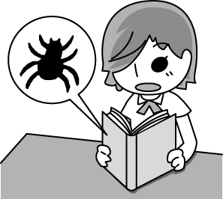
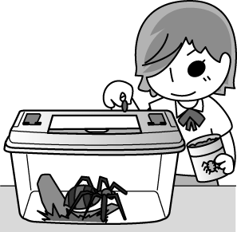
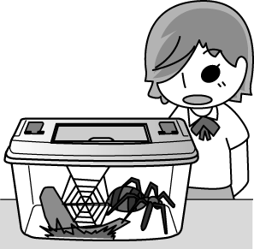

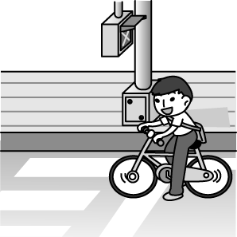
2. (Ａ) (Ｂ) (Ｃ)
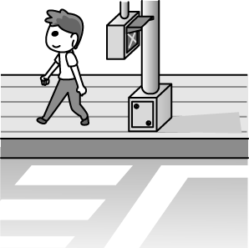
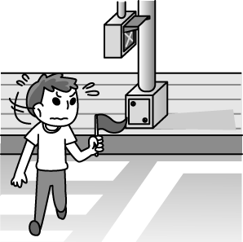

3. (Ａ) (Ｂ) (Ｃ)
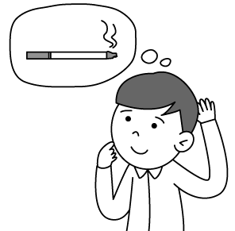
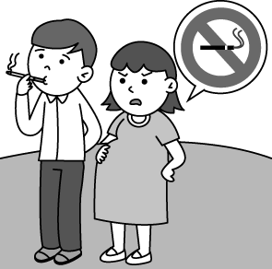
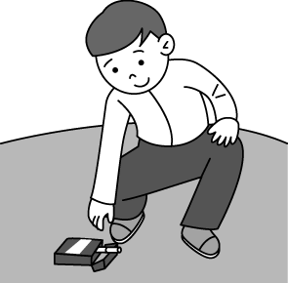

4. (Ａ) (Ｂ) (Ｃ)
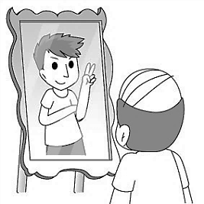
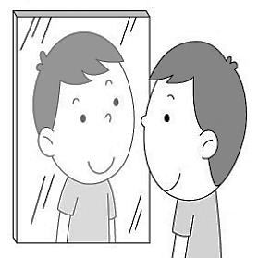
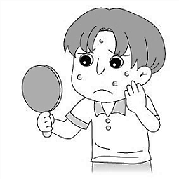

5. (Ａ) (Ｂ) (Ｃ)

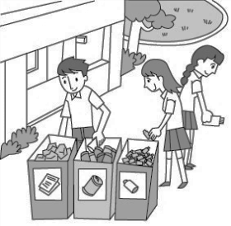
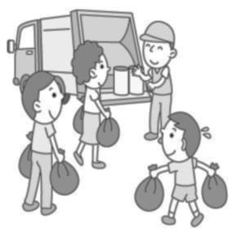

II. 基本問答: 依據聽到的內容，選出最適合的回應
6. (Ａ) That’s right. It’s around the corner.
(Ｂ) Sure. You can count on me.
(Ｃ) Yes. Count me in.
7. (Ａ) No, I don’t have any problems with teenagers.
(Ｂ) I think they are friendship and appearance.
(Ｃ) Perhaps it’s common for a teenager like you to ask the question.

【背面尚有試題】
8. (Ａ) Of course. He’s friendly.
(Ｂ) That’s a rude question.
(Ｃ) No problem. It’s a piece of cake.
9. (Ａ) You can say that again.
(Ｂ) The museum is too far to walk there.
(Ｃ) I can show you around the city.
10. (Ａ) I suppose so.
(Ｂ) That’s a serious problem.
(Ｃ) I don’t know how to work it out.
III. 言談理解: 根據聽到的對話內容與問題，選出正確的答案
11. (Ａ) Three years ago.
(Ｂ) Twenty years ago.
(Ｃ) Twenty-three years ago.
12. (Ａ) The woman went to Cambodia with the man.
(Ｂ) The man didn’t like anything in Cambodia.
(Ｃ) The man didn’t like the food in Cambodia.
13. (Ａ) He becomes healthier.
(Ｂ) He eats more than before.
(Ｃ) He feels cold easily.
14. (Ａ) Whether Jane likes animals or not.
(Ｂ) Whether Jane will agree with them or not.
(Ｃ) Whether Jane will join the party tonight.
15. (Ａ) To take some rest.
(Ｂ) To go upstairs as quickly as possible.
(Ｃ) To keep climbing the mountain.
二、請依題意選出最適當的答案：32 %
16. Catherine was seen ____________ to music at school.
(A) listen (B) listened (C) to listen (D) to listening
17. The garbage at the door needs __________ out tonight.
(A) to take (B) to be taking (C) taken (D) to be taken
18. A barking dog seldom ___________.
(A) sights (B) bites (C) notices (D)crosses
19. There are _____________ people in this country.
(A) three millions (B) one million of (C) millions of (D) three million of
20. Do you know ___________________?
(A) what time is it (B) what happened to Peter (C) how to do (D) when did he leave
21. It’s good for your health to ______________.
(A) quit smoke (B) quit smoking (C) stop to smoke (D) give up smoke
22. It’s _________ for Taiwanese students to go to cram school after school.
(A) lonely (B) confident (C) proud (D) common
23. Andy: Will Mary come to the party tomorrow? Ken:__________________
(A) I suppose so. (B) I agree with you. (C) Count me in. (D) I’m glad to hear that.
24. The waiter asked her ____________ to order.
(A) what she would like (B) what would she like (C) how she would like (D) how would she like
25. Amy: I’m too shy to tell him how I feel. Betty: Perhaps you can _____________.
(A) turn him down (B) drop him a note (C) share the secret with him (D) communicate with him
26. Jack __________ us again. I won’t believe him any more.
(A) lied (B) lay to (C) lied to (D) lay
27. The boy is _____________ to solve the problem.
(A) smart enough (B) too smart (C) so smart (D) enough smart
28. Which of the following sentences is correct?
(A) The coffee is too hot for me to drink. (B) The coffee is so hot that I can’t drink.
(C) The coffee is too hot for me to drink it. (D) The coffee is hot enough for me to drink it.
29. It’s _________ to keep quiet in the hospital.
(A) convenient (B) polite (C) rude (D) lost
30. We don’t know if ___________ tomorrow.
(A) it rains (B) it will rain (C) it is raining (D) it is rainy
31. A: I took the wrong bus, so I was late for school. I also forgot to bring my lunch box.
B: _______________
(A)You should get a day off. (B) It didn’t work out. (C) God bless you. (D) What a day!
三、克漏字選擇及閱讀測驗：16 %
I had the strangest dream last night. I dreamed 32. I was walking down the street and I was completely naked. I had my book bag and my purse, but I didn’t 33. anything else. The strangest part was that everyone 34. around me but didn’t even notice that I was naked. Cars drove past me, and a man even came up to me and asked me how 35. to the nearest bank. When I woke up, I remembered my dream and I couldn’t help but laugh . I just hope nothing like this happens in real life. I would die of embarrassment if this really 36. .

32. (A) of (B) that (C) which (D) what
33. (A) make (B) put (C) tear (D) wear
34. (A) walking (B) walks (C) walked (D) to walk
35. (A) getting (B) to get (C) I get (D) can get
36. (A) happening (B) happens (C) happened (D) will happen

In front of the enormous Shibuya train station in Tokyo, there is a life-size bronze statue of a dog. Even though the statue is very small when compared to the huge neon signs flashing, it isn't difficult to find. It has been used as a meeting point since 1934 , and today you will find hundreds of people waiting there for their friends to arrive- just look for the crowds.
Hachiko, an Akita dog, was born in 1923 and brought to Tokyo in 1924. His owner, Professor Eisaburo Uyeno and he were inseparable friends right from the start. Each day Hachiko would accompany his owner, a professor at the Imperial University, to Shibuya train station when he left for work. When he came back, the professor would always find the dog patiently waiting for him. Sadly, the professor died suddenly at work in 1925 before he could return home.
Although Hachiko was still a young dog, the bond between him and his owner was very strong and he continued to wait at the station every day. Sometimes, he would stay there for days at a time, though some believe that he kept returning because of the food he was given by street vendors. He became a familiar sight to commuters over time. In 1934, a statue of him was put outside the station. In 1935, Hachiko died at the place he last saw his friend alive

37. What can we learn from the reading?
(A) The professor died because of a car accident.
(B) The professor worked in a university.
(C) The statue was put outside the station after the dog died.
(D) The statue of Hachiko is so small that it’s hard to find it.

【背面尚有試題】
38. What is the reading about?
(A) The story of a life-size bronze statue of a dog.
(B) How people put the dog statue outside the station.
(C) The death of a professor and his dog.
(D) A sad story about a dog.
39. What does it refer to in the first paragraph?
(A) The huge neon signs.
(B) The enormous Shibuya train station.
(C) A meeting point.
(D) The bronze statue of a dog.

…………………………………………………………………………………………………………………
※ 將以下的答案寫在答案欄中
四、依提示作答：10 %
40. Will they serve steak as food? . (改成被動語態)
41. I have no idea. / Who should I ask for help? (用名詞片語合併)
42. How long did it take to get there? / Andy didn’t know that. (用間接問句合併)
43. The weather is so hot that we can’t stay outside. (用too…to…改寫)
44. Did Ben turn off the lights? / Ben is not sure. (用whether合併)

五、翻譯：12 %
45. 我們應該跟彼此多溝通以更加瞭解彼此。
46. 人們很難不注意到牠們，因為牠們全身被覆蓋濃密的毛。
47. 因為這個強颱，我們前天放假一天。
48. 當我經過時，我可以聞到他們制服上有煙味。

【試題結束】

新北市立溪崑國民中學107學年度第一學期第二次定期評量 英語科 答案卷
九年級 班 座號 姓名
答案欄
四、依提示作答：10 %
40. _______________________________________________________________
41. _______________________________________________________________
42. _______________________________________________________________
43. _______________________________________________________________
44. _______________________________________________________________

五、翻譯：12%
45. _______________________________________________________________
46. _______________________________________________________________
47. _______________________________________________________________
48. _______________________________________________________________

107-1-2 九年級 英語科－解答
一、聽力測驗：30 %
AABCB CBCAA BCACA
二、請依題意選出最適當的答案：32%
CDBCB BDAAB CAABB D
三、克漏字選擇及閱讀測驗：16 %
BDCBB BAD

四、依提示作答：10 %
40. Will steak be served as food (by them)?
41. I have no idea who to ask for help.
42. Andy didn’t know how long it took to get there.
43. The weather is too hot for us to stay outside.
44. Ben is not sure whether he turned off the lights.

五、翻譯：12 %
45. We should communicate with each other more to understand each other better.
46. It's hard not to notice them because their bodies are covered with thick hair.
47. Because of the strong typhoon, we had/got a day off the day before yesterday.
48. I could smell cigarette smoke on their uniforms when I passed by.

新北市立溪崑國民中學107學年度第一學期第二次定期評量
九年級 英語科 聽力測驗稿

一、聽力測驗：
A. 辨識句意: 根據聽到的內容，選出符合描述的圖片。
1. She is looking at a spider web.
2. It is important to look to both sides when crossing the street.
3. The man was told to quit smoking.
4. The boy feels worried because he has acne on his face.
5. Recycling is a good way to be friendly to the Earth.
B. 基本問答: 依據聽到的內容，選出最適合的回應
6. Are you interested in going on a trip to Green Island with us?
7. Do you know what the two common problems for teenagers are?
8. I wonder if you can help me solve this math problem.
9. The art museum is so amazing that I want to go there again.
10. Will the plane arrive on time today?
C. 言談理解: 根據聽到的對話內容與問題，選出正確的答案
11. M: Amy, do you still remember the church?
W: Of course. It was built when we were three years old.
M: Time really flies. Now, we are twenty-three years old.
Q: When was the church built?
12. G: Have you ever been to Cambodia?
B: Yes, I have.
G: How was it?
B: The trip was fun, but not the food.
G: Why? Anything wrong with the food?
B: I felt scared when spiders were served as food.
Q: Which is true?
13. W: I am so happy because Brian finally gave up smoking. He looks very fine now.
M: Wow! That’s good news.
W: Right. He won’t catch a cold so easily, and he can really enjoy delicious food.
Q: How is Brian after he quit smoking?
14. W: I don’t know whether Jane will attend the party tonight.
M: She’s a party animal, so she won’t miss any chance to go to a party.
W: I can’t agree with you more.
Q: What are they talking about?
15. M: Come on! We are almost there, the top of the mountain.
W: I’m too tired to climb all the stairs.
M: Let’s take a short break!
W: Good idea!
Q: What are the man and the woman going to do?

