新北市立溪崑國民中學107學年度第一學期第二次定期評量 英語科 試題卷
八年級 班 座號 姓名
第 一部分 聽力測驗
一、辨識句意：每題均有三張圖片，請依據所聽到的句子，選出符合描述的圖片(5%)
- (A)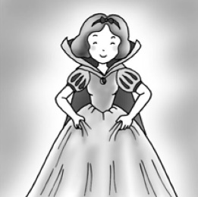 (B)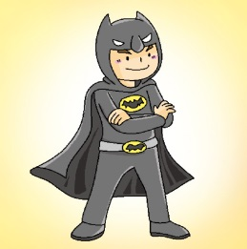(C)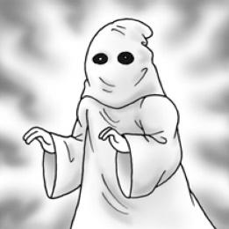
- (A)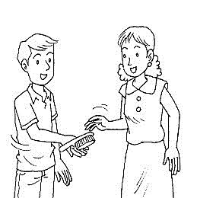 (B)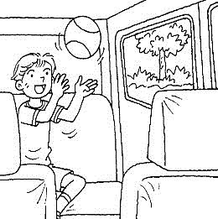 (C)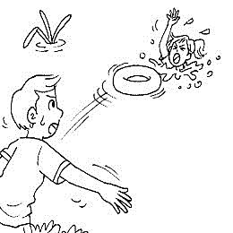
- (A)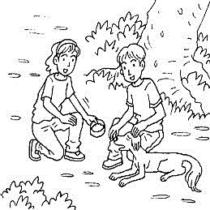 (B)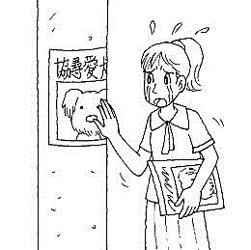(C)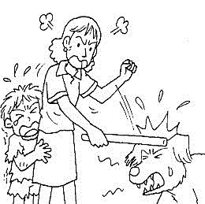
- (A)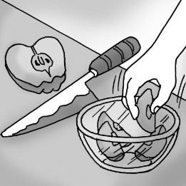 (B)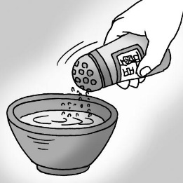(C)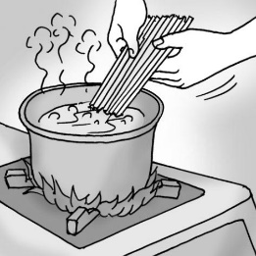
- (A)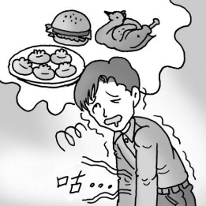 (B)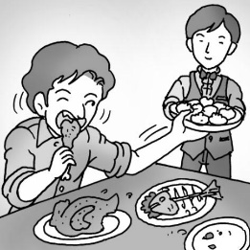(C)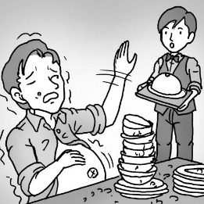
二、基本問答：每題均有三個選項，請依據所聽到的內容，選出一個最適合的回應 5%
6 .(A) He is reading the newspaper now.
(B) He was watering the flowers in the garden.
(C) He didn’t have your phone number to call back.
7 .(A) Yes, they like to live alone.
(B) No, they don’t have to live alone.
(C) That’s true.
8 .(A) It’s easy for us to learn about something on the Internet.
(B) It’s important to shake hands with him when you meet him.
(C) It’s strange of you to miss a woman like her.
9. (A) Really? Where did he go?
(B) Really? Who did he go with?
(C) Really? What did he make?
10. (A) Sure. I don’t want to share it with you.
(B) Sure. Please put some sugar in my coffee.
(C) Sure. It’s not common to share food in Japan.
三、言談理解：每題均有三個選項，請依據所聽到的對話與問題，選出一個最適當的答案 10%
11. (A) She was talking on the phone.
(B) She was cleaning her house.
(C) She was cleaning her pet.
12. (A) They were sleeping.
(B) They were running after the monkeys.
(C) They were playing in the water.
13. (A) They need to finish the work together.
(B) They want to make a plan first.
(C) It’s easy for them to finish the work on time.
14. (A) It is not hard for the mother to prepare dinner tonight.
(B) It is important for the kids to help clean the house.
(C) It is difficult for the kids to read their mom’s note.
15. (A) She needs money to help her friend.
(B) She doesn’t want to stay home.
(C) She wants to work with her friend.

第 二部分 綜合測驗(32%)
16. Mr. Chen is an interesting teacher. He brings a lot of _____ to us.
(A) hens (B) beach (C) holes (D) joy
17. Rita didn’t eat her lunch. She _____ it for her son.
(A) bought (B) began (C) saved (D) grew
18. Judy _____ at us and said goodbye to us.
(A) look (B) waved (C) fried (D) smile
19. Dad _____ the house when Mom_____ home.
(A) cleaned , came (B) cleaned , was coming (C) was cleaning , was coming (D) was cleaning , came
20. To take care of _____ ______ not easy.
(A) plants , are (B) plants , is (C) plant , is (D) plant , are
21. Frank _____ making rice dumplings. (選錯的 )
(A) tried (B) loved (C) liked (D)wanted
22. Grandma _____ our dog, Marble. In fact, she gave it some food this morning.
(A) forgets to feed (B) forgot to feed (C) forgot feeding (D) forget feeding
23. Grandpa _____ the newspaper without _____ his glasses.The words are too small.
(A) can’t reading , wear (B) can read , wearing (C) can read , to wear (D) can’t read , wearing
24. My father asked me _____ online before I finished my homework.
(A)not staying (B) to not stay (C) not to stay (D) not stay
25. _____ good English , we have to practice hard.
(A) Speaking (B) Speak (C) Spoke (D) To speak
26. Never stop _____ English. Always keep _____ speaking English every day.
(A) learning , practicing (B) learning , to practice (C) to learn , to practice (D) to learn , practicing
27. Uncle Sam likes _____ up early and going jogging at the park.
(A) to get (B) getting (C) gets (D) got
28. _____ a lot of fun to go sing songs at a KTV with good friends.
(A) I am (B)there is (C) It is (D) They are
29. Terry: I can’t make delicious coffee.
Tim: _____ I can’t do it well, either.
(A) I can’t, too. (B) No big deal.
(C) It’s not common. (D) How interesting.
30. Jack: What were you doing at eight yesterday evening?
Eva: I was sleeping then.
Jack: _____ Why did you go to bed so early?
(A) Were you?
(B) You did?
(C)There was an interesting movie then.
(D) Yes, I was sleeping.
31. 選錯誤的句子
(A) Swimming and hiking help Mark keep healthy.
(B) Eating fruit and vegetables is very important for our health.
(C) Taking a nice bath before going to bed helps you sleep well.
(D) Taking a nice bath before you go to bed.

第三部分 克漏字選擇5%
Peter is fourteen. He is a junior high school student. He enjoys __32___ English. In class, he practices English with his teacher and classmates. At home, he practices __33___ them with the CD three times a week he also wants __34___ in the USA some day. Now he plans __35___ an English storybook every week. He is always keeps __36___ well on all the English tests at school.
32. (A) study (B) to study (C) studies (D) studying
33. (A) to speak (B) speak (C) speaking (D) speaks
34. (A) study (B) to study (C) studies (D) studying
35. (A) reading (B) reads (C) to read (D) read
36. (A) doing (B) to do (C) does (D)do
第四部份 閱讀測驗 12%
(A)
Tony likes chocolate very much, but his mother never gives him any because she thinks it is bad for his teeth. But, __37___ . The old man loves his grandson very much, and he usually brings the young boy some chocolate when he comes to see him. Then Tony’s mother lets him eat it because __38___.
However, this time, the old man comes again , but __39___ , so the little boy is very sad.
Before Tony goes to bed, he says his prayers in his bedroom. “ Please, God,” he shouts, “ let Grandpa bring me a box of chocolate every time when he comes here.”
“Why are you shouting, Tony?” the mother goes into her son’s room and asks him. “ God can hear you when you talk quietly.”
“ I know, ” answers the boy, “ but Grandfather is in the next room, and __40___ if I talk quietly.”

37. (A) Tony has many bad teeth. (B) Tony has a very nice grandfather. (C) Tony buys a lot of chocolate (D) The mother often takes him to the dentist.
38. (A) she wants to make them happy (B) she wants to eat chocolate, too (C) the old man is very old and sick (D)the old man can’t eat chocolate
39. (A) he doesn’t wear his glasses (B) he has a cold again (C) he doesn’t bring any chocolate to Tony (D) he doesn’t buy Tony any toy
40. (A) he can’t buy chocolate (B) he can’t eat chocolate (C) he doesn’t like his room (D) he can’t hear my prayers
(B)
Martin Luther and George Washington are the only Americans whose birthdays are holidays. We celebrate Martin Luther King’s birthday on the third Monday in January, but he was born on January 15th, 1929, in Atlanta, Georgia.
He wanted all people in America to have the same rights. In the past, African-American children could not go to the same school or ride on the same buses as white people. Martin Luther King did not think this was right, so he brought many people together for the “March on Washington” to protest against this and other problems. They walked around Washington to show the rest of the people they wanted to solve these problems. There he gave his famous speech “ I have a dream,” in which he said he wanted a world where his children would have a better future.

41. What is true about Martin Luther King ?
(A) He wanted his children to have a better future.
(B) He often had dreams while sleeping.
(C) He wanted all people in America to have a holiday.
(D) He was born in March.
42. When do Americans celebrate Martin Luther King’s Birthday?
(A) The third Monday in March.
(B) The third Monday in January.
(C) On January 15th.
(D)On January 15th, 1928.
第五部分 翻譯填充 16%
43.A: 媽媽為什麼對你生氣?
B: 因為我用雜誌丟弟弟。
A : Why _____ Mom _(m)____ at you ?
B : Because I _____ the magazine _____ my little brother.
44.修女們為我們演出一場好笑的短劇。
The _____ _____ _____ a funny _____ for us.
45.試試看這些雞肉三明治。這是我的拿手菜。
Try the chicken _____. It’s my _____ .
46.去年我們計劃捐血給那些孩子。
We _____ to _____ _____ to those kids last year.
47.準時很重要。
_____ _____ _____ is important.

第六部分整句式翻譯15%
48.當我正在做一個奇怪的夢時,媽媽把我叫醒。
49.我常常練習用筷子 ,但是當我使用時 ,我的食物總是會飛走。
50.對老人家而言 ,獨居是很辛苦的。他們總是會想念孩子。
51.美國人擅長使用刀叉吃牛排。
52.當你在日本度假時別忘了這些餐桌禮儀。

新北市立溪崑國民中學107學年度第一學期第二次定期評量 英語科 答案卷
八年級 班 座號 姓名
第五部分 翻譯填充16%
43
44
45
46
47

第六部分 整句式翻譯 15%
48
49
50
51
52

107-1-2 八年級 英語科－解答
1.CCBCB 6.BCACB 11.CACBC
16.DCBDB 21.DCDCD 26.ABCBA 31.DDCBC 36ABACD 41AB
第五部分 翻譯填空16%
43. was mad threw at
44. sisters put on play
45. sandwiches specialty
46. planned donate blood
47. Being on time
第六部分 整句式翻譯15% 每題三分
48.When I was having a strange dream, my mother woke me up.
49.I practice using chopsticks a lot, but when I use them, my food always flies away.
50.For the elderly, to live alone is hard. They always miss their children.
51. Americans are good at using knives and forks when they eat steak.
52. Don’t forget the table manners when you are on vacation in Japan.

新北市立溪崑國民中學107學年度第一學期第二次定期評量
八年級 英語科 聽力測驗稿
一、辨識句意：每題均有三張圖片，請依據所聽到的句子，選出符合描述的圖片
- 《腳本區》
CD: The student played a ghost at the party.
《題目區》
(A)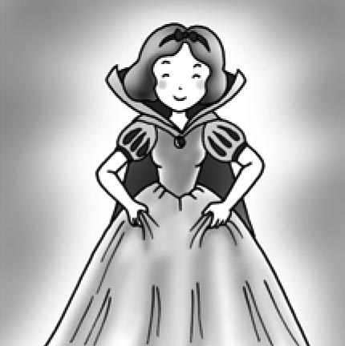 (B)
(C)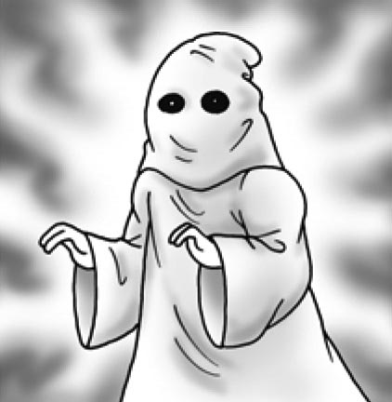
《答案區》
答案：C
- 《腳本區》
CD: The man threw something at the girl.
《題目區》
(A)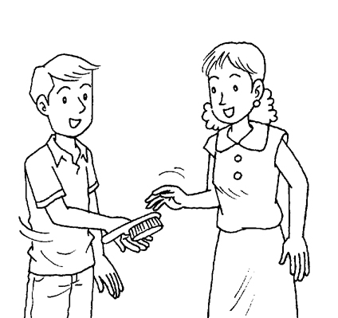 (B)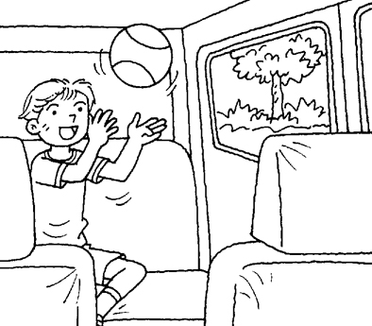
(C)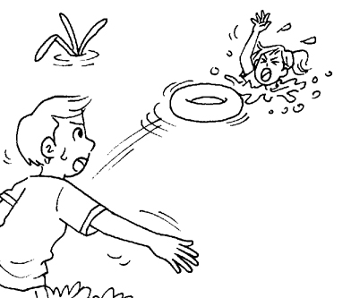
《答案區》
答案：C
- 《腳本區》
CD: The woman felt sad because she lost her pet.
《題目區》
(A)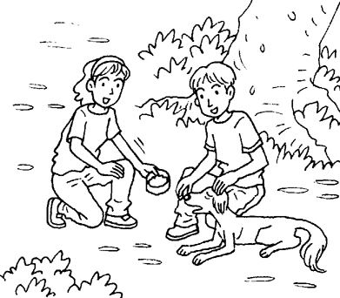 (B)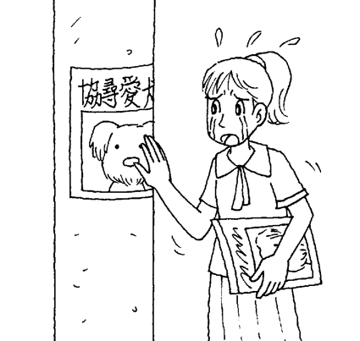
(C)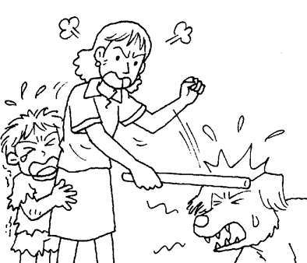
《答案區》
答案：B
- 《腳本區》
CD: Boil the water before you put the noodles in.
《題目區》
(A)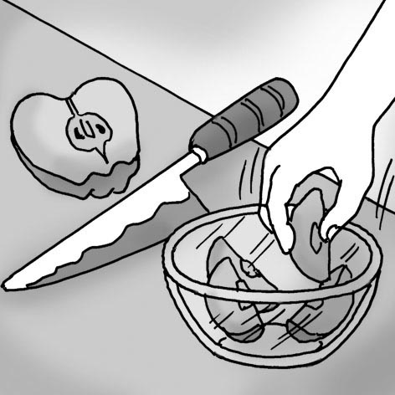 (B)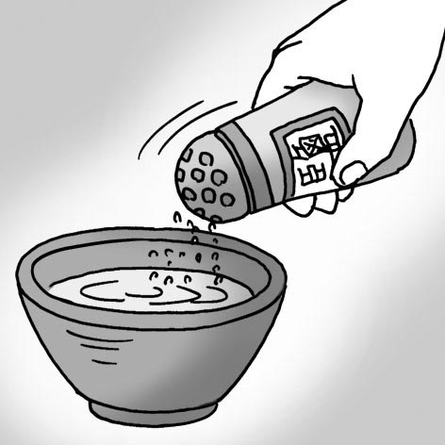
(C)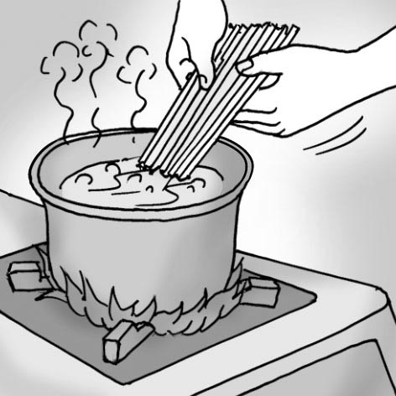
《答案區》
答案：C
- 《腳本區》
CD: The man had food in each hand, and he kept eating.
《題目區》
(A)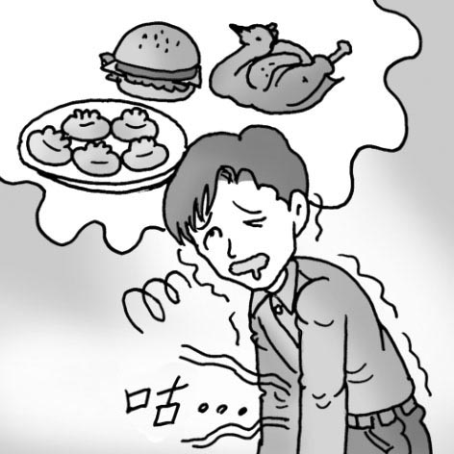 (B)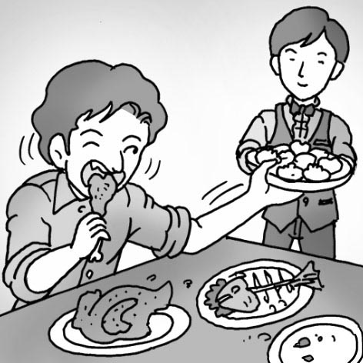
(C)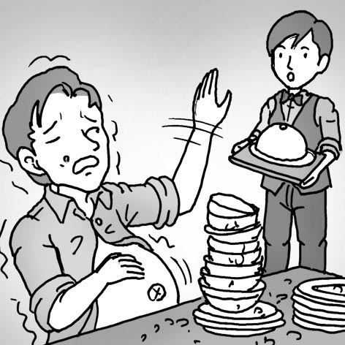
《答案區》
答案：B
二、基本問答：每題均有三個選項，請依據所聽到的內容，選出一個最適合的回應
- 《腳本區》
CD: What was your father doing when I called him?
《題目區》
(A) He is reading the newspaper now.
(B) He was watering the flowers in the garden.
(C) He didn’t have your phone number to call back.
《答案區》
答案：B
- 《腳本區》
CD: For the elderly, it’s not easy to live alone.
《題目區》
(A) Yes, they like to live alone.
(B) No, they don’t have to live alone.
(C) That’s true.
《答案區》
答案：C
- 《腳本區》
CD: Woman: Hey, your favorite singer has a new boyfriend now.
Man: How did you know the news?
《題目區》
(A) It’s easy for us to learn about something on the Internet.
(B) It’s important to shake hands with him when you meet him.
(C) It’s strange of you to miss a woman like her.
《答案區》
答案：A
- 《腳本區》
CD: Ken’s parents went to Japan for a vacation, so he had to prepare three meals for his little sister.
《題目區》
(A) Really? Where did he go?
(B) Really? Who did he go with?
(C) Really? What did he make?
《答案區》
答案：C
- 《腳本區》
CD: The coffee is great. Do you want some?
《題目區》
(A) Sure. I don’t want to share it with you.
(B) Sure. Please put some sugar in my coffee.
(C) Sure. It’s not common to share food in Japan.
《答案區》
答案：B
三、言談理解：每題均有三個選項，請依據所聽到的對話與問題，選出一個最適當的答案
- 《腳本區》
CD: Man: Were you at home at eight last night?
Woman: Yes. Why?
Man: I went to your house, but no one answered the door.
Woman: Oh, sorry. I was washing my dog then.
Question: What was the woman doing at eight last night?
《題目區》
(A) She was talking on the phone.
(B) She was cleaning her house.
(C) She was cleaning her pet.
《答案區》
答案：C
- 《腳本區》
CD: Woman: Did you have a good time at the zoo today?
Boy: No, I didn’t.
Woman: Why not?
Boy: It was a hot day. When I was at the zoo, the lions were sleeping, and the monkeys were sleeping in the trees. I couldn’t see them.
Woman: Too bad!
Question: What were the lions doing when the boy was at the zoo?
《題目區》
(A) They were sleeping.
(B) They were running after the monkeys.
(C) They were playing in the water.
《答案區》
答案：A
- 《腳本區》
CD: Man: It’s not easy to finish the work on time. There is too much work to do.
Woman: Yeah. We need a plan.
Man: You’re right. Let’s sit down and make a plan first.
Question: What can’t we say about the man and the woman?
《題目區》
(A) They need to finish the work together.
(B) They want to make a plan first.
(C) It’s easy for them to finish the work on time.
《答案區》
答案：C
- 《腳本區》
CD: Girl: Where is Mom?
Boy: I have no idea.
Girl: Oh, she’s still working.
Boy: How did you know?
Girl: She left us a note. It says “Sorry, kids. I have to work late today. You need to clean the house and help Daddy prepare dinner before I get home. Love you, Mom”
Question: Which is true?
《題目區》
(A) It is not hard for the mother to prepare dinner tonight.
(B) It is important for the kids to help clean the house.
(C) It is difficult for the kids to read their mom’s note.
《答案區》
答案：B
- 《腳本區》
CD: Girl: Dad, I’m thinking about having a part-time job.
Man: Why? Do you want to buy something?
Girl: Not really. My friend, Ivy, is working at a fast food restaurant now. I’m thinking... maybe I can work with her.
Man: OK. It may be fun to work with your best friend.
Question: Why does the girl want to work part-time?
《題目區》
(A) She needs money to help her friend.
(B) She doesn’t want to stay home.
(C) She wants to work with her friend.
《答案區》
答案：C

