新北市立溪崑國民中學107學年度第一學期第一次定期評量 英語科 試題卷
九年級 班 座號 姓名
第一部分:聽力測驗 30%

辨識句意：根據聽到的內容，選出符合描述的圖片或符合圖片的描述。
- (Ａ) 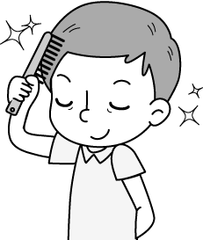 (Ｂ) 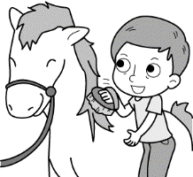 (Ｃ) 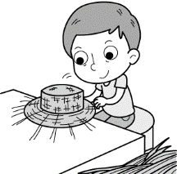
- (Ａ) 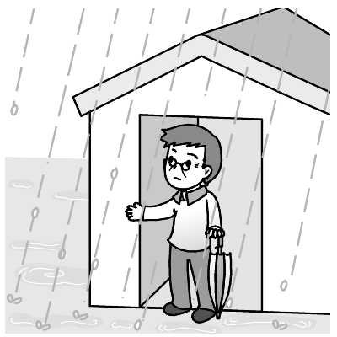 (Ｂ) 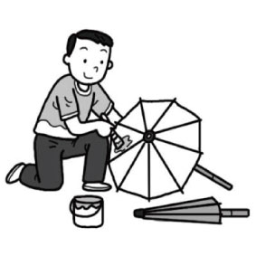 (Ｃ) 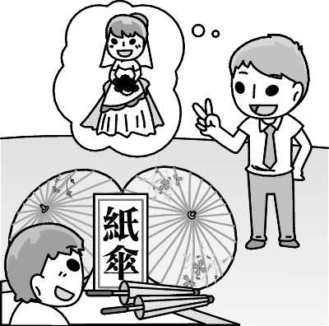
- (Ａ) 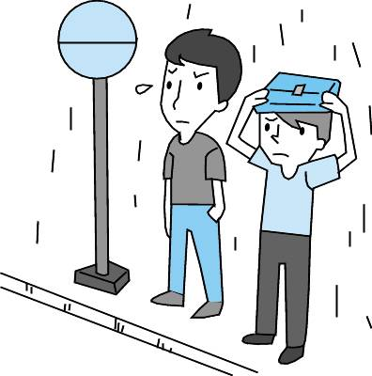 (Ｂ) 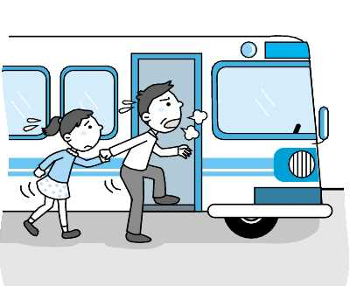 (Ｃ) 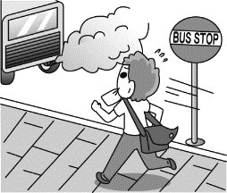
- (Ａ) 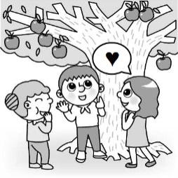 (Ｂ) 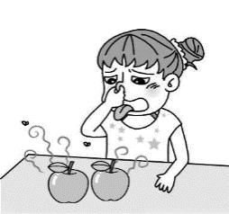 (Ｃ) 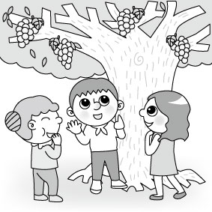
- (Ａ) 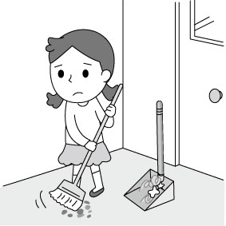 (Ｂ) 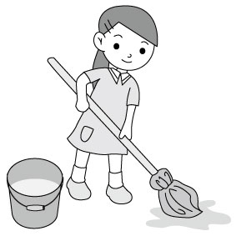 (Ｃ) 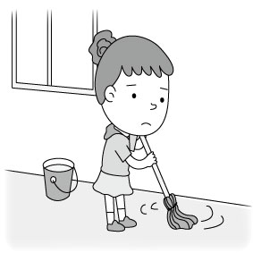

基本問答：根據聽到的內容，選出一個最適合的回應或最適合的問句。
- (Ａ) I’ve never heard of that. (Ｂ) I’ve had it for more than two years. (Ｃ) I bought it when I visited the Leather Museum.
- (Ａ) Yes, she can swim well. (Ｂ) No, she doesn’t like to swim. (Ｃ) Yes, she is practicing swimming.
- (Ａ) Wow. They’re going to get married.
(Ｂ) Yes, it’s the best wedding gift.
(Ｃ) No. I have not decided yet. Do you have any ideas?
- (Ａ) It’s funny. (Ｂ) The theater is on the street corner. (Ｃ) It’s a movie about Japanese ghosts.
- (Ａ) You shouldn’t be worried. (Ｂ) Watching movies is not my cup of tea. (Ｃ) I’m afraid to see ghost movies very much.

言談理解：根據聽到的內容，選出一個最適合的答案。
- (Ａ) The boy showed some tricks to Ms. Taylor. (Ｂ) Ms. Taylor dressed up as a ghost. (Ｃ) Today is Halloween, not Christmas.
- (Ａ) The woman likes her son’s painting. (Ｂ) The robot has a triangle head and rectangle body.
(Ｃ) There was a dog on the painting.
- (Ａ) He isn’t smart enough to understand the English language.
(Ｂ) He doesn’t know “feet” and “yard” have two different meanings.
(Ｃ) He doesn’t think Jeremy Lin is a good basketball player.
- (Ａ) She has played the piano and fed the dog. (Ｂ) She has done her homework. (Ｃ) She has done nothing yet.
- (Ａ) To teach Alice to make a pumpkin lantern.
(Ｂ) To let Alice make dinner for his mother.
(Ｃ) To ask Alice to finish the pumpkin lantern for him.

第二部分:單題選擇: 40%
16. My mom likes to put olive(橄欖) ______ into the boiling water when cooking spaghetti.
(A)candy (B)key (C)oil (D)envelope
17. I’m going to wear the pink shoes to the party because they have brought me a lot of good ___________.
(A)luck (B)shape (C)comb (D)information
18. Mom and Dad drive ________ cars to work every day.
(A)wooden (B)possible (C)straight (D)separate
19. When you are on the top of the mountain, everything looks so small __________.
(A)forward (B)below (C)certainly (D)proudly
20. A _____ has four angles, and a________ has three.
(A)square; triangle (B) rectangle; circle (C)heart; triangle (D) triangle; rectangle
21. The dog is playing with its own _____. It is having fun.
(A)program (B)sense (C)tail (D)glue
22. People under eighteen can’t see this scary movie; it’s for _______ only.
(A)tricks (B)corners (C)holes (D)adults
23. This job is so boring. I wish I could do something more ___________.
(A)creative (B)scared (C)afraid (D)certain
24. When David Blain, the American magician, performed his close-up magic on the street, the ________ have a whale of a time with their mouth open.
(A)specials (B)doorbells (C)dots (D)spectators
25. I have __________ all over when I see a cockroach.
(A)goose bumps (B)a piece of cake (C)brain (D)witch
26. Nick and Tom __________ each other ________ last spring.
(A)know; since (B)are knowing; for (C)have known; since (D)has known; for
27. My cousin ___________ married next month, so I want to _____ a pair of paper umbrellas ______ him.
(A)has been; send; to (B)is getting; buy; for (C)is; give; x (D)was; make; to
28. All of the students are ___________ about the trip. And some of them have already planned to ride the ______ roller-coaster together.
(A)excited; exciting (B) exciting; excited (C) excited; excite (D) exciting; exciting
29. It is said that ghosts will ________ in the seventh lunar month. That’s why people in Taiwan celebrate the Ghost Festival during the ghost month.
(A)play it safe (B)come out (C)show off (D)put on
30. Don’t you think ________ should be one more electric fan in the classroom?
(A)this (B)that (C)it (D)there
31. I learned from the TV news _______ Typhoon Jebi did much damage(傷害) to the Kansai region(區域) in Japan.
(A)where (B)which (C)that (D)this
32. Alice: Have you ever been to Meinong?
Tim: No, I __________. __________
(A)do never; Do you? (B)never have; Have you? (C)never do; Don’t you? (D)have never; Haven’t you?
33. Is your mom’s answer _____________ you?
(A)surprised at (B)surprised (C)surprising to (D)surprise
34. Choose the wrong sentence.
(A)Kevin, what were you doing when I called last night?
(B)My grandpa has been dead for two years.
(C)Our eyes get information for our brain to make sense of the world around us.
(D)Some of the puppets look funny or strange, and some of them look scaring.

35. Choose the right sentence.
(A)I think that take up a hobby is good for you.
(B)The circles in the picture started turn when I move my body.
(C)Tom isn’t an interesting person. I feel bored with his boring jokes.
(D)John’s mother made him to get a cup of tea.

第三部分:題組: 12%
A. (36〜38)
An old festival from Mexico is becoming the newest holiday in America. The Day of the Dead is celebrated 36 , the day after Halloween. Mexicans believe the spirits of the dead come back on Halloween and stay for two days. While the spirits are around, people show them respect by leaving food and drinks for them. Family members and friends often meet to eat and talk. In some cities, people can go watch 37 or shows with music. It may seem weird to be cheerfully celebrating a day for the dead, but Mexicans would not agree. They consider the festival 38 , not death. weird 詭異的
36. (A)every Monday (B)this year (C)on November 1 (D)in winter
37. (A)parades (B)strangers (C)holes (D)programs
38. (A)an interesting activity (B)an outdoor event (C)is scary for people in America (D)to be about life
B. (39〜41)
Peter Wohlleben (born in 1964) used to work in a forest in Germany. His job was to take care of trees. Before he began his career, he knew little about trees, but after years of hard work, he got to know more about them. One thing especially changed the way he sees trees.
It happened one afternoon when Peter was walking in the forest. A big rock with a very strange shape caught his eye. He went over and studied it very carefully. To his surprise, it was not a rock, but a piece of wood covered with small green plants. More surprisingly, he saw a little green inside the wood after he cut off a small part of it. In fact, what Peter found was a tree which was cut down hundreds of years ago. “How could it be? Without leaves, it couldn’t have lived so long,” he thought. Soon he found out why this piece of wood was still living--it was because the other trees around it sent their roots to it underground and kept giving it “food.”
Peter was amazed by what he found and started to come up with all sorts of questions. What does it mean if trees do help each other? Do they have feelings? Can they talk to each other? Since then, Peter hasn’t stopped studying trees.
especially特殊地 career職業 sorts種類
39. What does “them” refer to in the reading?
(A)trees (B)rocks (C)roots (D)feelings
40. What do we know about Peter Wohlleben from the reading?
(A)His job was to cut off woods. (B)He knows nothing about trees after he took up his job.
(C)He studied trees before he began his career. (D)He was a German forester.
41. Which is true?
(A) Peter found it boring to work in a forest. (B) Peter has been studying trees since he found what’s going on underground. (C)The wood that Peter found is a strange rock. (D)Peter heard trees talk to each other.

第四部份、依提示作答: 6% (每題2分)
42. The teacher will be proud of the students. /The students believe so. (用that合併成一句)
43. You and Mark have to study harder. (加入附加問句改寫)
44. Mom makes dinner every day. /Mom is tired of it. (合併成一句)

第五部份、翻譯: 12%(每題4分)
- 自從國中以來，我就一直對烹飪感興趣。(………since…………)
- 親眼所見不一定是對的。我們不能全然相信自己親眼所見，是吧?
47.小孩們直到把不給糖就搗蛋的袋子裝滿後才會返家。

新北市立溪崑國民中學107學年度第一學期第一次定期評量 英語科 答案卷
九年級 班 座號 姓名
第四部分、依提示作答: 6% (每題2分)

42.

43.

44

第五部分、翻譯: 12%(每題4分)
45.

46.

47.

107-1-1 九年級 英語科－解答
- B | - B | - C | - A | - C
- C | - B | - C | - A | - B
- C | - A | - B | - C | - C
- C | - A | - D | - B | - A
- C | - D | - A | - D | - A
- C | - B | - A | - B | - D
- C | - B | - C | - D | - C
- C | - A | - D | - A | - D
- B

四、依提示作答: 6% (每題2分)
42. The students believe that the teacher will be proud of them.
- You and Mark have to study harder , don’t you?
- Mom is tired of making dinner every day.

五、翻譯: 12%(每題4分)
- 自從國中以來，我就一直對烹飪感興趣。(………since…………)
I have been interested in cooking since I was in junior high school.
- 親眼所見不一定是對的。我們不能全然相信自己親眼所見，是吧?
Seeing is not believing. We can’t always trust our eyes, can we?
- 小孩們直到把不給糖就搗蛋的袋子裝滿後才會返家。
Children don’t go home until they fill up their trick-or-treat bags

新北市立溪崑國民中學107學年度第一學期第一次定期評量
九年級 英語科 聽力測驗稿
九年聽力測驗稿
- 辨識句意：根據聽到的內容，選出符合描述的圖片或符合圖片的描述。
- （ ）(Ａ) (Ｂ) 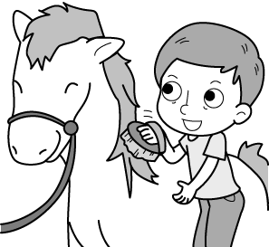(Ｃ) 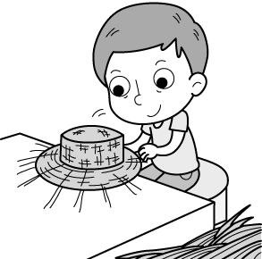
答案：(Ｂ)
解析：音軌：請參考 Unit 1 A5010005
錄音稿：The man is combing the horse’s hair.
- （ ）(Ａ) (Ｂ) (Ｃ)
答案：(Ｂ)
解析：音軌：請參考 Unit 1 A5010014
錄音稿：M: I made a paper umbrella by myself.
- (Ａ) (Ｂ) (Ｃ)
答案：(Ｃ)
解析：音軌：請參考 Unit 2 A5020084
錄音稿：：The boy didn’t get to the stop in time.
- （ ）(Ａ) 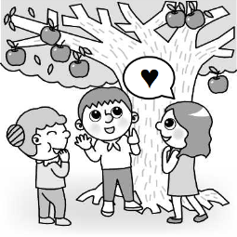(Ｂ) 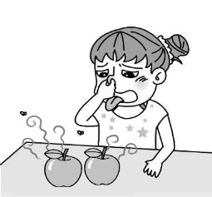(Ｃ)
答案：(Ａ)
解析：音軌：請參考 Unit 2 A5020090
錄音稿：B: The apples are very sweet, aren’t they?
G: Of course, they are the sweetest apples in the world.
- （ ）(Ａ) (Ｂ) (Ｃ)
答案：(Ｃ)
解析：音軌：請參考 Unit 3 A5030146
錄音稿：Mopping the floor is boring to Sarah.
- 基本問答：根據聽到的內容，選出一個最適合的回應或最適合的問句。
- (Ａ) I’ve never heard of that.
(Ｂ) I’ve had it for more than two years.
(Ｃ) I bought it when I visited the Leather Museum.
答案：(Ｃ)
解析：音軌：請參考 Unit 1 A5010036
錄音稿：Where did you get this leather wallet?
- (Ａ) Yes, she can swim well.
(Ｂ) No, she doesn’t like to swim.
(Ｃ) Yes, she is practicing swimming.
答案：(Ｂ)
解析：音軌：請參考 Unit 2 A5020100
錄音稿：Your sister doesn’t like to swim, does she?
- (Ａ) Wow. They’re going to get married.
(Ｂ) Yes, it’s the best wedding gift.
(Ｃ) No. I have not decided yet. Do you have any ideas?
答案：(Ｃ)
解析：音軌：請參考 Unit 1 A5010043
錄音稿：Do you have any ideas for Terry and Emma’s wedding gift?
- (Ａ) It’s funny.
(Ｂ) The theater is on the street corner.
(Ｃ) It’s a movie about Japanese ghosts.
答案：(Ａ)
解析：音軌：請參考 Unit 3 A5030166
錄音稿：How do you like the movie?
- (Ａ) You shouldn’t be worried.
(Ｂ) Watching movies is not my cup of tea.
(Ｃ) I’m afraid to see ghost movies very much.
答案：(Ｂ)
解析：音軌：請參考 Unit 3 A5030179
錄音稿：I’m free tonight, George. Are you interested in going to a movie with me?
- 言談理解：根據聽到的內容，選出一個最適合的答案。
- (Ａ) The boy showed some tricks to Ms. Taylor.
(Ｂ) Ms. Taylor dressed up as a ghost.
(Ｃ) Today is Halloween, not Christmas.
答案：(Ｃ)
解析：音軌：請參考 Unit 3 A5030187
錄音稿：B: Trick-or-treat, Ms. Taylor!
W: Oh, look at the pretty costume. How should I call you, dear?
B: I’m Jack the Ghost.
W: You’re so cute. Here’s the candy for you, Jack.
B: Thank you, Ms. Taylor.
Q: Which is true?
- (Ａ) The woman likes her son’s painting.
(Ｂ) The robot has a triangle head and rectangle body.
(Ｃ) There was a dog on the painting.
答案：(Ａ)
解析：音軌：請參考 Unit 2 A5020117
錄音稿：W: Honey, your painting is interesting. The dog in it has a triangle body and rectangle head.
B: Mom, that’s not a dog. It’s a robot.
W: Oops.
Q: Which is true?
- (Ａ) He isn’t smart enough to understand the English language.
(Ｂ) He doesn’t know “feet” and “yard” have two different meanings.
(Ｃ) He doesn’t think Jeremy Lin is a good basketball player.
答案：(B)
解析：音軌：請參考 Unit 2 A5020135
錄音稿：B: Mom, the TV news says Jeremy Lin is six feet two inches tall, doesn’t it? I have only two feet, but why does he have six feet? Is it because he is a famous basketball player?
W: Frank, this “feet” is different from that “feet”. The first one is a kind of measurement. It’s like “yard”. One yard is three feet.
B: What? There are three feet in our yard! I only see flowers, not feet. It sounds terrible!
Q: What is Frank’s problem?
- (Ａ) She has played the piano and fed the dog.
(Ｂ) She has done her homework.
(Ｃ) She has done nothing yet.
答案：(Ｃ)
解析：音軌：請參考 Unit 1 A5010066
錄音稿：M: Have you finished your homework, practiced the piano, and fed Lucky, Amber?
W: Well, I’ve taken out the workbooks from my school bag and played with Lucky for a long time. In fact, I’m ready to begin!
M: Really? You said so five hours ago!
Q: What has Amber done?
- (Ａ) To teach Alice to make a pumpkin lantern.
(Ｂ) To let Alice make dinner for his mother.
(Ｃ) To ask Alice to finish the pumpkin lantern for him.
答案：(Ｃ)
解析：音軌：請參考 Unit 3 A5030195
錄音稿：M: Dear Alice,
There is a pumpkin on the table. I cut a large hole on the top of the pumpkin, and took out the seeds. Then, Mom told me to shop for the dinner. Please finish it for me. Thanks a lot.
Frank
Q: Why did Frank leave the note to Alice?

