新北市立溪崑國民中學106學年度第二學期第三次定期評量英語科 試題卷
八年級 班 座號 姓名
第一部分:聽力測驗 30%

一、辨識句意：根據聽到的內容，選出符合描述的圖片或符合圖片的描述。
- (Ａ) 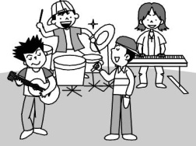 (Ｂ) 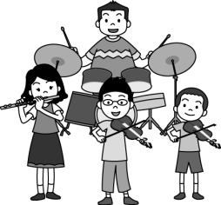 (Ｃ) 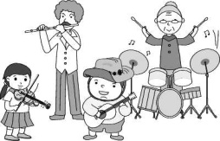
- (Ａ) 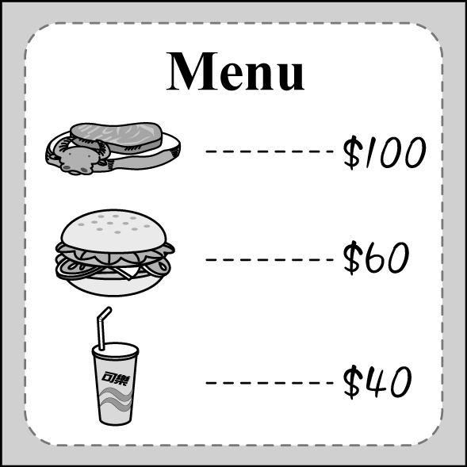 (Ｂ) 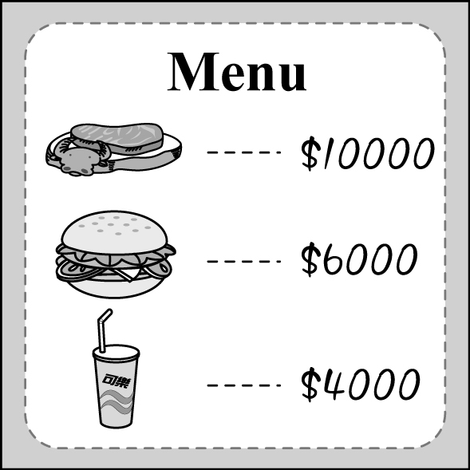 (Ｃ) 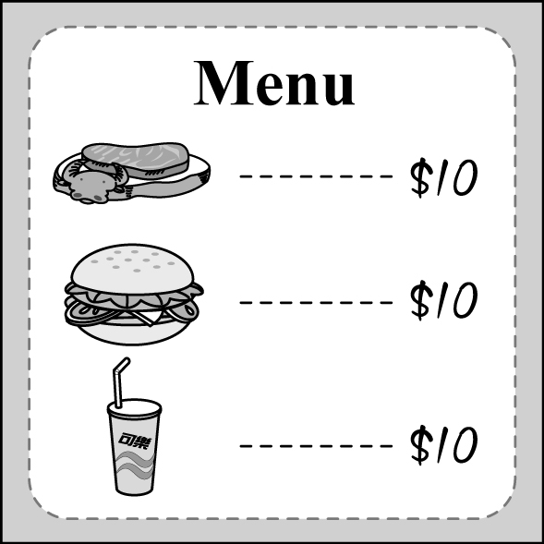
- (Ａ) 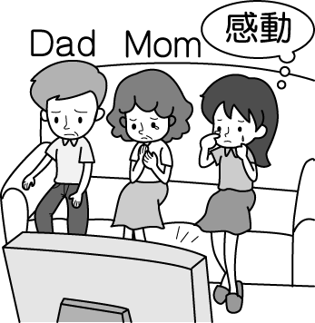 (Ｂ) 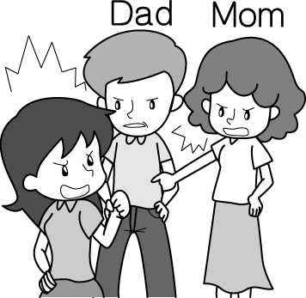 (Ｃ) 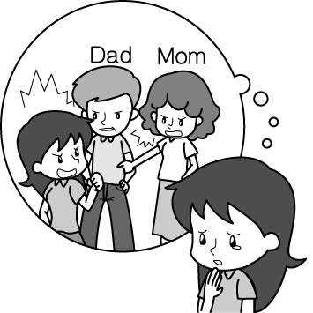
- (Ａ) 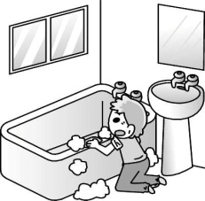 (Ｂ) 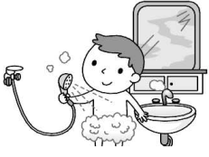 (Ｃ) 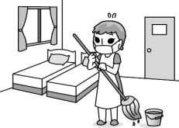
- (Ａ) 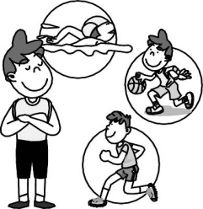 (Ｂ) 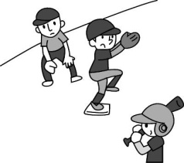 (Ｃ) 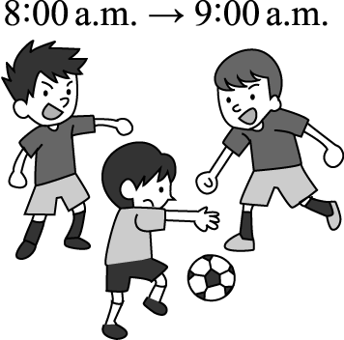

二、基本問答：根據聽到的內容，選出一個最適合的回應或最適合的問句。

6. (Ａ) Can I have the menu, please? (Ｂ) It sounds like a good idea. (Ｃ) Try it, and you’ll like it.

7. (Ａ) I didn’t like the movie at all.
(Ｂ) I went to the movie theater with Jerry.
(Ｃ) I didn’t go anywhere. I just went home.

8. (Ａ) Morning is the best time of the day.

(Ｂ) School plays an important part in my life.
(Ｃ) I enjoy sharing everything with my classmates.

9. (Ａ) He always checked the answers twice.

(Ｂ) Not very well. He failed it.
(Ｃ) He studied at the last minute.

10. (Ａ) That’s not a question. (Ｂ) By exercising regularly. (Ｃ) I finish all the science exercise.

三、言談理解：根據聽到的內容，選出一個最適合的答案。

11. (Ａ) She doesn’t eat beef. (Ｂ) She doesn’t eat soup. (Ｃ) She doesn’t eat Chinese food.

12. (Ａ) Enjoy delicious food. (Ｂ) Listen to great music. (Ｃ) Join a dancing contest.

13. (Ａ) No cellphone. (Ｂ) No food or drinks. (Ｃ) No pictures.

14. (Ａ) A computer game. (Ｂ) A short story. (Ｃ) A movie.

15. (Ａ) She can give the man a call.
(Ｂ) She can take it home and keep it.
(Ｃ) She should bring it back to the night market.
第二部分: 單題 40%
16. China Post is a _________ newspaper； its reports are fair and objective.
(A)medium (B)national (C)convenient (D)correct
17. Be careful when using a sharp ________.
(A)flute (B)straw (C)stage (D)knife
18. While all ____________ have their ups and downs, we will stay true through the end.
(A)princes (B)hearts (C)bows (D)friendships
19. All of the waiters and waitresses at the fast food restaurant wear smiles ________ greeting customers.
(A)before (B)after (C)if (D)when
20. A: Are you ready to ________,sir?
B: Yes, I'd like your today's special.
(A)menu (B)order (C)lead (D)pass
21. Two Islamic State bombers ran into Afghanistan's city Kabul on April 30. At least 29 people were killed
in the __________.
(A)attacks (B)gates (C)underground (D)soldiers
22. My little sister fell off from the bike and cried loudly. But she seemed more _______ than hurt.
(A)real (B)safe (C)scared (D)lovely
23. I've wanted to read The Lord of the Rings for months, __________ today I finally borrowed the novel from
the library.
(A)but (B)and (C)until (D)after
24. If you want to know the new word, you can ___________ in the dictionary or surf the Net.
(A)give it up (B)let it out (C)look it up (D)keep in touch
25. My mom is forgetful, she often _____________ the gas after cooking.
(A)remembered to turn on (B)forgets to turn off (C)remembered closing (D)forgets closing
26. Spring Scream, a music party held each year at the beach of Kenting, _________ the start of the summer.
(A)fails (B)understands (C)checks (D)marks
27. Richard _____ ten years ______ enough money to buy an apartment. He finally has his own place to live in.
(A)spent...to save (B)spent...saving (C)paid...to save (D)cost...saving
28. Several years ago, some of ____ on the farm got H5N3, and many of ____ had been made into salty chicken.
(A)chickens.....them (B)chickens.....it (C)the chickens.....them (D)the chicken.....it
29. At the end of the party, the birthday girl _____________________.
(A)asked someone to take a picture for her (B)asked someone take a picture of her
(C)asked someone taking a picture for herself (D)asked someone to take a picture of herself
30. If you listen to English CDs often, _________________.
(A)try to find the answers by yourself (B)this will help you prepare for tests more easily
(C)you should take the important notes in the book (D)your listening skills will get better and better
31. A: Someday I will win the lottery to buy a Lamborghini. B: Yeah..... and _______________.
(A)make your life a lemonade (B)a cat has nine lives
(C)pigs will fly (D)free as a bird
32. When ______________________, ______________________________________.
(A)Peter has free time, he went to the movies (B)Peter will come, he knows the truth
(C)he having breakfast, Peter saw a cat running into the kitchen (D)Peter feels happy, he will sing
33. Some of the band members played the violins, and ________________.
(A)the others sang songs with the music (B)others did not bring their drums and flutes
(C)both of them practiced until it was dark (D)all of them were tired of eating and talking
34. Which sentence is correct?
(A)Joe makes dinner by himself if his parents will not be home tomorrow.
(B)Listen to your own voice will help you memorize the vocabulary.
(C)Although it took James two hours to study history, he still didn't get a higher grade.
(D)All of my hands are full. Would you open the door for me?

35. Which sentence is wrong?
(A)Far away from Earth, there were a group of people living on Kepler 32, a beautiful planet.
(B)Do not wave your utensils during the meal. (C)Some of it are cheaper and useful.
(D)How many of your classmates voted for French food?

第三部分:題組 30%

A. 根據文章內容，選出最適當的答案
Tips for Taking Tests
1. Before you start, ____________ and plan your time.
2. _______________ before you answer them.
3. If you don't know the answer to a question, ________________. Answer the easy questions first.
4. Write clearly. The teachers will probably mark your answers wrong if they can't read them.
5. Check your answers ____________________.

36. | (A)make a shopping list clearly | (B)correct the mistakes carefully
 | (C)go over the test quickly | (D)look for the wrong answers
37. | (A)Write down your answer quickly | (B)Spend your time looking up new words
 | (C)Ask your classmates for help | (D) Read the questions carefully
38. | (A)come back to it later | (B)coming back to them later
 | (C)and come back to it later | (D)to come back to them later.
39. | (A)after you vote for it | (B)before you hand in your test
 | (C)although you read them again | (D)if you can use your time well

B. 根據下方Carol 和Victor上周六的行程，選出適當的回答

Carol |  | Victor
9:30 | do exercise in a gym | 8:30 | go jogging in the park
11:00 | do English exercises | 10:30 | study for the English test
13:30 | Buy some drinks | 13:00 | play basketball with Mike
15:30 | meet Victor at National Concert Hall | 15:30 | go to a concert with Carol
40. Before Victor prepared for the test, what did he do?
(A)He did exercise with Carol. (B)He visited Mike.
(C)He went jogging in the park. (D)He played basketball with Mike.
41. Where did Carol go first before she did English exercises?
(A)To a gym. (B)To a park. (C)To a concert hall. (D)To a supermarket.
42. Which is true about last Saturday?
(A)Carol bought something to drink before lunch. (B)Carol went to a gym after she did homework.
(C)It took Victor half an hour to go jogging. (D)Carol and Victor spent some time together last Saturday.

C.
"A car hit a man and his son. Someone saw it and took them to the hospital. The doctor looked at the boy and said, "I can't operate on this boy. Why?" This is a situation puzzle. Solving situation puzzles is a fun activity for a group of people to play together. First, there will be a host telling the players some parts of a short story. Then the players must try to get the whole picture of the story by asking the host questions. The host can only answer "yes" or "No." If the player's question doesn't have anything to do with the host's story, the host should answer "doesn't matter." The questions can go on until one of the players finds out the answer to the puzzle. Take the above for example. The questions may be:
- Q: Is the boy's father a doctor? A: No.
- Q: Is the man the boy's birth father ? A: Yes.
- Q: Does the boy have more than one father? A: No.
- Q: Is the doctor joking? A: No.
- Q: Does the boy have any brothers? A: Doesn't matter.
- Q: Does the doctor know the boy and the man? A: Yes.
- Q: Is the doctor a woman? A: Yes.
After several questions, there might be more than one possible answer to the puzzle. However, players need to try their best to get as close as possible to the host's. Solving situation puzzles may not be easy, but it sure is a good way to practice thinking in different ways.
43. What is the reading about?
(A)A game. (B)A story. (C)A puzzle. (D)A way of thinking.
44. According to the reading, which may be the most possible answer to the puzzle?
(A)The doctor is in fact the boy's mother. (B)The boy is not the doctor's son.
(C)The boy's father works in the hospital. (D)The doctor and the man don't know each other.
45.
Here is an easy situation puzzle. Read the puzzle and questions. What might be the answer to the puzzle?
Puzzle: A young girl at her mother's funeral, met a handsome guy she had never seen before. She fell for him right away. She forgot to take the number of the guy and now she can't find him. A few days later, she killed her older brother. Why?
- Q: Does the girl fall in love with the guy? A: Yes.
- Q: Is the guy a part of the family? A: No.
- Q: Is the girl's elder brother the guy's friend? A: Doesn't matter.
- Q: Does the girl's elder brother have the number of the young man? A: No.
funeral 葬禮
(A)The girl is the guy's best friend. (B)The girl hates her brother.
(C)The young man works at the funeral.
(D)The girl hopes that the young man would show up at the funeral again.

D.
A Food For Everything
Meals are the food for the body;
Knowledge is the food for the mind;
Meditation is the food for the spirit;
Music is the food for the love of heart;
Dreams are the food for the consciousness;
Prayer is the food for the Almighty;
Love is the food for the living heart;
Thoughts are the food for the brain;
Colorful ink is the food for the ________;
Ideas are the food for the stories;
Truth is the food for the will;
Sun’s energy is the food for the plants;
Plants are the food for the living beings;
But one man's food is another man's poison! by Ramesh T A
46. What does Almighty mean?
(A)Lord. (B)Evil. (C)Dragon. (D)Werewolf.
47. Which word may _________ be?
(A)corn (B)bun (C)kitten (D)pen

E.

The Incredibles comes back. Incredibles(2004) is about a family they just happen to have superpowers. Incredibles 2, a sequel to Incredibles, is shown in theaters this month. Both the films are written and directed by Brad Bird. In an interview in 2013, a Hollywood reporter asked Mr. Bird what the chances were for the fans to see another Incredbles. He said " I have been thinking about it. People think that I have not been,
but I have. Because I love those characters and love that world. I am stroking my chin and scratching my head. I have many elements that I think would really work well......... "
If you are new to this incredible crew, you will have to see the first movie because Incredibles 2 picks up right where it ended.

sequel續集 elements元素 character人物 scratch 抓癢

48. What do we know about Brad Bird from the reading?
(A) Brad Bird is Mr. Incredibles.
(B) Brad Bird is a Hollywood reporter.
(C) Brad Bird is not only a writer but also a director.
(D) Brad Bird is the man with superpowers.
49. What does it mean in the reading?
(A) stroking one's chin
(B) making a sequel
(C) seeing the first movie
(D) being a superhero
50. Why should you see Incredibles(2004) first before you see the latest Incredibles 2?
(A)Because the first one is better than the latest one.
(B)Because the two films were both written and directed by Brad Bird.
(C)Because the sequel will take place moments after Incredibles 2 ended.
(D)Because both of the two films talk about superpowers.

106-2-3 八年級 英語科－解答
- B | - B | - C | - A | - C
- B | - C | - C | - B | - B
- A | - C | - B | - C | - A
- B | - D | - D | - D | - B
- A | - C | - B | - C | - B
- D | - B | - C | - A | - D
- C | - D | - A | - C | - C
- C | - D | - A | - B | - C
- A | - D | - A | - A | - D
- A | - D | - C | - B | - C

新北市立溪崑國民中學106學年度第二學期第三次定期評量
八年級 英語科 聽力測驗稿()
第一部分:聽力測驗

一、辨識句意：根據聽到的內容，選出符合描述的圖片或符合圖片的描述。
- (Ａ) 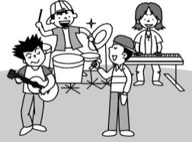(Ｂ) (Ｃ) 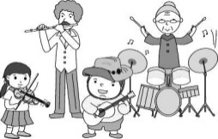
答案：(Ｂ)
解析：音軌：請參考 A4070438
錄音稿：Two of the men play the violin.
- (Ａ) (Ｂ) (Ｃ)
答案：(Ｂ)
解析：音軌：請參考 A4070443
錄音稿：Most of the food at the restaurant is expensive.
- (Ａ) (Ｂ) (Ｃ)
答案：(Ｃ)
解析：音軌：請參考 A4080506
錄音稿：The girl felt sad after she had a fight with her parents.
- (Ａ) (Ｂ) (Ｃ) 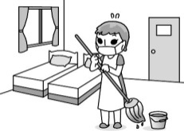
答案：(Ａ)
解析：音軌：請參考 A4080513
錄音稿：After you take a bath, please wash the bathroom for me.
- (Ａ) 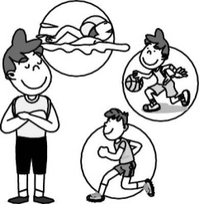(Ｂ) (Ｃ)
答案：(Ｃ)
解析：音軌：請參考 A4090572
錄音稿：The boys are practicing soccer.

二、基本問答：根據聽到的內容，選出一個最適合的回應或最適合的問句。

6. (Ａ) Can I have the menu, please.
(Ｂ) It sounds like a good idea.
(Ｃ) Try it, and you’ll like it.
答案：(Ｂ)
解析：音軌：請參考 A4070468
錄音稿：It’s very hot. Let’s have some watermelon juice.
7. (Ａ) I didn’t like the movie at all.
(Ｂ) I went to the movie theater with Jerry.
(Ｃ) I didn’t go anywhere. I just went home.
答案：(Ｃ)
解析：音軌：請參考 A4080524
錄音稿：Where did you go after you watched the movie?
8. (Ａ) Morning is the best time of the day.
(Ｂ) School plays an important part in my life.
(Ｃ) I enjoy sharing everything with my classmates.
答案：(Ｃ)
解析：音軌：請參考 A4080539
錄音稿：What’s the best part of your school life?
9. (Ａ) He always checked the answers twice.
(Ｂ) Not very well. He failed it.
(Ｃ) He studied at the last minute.
答案：(Ｂ)
解析：音軌：請參考 A4090604
錄音稿：How did Ryan do on the quiz?
10. (Ａ) That’s not a question.
(Ｂ) By exercising regularly.
(Ｃ) I finish all the science exercise.
答案：(Ｂ)
解析：音軌：請參考 A4090612
錄音稿：How do you become healthier and healthier?

三、言談理解：根據聽到的內容，選出一個最適合的答案。

11. (Ａ) She doesn’t eat beef.
(Ｂ) She doesn’t eat soup.
(Ｃ) She doesn’t eat Chinese food.
答案：(Ａ)
解析：音軌：請參考 A4070485
錄音稿：M: Would you like a bowl of beef soup?
W: No, thanks. I don’t eat beef.
Q: What doesn’t the woman eat?
12. (Ａ) Enjoy delicious food.
(Ｂ) Listen to great music.
(Ｃ) Join a dancing contest.
答案：(Ｃ)
解析：音軌：請參考 A4070495
錄音稿：W: Hi, everybody. It’s party time. Please help yourselves to the food and have fun. At 8 : 30, Louis Taylor, the most famous singer, will have a small concert here. At the end of the party, we’ll hold a guessing game.
Q: What won’t people do at the party?
13. (Ａ) No cellphone.
(Ｂ) No food or drinks.
(Ｃ) No pictures.
答案：(Ｂ)
解析：音軌：請參考 A4080549
錄音稿：M: Do you want to buy anything to eat or drink before the movie?
W: Yes, but please look at the sign there.
M: It is OK. Maybe we can finish that before the movie.
W: That is a good idea. But I just want some water.
Q: What does the sign say?
14. (Ａ) A computer game.
(Ｂ) A short story.
(Ｃ) A movie.
答案：(Ｃ)
解析：音軌：請參考 A4080565
錄音稿：M: In Oldypic, James Pond will help attack the bad guys, save the Earth, and give everyone an amazing experience. It will be on next Friday night. Watch it at the theater and have fun!
Q: What is “Oldypic”?
15. (Ａ) She can give the man a call.
(Ｂ) She can take it home and keep it.
(Ｃ) She should bring it back to the night market.
答案：(Ａ)
解析：音軌：請參考Review 3 A4120800
錄音稿：M: Please help! I lost my dog, Duncan. I lost it when I was buying snacks in DiDi Night Market. Here is the photo of Duncan. If you see it, please call me at 5486-1122. Duncan is my family. Please help take it home.
Q: Nina lives near DiDi Night Market. What can she do if she finds Duncan?

