新北市立溪崑國民中學106學年度第二學期第三次定期評量英語科 試題卷
七年級 班 座號 姓名
聽力測驗：本測驗共分成三部分，每題2分
一、辨識句意：每題均有三張圖片，請依據所聽到的句子，選出符合描述的圖片
1 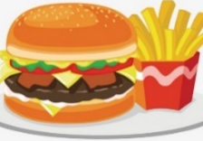 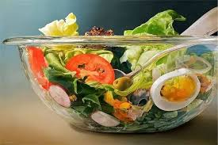 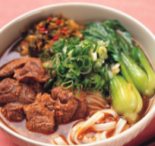 | 2 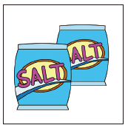 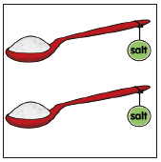 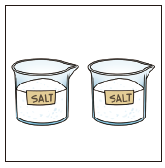
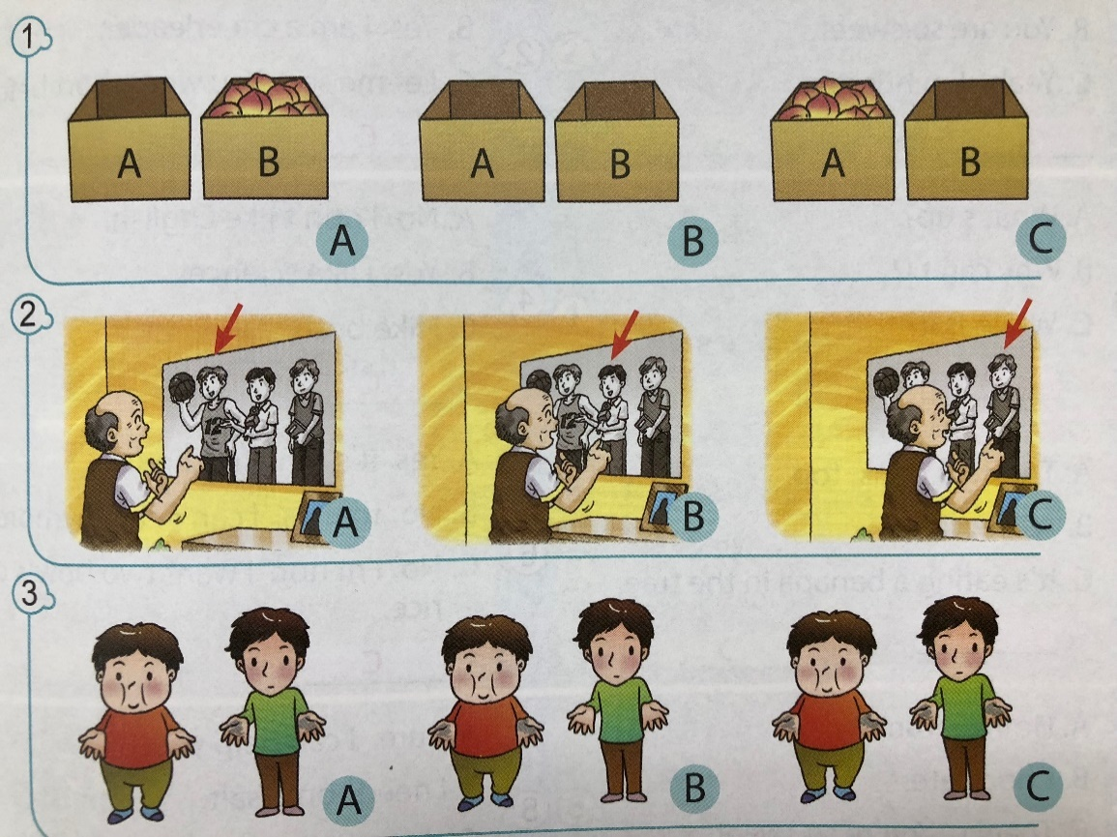
3 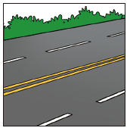 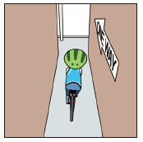 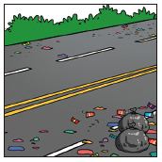 | 4 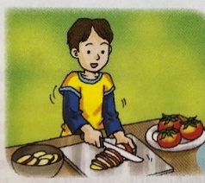 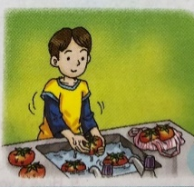 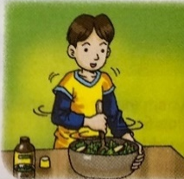
5 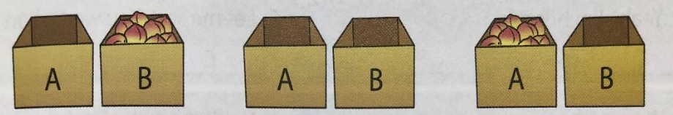
二、基本問答：每題均有三個選項，請依據所聽到的內容，選出一個最適合的回應
6. (A) Yes, we were in different classes. (B) Yes, we were in the same class. (C) Yes, I was your classmate.
7. (A) Yes, there are twelve. (B) No, there are only six. (C) There are twelve.
8. (A) 40 NT dollars. (B) Large is fine. (C) It’s too much for me.
9. (A) OK. See you at the school gate.
(B) I see. Let’s meet next door then.
(C) All right. You can go to the restroom then.
10. (A) Yogurt is fine. (B) How about pork? (C) Let’s get peaches.
三、言談理解：每題均有三個選項，請依據所聽到的對話與問題，選出一個最適合的答案
【特別注意】第11&12題，以及第13&14題是同一組對話內容，需連續作答！
11. (A) Every morning. (B) On weekdays. (C) On weekends.
12. (A) Every day. (B) Twice a week. (C) He never does.
13. (A) Mark. (B) Mark’s father. (C) The girl’s father.
14. (A) Tennis. (B) Baseball. (C) Basketball.
15. (A) Black tea. (B) Papaya milk. (C) Ice cream.
四、綜合測驗：
16. Many students eat junk food every day. It’s not good for them. They need a healthy .
(A) grade (B) room (C) diet (D) fruit
17. Jack: Is the pizza 399 dollars? Rose: No, it 399 dollars, but now it’s 499 dollars.
(A) is (B) was (C) were (D) does
18. The Lin family always eats on Chinese New Year’s Eve(除夕) every year to wish good luck.
(A) black tea (B) ice cream (C) salad (D) dumplings
19. Peter isn’t healthy. He learns some do’s and don’ts his doctor.
(A) at (B) from (C) on (D) to
20. Tom doesn’t eat junk food anymore. His family is happy that.
(A) on (B) about (C) to (D) at
21. Jack: Look! There are a lot of people in this restaurant. Rose: Yes.
(A) It’s next to the park. (B) I’m really full.
(C) I like both. (D) They come here for the delicious food.
22. Jack: How many do we need for green salad? Rose: At least three.
(A) yogurt (B) tomato (C) lettuce (D) tomatoes
23. Jack: Do you want to some milk to your tea? Rose: Yes, please.
(A) add (B) cut (C) bake (D) clean
24. I can’t eat the whole(全部的) cake. Just a small is enough for me.
(A) bottle (B) step (C) kilo (D) piece
25. My son can eat a lot. He often eats three of fried rice a meal.
(A) glasses (B) bags (C) bottles (D) plates
26. Jack: How much coffee there on the table? Rose: There two cups.
(A) is; are (B) is; is (C) are; are (D) are; is
27. Jack: Can you buy a hamburger after school? Rose: Sure.
Jack: And a cup of black coffee.
(A) Anything else? (B) How many? (C) How much? (D) What’s it for?
28. Meg: Let’s make Caesar salad for breakfast. John: Really? Can you make Caesar salad?
Meg: Don’t worry. This is a recipe(食譜) from my grandma. It’s not difficult.
(A) We don’t need anything. (B) Mix them together in the bowl.
(C) She can drink some cola. (D) Just follow the steps.
29. Jack: Do we have chocolate? Rose: Yes, we have .
(A) any; any (B) some; any (C) any; some (D) some; a few
30. My brother is playing the drums, and it’s too loud. I’m going to study in the with my classmates.
(A) playground (B) library (C) restroom (D) sports field
31. Rose: Who is that basketball player?
Jack: That’s Stephen Curry. I every basketball star’s name. Just ask me.
(A) forget (B) live (C) mix (D) remember
32. The is heavy on weekends. There are a lot of cars on the streets.
(A) building (B) traffic (C) store (D) team
33. The trash is in the classroom. Let’s clean it up.
(A) everything (B) everywhere (C) anything (D) nowhere
34. Jack: There were a lot of farms in Taipei before. It was quiet and simple.
Rose: Now, there are tall buildings and wide roads there.
(A) Everything is different. (B) How much are they?
(C) I can’t remember your name. (D) Just like before.
35. Sandy and I were good friends before; however, .
(A) we don’t talk anymore (B) she was very clean
(C) she lives next to me (D) she is also my classmate
36. My brother is good at soccer.
(A) He likes everything but sports. (B) This sport is too difficult for him.
(C) I play baseball with him every weekend. (D) He was the captain of his school team before.

五、克漏字選擇
37. (A) fruit (B) vegetables (C) meat (D) sports
Waiter: Welcome to XiKun Beverage Shop. We have fresh 37 today. Do you want some juice?
Anna: Sure. 38 flavor do you have?
Waiter: We have papaya milk, apple juice, and peach juice.
Anna: I want apple juice. What about you, Eason?
Eason: Well, let me think. 39
Waiter: 50 NT dollars.
Eason: It’s cheap! I want a glass of peach juice.
38. (A) Which (B) How (C) What (D) Who
39. (A) How often do you have fruit? (B) How much juice do you need?
(C) What day do you buy fruit? (D) How much is a glass of juice?
amazing 令人驚奇的 vitamin 維他命 example 例子 tired 疲倦的 sleepy 嗜睡的 will 將 tablet 錠劑
Amazing Vitamins are very good vitamins. Let me give you some good examples. Mr. and Mrs. Chen
40 always sick before, but now they aren’t. Ms. Brown was often tired, but now she 41 . She can do many things in a day and doesn’t feel tired and sleepy. Mr. Yeh 42 sad, but now he feels happy all the time and always puts on smiles. Mr. Huang’s son was very weak before, but now he is strong.
Why not try some Amazing Vitamins now? You will feel how amazing they are after you try them for a few days. They are very good for you and your family. Take one tablet 43 , and you can 44 healthy and happy every day.
40. (A) are (B) is (C) was (D) were
41. (A) is (B) wasn’t (C) was (D) isn’t
42. (A) is often (B) was often (C) is never (D) was never
43. (A) twice a day (B) anymore (C) last January (D) one year ago
44. (A) do (B) make (C) be (D) have
六、閱讀測驗
Simon’s Guinea Pig
Where? Where? Where? Where’s Simon’s guinea pig?
It was on Simon’s desk three hours ago.
But it’s not there now.
Where? Where? Where? Where’s Simon’s guinea pig?
It was under Simon’s bed two hours ago.
But there’s nothing under his bed now.
Where? Where? Where? Where’s Simon’s guinea pig?
It was in Simon’s bag one hour ago.
With Simon’s notebooks and his red pencil case there.
Where? Where? Where? Where’s Simon’s guinea pig?
Open the big box and look inside.
Here it is. Right next to the basketball.

45. What was there in Simon’s bag an hour ago?
(A) Notebooks and a basketball. (B) A guinea pig, notebooks, and a red pencil case.
(C) A guinea pig, notebooks, and a big box. (D) A guinea pig, a red pencil case, and a basketball.
46. Where is Simon’s guinea pig?
(A) Right next to the baseball. (B) Under the bed.
(C) On the desk. (D) In the big box.

bright 明亮的
the rest 其餘的(對象)
brightness 明亮度

all the others 所有其餘的(對象)
move around 繞著轉
roam 漫遊

yet 然而
still 靜止不動的
Little Dipper
Little Dipper in the sky,
Little Dipper, please don’t cry.
Not as bright as all the rest?
Brightness doesn’t make them best.
All the others move around,
Always on the roam.
You stay right there in the north
And point the way back home.
Little Dipper in the sky,
Little Dipper, please don’t cry.
Small you are…yet still you stay,
And that is how I find my way.

47. What can Little Dipper be?
(A) The sun. (B) The moon. (C) The light.(燈光) (D) The stars.
48. What can we learn from the poem (詩) ?
(A) Little Dipper often cries because(因為) it’s small.
(B) By Little Dipper, we can learn where the north is.
(C) Little Dipper is the brightest(最明亮的) in the sky.
(D) Little Dipper moves around like all the others.
Lunch Specials at the
Tuesday
．Chicken Salad
．Beef Noodles
．Pearl Milk Tea
Monday
．Tomato Soup
．Fried Dumplings
．Chocolate Cake
Wednesday
．Green Salad
．Baked Potato with Cheese
．Coffee Cake

Saturday
．Miso Soup (味噌湯)
．Japanese Curry (咖哩) Rice
．Green Tea Ice Cream
Friday
．Fried Egg
．Fish Burger
．Cola
Thursday
．Pumpkin Soup
．Ham Sandwich(三明治)
．Brown Sugar Cake

49. Louisa doesn’t eat any meat. She wants to enjoy a lunch special at
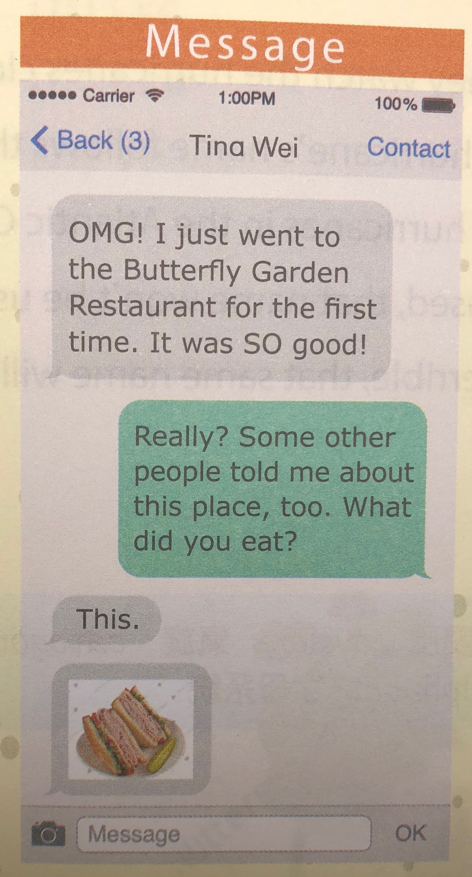

the Yummy Kitchen. What day should she visit the restaurant?
(A) Tuesday. (B) Wednesday.
OMG! I just went to the Yummy Kitchen for the first time. It was SO good!
(C) Friday. (D) Saturday.
50. Look at the Message on the right. What day did Tina eat lunch
at the Yummy Kitchen?
Really? Some other people told me about this place, too. What did you eat?
(A) Thursday. (B) Wednesday.
(C) Friday. (D) Saturday.
message 訊息 went go的過去式(去)
other 其他的 told tell的過去式(告訴)
did do 的過去式
This.
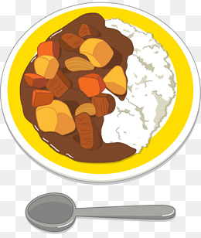

106-2-3 七年級 英語科－解答
1-5 CBACA 6-10 BCAAB 11-15 CCBAC
16-20 CBDBB 21-25 DDADD 26-30 AADCB
31-36 DBBAA D

37-39 ACD
40-44 DDBAC
45-46 BD 47-48 DB 49-50 BD

新北市立溪崑國民中學106學年度第二學期第三次段考
七年級 英語科 聽力測驗。本測驗共分成三部分，每題會重複兩次。
聽力測驗開始
一、辨識句意：每題均有三張圖片，請依據所聽到的句子，選出符合描述的圖片
1. My sister wants some beef noodles. C
2. We need two spoons of salt. B
3. The street isn’t dirty. It’s wide and clean. A
4. Tom is mixing some fruit and vegetables together in the bowl. C
5. Box B is full. However, there isn’t anything in Box A. A
二、基本問答：每題均有三個選項，請依據所聽到的內容，選出一個最適合的回應
6. Were you and Ted classmates before? B
7. How many cans of cola are there in the box? C
8. B: Which do you want, milk or juice? G: Juice, please. How much is it? A
9. Let’s meet in front of the school at 5:00 p.m. A
10. B: Let’s make dumplings for dinner today.
G: OK. What meat do you want in the dumplings? B
三、言談理解：每題均有三個選項，請依據所聽到的對話與問題，選出一個最適合的答案。請特別注意第11題和第12題是同一組對話內容，以及第13題和第14題也是如此。
11 & 12.
Boy: Where were you this morning?
Girl: I was in the library.
Boy: How often do you go there?
Girl: I go there on weekends. Do you often study in the library, too?
Boy: No, I never do. I have my own room, and I always study at home.
Girl: I see.
Q11: When does the girl go to the library? (8 sec) C
Q12: How often does the boy study in the library? (8 sec) C

13 & 14.
Girl: Mark’s father was a basketball player before.
Girl’s father: I know. We were on the same team.
Girl: Really? That’s cool!
Girl’s father: We were both star players. He was our captain.
Girl: How about Mom? Was she good at sports, too?
Girl’s father: Yes, she was a good tennis player.
Q13: Who was the captain of a basketball team before? (8 sec) B
Q14: What sport was the girl’s mother good at before? (8 sec) A
15.
Girl: Can we have some ice cream after lunch, Dad?
Girl’s father: OK. We can have some ice cream next door.
Girl: Dad, can I have black tea or papaya milk?
Girl’s father: No, you can’t. Eat your rice, fish, and vegetables now.
Girl: All right.
Q15: What can the girl have after lunch? (8 sec) C
聽力測驗結束

