新北市立溪崑國民中學106學年度第二學期第二次定期評量英語科 試題卷
九年級 班 座號 姓名
一、 聽力測驗 30%
A 辨識句意：根據聽到的內容，選出符合描述的圖片或符合圖片的描述。
- (Ａ) 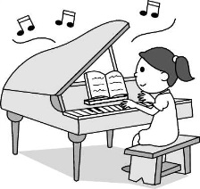 (Ｂ)  (Ｃ) 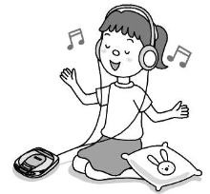
- (Ａ) 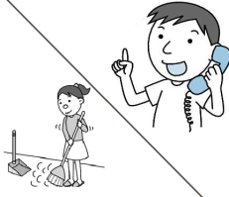 (Ｂ) 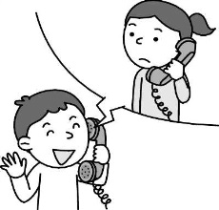 (Ｃ) 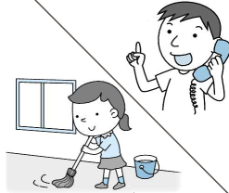
- (Ａ) 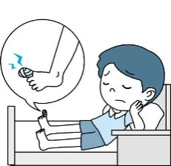 (Ｂ) 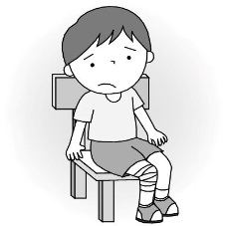 (Ｃ) 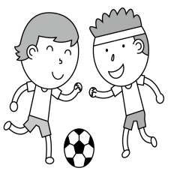
- (Ａ) 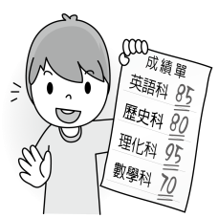 (Ｂ) 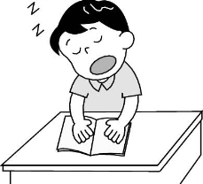 (Ｃ) 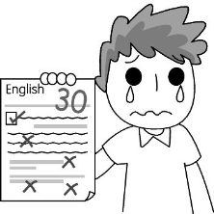
- (Ａ) 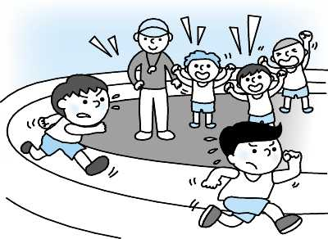 (Ｂ) 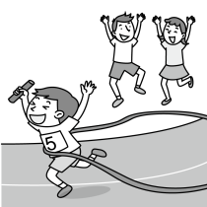 (Ｃ) 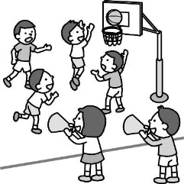
B 基本問答: 根據聽到的內容，選出一個最適合的回應或最適合的問句。
- (A) Oh, sorry, Mom. I won’t do that again.
(B) Doing trick-or- treating is interesting.
(C) You’re right. Let’s tell Andy to be a good boy.
- (A) I hope that you can listen to the song carefully.
(B) I don’t like to tell stories to strangers.
(C) Wow! I’m really glad the story I told interests you. Listen carefully!
- (A) Yes, her oldest son is four years old.
(B) Yes, time flies. Jessica has been a mother for three years.
(C) Yes, Jessica just celebrated her twenty-third birthday.
- (A) We talked all night.
(B) We liked the stars in the sky.
(C) We were cute and smart girls.
- (A) She’s a cheerleader.
(B) We led the students to the classroom.
(C) My class leader did.
C 言談理解：根據聽到的內容，選出一個最適合的答案。
- (A) The man is an engineer of Facebook.
(B) The woman is a Facebook user.
(C) The woman wants to have a Facebook account.
- (A) The records of the world.
(B) The cold season in Japan and the USA.
(C) The winter activities.
- (A) The boy spends more time having fun than studying.
(B) The girl thinks that the boy is an interesting person.
(C) The boy spends more than 10 hours a day studying.
- (A) We need to know more about sharks.
(B) Sharks are the most terrible animals on Earth.
(C) Sharks kill a large numbers of people every year.
- (A) To plan to meet someone.
(B) To find something by chance.
(C) To get something special.
二、綜合測驗 70%
- My younger brother is too short to _______ the apple on the table.
(A) expect (B) attack (C) beat (D) reach
- Six months later we heard, to our great ______, that he died.
(A) sorrow (B) accident (C) package (D) imagine
- Harry helped me a lot. I really want to thank him from the _______ of my heart.
(A) above (B) below (C) bottom (D) behind
- Remember to ______ the lights when you leave the room.
(A) turn on (B) pass on (C) turn off (D) take off
- Ada ________ several dresses at the store, but she didn’t buy any of them.
(A) gave away (B) got on (C) tried on (D) gave up
- Lily ________ to the USA several times before I talked to her.
(A) has gone (B) has been (C) had been (D) had gone
- I’m wondering whether he ______ to my birthday party next Saturday, but whether he _____ or not, I’m sure
everyone at the party will have a whale of time.
(A) comes; will come (B) will come; comes (C) comes; comes (D) will come; will come
- Jeremy is 190 centimeters tall. He is taller than _______ in his school.
(A) any student (B) all the student (C) all the other student (D) any other student
- It’s wonderful to imagine _____ to have a long summer vacation like students.
(A) what it is (B) what it feels like (C) how it would be like (D) how beautiful is it
- Lisa : _______ a basketball game on Saturday in our school?
David: No, I don’t think so. It’s been raining through the week.
(A) Will there have (B) Will there be (C) Is there going to have (D) Be there have
- We haven’t heard anything from Diane ______ she moved to Yilan.
(A) if (B) since (C) until (D) when
- Grand hotel is ____ place to see the beautiful beach. I can’t think of a _____ view than this.
(A) the best ; better (B) better ; better (C) better ; the best (D) the best ; the best
- It’s raining _____ outside. Bring a raincoat with you when you go out.
(A) hardly (B) heavily (C) heavy (D) badly
- He was asked _____ the meeting as soon as possible.
(A) hold (B) held (C) holding (D) to hold
- Sorry, you have the wrong number. There isn’t anyone ____ Vivian here.
(A) who calls (B) calling (C) that is called (D) calls
- Jack is a _____ swimmer than his sisters. He swims ______ of the three.
(A) slowly ; the most slowly (B) slow ; the slowiest
(C) slower ; the most slowly (D) the more slowly ; the slowest
- Which is correct?
(A) There used to be more rain in Keelung in winter.
(B) There used to have a lot of rain in Taipei in spring.
(C) We are used to being rainy in this season every year.
(D) It used to have a lot of rain here every summer.
- Which is correct ?
(A) I went to the bookstore where sold many kinds of books.
(B) The office where my father works is not only big but also comfortable.
(C) The department store where we used to visit has become more and more popular.
(D) I really want to stay in a hotel where has a beautiful view.
- Which is correct ?
(A) I have fried rice every day, and so has my brother.
(B) Mom had a bad cold last week, and I had, too.
(C) Gary seldom exercised when he was in America, and neither did I.
(D) Adam had had dinner before I arrived home, and so did Nick.
- 將”that”填入最適當的空格中。
(i) The fact is_____ he doesn’t have enough money to buy the house.
(ii) One day, I will travel to New York, ______ is the biggest city in the world.
(iii) _______ Susan is going to move out is ______ my father told me.
(iv) Some people believe _____ the number four is thought to bring bad luck.
(A) (B) (C) (D)
- 找出下列答案中，共有幾個”what” 和”how”。(大小寫皆算)
(i) _______ delicious food he cooks! He is _____ a great cook!
(ii) _______ beautifully she dances! _____ a dancer!
(iii) Your way of doing it is fine, but that’s not ____ we do it.
(iv) _____ great it will be to have a cup of hot tea on ______ cold a day.
(A) what : 2 / how : 3 (B) what : 3 / how : 2 (C) what : 2 / how : 2 (D) what : 2 / how : 4

The lion was dying, so there were (37) animals coming to pay him the last visit. First, a hen walked into his den. Then, a sheep passed by. “ Mr. Lion, I can hear you (38) from miles away. Are you OK?” said the sheep. “No. I think I (39) any second. It feels that something is stuck at the base of my throat,” said the lion. The sheep went into the lion’s den after (40) to the lion. The hen and the sheep never came out of the den. It is said that the lion has eaten them up just like that.
- (A) more and more (B) much a lot (C) very more (D) a little much
- (A) have coughed (B) coughed (C) cough (D) coughs
- (A) should die (B) might die (C) die (D) to die
- (A) to talk (B) talking (C) talks (D) talked
Twin Power is a team like no other. One of the team is Chloe, and (41) is Christy. Both of them together will take care of all your household needs. They can be counted on to take our garbage, pick up food from the market, put things away, and even look after children. They have also been known to put out a fire. They do it all, so you don’t have to worry about not having enough time to do the things you care about.
(42) , and the others are common working people. Each of them loves the work Twin Power has done for them. It’s time to stop putting off your life. (43) Call Twin Power now!
household 家用的 count on 指望

- (A) the another (B) the other (C) some other (D) the others
- (A) All of their friends like them (B) Everybody is doing their part
(C) Most of their workers are full of energy (D) Some of their bosses are rich and famous
- (A) What are you waiting for ? (B) Why aren’t you taking down notes ?
(C) When are you going to give it back ? (D) Who knew they were running after you ?

It’s true that many dads in the wild aren’t interested in taking care of their children, but there are some that work really hard to give their little ones a good start. Maybe one of these dads will remind you of your own dad!
The male giant water bug doesn’t seem to mind having a heavy load of his kids on the back. The female water bug puts about 100 to 150 eggs onto the back of the male and leaves. Then the male has to look after the eggs. It usually takes one to two weeks for the eggs to hatch. The father jumps around to let air flow over the eggs, and he makes sure they get enough water. During the time, he can’t fly because of the weight of the eggs on his back.
Now let’s see what a male stickleback fish does for his kids. The male stickleback fish builds a nest on the bottom of the river for the female to lay eggs inside. After laying her eggs, the female will leave, leaving the male to watch over his young. If the young fish go too far from the nest, their father returns them to safety by carrying them back in his mouth. The male stickleback looks after all his young-as many as 100-until they can live on their own.
A similar example can be found in emperor penguins, which live in Antarctica. Female emperor penguins can’t blame their husband for being too fat! The male emperor penguin needs the fat because he can’t feed himself while looking after the eggs. For about 62 to 67 days, the male emperor penguin stands still and keeps the egg on top of his feet in temperatures that can drop to -40°C. Therefore, the male emperor penguin may lose nearly 50 % of his body weight while waiting for the egg to hatch!

remind 提醒 load 負載 hatch 孵化 stickleback 棘魚 return 將….放回原處
similar 相似的 emperor penguin 國王企鵝 Antarctica 南極洲 blame 責怪 temperature 溫度

- What is the best title for the reading ? title 標題 emotion 情感 childbirth 生產
(A) Animals Have Emotions, Too (B) Mr. Moms in the Wild
(C) Natural Loves Us like Our Dad (D) Childbirth in the Animal World
- From the reading, which is NOT true about the giant water bug? expose 暴露
(A) The male jumps around to expose his eggs to air.
(B) The female takes care of her eggs together with the male.
(C) The giant water bug’s eggs grow on the father’s back.
(D) The male is able to fly if he doesn’t carry any eggs on his back.
- What can be guessed about male emperor penguins?
(A) They are blamed by their wives for being fat.
(B) They go on a diet to lose weight before looking after their eggs.
(C) They are sometimes fed by female penguins.
(D) They can live without eating anything for more than 60 days.

Samuel L. Clemens, popularly known as Mark Twain, is considered by many people to be one of the greatest writers in American history. He was born in Florida, USA in 1835, and was the sixth of seven children in his family. When Twain was only 11, his father passed away. To help his family, he started to work and wrote short stories for a newspaper. Twain also continued his studies by reading hundreds of books in public libraries every evening. After several years of hard work, Twain became a steamboat pilot and got a chance to travel along the great Mississippi river. He saw many interesting things in his trips and used these experiences to write short and funny stories. Mark Twain’s writings became very popular because his style was very different from other writers at that time. Most other writers had a serious style which Mark Twain didn’t like. Twain often wrote stories that gave readers a happy feeling. Today, Mark Twain is still famous all over the world for his wonderful stories. One of his most famous stories is the Adventures of Huckleberry Finn.
consider 認為 pass away 逝世 steamboat pilot 汽船領航員

- What would be the best title (標題) for the reading?
(A) The History of Funny Stories (B) The Life of Samuel Clemens
(C) The Great Writers in the World (D) Mark Twain and His Family
- According to (根據)the reading, which is true about many of Mark Twain’s stories.
(A) They were like the stories of other writers.
(B) They were mostly sad but touched many people.
(C) They didn’t become popular until he passed away.
(D) They were written from Twain’s experiences on the Mississippi River.
- What does the work “ studies” in the article mean?
(A) Students. (B) Libraries. (C) Education. (教育) (D) History.
- According to the reading, which is true?
(A) Mark Twain had to work at a young age.
(B) Mark Twain did not have any brothers or sisters.
(C) Mark Twain learned everything about writing from school.
(D) Mark Twain’s father was very proud of him when he became a writer.

106-2-2 九年級 英語科－解答
1 | 2 | 3 | 4 | 5 | 6 | 7 | 8 | 9 | 10
B | C | A | C | B | A | C | B | A | C
11 | 12 | 13 | 14 | 15 | 16 | 17 | 18 | 19 | 20
C | B | C | A | B | D | A | C | C | C
21 | 22 | 23 | 24 | 25 | 26 | 27 | 28 | 29 | 30
C | B | D | B | B | B | A | B | D | C
31 | 32 | 33 | 34 | 35 | 36 | 37 | 38 | 39 | 40
C | A | B | C | D | A | A | C | B | B
41 | 42 | 43 | 44 | 45 | 46 | 47 | 48 | 49 | 50
B | D | A | B | B | D | B | D | C | A

新北市立溪崑國民中學106學年度第二學期第二次定期評量
九年級 英語科 聽力測驗稿()
一、 聽力測驗
A 辨識句意：根據聽到的內容，選出符合描述的圖片或符合圖片的描述。
- Belle is listening to music on the radio.
- Dora was mopping the floor when John called her.
- The boy hurt his toe when he was kicking the ball.
- He studied for the test all night, but he still got a low grade.
- When Ted got to the finish line, everyone cheered for him.

B 基本問答：根據聽到的內容，選出一個最適合的回應或最適合的問句。
- Andy, I don’t like a boy who often plays tricks on others.
- Please tell me the interesting story you told me yesterday again, Mom.
- Do you know Jessica gave birth to her oldest son three years ago.
- What did you girls end up doing after I left last night?
- Who made you collect the test papers for the class?
C 言談理解：根據聽到的內容，選出一個最適合的答案。
- W: Can you show me how to set up a Facebook account?
M: Sure. I’m glad to help you.
Q: Which is true?
- M: Another cold day!
W: It must be the coldest winter in the world in the past ten years.
M: According to the weather forecast, It snows a lot in Japan and in the USA.
Q: What are they talking about?
- G: How many hours do you study a day?
B: Twelve hours.
G: What do you do in your free time?
B: Only sleep and tea.
G: You should spend less time studying and more time having fun. Studying all day makes you a boring person.
Q: Which is true?
- People have long believed that sharks are one of most dangerous animals in the world and that they are scary killers in the sea. In fact, every year, no more than ten human beings in the entire world are attacked and die. Sharks are never as terrible as we think.
Q : What might the main purpose of the speaker’s talk?
- M: Lucy said you came across somebody’s wallet in the classroom.
W: Yes. I found it under my chair.
Q: What does came across mean ?

