新北市立溪崑國民中學106學年度第二學期第二次定期評量英語科 試題卷
八年級 班 座號 姓名
第一部分: 聽力測驗 30%

一、辨識句意：根據聽到的內容，選出符合描述的圖片。
( )1. | (Ａ) | 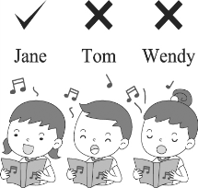 | (Ｂ) | 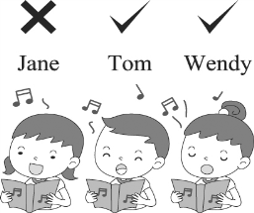 | (Ｃ) | 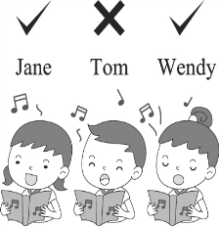
( )2. | (Ａ) | 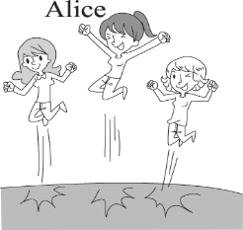 | (Ｂ) | 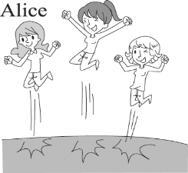 | (Ｃ) | 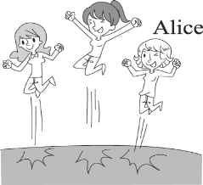
( )3. | (Ａ) | 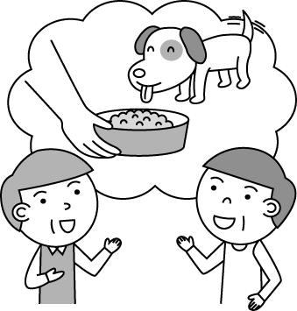 | (Ｂ) | 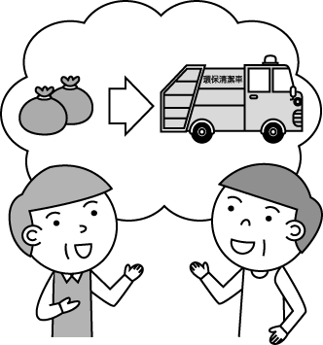 | (Ｃ) | 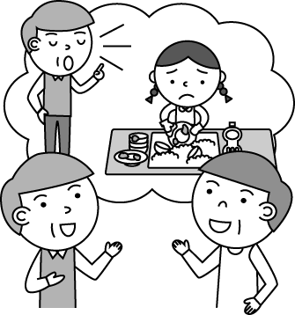
( )4. | (Ａ) | 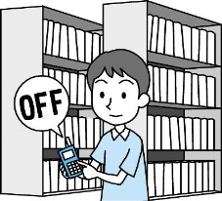 | (Ｂ) | 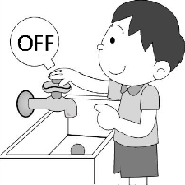 | (Ｃ) | 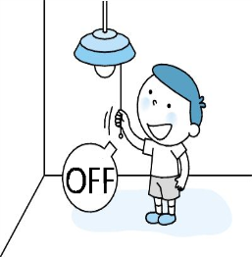
( )5. | (Ａ) | 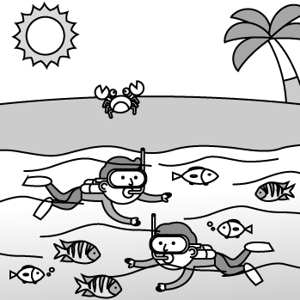 | (Ｂ) | 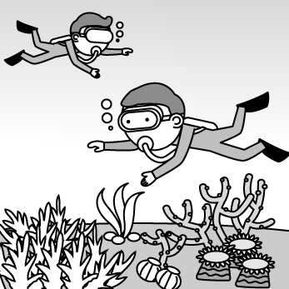 | (Ｃ) | 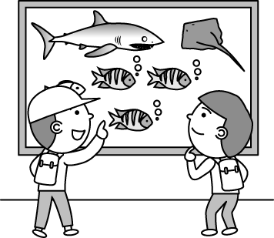

二、基本問答：根據聽到的內容，選出一個最適合的回應。
( )6. (Ａ) I can take your place.
(Ｂ) I couldn’t agree with you more.
(Ｃ) I can do that right away.
( )7. (Ａ) Oh, you got hurt badly.
(Ｂ) He dropped the baton during the relay race.
(Ｃ) Look! Now it’s Jack’s run. He’s running faster than others.
( )8. (Ａ) She made up the story by herself.
(Ｂ) She made him wash hands before the meal.
(Ｃ) She made up her mind to help the earth.
( )9. (Ａ) I will make it a habit.
(Ｂ) I must take action now.
(Ｃ) I see. I will keep this in mind.
( )10. (Ａ) How about seven thirty?
(Ｂ) It will be at twelve forty.
(Ｃ) It’s convenient for me to help Jack now.
- 言談理解：根據聽到的內容，選出一個最適合的答案。
( )11. (Ａ) Don’t spend much time practicing the relay race.
(Ｂ) We should always be the number one.
(Ｃ) Winning is not everything
( )12. (Ａ) She promised to teach people.
(Ｂ) She promised to keep the earth healthy and beautiful.
(Ｃ) She promised to do the 3Rs.
( )13. (Ａ) She let her mother play computer games.
(Ｂ) She practiced English for two hours today.
(Ｃ) She found taking action was more important than making a promise.
( )14. (Ａ) People can take a hot spring bath in it.
(Ｂ) People can swim happily in it.
(Ｃ) People can boil eggs in it.
( )15. (Ａ) Jacky had a lot of fun on Green Island.
(Ｂ) Jacky was not lucky during his vacation.
(Ｃ) Jacky saw a lot of sea animals swimming underwater.
第二部分: 綜合測驗 18%
( )16. At first, the rabbit ran faster than the turtle, but who won the race ?
- already (B) in the end (C) in fact (D) however
( )17. The earth is a beautiful planet. We should take to save it.
- word (B) land (C) garbage (D) action
( )18. When I was a kid, I liked to listen to my grandma a story.
- tell (B) to tell (C) told (D) say
( )19. A: We are taking a trip to Green Island this weekend.
B: .
- Enjoy yourselves (B) Keep your word (C) Do your best (D) I guess so
( )20. The woman looks very much like Tina. She her mom.
- maybe (B) must be (C) has to be (D) should
( )21. Which sentence is wrong?
- Tim always helps his mom do housework.
- My sister made me mop the floor.
- Our teacher asked us not talk in class.
- Must I come home before ten ?
( )22. A:Did you Stella at the party? B:Yes, it was really wonderful.
(A) watch ; danced (B) have ; to sing (C) ask ; singing (D) hear ; sing
( )23. Which sentence is right?
- We can feel the cool wind blowing all the way. (B) Will he able to come tomorrow?.
(C) Please help yourself of the food. (D) Ray saw many people flew kites over there.
( )24.Being in the water on a hot summer day him very happy.
- enjoyed (B) got (C) took (D) made
第三部分: 克漏字選擇12%
My stomach (25) very much yesterday because I did badly on my math test again. I tried very hard for it but just couldn’t do it better. My teacher, Mrs. Li looked at me (26) for my poor grades and told me (27) my time more wisely .When I came home, Mom looked (28) because Mrs.Li called her. I promised Mom (29) it a habit of studying every day and be responsible for (30) .
responsible負責的
( )25. (A) got hurt (B) cut (C) hurt (D) ached
( )26. (A) colder (B) was cold (C) cold (D) coldly
( )27. (A) to use (B) use (C) using (D) used
( )28. (A) angrily (B) angry (C) happily (D) happy
( )29. (A) made (B) making (C) make (D) to make
( )30.(A) herself (B) myself (C) yourself (D) themselves
第四部份: 閱讀測驗10%
(1)
Yesterday was Earth Day. Our teacher shared a website with us and introduced a new movie”Earth: One Amazing Day”to us.
If we join hands together, we can make a better world! Here is the website:

Earth Day 2018: (31)
Countdown to April 22
From poisoning and injuring marine life to disrupting human hormones, from littering our beaches and landscapes to clogging our waste streams and landfills, the exponential growth of plastics is now threatening the survival of our planet.
In response, Earth Day 2018 is dedicated to providing the information and
inspiration needed to fundamentally change human attitude and behavior about plastics.
Choose an option below to take action to End Plastic Pollution on Earth Day and beyond!
Are you an individual?
Learn and act to End Plastic Pollution for yourself and your close communities.
Get Started ↙click here
Are you an organization?
Learn and act to End Plastic Pollution and organize for Earth Day and beyond.
Get Started ↙click here
Are you an educator?
Use our resources to teach and help others organize to End Plastic Pollution in your school or university.
Get Started ↙click here

( )31. What’s the best answer for question 31?
(A) Books About Our Earth.
(B) End Plastic Polution .
(C) End Air Polution.
( )32. What is threatening in the reading?
- doing good to (B) giving hopes to (C) hurting

(2)
A doctor planned to take a trip to the south with his wife.The doctor had to give a speech in a college, so he went first. After he checked in the hotel, he sent an e-mail to his wife. However, he didn’t notice that he sent the e-mail to an old woman who just returned home from her husband’s funeral. When the woman opened the e-mail, she shouted loudly and then passed out. Here is the e-mail she read:
My dear wife,
I have checked in and prepared everythig you will need down here.But , it is so cold. When you come, remember to bring the clothes that can keep us warm. Thanks to the Internet, I can even send e-mails from here easily.
Your husband funeral 葬禮 pass out 昏倒

( )33. Why did the old woman shout loudly?
(A) She thought her dead husband sent her the e-mail.
(B) Her husband returned home.
(C) She was shocked that her husband was dead.
( )34. What is true about the doctor?
(A) He wrote an e-mail to the hotel.
(B) He went to the hotel by himself first.
(C) He sent the e-mail to a correct person.
(3)

Toilet Paper Panic
How to make people panic right away? If you paid attention to the news or shopped at a supermarket, you may just come up with what the title means .
The rumor said that the price of the toilet paper will rise soon. The day after the news, people ran to markets and tried to keep some at home before it was too late. Not before long, people started to share pictures of empty shelves where the toilet paper were. Some even began to line up in front of the empty shelves and waited to buy more toilet paper. Of course, some people started to make fun of this interesting scene. They think it’s not worthy to spend so much time on buying toilet paper. After all, nothing is more valuable than time.
Maybe we couldn’t stop the price of the toilet paper from going up one day, but at least,we could do something to prevent it from getting worse.
panic 恐慌 rumor 謊言 valuable珍貴的

( )35. Which is true about the article?
(A) The day before the news, people ran to markets to keep some toilet paper at home.
(B) No one shared photos of empty shelves of the toilet paper.
(C) Not all the people will try to buy as much toilet paper as they can.

第五部分:非選擇題30%(✽以下答案請寫在答案卷上✽)
- 依提示回答6%
1. Jay was a more terrible singer than Justin.(用副詞改寫句子)
2. She mopped the floor yesterday.(用 Mom had….改寫)
3. I saw the children in the classroom. The children were playing the guitar.(請合併成一個句子)
(二)整句翻譯24%(每句4分)
1.每個人為了這周五的接力賽跑努力地練習。
2.我們已經是他心目中第一名的團隊。我非常同意他的看法。
3.使用我們自己的購物袋幫助減少垃圾量。
4.少開車,並且試著搭公車或捷運。
5.他看到了一些海龜,甚至是一條海蛇正躲在岩石中。
6.他們泡溫泉並同時欣賞日出。

------試題結束-----

新北市立溪崑國民中學106學年度第二學期第二次定期評量 英語科 答案卷
八年級 班 座號 姓名
第五部分:非選擇題30% (✽以下答案請寫在答案卷上✽)
(一)依提示回答6%
1、
2、
3、
(二) 整句翻譯24%
1、

2、

3、

4、

5、

6、

106-2-2 八年級 英語科－解答
第一部分: 聽力測驗 30%
1~5 AABCA
6~10 BCBCA
11~15 CBABB

第二部分:綜合測驗 18%
16~20 BDAAB
21~24 CDAD

第三部分:克漏字選擇12%
25~30 CDABDB

第四部份:閱讀測驗10%
31~35 BCABC

第五部分:非選擇題30%(✽以下答案請寫在答案卷上✽)
- 依提示回答6%
- Jay sang more terribly than Justin.
- Mom had her mop the floor yesterday.
- I saw the childred playing the guitar in the classroom.
- 整句翻譯24%(每句4分)
1.Everyone practiced hard for the relay race this Friday.
2.We are already the number one team to him. I couldn’t agree with him more.
3.Using our own shopping bags helps reduce trash.
4.Drive less often, and try to take a(the) bus or the(an) MRT.
5.He saw some sea turtles ,and even a sea snake hiding in the rock(s).
6.They soaked in the hot spring and watched the sun rise at the same time.

新北市立溪崑國民中學106學年度第二學期第二次定期評量
八年級 英語科 聽力測驗稿()

一、辨識句意：根據聽到的內容，選出符合描述的圖片。
- (Ａ) 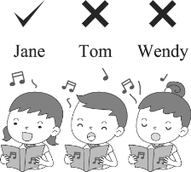(Ｂ) 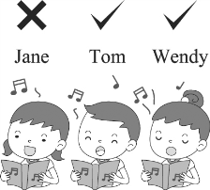(Ｃ) 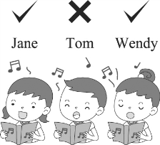

答案：(Ａ)
錄音稿：Jane sings the most beautifully of the three.
- (Ａ) 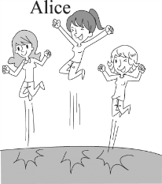 (Ｂ) 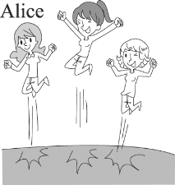 (Ｃ) 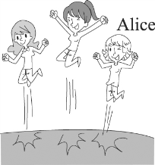
答案：(Ａ)
錄音稿：No one can jump higher than Alice.
3. (Ａ) (Ｂ) (Ｃ)

答案：(Ｃ)
錄音稿：Could you help me throw away the garbage?
4. (Ａ) (Ｂ) (Ｃ) 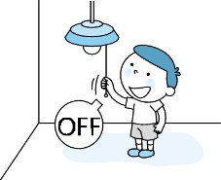

答案：(Ｃ)
錄音稿：Please make it a habit to turn off the lights after use.
5. (Ａ) (Ｂ) (Ｃ)

答案：(Ａ)
錄音稿：They went snorkeling and saw many fish swimming.

- 基本問答：根據聽到的內容，選出一個最適合的回應。

6.（ ）
(Ａ) I can take your place.
(Ｂ) I can do that right away.
(Ｃ) I couldn’t agree with you more.
答案：(Ｃ)
錄音稿：It’s important to try our best to win the game.
7.（ ）
(Ａ) Oh, you got hurt badly.
(Ｂ) He dropped the baton during the relay race.
(Ｃ) Look! Now it’s Jack’s run. He’s running faster than others.
答案：(Ｃ)
錄音稿：Our team is running more slowly than the other teams!
8.（ ）
(Ａ) She made up the story by herself.
(Ｂ) She made up her mind to help the earth.
(Ｃ) She made him wash hands before the meal.
答案：(Ｃ)
錄音稿：What did the woman make her son do?
9.（ ）
(Ａ) I will make it a habit.
(Ｂ) I must take action now.
(Ｃ) I see. I will keep this in mind.
答案：(Ｃ)
錄音稿：You mustn’t make a habit of staying out late at night, or Mom will be worried.

10.（ ）
(Ａ) How about seven thirty?
(Ｂ) It will be at twelve forty.
(Ｃ) It’s convenient for me to help Jack now.
答案：(Ａ)
錄音稿：What time is convenient for you to help me send the books to Peter, Jack?

三、言談理解：根據聽到的內容，選出一個最適合的答案。
11.（ ）
(Ａ) Don’t spend much time practicing the relay race.
(Ｂ) We should always be the number one.
(Ｃ) Winning is not everything
答案：(Ｃ)
錄音稿：W: Winning is not everything, my dear boy!
B: I know. I spent much time practicing for the relay race... but I fell...
W: It is OK. You’ve tried your best. You are always the number one to me. I am so proud of you.
B: Thank you, mom. Yeah, I think I’ve tried my best and it is enough! Maybe I should work harder next time.
W: Try harder next time. You will be better surely.
Q: What is the best topic?
12.（ ）
(Ａ) She promised to teach people.
(Ｂ) She promised to keep the earth healthy and beautiful.
(Ｃ) She promised to do the 3Rs.
答案：(Ｂ)
錄音稿：W: The earth is my home. I promise to keep it healthy and beautiful. So let’s think about what to do.
M: Do you know 3Rs? My teacher taught us last week. They are really important and helpful.
W: What are the 3Rs?
M: They are reduce, recycle and reuse. If we can do the 3Rs well, the earth will be healthy and beautiful. So we should keep it in mind.
Q: What does the woman promise to do?
13.（ ）
(Ａ) She let her mother play computer games.
(Ｂ) She practiced English for two hours today.
(Ｃ) She found taking action was more important than making a promise.
答案：(Ａ)
錄音稿：G: Actions speak louder than words! My mother never let me play computer games because I hated to study English and never went to the English class on time. However, today I began to practice speaking English with Mr. Smith and I found it is easy to learn English! After two-hour practice, she let me play computer games for one hour!
Q: Which is NOT true about the girl?
14.（ ）
(Ａ) People can take a hot spring bath in it.
(Ｂ) People can swim happily in it.
(Ｃ) People can boil eggs in it.
答案：(Ｂ)
錄音稿：M: It’s getting colder and I’d like to soak in Mimo Hot Spring. Want to join me?
W: That famous saltwater hot spring? Not bad. We can also boil some eggs in the water by ourselves and taste them. And then let’s swim in it.
M: It’s a good idea to have eggs, but we mustn’t swim in a hot spring.
Q: Which is NOT true about Mimo Hot Spring?
15.（ ）
(Ａ) Jacky had a lot of fun on Green Island.
(Ｂ) Jacky was not lucky during his vacation.
(Ｃ) Jacky saw a lot of sea animals swimming underwater.
答案：(Ｂ)
錄音稿：M: Dear Alice,
I planned to go snorkeling and go bike riding on Green Island for two days last weekend. But guess what? It rained heavily for two days! I had to stay at the hotel watching TV and guessed I was in the water swimming like a fish with sea turtles and sea snakes. I was really ill-fated.
John
Q: What does “I was really ill-fated” mean?

