新北市立溪崑國民中學106學年度第二學期第二次定期評量英語科 試題卷
七年級 班 座號 姓名

一 聽力測驗 30%
A、辨識句意：每題均有三張圖片，請依據所聽到的句子，選出符合描述的圖片
- (A)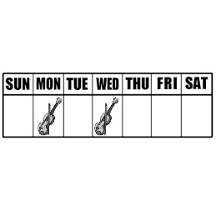 (B) 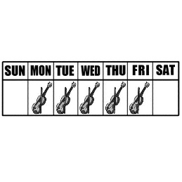(C)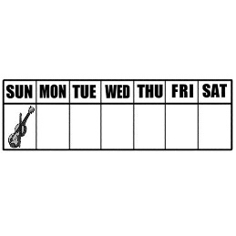
- (A)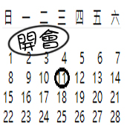 (B)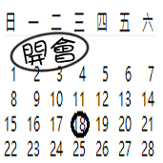(C)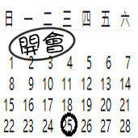
- (A)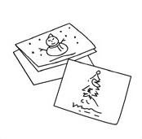 (B)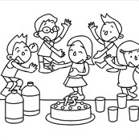(C)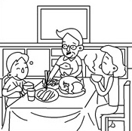
- (A)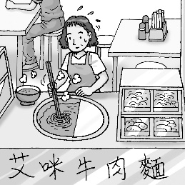 (B)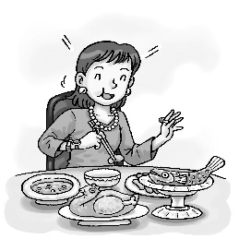(C)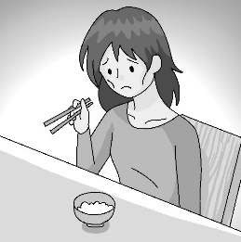
- (A)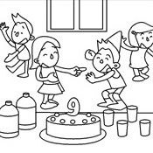 (B)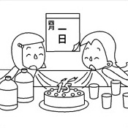(C)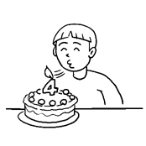

B、基本問答：每題均有三個選項，請依據所聽到的內容，選出一個最適合的回應
- (A) I do.
(B) It’s not my pen.
(C) We are.
- (A) I’m not sure. Maybe it’s fun.
(B) Yes, I am learning to make drums.
(C) No, I can’t, but I’m good at the guitar.
- (A) No, there are two students in front of him.
(B) Yes, there aren’t any students in front of him.
(C) No, there is just one student in front of him.
- (A) No, I have a lot of time this December.
(B) Yes, wish you a Happy New Year.
(C) Yes, my work is over in November.
- (A) Thank you.
(B) When is the vacation?
(C) How are you doing there?
C、言談理解：每題均有三個選項，請依據所聽到的對話與問題，選出一個最適當的答案
- (A) He can eat lunch now.
(B) He is free this afternoon.
(C) He can eat lunch after the meeting.
- (A) They often take their daughter to Japan.
(B) They go to Japan at least three times a year.
(C) They usually go to Japan with their daughter.
- (A) He wants to play basketball first.
(B) He wants to play badminton first.
(C) He wants to do two sports at the same time.
- (A) Joe.
(B) Tim.
(C) Joe and Tim.

(A) The band is making noise.
(B) The music is too loud for the man.
(C) The girl is practicing with her band.
二 綜合測驗 20%
16.Why does Tom have so many toys, but I don’t have any? It’s not _____.
(A) enough (B) fair (C) wish (D) band
17. Mom : Maggie, _____ good night to your dad.
Maggie : Good night, Dad.
(A)says (B) speaks (C) say (D) speak
18. A: Do you usually go to cram school after school?
B:_____
(A) Yes, I sometimes do . (B) No, I don’t always. (C) I seldom do. (D) No, never.
19. A: _____ don’t you go to school?
B: Every weekend.
(A)What date (B) What time (C) Why (D)What days
20. A: Who _____ a basketball?
B: John and Terry _____.
(A) has ; have (B) has ; does (C) plays ; do (D) has ; do
21. A: _____
B: It’s on Friday.
(A) What date is your concert? (B) What day is today? (C) What’s the date today? (D) When is the test?
22. My father _____ busy. He _____ dinner with us.
(A) always is ; seldom has (B) is always ; seldom has (C) is always ; has seldom (D) always is ; has seldom
23.Mother’s Day is _____ the second Sunday _____ May.
(A) of ; on (B) on ; of (C) at ; of (D) of ; at
24. This is my _____ meeting today . I’m so hungry and tired now.
(A) the third (B) only one (C) third (D) own
25. A:_____
B: Yes, I walk my dog every day.
(A) How often do you walk your dog? (B) What time do you walk your dog?
(C) Do you walk your dog every day? (D) When do you walk your dog?
26. Today Tony is late again ! In fact , he _____ for school.
(A) is often late (B) often is late (C) sometimes goes late (D) goes sometimes late
27. A: Does Billy often swim after school?
B:_____
(A) No, he never. (B) Yes, he often does. (C) No, he seldom doesn’t. (D) Yes, he does often.
28.Grandma has bad eyes because she watches TV _____.
(A) eight hours the day (B) a day eight hours (C) the day eight hours (D) eight hours a day
29.The baseball game is _____ 3:30 p.m. _____ Sunday.
(A) at ; of (B) on ; x (C) x ; x (D) at ; on
30.Tina: Is September second Friday?
Tracy: ______
(A) Yes, it is. (B) Yes, it does. (C) It’s Sunday. (D) No, it doesn’t.
31. 選出正確的句子
(A) Sometimes he has an egg for breakfast, but sometimes he doesn’t.
(B) Mr. and Mrs. Smith very often go to a movie .
(C) Jason never cares for his grades.
(D) The king is always busy, but the queen is never.
32. A: When does your school start?
B: It starts on _____.
(A) August 31th (B) August thirtieth-first (C) August 31st (D) Aug. thirty-one
33.My brother _____ every weekend.
(A) play the drums (B) plays the badminton (C) play chess (D) plays the guitar
34.Today is my cousin’s _____ birthday.
(A) fourteen (B) twentieth (C) nineth (D) twelveth
35.選出錯誤的句子
(A) Sorry, I have no money with me.
(B) Everyone in the class has a lot of fun in the club.
(C) Time for dinner. Go wash your hands.
(D) I’m not free now . Can you call for Mike?

三 閱讀測驗 20%
A.
In the past, being lost could be big trouble. Car drivers had a hard time driving in new areas. Airplane pilots had trouble flying in bad weather. With the GPS, we can help solve such problems.
The GPS is a system of 24 satellites in space, about 20000 kilometers above the earth. These satellites can tell an airplane or car exactly where it is. A hiker with a special device can figure out his location. And, there are many other uses. The world is a big place, but the GPS makes it a lot easier to go from A to B.

area地區 pilot飛行員 system系統 satellite 衛星 exactly精確地 device 設備 figure 弄清楚 location 位置

36.What does the GPS do?
(A) It tells people their exact location. (B) It flies airplanes and drives cars.
(C)It shows people how to fly 20,000 kilometers above the earth. (D)It solves everybody’s troubles.
37.What does “go from A to B” mean ?
(A)say one thing and then another (B)move from one place to another
(C)spell something well (D)learn to do something
38.Which of the following is true?
(A)The GPS satellites are on the earth.
(B)The GPS cannot help people in the mountains.
(C)A person doesn’t need to be on the ground to use the GPS.
(D)There are very few uses for the GPS.

B. This is today’s TV schedule. Please look at it and answer the questions
TV TODAY
Time | Channel | Program
2:00p.m. | 44 | CNN News
3:30p.m. | 62 | World Sports
3:30p.m. | 9 | Story Time
3:30p.m. | 66 | Cartoon:Pocket Monsters
4:00p.m. | 9 | MTV 30 Minutes
4:00p.m. | 66 | Fashion Show:Pretty Girls
4:30p.m. | 2 | Cartoon:Micky Mouse
4:30p.m. | 9 | Shopping Time
5:30p.m. | 2 | Movie:Avatar
5:30p.m. | 7 | Movie:Harry Potter V
5:30p.m. | 28 | Movie:Cape Number Seven
39.Tony likes watching soccer games. What channel can he watch?
(A) 44 (B) 62 (C) 7 (D) 9
40.After watching the soccer games for an hour, Tony is watching cartoons now.What time may it be?
(A) 3:30 p.m. (B) 4:40 p.m. (C) 5:30 p.m. (D) 4:00 p.m.
41.How long(多久) is the program “Story Time” ?
(A)We don’t know. (B)60 minutes. (C)90 minutes. (D)30 minutes.

C.
It is __42__ and exciting to visit different countries. __43__ , you can see beautiful montains and seas.You can learn different ways of living and doing things.You can try many different kinds of foods.You can meet different people and make friends with them. Also, you can buy special presents for yourself and your friends.
It is also a good way to learn a foreigh language because you can learn the language by __44__ it.You can practice speaking English when visiting America or __45__.Or you can practice speaking French in France or German in Germany.
Do you like to take a trip to a foreign country? Think about it for your next vacation!
42. (A) expensive (B) enjoy (C) easy (D) fun
43. (A) In fact (B) By the way (C) For example (D) However
44. (A) buying (B) using (C) seeing (D) playing
45. (A) China (B) the U.K. (C) Taiwan (D) Japan

四 翻譯填充 (請在答案卷上作答) 16%
46. 誰近視?
Who is _____ ?
47. 我的生日在十二月五日不是二月十二日。
My birthday is on _____ _____, not on _____ _____.(請用英文作答)
48. 請勿每晚待在線上。這樣對健康不好。
Don’t _____ _____ every night. This is bad for your _____.
49. 不用擔心。我可以很快幫你解決這個問題。
Don’t _____. I can help you _____ the _____ _____.
50.你可以先準備晚餐然後再慶祝生日。
You can _____ for dinner _____and _____ _____ the birthday.

五 整句式翻譯 (請在答案卷上作答) 14%
51.Maggie每星期二和星期四早上和學校樂團練習小提琴。(3%)
52.我哥總是在餐後刷牙但是我很少這麼做。(3%)
53.A:你多久看一次牙醫?
B: 一年至少兩次.但是我現在牙痛。(3%)
54.學生們,選擇你們自己的社團吧!
你可以交到許多朋友並玩得很開心。(3%)
55.離加拿大的父親節還有兩個月。(2%)

新北市立溪崑國民中學106學年度第二學期第二次定期評量 英語科 答案卷
七年級 班 座號 姓名

四 翻譯填充 (一格1分)(16%)
46.
47.
48.
49.
50.

五 整句式翻譯(14%)
51.(3%)
52.(3%)
53.(3%)A:
B:
54.(3%)
55.(2%)

106-2-2 七年級 英語科－解答

七年級英語科第二次月考解答
1. CBABC 6 .ACACA 11.ABBBC 16. BCDDD
21.DBBCC 26.ABDDA 31.ACDBD 36.ABCBB
41.DDCBB

四 翻譯填充(16%) 每格一分
46.nearsighted
47.December fifth February twelfth
48.stay online health
49.worry fix problem soon
50.prepare first then celebrate
五.整句式翻譯(14%)
(3%)51. Maggie practices the violin with the school band on Tuesday and Thursday mornings.

(3%)52. My brother always brushes his teeth after meals, but I seldom do.

(3%)53. A: How often do you go to the dentist?
B:Twice a year at least. But I have a toothache now.

(3%)54. Students, choose your own clubs.
You can make a lot of friends and have fun.

(2%)55.The Father’s Day in Canada is still two months away.

新北市立溪崑國民中學106學年度第二學期第二次定期評量
七年級 英語科 聽力測驗稿()

一、辨識句意：每題均有三張圖片，請依據所聽到的句子，選出符合描述的圖片
- ＿＿＿
(A) (B) (C)
- ＿＿＿
(A) (B)(C)
- ＿＿＿
(A) (B)(C)
- ＿＿＿
(A) (B)(C)
- ＿＿＿
(A) (B)(C)

二、基本問答：每題均有三個選項，請依據所聽到的內容，選出一個最適合的回應
- ＿＿＿
(A) I do.
(B) It’s not my pen.
(C) We are.
- ＿＿＿
(A) I’m not sure. Maybe it’s fun.
(B) Yes, I am learning to make drums.
(C) No, I can’t, but I’m good at the guitar.
- ＿＿＿
(A) No, there are two students in front of him.
(B) Yes, there aren’t any students in front of him.
(C) No, there is just one student in front of him.
- ＿＿＿
(A) No, I have a lot of time this December.
(B) Yes, wish you a Happy New Year.
(C) Yes, my work is over in November.
- ＿＿＿
(A) Thank you.
(B) When is the vacation?
(C) How are you doing there?
三、言談理解：每題均有三個選項，請依據所聽到的對話與問題，選出一個最適當的答案
- ＿＿＿
(A) He can eat lunch now.
(B) He is free this afternoon.
(C) He can eat lunch after the meeting.
- ＿＿＿
(A) They often take their daughter to Japan.
(B) They go to Japan at least three times a year.
(C) They usually go to Japan with their daughter.
- ＿＿＿
(A) He wants to play basketball first.
(B) He wants to play badminton first.
(C) He wants to do two sports at the same time.
- ＿＿＿
(A) Joe.
(B) Tim.
(C) Joe and Tim.
- ＿＿＿
(A) The band is making noise.
(B) The music is too loud for the man.
(C) The girl is practicing with her band.

