新北市立溪崑國民中學106學年度第二學期第一次定期評量英語科 試題卷
八年級 班 座號 姓名
一、聽力測驗：30%
I. 辨識句意 (根據聽到的內容，選出符合描述的圖片)
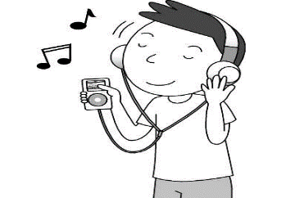

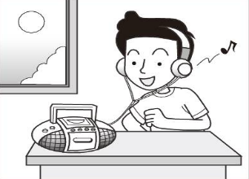
1. (Ａ) (Ｂ) (Ｃ)

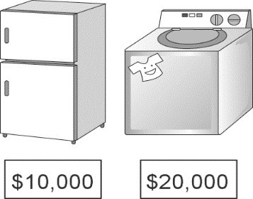
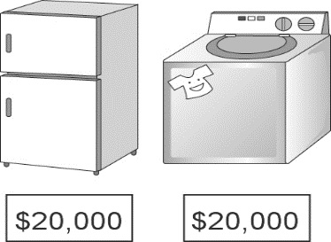
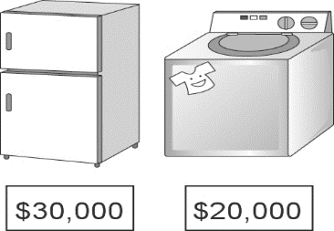
2. (Ａ) (Ｂ) (Ｃ)

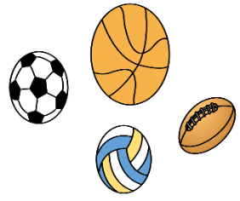
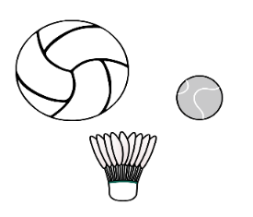
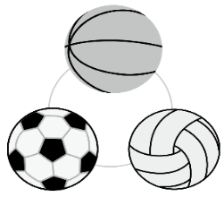
3. (Ａ) (Ｂ) (Ｃ)

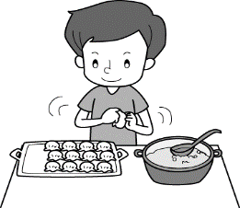
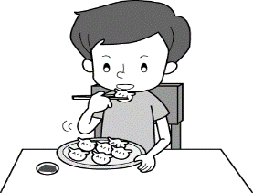
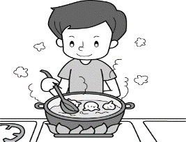
4. (Ａ) (Ｂ) (Ｃ)

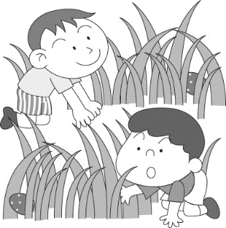
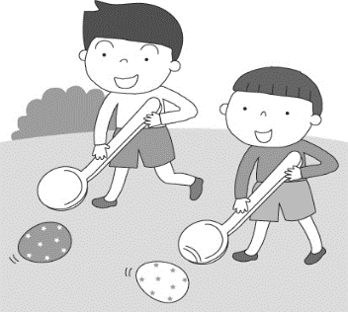
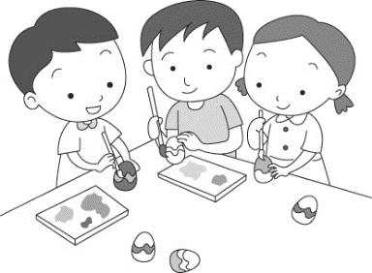
5. (Ａ) (Ｂ) (Ｃ)

II. 基本問答 (依據聽到的對話內容，選出最適合的回應)
6. (A) The weather is getting warmer and warmer.
(B) They feel excited.
(C) Why not?
7. (A) Because of the trash over there.
(B) I can smell the yummy buns.
(C) It tasted like vinegar.
8. (A) Do you want to go fruit picking with me?
(B) My grandfather does.
(C) That man is good at growing fruit.
9. (A) The red one. It can send e-mails and play music.
(B) This machine is very useful.
(C) The pink one on the left is mine.

10. (A) It has Wi-Fi and its picture quality is great.
(B) Let’s bring it with us during the trip to Japan
(C) I want to take high quality photos with it.
III. 言談理解（根據聽到的對話內容與問題，選出正確的答案）
11. (A) The gray one.
(B) The purple one.
(C) Both.
12. (A) They just saw an amazing movie.
(B) The man didn’t agree with the woman.
(C) The movie is the worst one of the year.
13. (A) Visiting the town is a wonderful experience.
(B) Getting away from the town is not a way to start a new life.
(C) Moving to a new place helps him start a new life.
14. (A) Keep the woman clean.
(B) Take a bath for Lucky.
(C) To be busy at work.
15. (A) People can have an Easter egg hunt at Green Park.
(B) The boy joined the helicopter Easter egg drop before.
(C) There’s nothing inside each Easter egg.
二、請依題意選出最適當的答案：30 %
16. Clerk: ____________________
John: I’d like to take a look at this shirt.
(A) Do you like the skirt? (B) What’s the total?
(C) The shirt looks good on you. (D) How may I help you?
17. I bought the car at a ________ price. It’s a good bargain.
(A) high (B) expensive (C) cheap (D) low
18. Of all the subjects, math is __________ for me.
(A) the most difficult (B) more difficult (C) the more difficult (D) most difficult
19. Let’s _______ for the singers on the stage.
(A) hide (B) drop (C) clap (D) boil
20. It _________ rain. We’d better carry an umbrella with us.
(A) looks (B) looks like (C) smells (D) smells like
21. Why not __________ the joy of __________ a farmer?
(A) to experience; being (B) experience; being (C) to experience; be (D) experience; be
22. A: _________ would you like to pay? B: _______ cash.
(A) What; In (B) How; In (C) What; By (D) How; By
23. It’s getting _______________ in spring.
(A) warm and warm (B) more and more warm (C) warmer and warmer (D) warmest and warmest
24. Your joke sounds ________ funnier than _________.
(A) more; he (B) more ; his (C) much; he (D) much; his
25. Please put the fish in the refrigerator to keep it ___________.
(A) free (B) fresh (C) amazing (D) grow
26. The new supermarket is only two blocks ____________ my house.
(A) away (B) away for (C) away from (D) away to
27. How about _________________ this weekend?
(A) going fruit picking (B) go fruit picking (C) go picking fruit (D) going pick fruit
28. Don’t panic! Try to be as ________ as a cucumber.
(A) wise (B) wiser (C) cool (D) cooler
29. There are many kinds of _____________ on his farm.
(A) vegetable (B) strawberry (C) vegetables (D) strawberrys
30. Mt. Jade is ___________ mountain in Taiwan.
=No ________ mountain in Taiwan is higher than Mt. Jade.
(A) highest; x (B) the highest; x (C) higher; other (D) the highest; other
三、克漏字選擇及閱讀測驗：10 %
Bill: I don’t know why, but I’m sure our teacher doesn’t like me.
Sue: I think that’s because you’re 31. student in the class.
Bill: I am NOT.
Sue: Of course you are. I’ve never seen you keep quiet in class. I think 32. teachers like students who always concentrate on what they’re learning.
Bill: What should I do?
Sue: Talk 33. and learn more.
Bill: OK. I’ll close my mouth from now on.
＊concentrate 專心

31. (A) very noisy (B) the noisiest (C) the noisier (D) noisier
32. (A) much (B) every (C) most (D) any
33. (A) fewer (B) more (C) most (D) less

A king lost his ring that his father had given to him as a gift. He and his servants looked all over the court, but they found nothing. “It looks as if only my queen can help me now,’ thought the king, so he waited until his queen came back from walking. “The ring is very important to me. Could you help me find it?” said the king. “Do not worry, my king. I will find it right now,’ said the queen.
Soon the queen walked around the court and among the servants and said, ‘My king, the ring itself is here in this court on one of the servants. The servant who has a straw in his hair stole your ring.” The servant who stole the king’s ring was very afraid, and he quickly moved his hand over his head. The queen noticed the action of the servant. She pointed her finger at the servant and said, “Search the man. He has the king’s ring.” Not long after, the king’s ring was found in the servant’s pocket. Yet, no straw was seen in his hair. The king could not understand how his queen could be so sure about where the ring was. The wise queen smiled and said,
“A guilty person is always scared.”
＊ servant 僕人

34. Who is “a guilty person”?
(A) Mark: He lost a cap that is very important to him.
(B) John: He took a man’s wallet without telling him.
(C) Lily: She helped a boy get his bike back.
(D) Jack: He failed a big test and felt sad.
35. Which is true about the story?
(A) The queen used the lie about a straw to make the bad servant get afraid and act.
(B) It was the queen who put a straw in the bad servant’s hair.
(C) The queen found the king’s ring by a lucky guess.
(D) The king lost the ring in order to find out who was not honest.

※ 將以下的答案寫在答案欄中
四、 寫出形容詞的原級、比較級、以及最高級: 12 %
原級 | 比較級 | 最高級
36. | worse | 37.
few | 38. | 39.
special | 40. | 41.

五、依題示作答：6 %
42. Janet is taller than Karen or Wendy. (改寫成Janet …of…)
43. He does not make as much money as his father. (改寫成 His father……than….)
44. The grapes taste sour. (請造原問句)
六、翻譯：12%
45. 在教堂慶祝復活節聽起來像是個好主意。
46. 小心! 不要把我昂貴的智慧型手機掉落在地上。
47 灰色那台洗衣機比紫色那台輕。
48. 他多年前搬到鄉下而且開始經營農場。

【試題結束】

新北市立溪崑國民中學106學年度第二學期第一次定期評量 英語科 答案卷
八年級 班 座號 姓名
答案欄

四、寫出形容詞的原級、比較級、以及最高級: 12 %

36. _______________ 37. ________________ 38. _______________

39. _______________ 40. ________________ 41. _______________

五、依題示作答：6 %
42. _____________________________________________________________________________________

43. _____________________________________________________________________________________

44. _____________________________________________________________________________________

六、翻譯：12%

45. _____________________________________________________________________________________

46. _____________________________________________________________________________________

47. _____________________________________________________________________________________

48. _____________________________________________________________________________________

106-2-1 八年級 英語科－解答
一、聽力測驗：30%
1. ACBAA 6. CABAA 11. BACBA
二、請依題意選出最適當的答案：30 %
16. DDACB 21. BBCDB 26. CACCD
三、克漏字選擇及閱讀測驗：10 %
31. BCDBA
四、寫出形容詞的原級、比較級、以及最高級: 12 %
36. bad 37. worst 38. fewer

39. fewest 40. more special 41. most special
五、依題示作答：6 %
42. Janet is the tallest of the three (girls).
43. His father makes more money than he/him.
44. How do the grapes taste?

六、翻譯：12%
45. Celebrating Easter at the church sounds like a good idea.
46. Watch out! Don’t drop my expensive smartphone on the ground.
47. The gray washing machine is lighter than the purple one.
48. He moved to the country and started to run a farm many years ago.

新北市立溪崑國民中學106學年度第二學期第一次定期評量
八年級 英語科 聽力測驗稿

一、聽力測驗：30%
I. 辨識句意 (根據聽到的內容，選出符合描述的圖片)
1. John likes to listen to music on the radio.
2. The washing machine is more expensive than the refrigerator.
3. The volleyball is the largest.
4. The man is boiling some dumplings.
5. They’re painting and coloring eggs for Easter.

II. 基本問答 (依據聽到的對話內容，選出最適合的回應)
6. How about having a picnic next weekend?
7. Why does this place smell so bad?
8. Who owns the biggest farm in the town?
9. Which smartwatch is more useful?
10. What’s special about the camera?

III. 言談理解（根據聽到的對話內容與問題，選出正確的答案）
11. M: Is the gray shirt more expensive than the purple one?
W: Yes, it is.
M: Then I’ll take the cheaper one.
W: OK, no problem.
Q: Which color of the shirt does the man take?
12. W: The movie is amazing. I want to see it again.
M: You can say that again. It’s the best movie of this year.
Q: Which is true?
13. W: Why are you moving to that town?
M: So many bad things happened these days, so I want to move to a new place and start a new life.
Q: What is the man trying to say?
14. M: Lucky looks so dirty. How often do you wash it?
W: Once a week. But last week I was too busy, so I didn’t take a bath for it.
M: Well, I’m free now. I want to make him clean.
Q: What is the man going to do next?
15. G: There’s going to be a helicopter Easter egg drop at Green Park on Easter.
B: What’s that? I never heard of it before.
G: A helicopter will fly to Green Park and drop hundreds of Easter eggs on the grass.
B: Wow, it sounds special. Then we can have an Easter egg hunt there.
G: Sure. Besides that, there is candy inside each Easter egg.
Q: Which is right?

