新北市立溪崑國民中學106學年度第二學期第一次定期評量英語科 試題卷
七年級 班 座號 姓名
一. 聽力測驗 30%
(一)、辨識句意：每題均有三張圖片，請依據所聽到的句子，選出符合描述的圖片
- ＿＿＿
(A)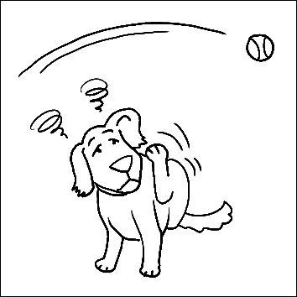 (B)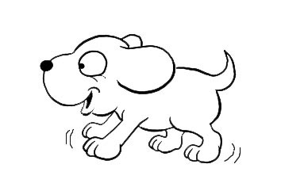 (C)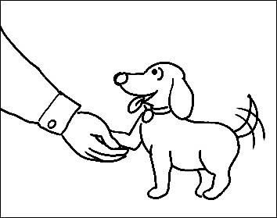
- ＿＿＿
(A)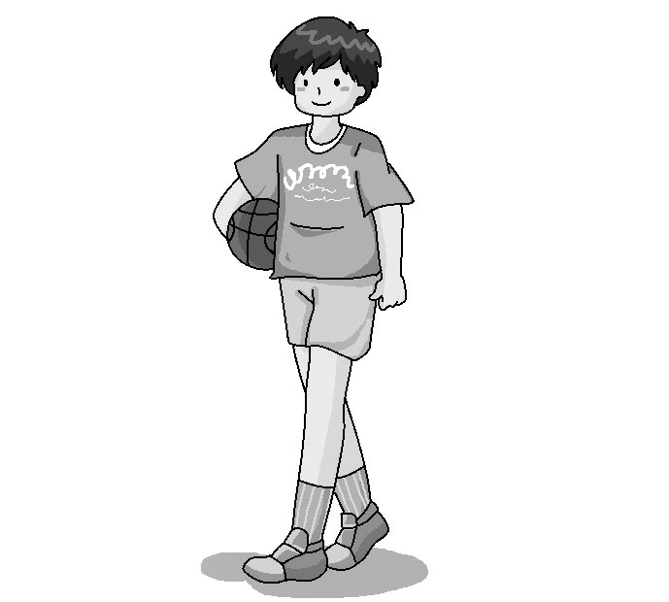 (B)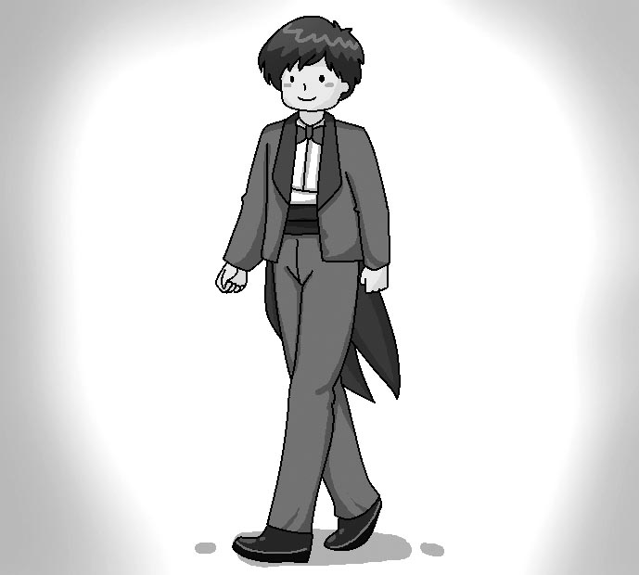 (C)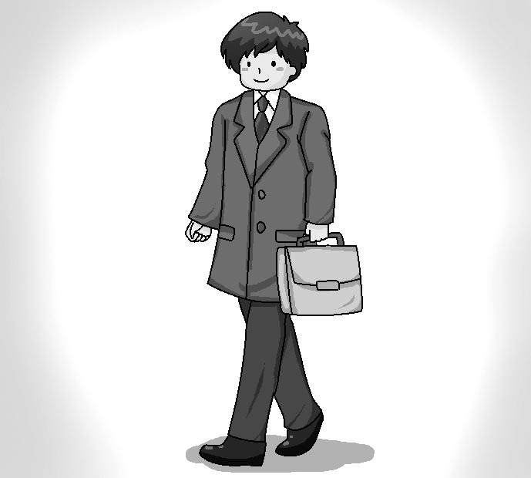
- ＿＿＿
(A)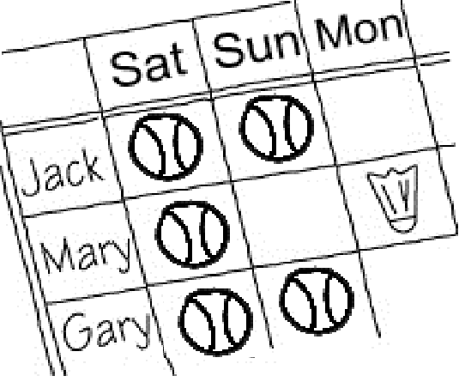 (B)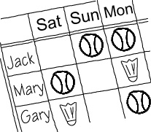 (C) 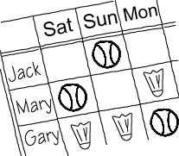
- ＿＿＿
(A)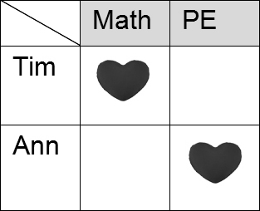 (B)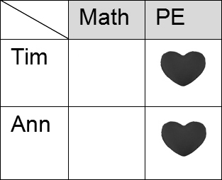 (C)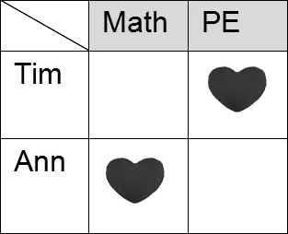
- ＿＿＿
(A)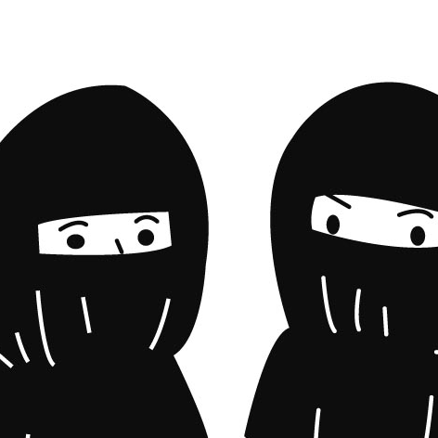 (B)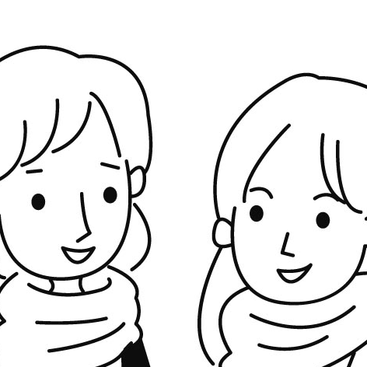 (C)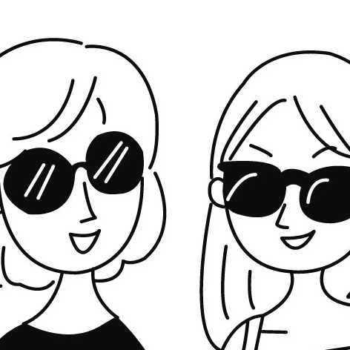
(二)、基本問答：每題均有三個選項，請依據所聽到的內容，選出一個最適合的回應
- (A) No, I don’t have any sisters.
(B) Yes, I’m your sister.
(C) Yes, I’m your cousin.
- (A) Too bad.
(B) It’s exciting.
(C) How about you?

- (A) What does she mean?
(B) Does she like her bedroom?
(C) How about the other room?
- (A) That’s too bad.
(B) This is excellent.
(C) It’s a little different.
- (A) You bet.
(B) I don’t get it, either.
(C) No one can help me.

(三)、言談理解：每題均有三個選項，請依據所聽到的對話與問題，選出一個最適當的答案
- (A) He is the girl’s friend.
(B) He is the girl’s favorite actor.
(C) He is the teacher of the movie club.
- (A) He is a baseball player.
(B) He is the girl’s basketball coach.
(C) He is the girl’s badminton coach.
- (A) There are many tests every day.
(B) The teachers give a lot of homework.
(C) The students study together for good grades.
- (A) John doesn’t have red pens, either.
(B) She has a red pen in the pencil case.
(C) The man can ask John for a red pen.
- (A) She is helping at the restaurant, too.
(B) She likes the food in the restaurant, too.
(C) She doesn’t like the food in the restaurant, either.

二. 綜合測驗 26%
16.Sandy and Judy have the same Grandmother. That means that they are _____ .
(A) brothers (B) daughters (C) cousins (D) wives
17.James: Can everyone in the class play the piano?
Sarah: _____ Jack and Tom can’t.
(A) Yes, no one. (B) Yes, I am a player. (C) No wonder. (D) No,not everyone.
18. Frank _____ two brothers, but I _____ only one.
(A) have ; have (B) has ; has (C) have ; has (D) has ; have
19. Amy: _____ your father swim?
Mag: Yes, he can.
(A) Does (B) Is (C) Can (D) Do
20. We eat hamburgers for breakfast, and our teacher _____,_____.
(A) eats ; too (B) does ; too (C) doesn’t ; either (D) don’t ; either
21._____ the man from the USA _____ Chinese?
(A) Does ; speak (B) Can ; speaks (C) Are ; speaks (D) Do ; speak

22. Andy : _____ the rules different?
Jack : We only play with one ball.
(A) How do (B) What else do (C) What is (D) How are
23. Melody uses chopsticks well, but her younger sisters _____.
(A) doesn’t (B) don’t (C) aren’t (D) isn’t
24.Willy is good at English. He often _____ me _____ my English homework.
(A) help ; with (B)helps ; for (C) helps ; with (D) help ; for
25. Ben : What _____ Mr. Lee teach?
Mark: He _____ PE.
(A) does ; teach (B) does ; teaches (C) can ; teach (D) is ; teaching
26.The computer doesn’t work. Who can _____ it?
(A) fix (B) play (C) catch (D) shake
27. 選出錯誤的句子
(A) Now, he always washes his hands before lunch.
(B) My baby daughter is sleeping with me every night now.
(C) Look! Mark is nodding off in class again.
(D) The girls are asking questions in the classroom now.
28. 選出正確的句子
(A) Do you often busy in the morning?
(B) The children in the picture don’t happy.
(C) Are your friends come from Japan?
(D) Is Ray late for work every morning?

三.閱讀測驗 14%
(1). Solina’s Class Schedule
Days | Mornings |  | Afternoons
Monday | Computer | Math | English
Tuesday | English | Math | Chinese
Wednesday | English | Chinese | PE
Thursday | Chinese | English | Music
Friday | English | Art | Art

29. According to the class schedule, how many Chinese classes does Solina have during the week?
(A) Three. (B) One. (C) Four. (D) Two.
30. When does Solina have English class?
(A) Every morning. (B) Monday morning. (C) Wednesday afternoon. (D) Every day.
31. Tim: Hi, Solina. Where are you going?.
Solina: To the playground. Mr. Wang will teach us how to play baseball later.
When do they have the dialogue?
(A) Monday afternoon. (B) Wednesday afternoon. (C) Thursday morning. (D) Friday night.

(2)
Falling Rain
I like the sound of falling rain---
Like music played on empty streets:
A concert on a summer’s day,
Soft tapping with a gentle beat.

On rainy days I close my eyes
And smell the freshly blowing air.
It calms me down and gives me hope ---
Enough to forget all my fear.

On rainy days, I look outside.
The streets are quiet, calm, and plain.
Is everyone else like me—inside,
Listing to the falling rain? tap輕拍 gentle輕柔的 calm平靜的 fear害怕 plain簡樸的

32.The writer compares(比較) the rain to _____.
(A) a street (B) everyone else (C) music (D) the summer
33. On rainy days, the writer _____.
(A) stays inside (B) walks around (C) play music (D) goes outside
34. How does the rain make the writer feel?
(A) Nervous. (B) Calm. (C) Sad. (D) Worried.
35. What is fresh during the rain?
(A) The streets. (B) The water. (C) The city. (D) The wind.
四 翻譯30%
(翻譯填空，每格1分)
1.自然科學和歷史是Peter最喜歡的科目。
_____ and _____ are Peter’s _____ _____.
2.這部電影有一點刺激。
The movie is _____ _____ ______.
3.我們一起學習是為了樂趣而非成績。
We _____ _____ for _____ , not for _____.
4.A: 你的狗還會做什麼?
B: 他會跳繩。
A: What _____ can your dog do?
B: He can _____ _____.
(整句翻譯，每題4分)
5.我們學校有羽球社團而且我們有優秀的羽球教練。
6.我爸每個周末看電視上的網球賽，但是我媽不看。
7.A:學校生活過得如何?
B:還不錯。國文老師每天給很多作業，但是我喜歡國文。
8.我阿姨的女兒是個工程師，她可以同時聽音樂和算數學。

新北市立溪崑國民中學106學年度第二學期第一次定期評量 英語科 答案卷
七年級 班 座號 姓名
翻譯填空14% 每格1分
1.
2.
3.
4.

整句式翻譯16% 每題4分
5. ____________________________________________________________________________
____________________________________________________________________________

6. ____________________________________________________________________________
____________________________________________________________________________

7. ____________________________________________________________________________
____________________________________________________________________________

8. ____________________________________________________________________________
____________________________________________________________________________

106-2-1 七年級英語科解答
1.ACACA 6.CACAB 11.CBBCC 16.CDDCB 21.ADBCB
26.ABDAD 31.BCABD
翻譯填充14% 每格一分
1. Science history favorite subjects
2. a little exciting
3. study together fun grades
4. else jump rope
整句式翻譯16% 每題4分
5.There is a badminton club at our school, and we have an excellent badminton coach.
6.My father watches tennis games on TV on weekends, but my mother doesn’t.
7.A: How’s it going at school?
B: Not bad. The Chinese teacher gives a lot of homework every day, but I like Chinese.
8. My aunt’s daughter is an engineer, and she can listen to the music and study Math at the same time.
註 (,and she)的部分可以換成( . She ) 或是 (.And she)

新北市立溪崑國民中學106學年度第二學期第一次定期評量
七年級 英語科 聽力測驗稿()
一、辨識句意：每題均有三張圖片，請依據所聽到的句子，選出符合描述的圖片
- 《腳本區》
CD: The dog can’t catch a ball.
《題目區》＿＿＿
(A) (B)(C)
《答案區》答案：A
- 《腳本區》
CD: The tall man is my uncle. He is a businessman.
《題目區》＿＿＿
(A) (B)(C)
《答案區》答案：C
- 《腳本區》
CD: Jack, Mary, and Gary play baseball only on weekends. They don’t play it on Mondays.
《題目區》＿＿＿
(A) (B)(C)
《答案區》答案：A
- 《腳本區》
CD: Tim and Ann like different subjects. Tim likes PE, and Ann likes math.
《題目區》＿＿＿
(A) (B)(C)
《答案區》答案：C
- 《腳本區》
CD: We can only see the women’s eyes.
《題目區》＿＿＿
(A) (B)(C)
《答案區》答案：A
二、基本問答：每題均有三個選項，請依據所聽到的內容，選出一個最適合的回應
- 《腳本區》
CD: Are you Uncle Ted’s daughter?
《題目區》＿＿＿
(A) No, I don’t have any sisters.
(B) Yes, I’m your sister.
(C) Yes, I’m your cousin.
《答案區》答案：C
- 《腳本區》
CD: Man: Our favorite show is on. Let’s watch it.
Woman: Sorry. I can’t join you. I’m very busy now.
《題目區》＿＿＿
(A) Too bad.
(B) It’s exciting.
(C) How about you?
《答案區》答案：A
- 《腳本區》
CD: Wendy is not in her room.
《題目區》＿＿＿
(A) What does she mean?
(B) Does she like her bedroom?
(C) How about the other room?
《答案區》答案：C
- 《腳本區》
CD: We have a coach and great players, but we don’t have a basketball court.
《題目區》＿＿＿
(A) That’s too bad.
(B) This is excellent.
(C) It’s a little different.
《答案區》答案：A
- 《腳本區》
CD: What does this sentence mean?
《題目區》＿＿＿
(A) You bet.
(B) I don’t get it, either.
(C) No one can help me.
《答案區》答案：B
三、言談理解：每題均有三個選項，請依據所聽到的對話與問題，選出一個最適當的答案
- 《腳本區》
CD: Man: Do you like movies?
Girl: Yes, I do.
Man: Come to our movie club. I’m the teacher of the club.
Girl: OK.
Question: Who is the man?
《題目區》＿＿＿
(A) He is the girl’s friend.
(B) He is the girl’s favorite actor.
(C) He is the teacher of the movie club.
《答案區》答案：C
- 《腳本區》
CD: Boy: Who is the man?
Girl: He’s our new coach, Mr. Wang.
Boy: Really? He’s so heavy. Can he jump? What’s wrong with this basketball club?
Question: Who is Mr. Wang?
《題目區》＿＿＿
(A) He is a baseball player.
(B) He is the girl’s basketball coach.
(C) He is the girl’s badminton coach.
《答案區》答案：B
- 《腳本區》
CD: Man: Do you like your new school?
Girl: Yes, I do. The teachers are nice. They don’t give any tests.
Man: How about homework? Do you have homework?
Girl: Yes, we do. We have a lot of homework, but it’s fun.
Question: What is right about the girl’s new school?
《題目區》＿＿＿
(A) There are many tests every day.
(B) The teachers give a lot of homework.
(C) The students study together for good grades.
《答案區》答案：B
- 《腳本區》
CD: Man: Mary, do you have a red pen?
Woman: No, I don’t have any pens.
Man: Then, who does?
Woman: Well, you can ask John. He has many pens.
Question: What does the woman mean?
《題目區》＿＿＿
(A) John doesn’t have red pens, either.
(B) She has a red pen in the pencil case.
(C) The man can ask John for a red pen.
《答案區》答案：C
- 《腳本區》
CD: Man: Wow! Are these people waiting in line for the food in the restaurant?
Woman: Yes, they are. This restaurant is famous.
Man: But its food is terrible.
Woman: You bet.
Question: What does the woman mean?
《題目區》＿＿＿
(A) She is helping at the restaurant, too.
(B) She likes the food in the restaurant, too.
(C) She doesn’t like the food in the restaurant, either.
《答案區》答案：C

