新北市立溪崑國民中學113學年度第一學期第二次定期評量 英語科 試題卷
七年級 班 座號 姓名
一、聽力測驗30%
(一)辨識句意：每題均有三張圖片，請依據所聽到的句子，選出符合描述的圖片(每題2分，共10分)
- (A)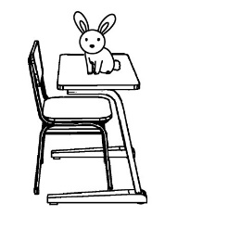 (B)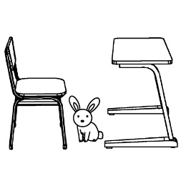 (C)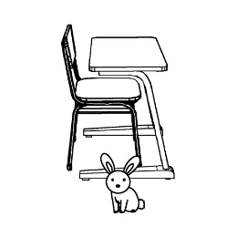
- (A)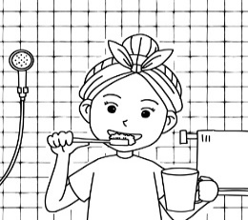 (B)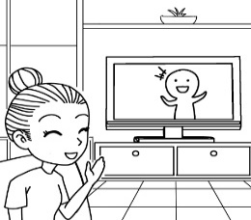 (C)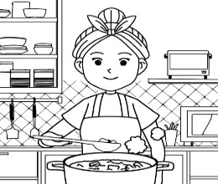
- (A)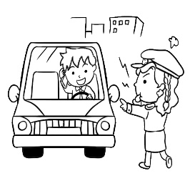 (B)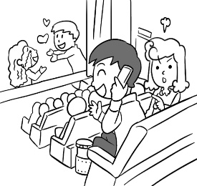 (C)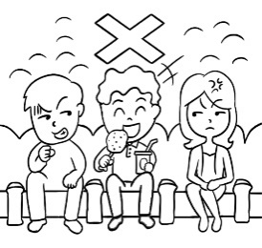
- (A)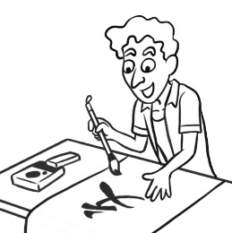 (B)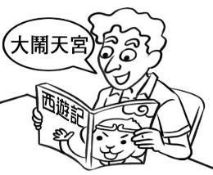 (C)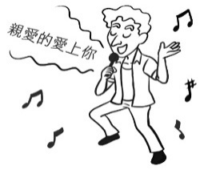
- (A)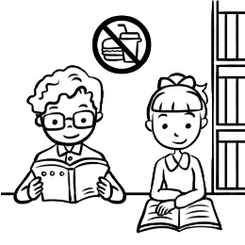 (B)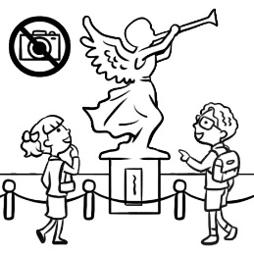 (C)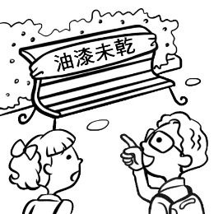
(二)基本問答：每題均有三個選項，請依據所聽到的內容，選出一個最適合的回應(每題2分，共10分)
- (A) Yes, I am not OK with that.
(B) Yes, but it’s expensive.
(C) Yes, choose that smartphone.
- (A) He is a cook.
(B) They can dance.
(C) They like the song.
- (A) Same here.
(B) Are you OK?
(C) I’m a real phubber.
- (A) Don’t be late.
(B) I can’t talk now.
(C) That’s a great idea.
- (A) Smart, right?
(B) I’m fine, thanks.
(C) It can walk and dance.

(三)言談理解：每題均有三個選項，請依據所聽到的對話與問題，選出一個最適當的答案(每題2分，共10分)
- (A) She is the short girl next to Paul.
(B) She is the tall girl next to Paul.
(C) She is Paul’s mother.
- (A) Yes, and it’s nice.
(B) Yes, and it’s warm.
(C) No, but it’s warm.
- (A) No, she can’t. She has a talk with her son’s teacher.
(B) No, she can’t. She has a problem with her son.
(C) No, she can’t. She has（有）a class at school.
- (A) They can eat on the bus.
(B) They can run on the bus.
(C) They can talk on the bus.
- (A) The man will（將要）watch Lisa’s new movie next.
(B) The man will watch Lisa’s live stream next.
(C) The man will listen to Lisa’s new songs next.

二、綜合測驗24%
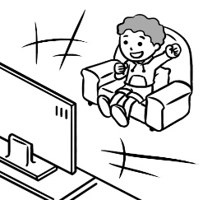
16.

Look at the picture. The boy is watching TV .

(A)in the kitchen (B) in the living room (C) in the bathroom (D) in the classroom
17. A: What’s that from the box? B: It’s a big mouse.
(A) idea (B) photo (C) voice (D) noise
18. ! The traffic light is red. We can’t cross the road.
(A) Listen (B) Guess what (C) Watch out (D) I see
19.Users can the app to design their houses. It’s quite easy!
(A) talk (B) dance (C) wait (D) download
20.A: Where is my smartphone ? B: .
(A) It’s on the table (B) Yes, it’s in your bag (C) It’s from Taiwan (D) Check out
21.Let’s follow the rules in the movie theater. Don’t take any photos stand up. Is that ok you ?
(A) too; for (B) or; with (C) and; about (D) but; with
22.Please and . It’s late.
(A) don’t dance; quiet (B) not dance; be quiet (C) dance; quiet (D) don’t dance; be quiet
23.My sister’s birthday is today. This is a gift for .
(A) me (B) she (C) her (D) him
24. Adam but . His voice is beautiful.
(A) can sing; can’t write songs (B) can sing; write songs (C) can’t sing; can’t write songs (D) can sing; dance
25. My uncle isn’t old. , he is in his early twenties.
(A) In front of (B) That way (C) In fact (D) Guess what
26.A: I like to watch Jay Chao’s live stream and listen to his songs again and again . B: His songs are all great.
(A) Next. (B) I’m fine, thanks. (C) Smart, right? (D) Same here.
27. Let’s . Our teacher could be angry.
(A) draw on our books (B) draws on our books
(C) not draw on our books (D) drawing on our books

三、克漏字測驗10%
A Recipe for a Banana Cake
(29) one, open two eggs. Then, mix the eggs until they are soft. In another bowl, blend the butter and sugar until they are soft,too. Next, mix the bananas (30) the butter and sugar. After that, blend all the dry ingredients together, (31) . Mix the dry and wet ingredients together until everything is mixed well. At last, put the mash into a baking pan and bake it in the oven at 180 degrees for 30 minutes.
recipe食譜 blend 攪拌 dry乾的 ingredient 成份 flour麵粉 powder粉 pan平底鍋 bake烤 oven烤箱 degrees度
28. Whats is the reading mainly about ?
(A) A story about food. (B) How to make a banana cake. (C) An app about room styles. (D) How to choose a cake.
29. (A) Photo (B) Wait (C) Get (D) Step
30. (A) up (B) with (C) down (D) under
31. (A) like flour and baking powder (B) like ice and juice (C) like milk and butter (D) like orange juice
32. Who most likely(最有可能) use the recipe?
(A) Bob: “ I have a swimming class today. ” (B) Ted: “ I can watch Twice’s live stream tonight . “
(C) Janey: “ My mom’s birthday is coming. ” (D) Kevin: “ My friend and I go to a movie together . “
四、閱讀測驗16%
(一)
Welcome to Star City News, I’m Julia.
Today’s news is about new traffic lights in Star City. These special lights are for colorblind people. These lights use shapes, not just colors. The red light is a square, the yellow light is a diamond, and the green light is a circle. These shapes can help colorblind people know what to do, even if they can’t see the colors. The square means “stop,” and the circle means “go.” This way, everyone can be safe on the road. Believe it or not, this idea is from Enid, a smart student in Star Senior High School. Good job, Enid!
That’s all for today’s news. Do you have any ideas to make Star City better? 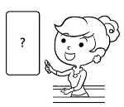
colorblind 色盲 shape 形狀 square 正方形 diamond 菱形 circle 圓形 help 幫助 know知道even if即使safe 安全
33. What traffic light shapes can you see in the news?
(A) 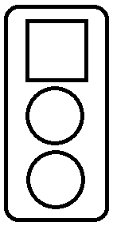 (B)  (C)  (D) 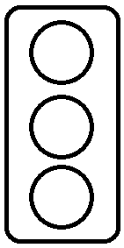
34. What can you do from the news when you see the square light on?
(A) Go. (B) Stop. (C) Speed up. (D) Turn around.
35. What is the news mainly about?
(A) New ways to use old traffic lights.
(B) A new senior high school in Star City.
(C) New traffic lights for colorblind people.
(D) Smart designs for senior high school students.
(二)

A triathlon is a kind of race. In a triathlon, each competitor swims, cycles, and runs over a very long distance. The competitors must do the three parts but can’t take a rest. When they finish swimming and get to the first transition area, they change their clothes and shoes, get their bicycles, and go on to the next stage of the race. Then they arrive at the second transition area, change their clothes and shoes again, and run for the last stage. Usually, in a triathlon, there are aid stations on the course. These competitors can get food and drinks when they pass by aid stations. A triathlon is not an easy sport for most people. These competitors need to be good at swimming, cycling, and running at the same time. They also have to stay healthy and have a strong will to finish the race.
transition area轉移區 aid station補給站 competitor參賽者 distance距離 must必須 last stage最後階段 course跑道 will意志
36. What does “cycles” mean in the reading?
(A) 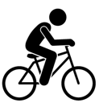 (B) 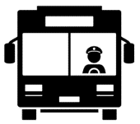 (C)  (D) 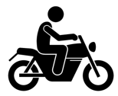
37. What CAN’T competitors do during a triathlon?
(A) They can’t eat. (B) They can’t rest. (C) They can’t run. (D) They can’t change clothes.
38. What is right from the reading?
(A) A triathlon is an easy sport for most people.
(B) There are no transition areas in a triathlon.
(C) There is only one part in a triathlon.
(D) Every competitor has to run over a very long distance.

___________________________________________________________________________________________________________
五、非選擇題:以下答案請用黑筆寫在答案卷上(24%)
A.單字中翻英(4%)
(1) 安靜的(adj.) (2) 選擇(v.) (3) 聲音;歌喉(n.) (4) 跨越(v.)

B.依提示回答(4%)
1. Terry is a good student.(改為祈使句,並在句尾加入please)
2. My brother can dance.(依畫線部分造原問句)

C.整句翻譯(16%)
(1).事實上，世界各地的床都不一樣。
(2). Jenny 是一個十一歲的女孩。她的房子是一間冰屋。
(3).那樣的話，智慧型手機使用者只會佔用其他低頭族的路。
(4).在臺灣你也可以看到像這些的聰明設計嗎？

--------------試題到此結束---------------

新北市立溪崑國民中學113學年度第一學期第二次定期評量 英語科 答案卷
七年級 班 座號 姓名
五、非選擇題:以下答案請用黑筆寫在答案卷上(24%)
A.單字中翻英(4%)
(1).安靜的(adj.) | (2).選擇(v.) | (3). 聲音;歌喉(n.) | (4).跨越(v.)

B.依提示回答(4%)
(1.)
(2.)

C.整句翻譯(16%)
(1).

(2).

(3).

(4).

113-1-2 七年級 英語科－解答
一~四 (2%)
1 | 2 | 3 | 4 | 5 | 6 | 7 | 8 | 9 | 10
B | A | C | B | C | B | B | A | C | A
11 | 12 | 13 | 14 | 15 | 16 | 17 | 18 | 19 | 20
A | C | A | C | B | B | D | C | D | A
21 | 22 | 23 | 24 | 25 | 26 | 27 | 28 | 29 | 30
B | D | C | A | C | D | C | B | D | B
31 | 32 | 33 | 34 | 35 | 36 | 37 | 38
A | C | B | B | C | A | B | D

五 、翻譯:24％
(1).安靜的 | (2).選擇 | (3).聲音;歌喉 | (4).跨越
quiet | choose | voice | cross

B.依提示回答(4%)
(1.)
Terry, be a good student , please.
(2.)
What can your brother do ?

C.整句翻譯(16%)
(1).
In fact, beds around the world are different.
(2).
Jenny is an eleven-year-old girl. Her house is an igloo.
(3).
That way, smartphone users are only in the way of other phubbers.
(4).
Can you see smart designs like these in Taiwan, too?

