新北市立溪崑國民中學113學年度第一學期第三次定期評量 英語科 試題卷
八年級 班 座號 姓名
一、聽力 30%
(一)、辨識句意：每題均有三張圖片，請依據所聽到的句子，選出符合描述的圖片。
- (A)  (B)  (C) 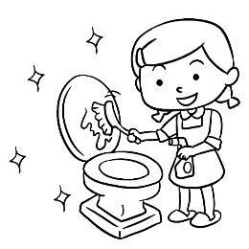
- (A) 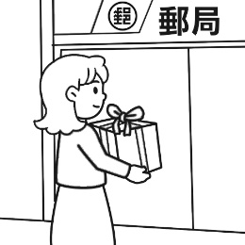 (B) 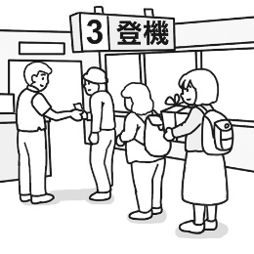 (C) 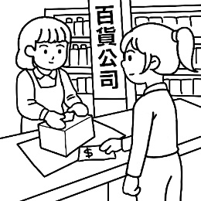
- (A) 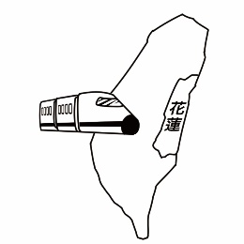 (B) 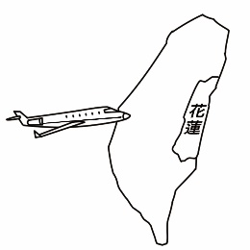 (C) 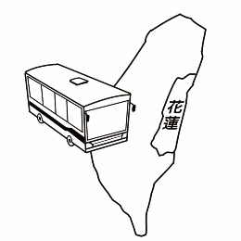
- (A) 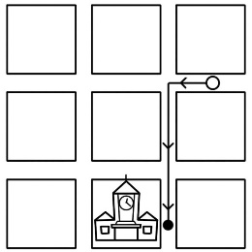 (B) 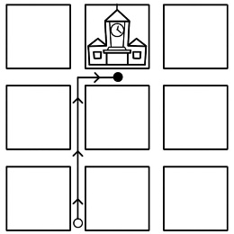 (C) 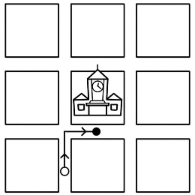
- (A) 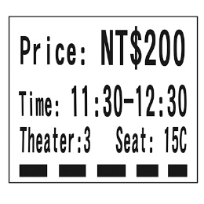 (B) 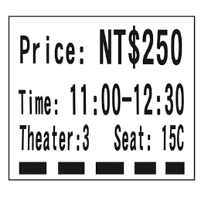 (C) 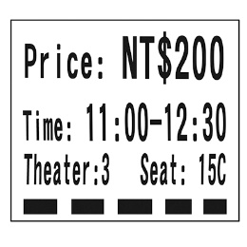
(二)、基本問答：每題均有三個選項，請依據所聽到的內容，選出一個最適合的回應。
- (A) I see. We will leave for Taitung tomorrow.
(B) OK. I can take you somewhere to enjoy the fireworks tomorrow.
(C) Sure. I know a nice department store around here.
- (A) I will leave Taiwan in May.
(B) I am going there next month.
(C) I will live there with my family.
- (A) It shouldn’t be long.
(B) It took me half a day.
(C) It will be a good report.
- (A) Yes, it was interesting.
(B) Yes, it takes one hour.
(C) Yes, it’s one block away.
- (A) We can’t. There aren’t enough parking spaces there.
(B) I can’t. I hurt my leg when I played basketball yesterday.
(C) Well. It’s a great place for shopping, but not for jogging.
(三)、言談理解：每題均有三個選項，請依據所聽到的對話與問題，選出一個最適當的答案。
- (A) She wants to go skiing.
(B) She can’t decide because of the weather report.
(C) She wants to stay home because it will be snowy.
- (A) The boy never sleeps late in the morning.
(B) The boy often stays up on weekends.
(C) The boy can’t get up early on weekends.
- (A) The woman spends thirty minutes going to work by bus.
(B) The man doesn’t take the bus to work.
(C) Both the man and the woman go to work by bus.
- (A) One thousand and two hundred NT dollars.
(B) Two thousand and four hundred NT dollars.
(C) Two thousand and one hundred NT dollars.
- (A) A school teacher.
(B) A reporter.
(C) A bookstore clerk.
二、綜合測驗 44%
16. David went to _______ school in Taichung, but now he goes to junior high school in Taipei.
(A) bakery (B) church (C) elementary (D) bookstore
17. Many people like to go shopping in the ________ when it is hot outside.
(A) nature (B) public (C) scooter (D) department store
18. The restaurant is on the ______ of Park Road and Apple Street.
(A) concert (B) corner (C) truck (D) pocket
19. We are going to watch the _______ at Taipei 101 on December 31.
(A) parking space (B) fireworks (C) bookstore (D) hotel
20. Tom made a _______ yesterday. He brought Tim’s schoolbag home.
(A) excuse (B) mistake (C) monster (D) clerk
21. Tom: What country _____ you visit this winter? Alex: I plan to take a trip to Japan.
(A) are (B) do (C) did (D) will
22. I _____ fifteen minutes _____ to the shopping mall, but looking for a parking space _____ me almost an hour.
(A) spent; to drive; took (B) spent; driving; took
(C) took; to drive; spent (D) took; driving; spent
23. Dad: What _____ you going to do this morning?
Jane: Today is Saturday, but I _____ just say home and clean up my bedroom.
(A) are; will (B) will; am (C) are; am (D) will; will
24. _____ there _____ a baseball game at the Taipei Dome this weekend?
(A) Will; have (B) Will; be (C) Are; going to be (D) Are; going to have
25. Tim: ______ did it _______ you to clean the bathroom? Sally: Thirty minutes.
(A) How long; spend (B) How much; spend (C) How much; take (D) How long; take
26. My good friend, Irene, ______ Taichung this weekend. I’ll take her to some famous places here in Taichung and eat some yummy snacks.
(A) is coming to (B) will go (C) are going to come to (D) are coming
27. Go straight _____ three blocks, _____ you can see the park on your left.
(A) in; x (B) on; and (C) for; and (D) x; or
28. Mrs. Wang can’t ride a scooter. She _____ the metro to work every day.
(A) makes (B) takes (C) flies (D) drives
29. By the way, remember ______ a heavy coat and a hat because the winter here is very cold.
(A) bring (B) to bring (C) bringing (D) brings
30. I always go to work_____. It takes me thirty minutes to walk from home to my office.
(A) by metro (B) in a car (C) on foot (D) by bus
31. We _____ a bus to Taipei, but we came back home _____ train.
(A) drove; on (B) flew; in (C) took; by (D) rode; in a
32. Jerry: Did buying the new car _____ you a lot? Leo: You bet. I _____ most of my money for it.
(A) spend; spent (B) cost; cost (C) pay; paid (D) cost; paid
33. Mom will pick me up at the school after she _____ her office tomorrow.
(A) leaves (B) leaving (C) will leave (D) left
34. Derek: Excuse me. How do I get to CK Junior High School?
Allen : _______
(A) It’s on the corner of Green Road and Happy Street.
(B) Go along this road for two blocks. Then you can see it on your right.
(C) It’s across from the movie theater.
(D) You can go to the park by bike or by bus.
35. The Lin’s are reading a ______ and trying to find the museum.
(A) map (B) bank (C) supermarket (D) post office
36. I went to the restaurant across the street last night. The food was terrible, and the waiters were not nice to people .
I ______ there again.
(A) can’t go (B) don’t go (C) didn’t go (D) won’t go
37. Ben: will Ken go to the church next week?
Lee: He will his motorcycle there.
(A) How; take (B) What; take (C) What; ride (D) How; ride

三、克漏字 16%
(一)
Dear Dad and Mom,
Now, Vivian and I 38. in Australia. We are not in Green Hotel because it was too 39. and far away from the city of Sydney. We are at a youth hostel. It is small, but it is clean and doesn’t 40. us too much. We love Sydney so much. People here are friendly. Food is delicious, especially seafood. It is cool at night, and sometimes you may need to wear a jacket. 41. and we are happy to be here. Hope you can come with us next time. 42. my love to Grandpa and Grandma.
Love,
Josephine
youth hostel 青年旅館 especially 特別是
38. (A) were (B) am (C) are (D) will be
39. (A) expensive (B) modern (C) different (D) handsome
40. (A) spend (B) cost (C) take (D) pay
41. (A) We both caught a bad cold (B) We make much money
(C) We have a lot of fun (D) We don’t like the trip
42. (A) To send (B) Sending (C) Send (D) Sent

(二)

From: Pei-Ching (peiching2001@ckjhsmail.com)
Date: Tuesday, June 25, 2024
Subject: Re: I’m coming to Taipei!
Hi , Yuri,
You are finally coming to Taipei! Just walk to Keelung Train Station and take the train to Taipei Station.
Call me on the train and I’ll wait for you at Gate North of Taipei Station. 43 :
(1) I will give a SIM card so you can use the Internet. Don’t worry.
(2) You can visit Taipei 101, the National Palace Museum, and many other cool places. The MRT and buses
44 .
(3) The weather is mostly sunny or cloudy. It may rain heavily in the afternoon, but usually not for long.
See you soon,
Pei-Ching

*******************************************************************************************
From: Yuri Katou (ykjp1999@mail.santa.co.jp)
Date: Monday, June 24, 2024
Subject: I’m coming to Taipei!
Hi Pei-Ching,
I’ll be in Taipei from July 2 to 11!! My ship will 45. Keelung Port at 1 p.m. on July 2. How do I get
to Taipei City to meet you? I have some other questions:
(1) I need to use the Internet during my stay. Where can I get it?
(2) What are some good places to visits in Taipei?
(3) How’s the weather now in Taipei?
Lots of love,
Yuri
Re: 回覆 port 港口
43. (A) To give you some tips before you ask (B) To show you fun things to do in Taipei
(C) To help you learn more about the city (D) To answer the questions in your last e-mail
44. (A) are the convenient ways to move around the city
(B) can take you from Keelung to Taipei in an hour
(C) are good for moving between different cities in Taiwan
(D) can be full of people in the morning when people go to work or school
45. (A) arrive at (B) lead to (C) go from (D) start in
四、閱讀測驗 10%
(一)
This April, Tina will come to Taiwan to visit her Taiwanese friend, Kevin. Tina is interested in Taiwanese culture, so he invited her to go on the Dajia Mazu Pilgrimaged with him.
The pilgrimage is very important religious event in Taiwan. It is also one of the most popular goddesses in Taiwan. Mazu is the goddess of the sea, and it is said that she always takes care of the fishermen on the sea.
The Dajia Mazu Pilgrimage lasts about nine days every year and during the pilgrimage, the Mazu statue is carried all the time by the people from the temple. More than two thousand people will also join this event, and they will walk from city to city, over a long distance of more than 300 miles.
After Kevin meets Tina, they will prepare for their trip to Taichung. Luckily, it seldom rains in Taichung, so they only need to bring some summer clothes and a light jacket. They also need comfortable shoes because they will have to walk a lot during the pilgrimage. As for the places to stay, Tina is surprised to learn that Kevin didn’t book any hotel rooms. Kevin said that many people will let them stay for free at their places or that they can stay in the temples. They can also get free foods on the way. “This is the best way to experience the kindness of Taiwanese people! “Kevin said. Tina can’t wait to start the trip.

culture 文化 Daijia Mazu Pilgrimage 大甲媽祖繞境 religious 宗教的 event 事件
goddess 女神 statue 雕像 distance 距離

46. Who is Mazu?
(A) The goddess of the sea. (B) Kevin and Tina’s friend.
(C) A person from the temple. (D) A fisherman of the sea.
47. Why did Kevin Not book hotel rooms before the trip?
(A) People will pay for the hotel rooms for them. (B) People will share their houses for free.
(C) Tina will book hotel rooms for them. (D) They will sleep on the streets.
48. What can we learn from the reading?
(A) The Daijia Mazu Pilgrimage is held only in Taichung City.
(B) The Mazu statue stays in the temple during the pilgrimage.
(C) Kevin is not a Taiwanese.
(D) Tina is not a Taiwanese.
(二)
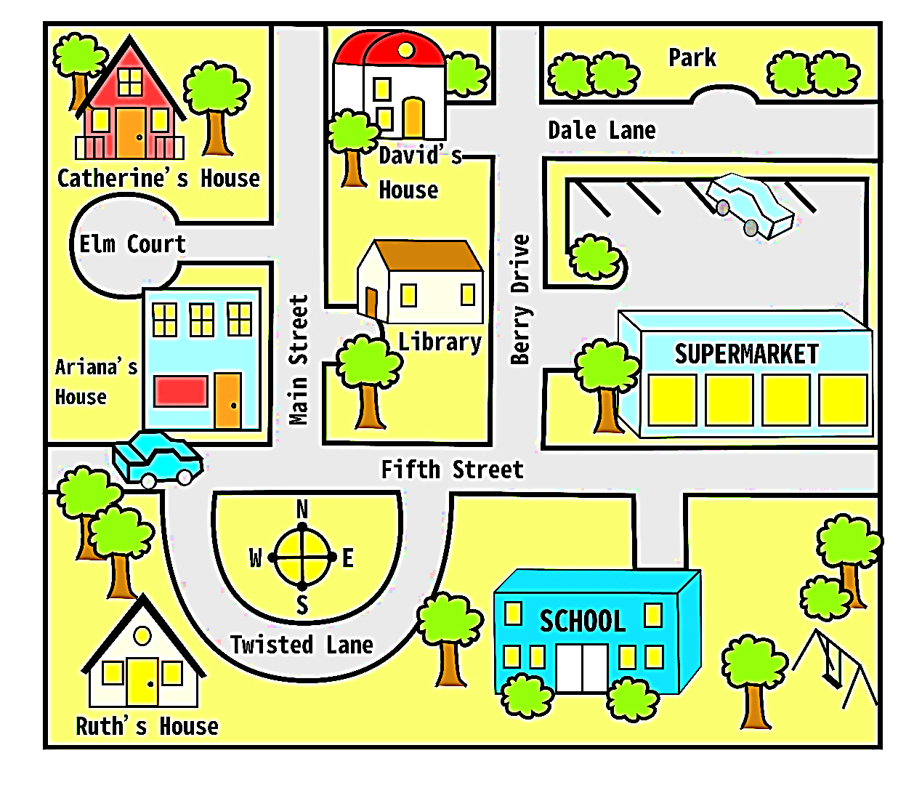
49. Which of the following is true about the map?
(A) Ariana’s house is across from David’s. (B) Both Ruth and Ariana live on Main Street.
(C) There is a parking lot at the back of the supermarket. (D) The school is behind the library.
50. Catherine leaves her house and walks east on Elm Court. She turns right and goes south on Main Street. Then she turns east on Fifth Street. At Berry Drive, Catherine walks north. Then she turns right on Dale Lane. What’s on her left?
(A) The park. (B) The supermarket. (C) David’s House. (D) The library.

113-1-3 八年級 英語科－解答
1-5 BAABC 6-10 CBBCB 11-15 ACCBA 16-20 CDBBB
21-25 DBABD 26-30 ACBBC 31-35 CDABA 36-40 DDCAB
41-45 CCDAA 46-50 ABDCA

