新北市立溪崑國民中學113學年度第一學期第二次定期評量 英語科 試題卷
八年級 班 座號 姓名
一、聽力測驗25%
(一)辨識句意：每題均有三張圖片，請依據所聽到的句子，選出符合描述的圖片5%

(A)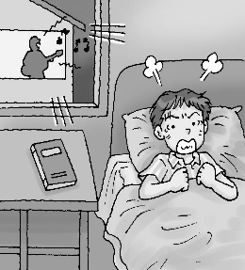 (B)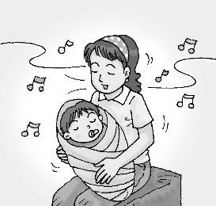 (C)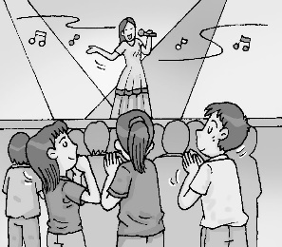

(A)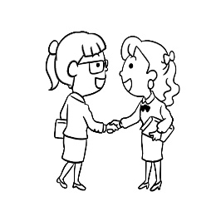 (B)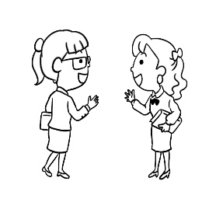 (C)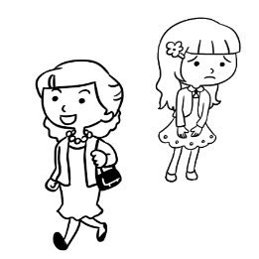

(A)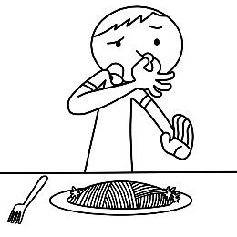 (B)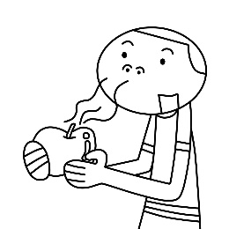 (C)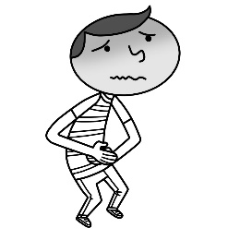
4.
(A)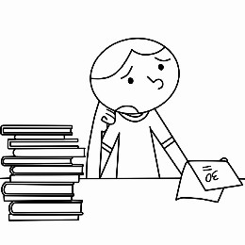 (B)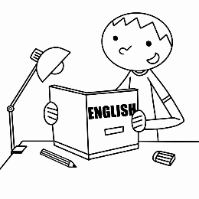 (C)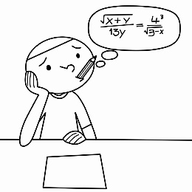
5.
(A)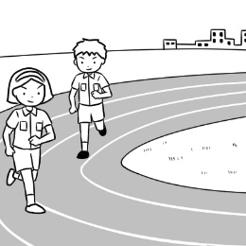 (B)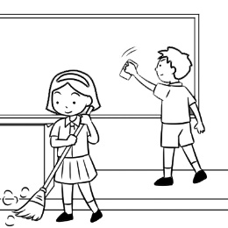 (C)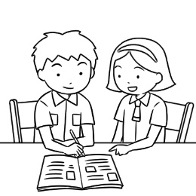
(二)基本問答：每題均有三個選項，請依據所聽到的內容，選出一個最適合的回應10%
6. (A) Because that led to a serious problem. (B) Because some men were fighting just now.
(C) Because the place was popular with teenagers.
7. (A) Finish your homework first. (B) I don’t have any homework today. (C) That’s a good habit. I usually watch TV first.
8. (A) Yes, and she is still working on it. (B) Yes, she started it after her dad got home.
(C) Yes, before her dad got home, she already finished it.
9. (A) No, I don’t know the reporter. (B) No, thanks. I can do it without you.
(C) No, I don’t want to help you write the report.
10. (A) Well, it’s a good basketball game. (B) Everything is OK. Don’t worry about me. (C) Of course. We can work together.

(三)言談理解：每題均有三個選項，請依據所聽到的對話與問題，選出一個最適當的答案10%
11. (A) After the meeting. (B) Before the meeting. (C) In the middle of the meeting.
12. (A) She lost her parents. (B) She doesn’t have parents. (C) She can’t find her parents.
13. (A) Because she listened to a lot of famous songs. (B) Because she took pictures with her favorite singers.
(C) Because she sang a lot of songs with the woman.
14. (A) A writer. (B) A reporter. (C) A police officer.
15. (A) He isn’t healthy. (B) He has sleep problems. (C) He often has bad dreams when he sleeps.

二、綜合測驗30%
16.( ) Zack: What do you want to be in the ? How about being a singer?
Liz: I like to, but I can’t. I can’t sing in front of too many people, you know.
(Ａ) country (Ｂ) future (Ｃ) idea (Ｄ) interview
17.( ) Alice doesn’t take medicine when she has a cold. She believes the body is able to the cold by itself.
(A) fight (B) hunt (C) pass (D) catch
18.( )After talking with her art teacher, she plans to keep comics in her free time.
(A) to practice to draw (B) practice to draw (C) practicing drawing (D) to practice drawing
19.( ) I write down everything about work in my blue notebook; it, I can’t do anything.
(A) after (B) before (C) outside (D) without
20.( ) Jane was not home when the brought the package, so she’ll have to get it at the post office.
(A) bus driver (B) mail carrier (C) secretary (D) police officer
21.( ) Every time Grandpa forgets where he puts his cellphone in the house, he always calls his own number with my cellphone to
it. (A) find (B) pick (C) notice (D) count
22.( ) When the kid was trying to pick up the plate, it from the table, hit the floor, and broke into pieces.
(A) arrived (B) hung (C) jumped (D) dropped
23.( ) Playing games on the cellphone popular with junior high school students. (A) is (B) are (C) to be (D) being
24.( ) Amy her mother make apples pies this afternoon. (A) wanted (B) helped (C) asked (D) planned
25.( ) It’s kind you to help me to do the housework. (A) for (B) at (C) of (D) to
26.( ) Sandy usually read a book before she to bed. (A) goes (B) going (C) went (D) was going
27.( ) Ricky in the park at six this morning. (A) jog (B) jogged (C) is jogging (D) was running
28.( ) in the day time is not good for you. You may not sleep well at night and feel tired the next day.
(A) Sleep (B) Slept (C) Sleeping (D) To sleeping
29.( ) Good eating habits important, for example, eating slowly.(慢慢地)
(A) is (B) are (C) be (D) being
30.( ) Tony practiced badminton with his classmates after school. (A) plays (B) played (C) to play (D) playing

三、克漏字測驗 8%
Sean needed to find a job after college, but there was a problem. Choosing a good job 31. .
At the dinner table one night, his father said to him, ‟Find your love and go for it. It’s very important. I worked for so many years, but in fact, I didn’t really enjoy my job.” Because of his father’s words, Sean 32. . That night, he told himself, ‟I will try different kinds of jobs. I have to find my favorite one.”
Sean did a new job each week for a year. That’s a total of 52 jobs. One week, he milked cows every morning as a farmer. Then for another week, he was a scientist. He had to study the night sky. Later, he worked as a radio DJ. He played songs and talked to people on the air. 33. , Sean’s favorite job was teaching. He was really happy about helping and taking care of his students.
In Sean’s eyes, it was fine not to have a dream job right away. He wrote a book about doing those 52 jobs, and he 34. a lot of college students. ‟Never stop trying. You’ll find your dream job one day. After all, I found mine.”
 college 大學 total 總共 scientist 科學家 radio 廣播節目
31. ( ) (A) was easy for him (B) was exciting to him (C) was important to him (D) was never easy for him
32. ( ) (A) had to listen to his father (B) needed to make some money (C) wanted to have a different future
(D) planned to do his father’s work
33. ( ) (A) Also (B) However (C) At first (D) For example
34. ( ) (A) told his story to (B) enjoyed kidding with (C) stopped working with (D) practiced speaking English with
四、閱讀測驗 18%
(一) I still remember the day. It was about half past two in the afternoon, and there were no customers in the restaurant. I was
cleaning a table when a sad little boy opened the door. His clothes were thin and not warm enough for the cold and rainy
weather outside.
He came up to me and asked, ‟May I have some food? I only need a little.” I told him, ‟Sure. Have a seat.” Then he
answered, ‟I can’t. I don’t have money.” Mary came over and joined us. She said, ‟It’s OK. Our cook Tina is preparing
lunch for us. You can sit down and have some.” The boy shook his head and said, ‟I can’t stay. My grandma is waiting for me
outside.” So, I said, ‟Well, while we are setting the table for lunch, why don’t you go get your grandma and bring her here?”
When the boy heard that, he smiled and ran out the door. Five minutes later, Mary, Tina, and I were enjoying a nice meal
with the boy and his grandma. From the day on, we often had lunch with our new friends during the restaurant’s afternoon break. remember 記得 customer 顧客 while 當……的時候 hear 聽到during 在……期間
35. ( )What do we know about the boy?
- He is funny. (B) He is hungry. (C) He is famous. (D) He is tall and thin.
36. ( )Who are the “new friends”?
(A) Mary and Tina. (B) Tina and the boy. (C) The boy and his grandma. (D) New customers in the restaurant.
37. ( )What can we say about “the day”? heart 內心 wet 潮濕的
(A) It was cold outside but warm in the people’s hearts. (B) The sun was bright, but the restaurant was cold and wet.
(C) It was a good cleaning day for the people in the restaurant.
(D) It was raining hard, so there were no customers in the restaurant.

(二) When I was walking in the park yesterday, I ran into Tina. She was sitting under the tree and smiling at her dog.
Tina and I worked together four years ago. She was the team leader, and no one liked her because she was very
strict. She always said things like,“Never chat at work” and “Finish your lunch in half an hour.” The team did a good job, but no one ever saw a smile on her face. However, she is so different now!
I said hello and sat down next to Tina. Then she told me her story. She said, “I cared too much about work and was
always under pressure, so I was unhappy. Then Lucky changed my life. When I found him on the street, he was dirty and hungry. I brought him home and took care of him. Now, Lucky is healthy, and my life is different.” I felt really happy for Tina.
smile 微笑 leader 領導者 ever 曾經 under pressure 壓力大的 unhappy 不高興的
38.( ) Which is the best title for this reading? best title 最好的標題
(A) Tina’s Pet. (B) Tina’s Team. (C) Tina’s Change. (D) Tina’s Rules.
39.( ) Who is most likely a “strict” person? most likely 最有可能
(A) Lydia. She seldom talks. (B) Paula. When she sleeps, she doesn’t like any noise.
(C) Terry. He has a dog, and he plays with it every day.
(D) Jason. When you work with him, there is no room for mistakes. room 空間 mistake 錯誤
40.( ) What do we know about Tina and the writer? writer 作者
(A) The writer was Tina’s good friend. (B) The writer was on Tina’s team at work.
(C) The writer never liked Tina, and she still doesn’t. (D) The writer liked Tina when they worked together.
(三) Is it possible for boys to wear skirts to school in Taiwan now? The answer is YES, and it has been so since September 2019. Banqiao Senior High School in New Taipei City changed its dress code to allow male students to wear skirts to school. The
reason why the school made the new change is to promote gender equality, not to ask boys to do that. The school also wants
students to make choices by themselves and respects their decisions. Not only boys but also girls can wear either pants or skirts to
school. However, students are not free to wear whatever they like. They must follow the uniform rules of the school. What they
wear to school must be dark blue or black. Besides, the skirts must not end higher than 10 cm above the knees. Banqiao Senior
High School is the first school to allow boys to wear skirts to school in Taiwan. Because of this, many schools like Taichung First
Senior High School and Taipei Municipal Jianguo(建國) High School also made a big change in their school uniform rules.
It's not the latest news, but it's a big one in Taiwan. Maybe by the time when you read this article, more and more schools have been joining in.
dress code 服儀規定 promote 提倡 gender equality 性別平等 respect 尊重 whatever 不管什麼樣的
41.( ) What does the word male mean?
(A) Boys. (B) Girls. (C) Children. (D) Teenagers.
42.( ) What do we know from the reading?
(A) The big change has been around for a few years.
(B) All the students in Taiwan can wear what they like to schools now.
(C) No other schools in Taiwan agree with Banqiao Senior High School.
(D) The male students in Taiwan are being asked to wear skirts to school.
43.( ) What does the writer think about the new rule?
(A) He has no feeling about it.
(B) He thinks students should be asked to wear skirts.
(C) He thinks it sets a bad example for all the other high schools.
(D) He thinks students can wear whatever they like to school in the near future.

五、依提示改寫 4%
44. Allan walked to school after eating breakfast with Betty. (Before放句首改寫句子)
45. Finishing homework on time is difficult for some teenagers. (用It放句首改寫句子)

六、翻譯15%
46.然而，這個工作有兩個面向。
47.我喜歡演戲，也享受製作影片，但我做那些事只是為了好玩。
48.烏鴉Tina和雞Billy正在太陽下沿著道路行走。
49.最後，當他們丟入最後一顆石頭時，罐子裡的水上升到頂端。

新北市立溪崑國民中學113學年度第一學期第二次定期評量 英語科 答案卷
八年級 班 座號 姓名
五、依提示改寫4%
44.
45.

六、翻譯15%
46.
47.

48.

49.

113-1-2 八年級 英語科－解答
1-5 ACCBA 6-10 BCABC 11-15 ACBBA
16-30 BACDB ADABC CDCBD
31-34 DCBA 35-37 BCA 38-40 CDB 41-43 AAD
44. Before Allan walked to school, he ate breakfast with Betty. (Before放句首改寫句子)
45. It is difficult for some teenagers to finish homework on time. (用It 改寫句子)
46. However, there are two sides to this job.(3%)
47. I like acting and I enjoy making videos, but I only do those just for fun.(4%)
48. Tina the Crow and Billy the Chicken were walking along the road in the sun.(4%)
49. Finally, the water was at the top of the jar when they dropped the last rock.(4%)

新北市立溪崑國民中學113學年度第一學期第二次定期評量
八年級 英語科 聽力測驗稿

(一)辨識句意：每題均有三張圖片，請依據所聽到的句子，選出符合描述的圖片
- CD: Someone was singing loudly outside. The noise woke Bob up, and he couldn’t go back to sleep again.
- CD: (W:) When I saw Kelly this morning, she didn’t say anything but just walked past me.
- CD: The boy feels terrible. He has to go to the toilet now.
- CD: Studying is interesting for the student. He enjoys it very much.
- CD: Maria teamed up with her friend. They practice for a running race every day.
(二)基本問答：每題均有三個選項，請依據所聽到的內容，選出一個最適合的回應
- CD: Why are there police officers in the gym?
- CD: I always do my homework after I get home.
- CD: Was Emily doing her homework when her dad got home?
- CD: Do you want me to help with your report?
- CD: You’re really good at playing basketball. Can I team up with you?

(三)言談理解：每題均有三個選項，請依據所聽到的對話與問題，選出一個最適當的答案
11.CD:
M: Why were you late for the meeting this morning?
W: It was rainy, and there were a lot of cars on the road.
M: Why didn’t you call me? It was an important meeting!
W: I tried to call you, but I couldn’t reach you.
Q: When did the talk take place?

- CD:
M: Look, there is a girl by the side of the road.
W: She’s crying. Let’s go help her.
M: Hi, little girl. Do you need help? Where are your mom and dad?
G: I don’t know. I’m looking for them. Please help me.
Q: What happened to the girl?

- CD:
M: How was the festival last night?
W: Linda was so happy because she saw her favorite singers and even took pictures with them.
M: What about you? Did you enjoy it?
W: Of course, I did. It was really exciting to listen to lots of famous songs.
Q: Why was Linda happy last night?

- CD:
W: Two men fought by the side of River Road because one man threw trash at the door of the other man’s house. No one could stop them. They even broke a restaurant’s windows. Finally, the police came and took them both to the police station. This is Lisa Wu reporting from Hill Town. Q: What does Lisa do?
15. CD:
W: Robert enjoys playing video games. He usually stays up and only sleeps three to four hours
a day. That’s because he wants to be a pro gamer and make a lot of money. However, he has
health problems. Robert stays up almost every day, so he often catches a cold. Sometimes he
even has a serious headache. Being a pro gamer may be bad for his health. Robert really has
to think again about his dream.
Q: What is Robert’s problem?

