新北市立溪崑國民中學113學年度第一學期第三次定期評量 英語科 試題卷
九年級 班 座號 姓名
第一大題 聽力測驗(1-15題，共30分)
第一部分 辨識句意：根據聽到的內容，選出符合描述的圖片或符合圖片的描述。(1-5題，每題2分)
( ) 1. | (A) | (B) | (C)
 | 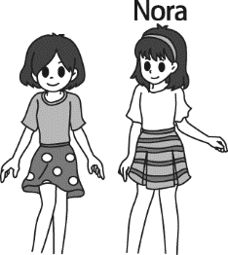 | 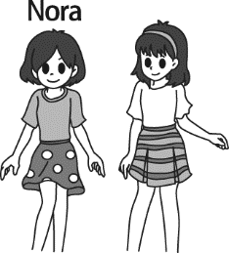 | 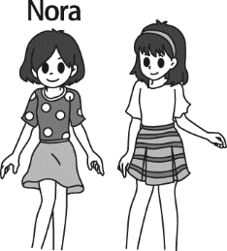
( ) 2. | (A) | (B) | (C)
 | 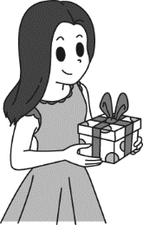 | 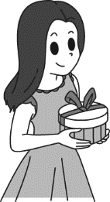 | 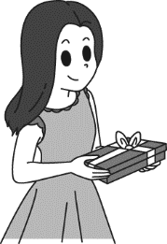
( ) 3. | (A) | (B) | (C)
 | 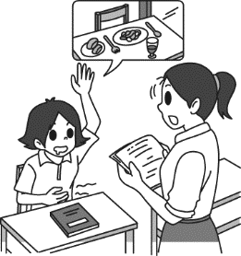 | 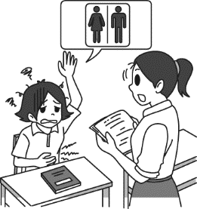 | 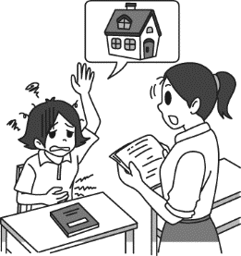
( ) 4. | (A) | (B) | (C)
 | 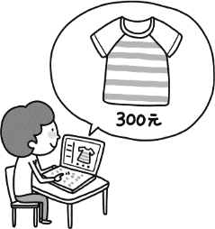 | 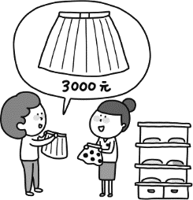 | 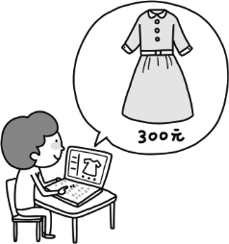
( ) 5. | (A) | (B) | (C)
 | 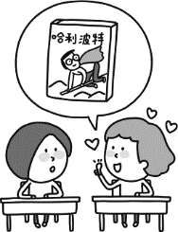 | 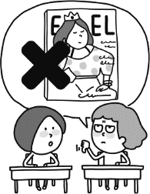 | 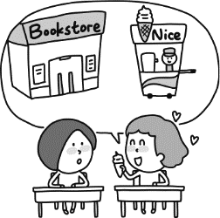

第二部分 基本問答：根據聽到的內容，選出一個最適合的回應或最適合的問句。(6-10題，每題2分)
( ) 6. (A) The glasses are on the table. (B) That is Ms. Wu, our new Chinese teacher.
(C) She enjoys singing in public.
( ) 7. (A) Is he the one who wears a school uniform? (B) No way. He is afraid to speak in public.
(C) Would you please buy me a string of pearls?
( ) 8. (A) That’s not surprising. He lives nearby. (B) Let’s look it up in the dictionary.
(C) I can meet you on the third floor.
( ) 9. (A) Why don’t you tell your parents the truth? (B) Then why did you leave Taichung?
(C) I have lived there for more than ten years.
( ) 10. (A) It was too hot to wear. (B) I like it very much.
(C) I feel so surprised to see him again.

第三部分 言談理解：根據聽到的內容，選出一個最適合的答案。 (11-15題，每題2分)
( ) 11. (A) She came here to take pictures. (B) She came here to learn Chinese.
(C) She came here to travel around Taiwan.
( ) 12. (A) They can go to the second-hand store to check first. (B) They can order anything online.
(C) They have to do the recycling at least two times a week.
( ) 13. (A) Jeff is a person who likes museums a lot. (B) Jeff has never been to any foreign countries.
(C) Jeff thinks the Louvre is the worst museum in the world.
( ) 14. (A) An actor. (B) A businessperson. (C) A fisherman.
( ) 15. (A) Monday. (B) Tuesday. (C) Wednesday.
第二大題 綜合測驗 (16-30題，每題2分，共40分)
( ) 16. A shy person may be afraid to speak in _______.
(A) public (B) front (C) time (D) somewhere
( ) 17. Mookie has been in Taiwan for over five years. He is no ______ to using chopsticks when he eats.
(A) trouble (B) difficult (C) stranger (D) foreigner
( ) 18. I don’t trust anyone here ______ Linda. She is the only friend I have here.
(A) besides (B) beside (C) except (D) expect
( ) 19. When I heard that my dad was injured in a car accident, my mind went _________ all of a sudden.
(A) sad (B) blank (C) light (D) heat
( ) 20. Hard work is the _______ to success.
(A) mother (B) key (C) prize (D) bottom
( ) 21. They are thinking about buying a _______ of pearls as their mother’s birthday gift.
(A) strong (B) line (C) string (D) style
( ) 22. When I tried asking Lisa if she and Jim were dating, she just told me to mind my own ________!
(A) thing (B) business (C) trouble (D) hobby
( ) 23. I like this ______ jacket because I can hardly feel its weight when I wear it.
(A) pin (B) blind (C) light (D) fairy
( ) 24. Clerk: How do you like this dress, ma’am? Customer: It looks fit on me, but I’m not into its color. Can I try _______ one?
(A) another (B) others (C) the other (D) the others
( ) 25. It _______ that Lily likes the new English teacher a lot. She studies much harder than before.
(A) looks (B) appears (C) perhaps (D) notices
( ) 26. A: Let’s play basketball after school. B: Sorry. _______. How about tomorrow?
(A) No worries. (B) Glad to meet you. (C) I have bigger fish to fry. (D) I’m broke.
( ) 27. Be sure to drink enough water and keep yourself cool when you work in the ______ of the day.
(A) hot (B) seat (C) town (D) heat
( ) 28. Nancy ______ on the grass and read her favorite novel, feeling satisfied.
(A) lied (B) seat (C) lies (D) lay
( ) 29. Jack has been preparing for the coming test very hard. I think we can give him a present ______ he gets a good grade.
(A) that (B) which (C) if (D) so
( ) 30. Emily: What’s wrong with Joe? He looks so sad. Tim: His dog died last week. _________
(A) He’s like on the planet. (B) He’s no stranger to that.
(C) From then on, he’s been like that. (D) Welcome to the real world.
第三大題 克漏字測驗 (31-39題，每題2分，共18分)
(31-35)
Food is a big part of French culture. It is said 31. French people live to eat, and the rest of the world eat to live. That’s why the most famous food guide in the world, the Michelin Guide, is from France.
Michelin is a tire company 32. the Michelin brothers started in 1889. At that time, not many people owned a car in France. 33. more tires, the Michelin brothers thought of an idea. Because French people loved food so much, the brothers decided to write a book that showed all the good restaurants in different cities. And that’s 34. the Michelin Guide was born. This way, people would drive more to try the food, and Michelin could sell more 35. .
tire 輪胎
( ) 31. (A) which (B) that (C) what (D) why
( ) 32. (A) which (B) what (C) whether (D) where
( ) 33. (A) Sold (B) Selling (C) To sell (D) By selling
( ) 34. (A) which (B) what (C) where (D) how
( ) 35. (A) food (B) restaurants (C) tires (D) books

(36~38)
Florence Nightingale was born on May 12, 1820 and died at age 90. She came from a rich family and had a very good education. She enjoyed helping people when she was little. In 1851, she went abroad to take care of poor people for three months. After that, she decided to become a nurse. Her parents 36. because at that time, only people who lived at the bottom of society would choose to be a nurse.
In 1853, the Crimean War started, and Nightingale was the first woman 37. to help in the war. When she arrived at the hospital, she found out 38. . Many soldiers died not because of the war 39. the poor condition of the hospital. Nightingale then made the hospital a better place for the soldiers. After the war ended, she also wrote books to spread medical knowledge. She really did her best to change the medical world.
society 社會 condition 狀況 medical 醫療的

( ) 36. (A) were glad about it (B) were unhappy about it
(C) needed her to make money (D) wanted her to be a doctor
( ) 37. (A) sending (B) to send (C) to be sent (D) send
( ) 38. (A) how many people died in the war (B) there wasn’t any woman but her there
(C) how terrible the hospital was (D) they had won the war
( ) 39. (A) but (B) however (C) and (D) or

第四大題 閱讀測驗 (40-50題，每題2分，共22分)
(40~41)
Twitter's power in the political world should be taken seriously. In fact, some say that Twitter even helped Donald Trump win the 2016 US presidential election. Twitter limits its posts to 140 characters, and this makes it a perfect tool for Donald Trump, who likes to use simple language to express himself.
However, there is another trick which helped Trump win. Look at the chart. During a week in September 2016, around 20% of tweet posts about the US presidential election were actually created and posted by computer programs. That's around 4 million posts! These posts shaped online discussions about the election and affected people's understanding of what others thought about Donald Trump. In fact, a large number of the posts led people to believe that there were many Trump supporters across the United States. And it was possible that people's choices in the election were affected as a result.
Donald Trump, of course, made it clear that he had nothing to do with the people behind the programs. Instead, he believed that he won the election because he was the better candidate than Hillary Clinton. Not everyone agrees with this, but his supporters do.
political 政治的 presidential election 總統大選 limit 限制 character 字元 express 表達 supporter 支持者

( ) 40. What does the word "candidate" refer to?
(A) A person who is competing for a job.
(B) A game in which people are competing for money.
(C) A deal that people make in business.
(D) A job that tests people's limits.

( ) 41. According to the writer, which of the following may be the reason why Trump won the presidential election?
(A) Hillary Clinton was not as good as Donald Trump. (B) Computer programs created wrong beliefs.
(C) The number of Clinton's supporters was getting higher. (D) More and more ads were posted to Twitter.

(42~44)
Work From Home
In most companies, workers spend five days a week at the office. They often spend 30 minutes or longer traveling to and from work. During busy hours, traffic and pollution are often quite serious. Teleworking (also called telecommunicating) is one way to fix these problems.
Teleworkers have office jobs, but they work from home one or more days each week. Using phones and computers with internet, they can do all their office work. Many jobs, such as sales, design, and even office management, can be done at home.
Teleworking has many advantages. With fewer cars on the road, traffic and air quality get better. Companies save money by using less light power or water for restrooms. Also, employees don't need to spend time taking a bus or taxi. They can get more sleep or enjoy a great breakfast.
However, some companies are slow to move to telework. They think employees need managers to look over their shoulders, or they won't work hard. In fact, studies show that to be far from the truth. People actually get 25% more work done when they telework.
There are already more than 20 million teleworkers in Europe and the USA. Japan has more than 10 million, and Australia has about 3 million. These numbers are growing because more people are learning the help of this new working style. How about you? Do you like to work from home? Imagine you go down the hall to your home office. Here you have everything you need to do your work. You don't have to hurry to work in a car or on the subway to work anymore. WFH is a good idea, isn't it?
management 經營 quality 品質 employee 員工

( ) 42. What do advantages mean here?
(A) Codes. (B) Changes. (C) Problems. (D) Good points.
( ) 43. In the last paragraph, the writer says, “These numbers are growing larger and larger because more people learn the help of
this new working style.” Who may agree with this new working style?
(A) Sam likes working with a real and warm smiling face more than talking to a cold machine.
(B) Paul still keeps driving his taxi hard to make a little money for his own life.
(C) Anna’s business is becoming successful because her workers work happily at their own places.
(D) Molly sends her kid to school and her husband to his office; both their places are near her office.
( ) 44. Who looks over someone’s shoulder?
(A) Leo, who watches his students carefully when they take their science tests.
(B) Hank, who seldom helps Joe with math but just laughs at him badly.
(C) Ms. Li, who is worried about our health because we have little sleep and much homework.
(D) Serina, who enjoys listening to music and having some snacks with friends at the party.

(45~47)
You are on a plane and ready to take your first bite of airplane food, but it doesn't taste as good as it does on land. So, why do food and drinks on airplanes taste different?
In fact, we tell flavors through our senses of smell and taste. Sadly, those two senses become less strong when we fly 30,000 feet above the Earth. The humidity level in the air is only 12%, and the air pressure is really low. As a result, our noses don't work so well. When our noses don't work well, our sense of taste doesn't, either. That is because 80% of our sense of taste comes from our sense of smell. Therefore, salty and sweet flavors go down by about 30%. On top of that, the loud noise from the plane makes the problem even worse. Luckily, we can still taste bitter, sour, and spicy flavors.
flavor 風味 humidity level 濕度 air pressure 氣壓
chili pepper 辣椒 vinegar 醋
Now, you know what changes the taste of food and drinks on airplanes. So, the next time you are on a plane and taste something bad, the problem may not just be with the cooks.

( ) 45. What are the airlines most likely doing to make their food taste better?
(A) Using sugar as little as possible. (B) Adding more salt to their dishes.
(C) Cooking with a lot of chili pepper. (D) Putting twice vinegar in the food.
( ) 46. According to the reading, which does NOT make airplane food taste bad?
(A) The air pressure is low. (B) The loud noise from the plane.
(C) The cooks on the plane are terrible. (D) The air is dry.
( ) 47. Which chart shows the changes when we fly?
(A) (B)

(C) (D)

(48~50)
Steve: Honey! There must be something wrong with the electricity bill! We have to pay $4,200this time?
Pepper: Let me see. Well, I think the number is correct. The date of the bill is from July to August. The fees during summer time are
higher, remember?
Steve: So, the fee is for two months?
Pepper: Of course, darling.
Steve: But, I still don’t get it. We used 1,400 kWh this July and August. How did Taiwan Power Company do the math?
Pepper: They collect fees according to electricity consumption, and there are six grades: below 200kWh, 201 to 600kWh, 601to
1,000 kWh, 1,001 to 1,500 kWh, 1,501 to 2,000 kWh, and over 2,000kWh. Each has different prices. Also the electricity fees are different from June to September.
Steve: It’s so confusing!
Pepper: We used 1,400kWh this time, right? The total fee is (1ꓫ200) +[(2ꓫ(600-200)] + [3ꓫ(1000-600]+ [5ꓫ(1400-1000)].
Get it?
Steve: Umm…
Pepper: No worries! All you have to do is to try hard to keep the electricity consumption in the lower grades to save more money.
Now, turn off the AC!
electricity bill 電費帳單 fee 費用 consumption 消耗
Grades | 200↓ | 600↓ | 1,000↓ | 1,500↓ | 2,000↓ | 2,001↑
☒Summer | 1.0 | 1.5 | 2.5 | 4.0 | 4.5 | 6
☑Summer | 1.0 | 2.0 | 3.0 | 5.0 | 6.0 | 7.0

( ) 48. How often does Taiwan Power Company collect fees?
(A) Every month. (B) Every season. (C) Every other month. (D) Half a year.
( ) 49. In September, how much does each kWh cost from 1,001 to 1,500kWh?
(A) 2.5 TWD. (B) 4.0 TWD. (C) 5.0 TWD. (D) 6.0 TWD.
( ) 50. Mr. Chen’s family used 950kWh during November and December. How much should they pay?
(A) 2,050 TWD (B) 1,344 TWD (C) 2,746 TWD (D) 838 TWD

113-1-3 九年級 英語科－解答
1 | 2 | 3 | 4 | 5 | 6 | 7 | 8 | 9 | 10
B | A | B | C | A | B | A | A | B | B
11 | 12 | 13 | 14 | 15 | 16 | 17 | 18 | 19 | 20
A | A | A | C | A | A | C | C | B | B
21 | 22 | 23 | 24 | 25 | 26 | 27 | 28 | 29 | 30
C | B | C | A | B | C | D | D | C | C
31 | 32 | 33 | 34 | 35 | 36 | 37 | 38 | 39 | 40
B | A | C | D | C | B | C | C | A | A
41 | 42 | 43 | 44 | 45 | 46 | 47 | 48 | 49 | 50
B | D | C | A | B | C | C | C | C | A(送)

