新北市立溪崑國民中學113學年度第二學期第三次定期評量 英語科 試題卷
七年級 班 座號 姓名
第一部分、聽力測驗(30%)
一、辨識句意：每題均有三張圖片，請依據所聽到的句子，選出符合描述的圖片。
- (A)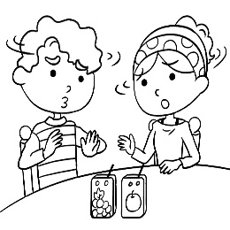 (B)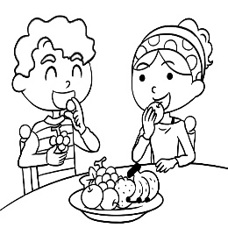 (C)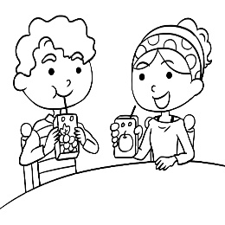
- (A)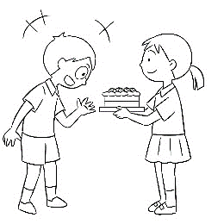 (B)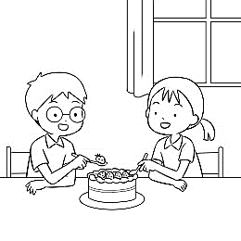 (C)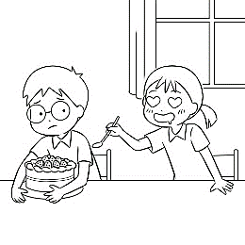
- (A) (B)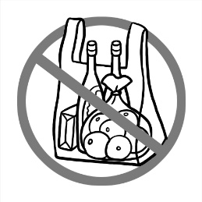 (C)
- (A)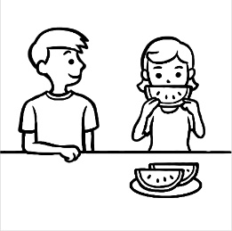 (B)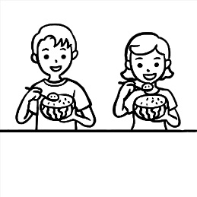 (C)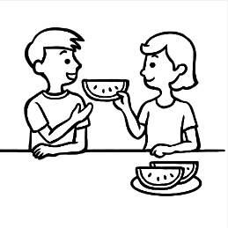
- (A)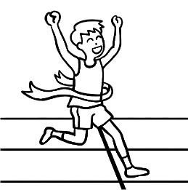 (B)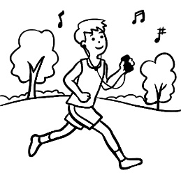 (C)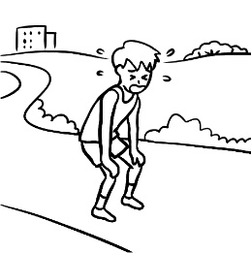
二、基本問答：每題均有三個選項，請依據所聽到的內容，選出一個最適合的回應。
- (A) Miss Lee wasn’t my teacher.
(B) Miss Lee was in the classroom.
(C) Miss Chen was my math teacher then.
- (A) Yes. Let’s wait until both sides are brown.
(B) Sorry, I didn’t know that. I was hungry.
(C) Yes, but I didn’t see any pies on the table.
- (A) I always go there on weekends.
(B) We surfed the Internet twice a week.
(C) I worked out there every day.
- (A) No, I loved all the food there.
(B) Yes, I enjoyed everything there.
(C) Yes, the market didn’t open until noon.
- (A) The law began ten months ago.
(B) It could save many poor families.
(C) I couldn’t swim in the lake. It was hard.
三、言談理解：每題均有三個選項，請依據所聽到的對話與問題，選出一個最適當的答案。
- (A) He was Jennifer’s classmate.
(B) He doesn’t like to exercise.
(C) He is short and thin.
- (A) She surfed the Internet.
(B) She worked there before.
(C) She learned about that from an old man.
- (A) He danced for hours.
(B) He ate a lot.
(C) He made many new friends.
- (A) It’s the man’s car now.
(B) The woman bought it five years ago.
(C) The woman’s dad often washed it before.
- (A) Jenny hated the movie.
(B) Jenny might not like Paul.
(C) Jenny enjoyed the date with Paul.
第二部分、綜合測驗(38%)
- Thanks for helping me with that report. You ____ my life.
- started (B) saved (C) sent (D) slid
- When lions are young, the mother stays with them while the father ____ for food.
- sets (B) slides (C) look (D) hunts
- Maggie read Snow White ____ .
- the next morning (B) last evening (C) two days before (D) yesterday ago
- The lights are too ____ here. They’re hurting my eyes.
- shine (B) shone (C) amazing (D) bright
- I saw the old man drive ____ a red light.
- though (B) thought (C) cross (D) through
- The waiter ____ us to our table.
- lead (B) leaded (C) let (D) led
- The child ____ the ball back over the fence.(圍欄)
- throw (B) through (C) threw (D) drew
- A: ____ your brother in the gym this morning?
B: No, he and I ____ at the supermarket then.
- Was; were (B) Was; was (C) Were; were (D) Were; was
- I can’t believe that Jonson ____ that thin ten years ago unless(除非) he can show me his photo before.
(A) did (B) does (C) is (D) was
- Tony, you should ____ surfing the Net for so long.
(A) stop (B) stopped (C) stops (D) stopping
- The house in old times ____ simple with most of work done by hand, but today there ____ more and more convenient machines in the house.
(A) were; are (B) were; is (C) was; are (D) was; is
- Kalwaski goes jogging every morning, but he ____ today because he hurt his knee yesterday.
(A) doesn’t (B) isn’t (C) wasn’t (D) didn’t

- Hey, the boy ____ basketball there. Let’s talk to him.
(A) played (B) plays (C) has played (D) is playing
- ____ your father swim every morning last winter?
(A) Did (B) Does (C) Is (D) Was
- Gimmy ____ sick yesterday; he even went swimming. That was what I saw in the swimming pool.
(A) was (B) wasn’t (C) didn’t (D) doesn’t
- How ____ the weather in Hualien and Taitung last winter?
(A) is (B) were (C) are (D) was
- Mr. Wu: One of you did a great job on the wall. Who drew these on the wall?
Elly: Tony ____.
(A) does (B) drew (C) did (D) draws
- Mr. Lorenzo: Come over here, Vivian! Who has to answer for the broken window?
Vivian: Sally does. I ____ her break the window. But she didn’t mean to.
(A) sees (B) saw (C) have to see (D) had to see
- Queena: What ____ our grandmother do after dinner this evening?
Maria: She ____ the dishes.
(A) did; did (B) does; does (C) did; do (D) does; did
第三部分、克漏字(10%)
Megan Montgomery (35) a 4th generation teacher. Her mother, grandmother, and great grandfather (36) all teachers before her. Megan (37) born in America, and she (38) to Taiwan in 1995. First she (39) English conversation classes at a large university. Soon after that, she (40) teaching business and writing classes. Those (41) her favorite areas to teach.
In her free time, Megan (42) to play the cello and do artwork. She (43) three cats now. Megan has a friendly personality and a positive attitude about life. In her teaching, she (44) to make students feel good about themselves and about learning English.
generation世代 born出生area區域cello大提琴personality個性positive正面的
- (A) was (B) is (C) does (D) did
- (A) are (B) is (C) was (D) were
- (A) is (B) are (C) was (D) be
- (A) moves (B) is moving (C) moved (D) move
- (A) teached (B) teaches (C) taught (D) teach
- (A) started (B) starts (C) start (D) is starting
- (A) were (B) are (C) will be (D) is
- (A) like (B) liked (C) likes (D) liking
- (A) had (B) is having (C) have (D) has
- (A) try (B) tries (C) tried (D) tryed
第四部份、閱讀測驗(22%)
Henry is walking along the street. Just on the corner, he sees a big dog barking at him, so he is afraid and stops walking. A girl with a little puppy in her arms is standing next to the big dog, so he walks up to her and talks to her.
“What a lovely little puppy you have!” says Henry.
“Thanks. It really is.” says the girl.
“By the way, does your big dog bite? Henry asks.
“No, it never does.” she answers.
After hearing this, Henry is not afraid, so he keeps walking. Suddenly the big dog runs after him, jumps to him and bites him.
“Hey! You said your big dog doesn’t bite.” Henry shouts to the girl.
“It doesn’t, but that’s not my dog. My big dog is at home.” The girl says.
Henry is really unhappy about this. It isn’t his day.
afraid害怕 suddenly突然地
- Where does Henry see the big dog?
(A) In the park. (B) On the street corner.
(C) At the girl’s house. (D) At the zoo.
- Why does Henry keep walking after talking with the girl?
(A) He thinks the big dog at the girl’s house doesn’t bite.
(B) He thinks the little puppy in the girl’s arms doesn’t bite.
(C) He thinks the little puppy in the girl’s arms is very cute.
(D) He thinks the big dog on the street doesn’t bite.
- What is “it”?
(A) The little puppy. (B) The big dog on the street.
(C) The big dog at the girl’s house. (D) The girl.
- What does “It isn’t his day.” mean?
(A) It isn’t his birthday. (B) It isn’t his lucky day.
(C) It isn’t his big day. (D) It isn’t his school day.
A Free Meal
“I’m hungry,” Pat said to his friend Mike. “Let’s have a meal somewhere.”
They walked down the road until they came to an expensive restaurant.
“This will be fine,” Pat said. “Just the place we want.”
He opened the door and they went inside. The head waiter came up to them immediately.
“A table for two, gentlemen?” he asked.
“Yes. The best table you have.”
He took them to a table near a window. He handed them the menu and went away.
Pat and Mike looked at the menu carefully, then ordered the most expensive dishes and a bottle of very good wine.
An hour later, they had almost finished their meals. It was one of the best meals they had ever had, and now they are eating their dessert. Suddenly Pat looked carefully at his dish.
“What’s this?” he cried, pointing at something small and black in the dessert. The head waiter hurried towards their table.
“Look at this!” Pat said to him in a very loud voice. “There’s a dead fly in my dessert. How terrible! I thought this was a good restaurant, but I was wrong.”
The head waiter was very embarrassed. “ Please, sir, do not speak so loud. You will upset the other customers. I am very sorry about the fly. I’m afraid accidents happen sometimes, even in the best restaurant. We will not, of course, charge you for your meals.”
Soon after this, Mike and Pat were walking past a hotel.
“Let’s go in and have a drink,” Pat said. “I’ve got a fly left.”
wine酒 embarrassed尷尬的 accident意外事件upset失望charge收費
- Where did Pat and Mike go for dinner?
(A) An expensive restaurant. (B) A cheap restaurant.
(C) Home. (D) A hotel.
- What did they order for dinner?
(A) Wine and dessert.
(B) The most expensive dishes and a bottle of wine.
(C) The best dishes and coffee.
(D) Dessert.
- What did Pat find in his dessert?
(A) An ant. (B)A bee.
(C) A live fly. (D) A dead fly.
- Why is this story called “ A Free Meal”?
(A) Because Pat and Mike had nothing to eat.
(B) Because the head waiter did not make them pay.
(C) Because they were friends of the head waiter.
(D) Because they had no money.
Located some 100 kilometers west of Tokyo, Kyoto is one of Japan’s most beautiful cities. Kyoto was once the capital of Japan. Now, besides being a cultural and business center, it is a very popular place to visit.
With its peaceful, tree-lined streets and quiet river paths, Kyoto is a great city to walk in. It’s the home of many famous temples, like the Golden Temple. Some temples have rock gardens. They’re carefully made with special designs. They give off a peaceful feeling. This feeling is also shown in the smiling faces of Kyoto’s friendly people.
loocated位於 path小路 give off散發 peaceful安謐
- Where is Kyoto?
(A) Next to the capital of Japan. (B) Somewhere east of Tokyo.
(C) In the center of Japan. (D) About 100 kilometers away from Tokyo.
- Which of the following is NOT discussed?
(A) The people of Kyoto. (B) Kyoto’s Museums.
(C) Rock gardens in Kyoto. (D) Kyoto’s temples.
- What do we learn about Kyoto’s temples?
(A) Many of them are famous. (B) They all have rock gardens.
(C) They charge people money to go inside. (D) Most of them have special designs.

113-2-3 七年級 英語科－解答
1.ACBBC 6.CBCBB
11.ACBCB 16.BDADD
21.DCADA 26.CDDAB
31.DCBAB 36.DCCCA
41.BCDBB 46.DCBAB
51.DBDBA

新北市立溪崑國民中學113學年度第二學期第三次定期評量
七年級 英語科 聽力測驗稿
一、辨識句意：每題均有三張圖片，請依據所聽到的句子，選出符合描述的圖片。
- 《腳本區》
CD: They don’t like fruit. They don’t even want to drink the juice.
《題目區》
＿＿＿
(A)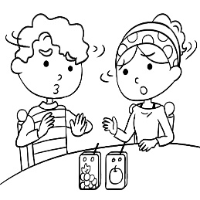 (B)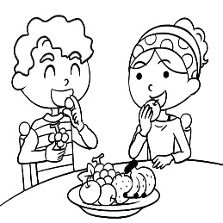 (C)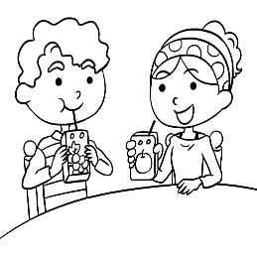
《答案區》
答案：A
題號：A02L5172
- 《腳本區》
CD: Frank didn’t want to share the cake with his classmate Gina.
《題目區》
＿＿＿
(A)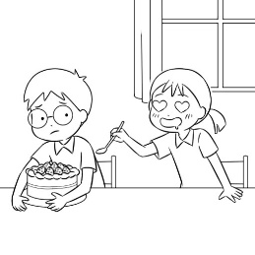 (B)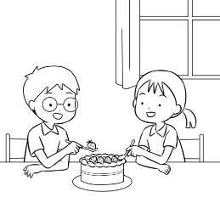 (C)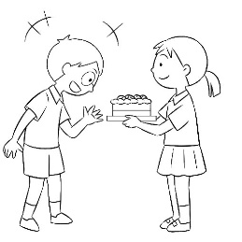
《答案區》
答案：A
題號：A02L5175
- 《腳本區》
CD: You can put your things in a box or basket. Don’t use plastic bags.
《題目區》
＿＿＿
(A) (B) (C)
《答案區》
答案：B
題號：A02L6178
- 《腳本區》
CD: (W:) Let’s share this watermelon, and you can take half.
《題目區》
＿＿＿
(A) (B) (C)
《答案區》
答案：B
題號：A02L6212
- 《腳本區》
CD: The runner stopped for a short break.
《題目區》
＿＿＿
(A) (B) (C)
《答案區》
答案：C
題號：A02L6213
二、基本問答：每題均有三個選項，請依據所聽到的內容，選出一個最適合的回應。
- 《腳本區》
CD: B: Miss Lee is my new math teacher this year.
G: Who was your math teacher last year?
《題目區》
＿＿＿
(A) Miss Lee wasn’t my teacher.
(B) Miss Lee was in the classroom.
(C) Miss Chen was my math teacher then.
《答案區》
答案：C
題號：A02L5069
- 《腳本區》
CD: The pie on the table was for Jason. Did you eat it?
《題目區》
＿＿＿
(A) Yes. Let’s wait until both sides are brown.
(B) Sorry, I didn’t know that. I was hungry.
(C) Yes, but I didn’t see any pies on the table.
《答案區》
答案：B
題號：A02L5073
- 《腳本區》
CD: How often did you go to the gym before?
《題目區》
＿＿＿
(A) I always go there on weekends.
(B) We surfed the Internet twice a week.
(C) I worked out there every day.
《答案區》
答案：C
題號：A02L5201
- 《腳本區》
CD: Was the visit to the street market fun?
《題目區》
＿＿＿
(A) No, I loved all the food there.
(B) Yes, I enjoyed everything there.
(C) Yes, the market didn’t open until noon.
《答案區》
答案：B
題號：A02L5204
- 《腳本區》
CD: What did you think about the law?
《題目區》
(A) The law began ten months ago.
(B) It could save many poor families.
(C) I couldn’t swim in the lake. It was hard.
《答案區》
答案：B
題號：A02L6203
三、言談理解：每題均有三個選項，請依據所聽到的對話與問題，選出一個最適當的答案。
- 《腳本區》
CD: M: Hi, Jennifer! Long time no see.
W: I’m sorry. Who are you?
M: We were classmates in KN Junior High. We were both in Class 705.
W: Eric? Wow! You were short and thin before.
M: I work out every day now.
W: No wonder.
Q: Which is true about Eric?
《題目區》
＿＿＿
(A) He was Jennifer’s classmate.
(B) He doesn’t like to exercise.
(C) He is short and thin.
《答案區》
答案：A
題號：A02L5096
- 《腳本區》
CD: M: This museum is beautiful.
W: Yes, and it’s old. It’s over 200 years old. By the way, it is the first museum in this town.
M: How do you know? Did you find that on the Internet?
W: No. I visited this town many years ago. An old man explained its story to me.
Q: How did the woman know about the museum?
《題目區》
＿＿＿
(A) She surfed the Internet.
(B) She worked there before.
(C) She learned about that from an old man.
《答案區》
答案：C
題號：A02L5104
- 《腳本區》
CD: W: What a great party! We had fun last night. I danced all night. I also made many new friends.
M: Not me.
W: What happened to you?
M: I had too much food and drank too many glasses of juice. I didn’t meet any new people. I went home early.
W: It’s too bad.
Q: What did the man do at the party?
《題目區》
＿＿＿
(A) He ate a lot.
(B) He danced for hours.
(C) He made many new friends.
《答案區》
答案：A
題號：A02L6092
- 《腳本區》
CD: M: Wow! Your new car is cool.
W: Thanks. But in fact, it’s not new. My dad bought it five years ago.
M: Really? It’s very clean. Did you wash it very often?
W: Yes. My dad washed it every week.
Q: What can we say about the car?
《題目區》
(A) It’s the man’s car now.
(B) The woman bought it five years ago.
(C) The woman’s dad often washed it before.
《答案區》
答案：C
題號：A02L6206
- 《腳本區》
CD: M: Jenny, how was your first date with Paul?
W: Well, the movie was amazing. And he brought me a beautiful cake.
M: Tell me more.
W: He is kind and handsome.
M: Do you like him?
W: Hmm. He’s a nice guy, but he’s just not my type.
Q: What can we know from the talk?
《題目區》
＿＿＿
(A) Jenny hated the movie.
(B) Jenny might not like Paul.
(C) Jenny enjoyed the date with Paul.
《答案區》
答案：B
題號：A02L6207

