新北市立溪崑國民中學113學年度第二學期第一次定期評量 英語科 試題卷
七年級 班 座號 姓名
(一)聽力測驗 30%
一、辨識句意：每題均有三張圖片，請依據所聽到的句子，選出符合描述的圖片。
- (A)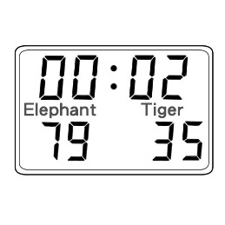 (B)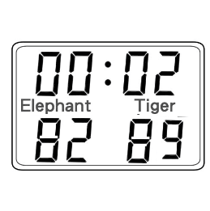 (C)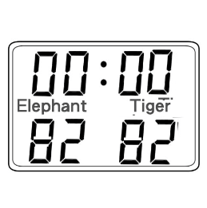
- (A)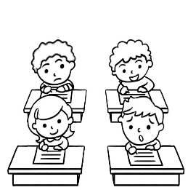 (B)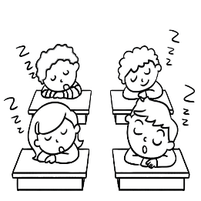 (C)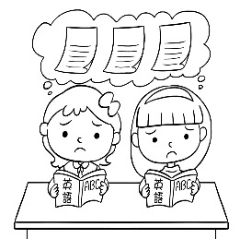
- (A)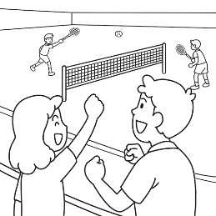 (B)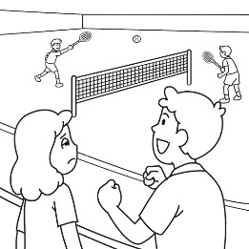 (C)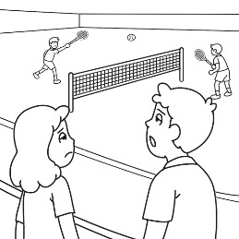
- (A)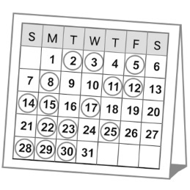 (B)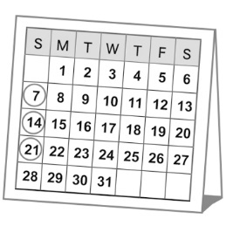 (C)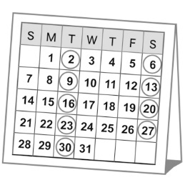
- (A)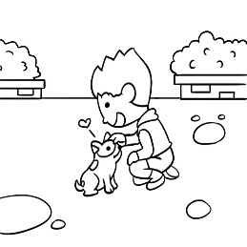 (B)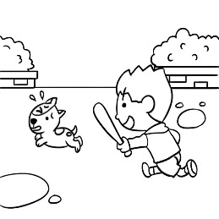 (C)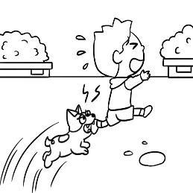
二、基本問答：每題均有三個選項，請依據所聽到的內容，選出一個最適合的回應。
- (A)No, we don’t. How much are they?
(B)Yes, I do. I have one hundred dollars.
(C)Don’t worry. They must be expensive.
- (A)We can’t lose it.
(B)He doesn’t, either.
(C)But I’m hungry.
- (A)She never does that at work.
(B)She wants a new cellphone for her work.
(C)She never checks her cell phone after work.
- (A)Yes, my sister eats them every day.
(B)They are one hundred and fifty dollars.
(C)Well, I don’t like strawberries.
- (A)All right. Let’s take a break.
(B)Sorry. I don’t have time for lunch today.
(C)Terrible. I seldom have time for lunch.
三、言談理解：每題均有三個選項，請依據所聽到的對話與問題，選出一個最適當的答案。
- (A)They want to play games with their brother.
(B)They want to study for tests.
(C)They want to go out with their parents.
- (A)Three hundred and fifty dollars.
(B)Nine hundred and fifty dollars.
(C)Six hundred dollars.
- (A)Yes. He gets up early every day.
(B)Yes. He cooks breakfast every morning.
(C)No. He only cooks breakfast on weekends.
- (A)He is never late for meetings.
(B)He is the last person to be in the meeting.
(C)He may not be happy about the man and the woman.
- (A)The woman is talking on the phone.
(B)The woman is doing housework now.
(C)The man is helping（幫助）her daughter with her homework.

(二)綜合測驗30%
- The youngest player won the most _____.
(A)dollar (B)fingers
(C)trash (D)points
- I’m trying not to get into the _____ of always having chocolate cake with my coffee.
(A)habit (B)set
(C)floor (D)town
- A: How long is the Christmas _____ this year?
B: I’m not sure.
(A)free (B)touch
(C)menu (D)break
- That new shelf in the bathroom is too low. I just _____ my head on it.
(A)lost (B)enjoy
(C)hit (D)move
- A: Who _____ the dishes in your family?
B: My brothers _____.
(A)do; does (B)washes; does
(C)does; wash (D)does; do
- _____ he gets up early to buy breakfast for his family.
(A)Never (B)Seldom
(C)Usually (D)Sometimes
- Tony doesn’t always get up early. It means _____.
(A)Tony sometimes gets up late. (B)Tony never gets up late.
(C)Tony always gets up late. (D)Tony usually gets up late.
- A: Look! Jojo _____ soccer again.
B:He _____ that after school every day.
(A)is practicing; do (B)practices; does
(C)practices; is doing (D)is practicing; does
- A:_____ Mia _____ a group meeting on Thursdays?
B: I don’t know. You can ask her.
(A)Do, have (B)Does, have
(C)Is, have (D)Must, has
- Maggie seldom goes to the gym on weekends. She _____ goes out with her friends.
(A)never (B)seldom
(C)every time (D)usually
- A: Do you usually do your homework with Mike?
B:_____.
(A)No, never. (B)Yes, I seldom do.
(C)Yes, I do usually. (D)No, I often do.
- The tall girl _____hard, and I don’t, either.
(A)studies (B)study
(C)don’t study (D)doesn’t study
- No one _____ to school today. It’s a holiday.
(A)don’t go (B)doesn’t go
(C)goes (D)go
- The teacher _____ my name now.
(A)is knowing (B)doesn’t knows
(C)knows (D)know
- Aine: Do you ever try any Italian food?
Maria:_____ But it’s very oily.
(A)Yes, ever. (B)Yes, very little.
(C)No, never. (D)Yes, sometimes.

(三)閱讀測驗
- 8%
Menu
Soup Main Dishes
Soup of the day $1.5 Spaghetti $5.50
Tomato $1.5 Mixed Vegetables $5.00
Vegetable Beef $2.00 Fried Chicken $6.00

Salads Drinks
Chef’s Salad $3.5 Coke $1.00
Caesar Salad $3.2 Iced Tea $1.00
Small Salad $1.75 Orange Juice $1.25
Coffee $.75

Sandwiches and Hamburgers Dessert
Cheese Sandwich $2.75 Ice Cream $1.5
BLT(Bacon, Lettuce, and tomato) $3.00 Cake $1.75
Hamburger $3.25 Apple Pie $1.75
Cheeseburger $3.75
Sequoia and Harry are having dinner at the Mountain Road Diner.
They go to the restaurant often. Sequoia loves cheeseburgers. She also loves apple pie. But, she ate apple pie last week. This time, she may try something different. She always drinks something hot.
Harry always has a soup with his meal. He may order spaghetti or the mixed vegetables. He wants to drink orange juice. But the restaurant doesn’t have any left. So, he has to drink something different. Harry doesn’t eat dessert.
- What may Sequoia’s order look like?
- Tomato soup, hamburger, and iced tea.
- Chef’s salad, BLT, coffee, and coke.
- Spaghetti, apple pie, and orange juice.
- Cheeseburger, coffee, and ice cream.
- What may Harry’s order look like?
- Soup of the day, cheese sandwich, and iced tea.
- Vegetable beef soup, mixed vegetables, and orange juice.
- Tomato soup, mixed vegetables, and iced tea.
- Small salad, fried chicken, coffee and apple pie.
- What is something Sequoia never orders?
- Coke. (B)Apple pie. (C)Cheeseburger. (D)Coffee.

- What is something Harry never orders?
(A)Tomato soup. (B)Cake. (C)Orange juice. (D)Spaghetti.

- 8%
Peter the Great was a very important Russian ruler. As a child, he was smart and curious. He learned about modern science and technology. And he was very interested in boats.
After 1689, he ruled Russia on his own. He created Russia’s first navy. He also made the army stronger. To learn more about modern science and technology, he traveled around Europe for 18 months. Many scientists returned with him to Russia.
In 1703, Peter built a brand new city – St. Peterburg. It was a symbol of the new Russia. People called it “the window to the west”.
Peter also brought many reforms to Russia. Education, business, politics, and the army became more modern. And he started Russia’s first newspaper.
Peter made Russia a strong, modern, and powerful country. Indeed Peter the Great changed Russia greatly!
curious好奇 technology科技 navy海軍 army軍隊 symbol象徵 reforms改革
- As a child, Peter _____.
- liked boats (B)was not very smart
(C)ruled Russia on his own (D)liked to read the newspaper
- What did Peter do in Europe?
- He visited his relatives. (B)He bought a boat.
(C)He created a navy. (D)He learned about new kinds of technology.
- What is it?
- Peter (B)Russia (C)Europe (D)St. Petersburg
- What can we say about Peter the Great?
- He didn’t do much to help Russia. (B)He wanted to make Russia modern.
(C)He was very lazy. (D)He didn’t like travel.

- 4%
Jake Kessel has a small farm. It’s near a river and a small hill. Every day, Jake (39) at 4:30 AM. He has to feed the animals and (40).
Jake’s wife, Sylvia, is a (41) woman. She helps Jake in the field, and she also cleans the house and cooks. Jake and Sylvia have two children. Their daughter is in high school. Their son is studying business at a university. Every Sunday, the family has a big meal together. Sometimes, the neighbors join them.
Working on a farm is difficult. Life is sometimes hard. Often, there’s not enough money. Bad weather can also be (42). Still, Jake and Sylvia like their peaceful life in the countryside.
- (A)goes to school (B)wakes up (C)eats dinner (D)cleans the river
- (A)watch TV (B)go to sleep (C)work in the field (D)drive to the office
- (A)angry (B)kind (C)stupid (D)lazy
- (A)helpful (B)a problem (C)good for the farm (D)exciting

(四) 翻譯(請在答案卷上作答) 20% 每題4分
- 我家的馬桶從來不髒。我媽一天打掃兩次。
- A:你爸多久拖一次地?
B:他一個月拖一次地。
- A:你每個周末通常做什麼呢?
B:我通常算數學，運動，打電動。
- A:你哥上班總是遲到嗎?
B:是的，他一向如此。
- 羽球是我最喜歡的運動。
草莓是我最喜歡的水果。

新北市立溪崑國民中學113學年度第二學期第一次定期評量 英語科 答案卷
七年級 班 座號 姓名

翻譯:20% 每題4分 答案不得超出格子 不可用鉛筆作答
43.
44.
45.
46.
47.

113-2-1 七年級 英語科－解答
1.ACBAC 6.ACABC
11.ABCCB 16.DADCD
21.DADBD 26.ADCCD
31.DCABA 36.DDBBC
41.BB

43. The toilet in my house is never dirty.
Mother cleans it twice a day.
44. A: How often does your father mop the floor?
B: He mops the floor once a month.
45. A: What do you usually do on weekends?(every weekend)
B: I usually study math, exercise, and play video games.
46. A: Is your brother always late for work?
(Does your brother always go to work late?)
B: Yes,he always is.
(Yes, he always does.)
47. Badminton is my favorite sport.
Strawberries are my favorite fruit.

新北市立溪崑國民中學113學年度第二學期第一次定期評量
七年級 英語科 聽力測驗稿
- 《腳本區》
CD: Team Elephant can win the game.
《題目區》
(A)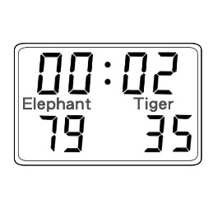 (B) (C)
《答案區》
答案：A
題號：A02L1168
- 《腳本區》
CD: The students are worrying about the coming English test.
《題目區》
(A) (B) (C)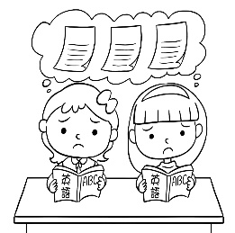
《答案區》
答案：C
題號：A02L1172
- 《腳本區》
CD: The man enjoys the sports game, but the woman doesn’t.
《題目區》
＿＿＿
(A)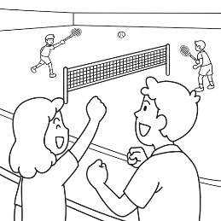 (B)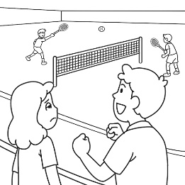 (C)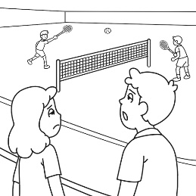
《答案區》
答案：B
題號：A02L1211
- 《腳本區》
CD: There is a nice gym near my house, and I go there three times a week.
《題目區》
＿＿＿
(A)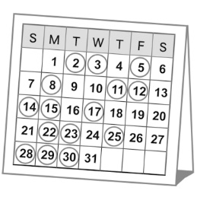 (B)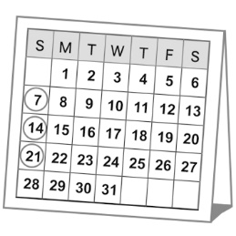 (C)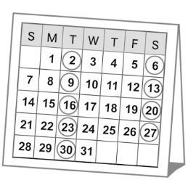
《答案區》
答案：A
題號：A02L2182
- 《腳本區》
CD: The dog always runs after Andrew. He doesn’t like the dog.
《題目區》
＿＿＿
(A)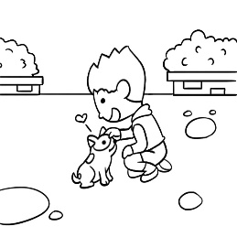 (B)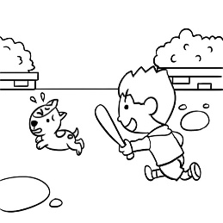 (C)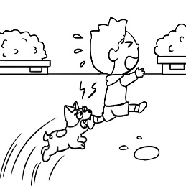
《答案區》
答案：C
題號：A02L2172
二、基本問答：每題均有三個選項，請依據所聽到的內容，選出一個最適合的回應。
- 《腳本區》
CD: Do we have the tickets for the robot theme park?
《題目區》
(A) No, we don’t. How much are they?
(B) Yes, I do. I have one hundred dollars.
(C) Don’t worry. They must be expensive.
《答案區》
答案：A
題號：A02L1061
- 《腳本區》
CD: Hey, don’t touch the cake on the table. It’s for your dad.
《題目區》
(A) We can’t lose it.
(B) He doesn’t, either.
(C) But I’m hungry.
《答案區》
答案：C
題號：A02L1070
- 《腳本區》
CD: How many times does Paula check her cellphone at work?
《題目區》
＿＿＿
(A) She never does that at work.
(B) She wants a new cellphone for her work.
(C) She never checks her cellphone after work.
《答案區》
答案：A
題號：A02L2201
- 《腳本區》
CD: How much are the strawberries?
《題目區》
(A) Yes, my sister eats them every day.
(B) They are one hundred and fifty dollars.
(C) Well, I don’t like strawberries.
《答案區》
答案：B
題號：A02L1072
- 《腳本區》
CD: How’s your work going?
《題目區》
＿＿＿
(A) All right. Let’s take a break.
(B) Terrible. I seldom have time for lunch.
(C) Sorry. I don’t have time for lunch today.
《答案區》
答案：B
題號：A02L2205
三、言談理解：每題均有三個選項，請依據所聽到的對話與問題，選出一個最適當的答案。
- 《腳本區》
CD: (B:) It’s Sunday today. My father isn’t home, and my mother isn’t, either. I’m studying now, but my sisters want me to play ball games with them. I have a test next Monday. Mom and Dad, please come home!
Q: What do the boy’s sisters want?
《題目區》
(A) They want to play games with their brother.
(B) They want to study for tests.
(C) They want to go out with their parents.
《答案區》
答案：A
題號：A02L1091
- 《腳本區》
CD: M: This chair is soft. I like it.
W: It’s only six hundred dollars.
M: What about this table?
W: It’s three hundred and fifty dollars.
Q: How much are the chair and the table?
《題目區》
(A) Nine hundred and fifty dollars.
(B) Three hundred and fifty dollars.
(C) Six hundred dollars.
《答案區》
答案：A
題號：A02L1098
- 《腳本區》
CD: W: A hot dog, three eggs, an apple, and a cake? Wow, that’s a big breakfast.
M: Yeah. I enjoy my breakfast.
W: Do you make breakfast every morning?
M: No, only on weekends.
W: Then what time do you get up?
M: I get up at 6 a.m.
W: Wow! That’s early.
Q: Does Peter cook breakfast every day?
《題目區》
＿＿＿
(A) Yes. He gets up early every day.
(B) Yes. He cooks breakfast every morning.
(C) No. He only cooks breakfast on weekends.
《答案區》
答案：C
題號：A02L1110
- 《腳本區》
CD: M: Diana, hurry up. We’re late.
W: Don’t worry. Mr. Wang is always late for meetings.
M: But he’s not late this time. See? He’s waiting for everyone in the room now.
W: Oops.
Q: Which is true about Mr. Wang?
《題目區》
＿＿＿
(A) He is never late for meetings.
(B) He is the last person to be in the meeting.
(C) He may not be happy about the man and the woman.
《答案區》
答案：C
題號：A02L2092
- 《腳本區》
CD: W: Dear, can you check Joyce’s homework?
M: I can’t. I’m talking to David on the phone.
W: Your friend can wait, but your daughter can’t.
M: But David has some problems with his wife.
W: You always say that. Just put down the phone and go help your daughter. Or you can clean the toilet for me, and then I go check her homework.
Q: What can we learn from the talk?
《題目區》
＿＿＿
(A) The woman is talking on the phone.
(B) The woman is doing housework now.
(C) The man is helping（幫助）her daughter with her homework.
《答案區》
答案：B
題號：A02L2208

